Supplementary Material:
Clinical Trials Bootcamp Topics
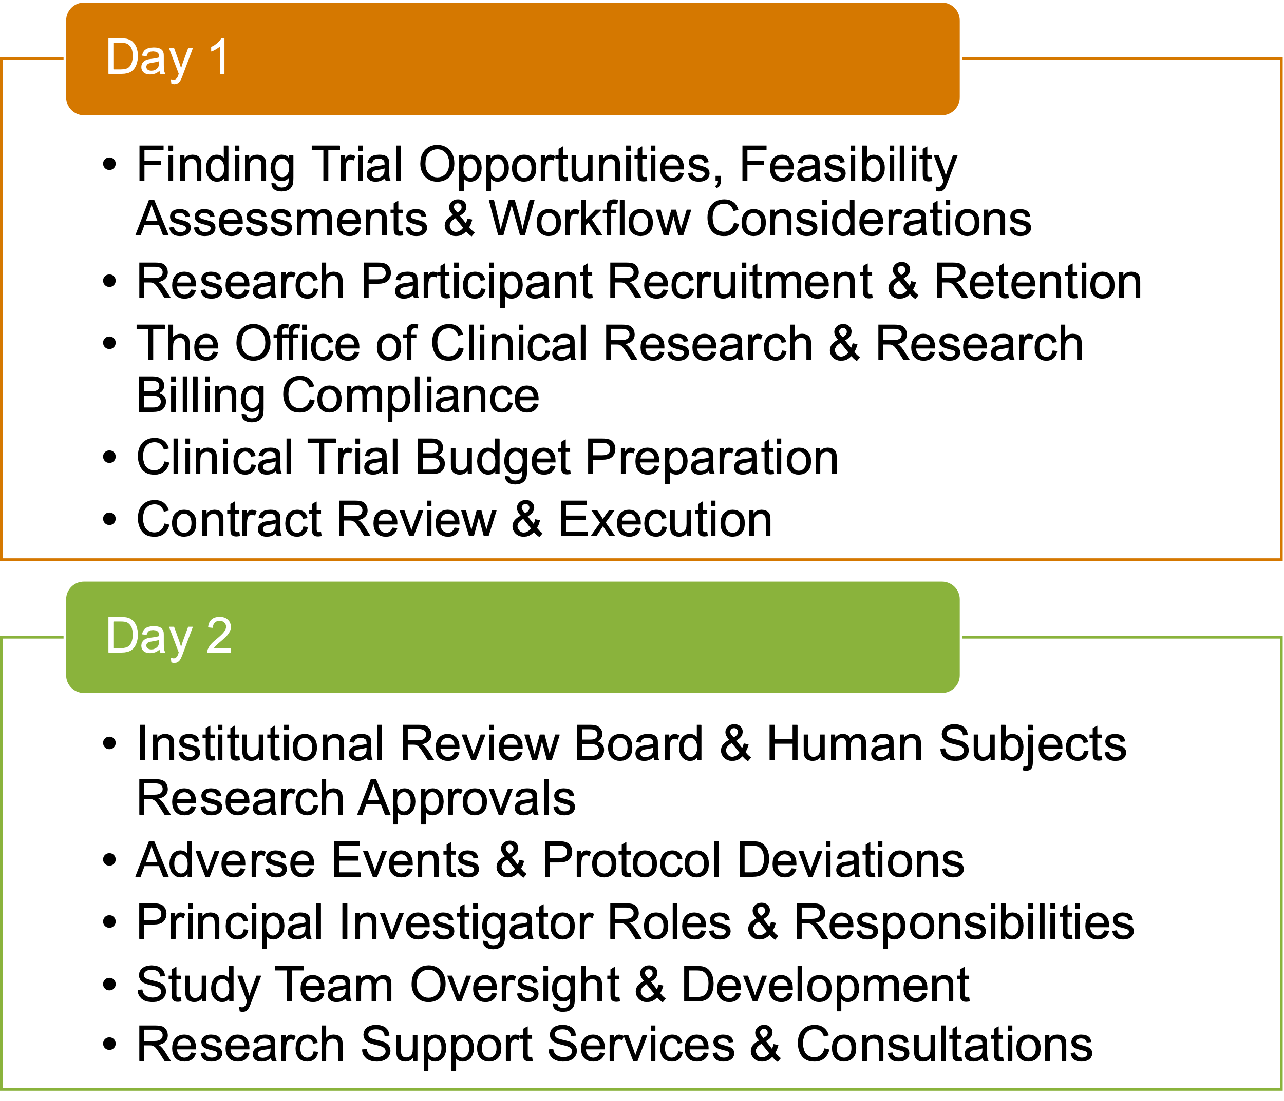

Overall Bootcamp Evaluation
Pre and Post Bootcamp Knowledge Questionnaire

