Supplementary table 1

STROBE Statement—Checklist of items that should be included in reports of cross-sectional studies
 | Item No | Recommendation | Page  No
Title and abstract | 1 | (a) Indicate the study’s design with a commonly used term in the title or the abstract | Page (p) 1
 |  | (b) Provide in the abstract an informative and balanced summary of what was done and what was found | p. 2
Introduction
Background/rationale | 2 | Explain the scientific background and rationale for the investigation being reported | p. 3-5
Objectives | 3 | State specific objectives, including any prespecified hypotheses | p. 5 & 7
Methods
Study design | 4 | Present key elements of study design early in the paper | p. 5
Setting | 5 | Describe the setting, locations, and relevant dates, including periods of recruitment, exposure, follow-up, and data collection | p. 7
Participants | 6 | (a) Give the eligibility criteria, and the sources and methods of selection of participants | p. 7
Variables | 7 | Clearly define all outcomes, exposures, predictors, potential confounders, and effect modifiers. Give diagnostic criteria, if applicable | p. 7-8
Data sources/ measurement | 8* | For each variable of interest, give sources of data and details of methods of assessment (measurement). Describe comparability of assessment methods if there is more than one group | p. 7 & 10
Bias | 9 | Describe any efforts to address potential sources of bias | p. 7
Study size | 10 | Explain how the study size was arrived at | p. 7
Quantitative variables | 11 | Explain how quantitative variables were handled in the analyses. If applicable, describe which groupings were chosen and why | p. 7-8
Statistical methods | 12 | (a) Describe all statistical methods, including those used to control for confounding | p. 7-8
 |  | (b) Describe any methods used to examine subgroups and interactions | p. 7-8
 |  | (c) Explain how missing data were addressed | n/a
 |  | (d) If applicable, describe analytical methods taking account of sampling strategy | n/a
 |  | (e) Describe any sensitivity analyses | n/a
Results
Participants | 13* | (a) Report numbers of individuals at each stage of study—eg numbers potentially eligible, examined for eligibility, confirmed eligible, included in the study, completing follow-up, and analysed | p. 8
 |  | (b) Give reasons for non-participation at each stage | n/a
 |  | (c) Consider use of a flow diagram | n/a
Descriptive data | 14* | (a) Give characteristics of study participants (eg demographic, clinical, social) and information on exposures and potential confounders | p. 8
 |  | (b) Indicate number of participants with missing data for each variable of interest | n/a
Outcome data | 15* | Report numbers of outcome events or summary measures | n/a
Main results | 16 | (a) Give unadjusted estimates and, if applicable, confounder-adjusted estimates and their precision (eg, 95% confidence interval). Make clear which confounders were adjusted for and why they were included | results from p. 8 onward
 |  | (b) Report category boundaries when continuous variables were categorized | n/a
 |  | (c) If relevant, consider translating estimates of relative risk into absolute risk for a meaningful time period | n/a
Other analyses | 17 | Report other analyses done—eg analyses of subgroups and interactions, and sensitivity analyses | p. 9-10
Discussion
Key results | 18 | Summarise key results with reference to study objectives
Limitations | 19 | Discuss limitations of the study, taking into account sources of potential bias or imprecision. Discuss both direction and magnitude of any potential bias | p. 11
Interpretation | 20 | Give a cautious overall interpretation of results considering objectives, limitations, multiplicity of analyses, results from similar studies, and other relevant evidence | p. 12-14
Generalisability | 21 | Discuss the generalisability (external validity) of the study results | p. 14-15
Other information
Funding | 22 | Give the source of funding and the role of the funders for the present study and, if applicable, for the original study on which the present article is based | p. 17-18

*Give information separately for exposed and unexposed groups.

Note: An Explanation and Elaboration article discusses each checklist item and gives methodological background and published examples of transparent reporting. The STROBE checklist is best used in conjunction with this article (freely available on the Web sites of PLoS Medicine at http://www.plosmedicine.org/, Annals of Internal Medicine at http://www.annals.org/, and Epidemiology at http://www.epidem.com/). Information on the STROBE Initiative is available at www.strobe-statement.org.

Supplementary figure 1. Obesity and Gender. Differences in the proportions of gender and obesity (normal, overweight, obese, and underweight) (χ² (3) = 12.021; p = .007; two-sided, 0.05 significance) were found. There was a significant difference between gender and obesity. Men (42%) tended to be more overweight compared to women (31%). However, it was found that women tended to be more obese (53%) compared to men (32%).

Supplementary figure 2. Stress and Gender. There was a statistically significant relationship between stress levels and gender (χ² (1) = 10.684; p = .001; two-sided, 0.05 significance). Women (68%) reported higher levels of stress than did men (42%).

Supplementary figure 3. Past Drug Use and Gender. A statistically significant difference was found between past drug use and gender (χ² (1) = 30.836; p < .000; two-sided, 0.05 significance). Men (60%) tended to have greater past drug use than women did.

Supplementary figure 4. Exercise and Gender. Differences in the proportions of gender and exercise
(χ² (1) = 14.14; p = .000; two-sided, 0.05 significance) were found. Women tended to exercise less than men did.

Supplementary figure 5. Diagnosis and Stress. Differences in the proportions of diagnosis and stress
(χ² (4) = 13.514; p = .009; two-sided, 0.05 significance) were found. Participants with depression (80%) tended to have higher levels of stress than did participants with other diagnoses.

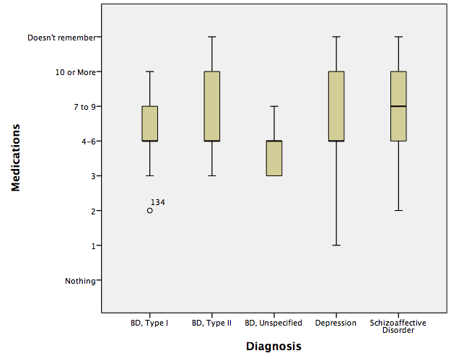
Supplementary figure 6. There were significant differences in the number of medications and diagnosis:
(χ² (24) = 38.242; p < .033; two-sided, 0.05 significance). The majority of the participants tended to take four to six medications, which was the case for 50% of the participants with depression.

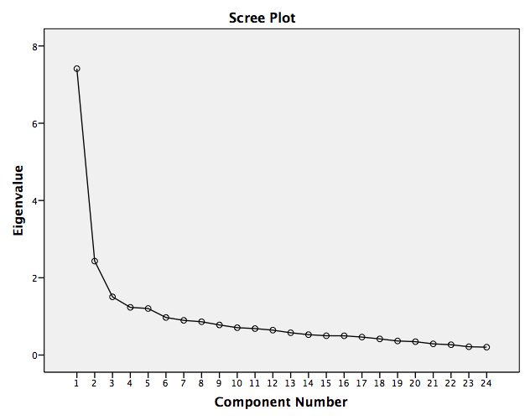

Supplementary figure 7. Scree Plot of the final scale.

Supplementary figure 8. Estimated marginal means of adherence/nonadherence scale across education categories.

