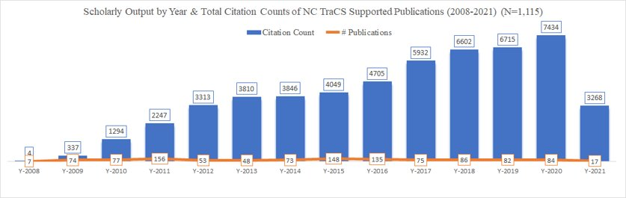
Supplementary Figure 1. Scholarly output by year and total citation counts of NC TraCS-supported publications (September 2008 – March 2021) (N=1,154) (Note: NC TraCS, North Carolina Translational and Clinical Science Institute)

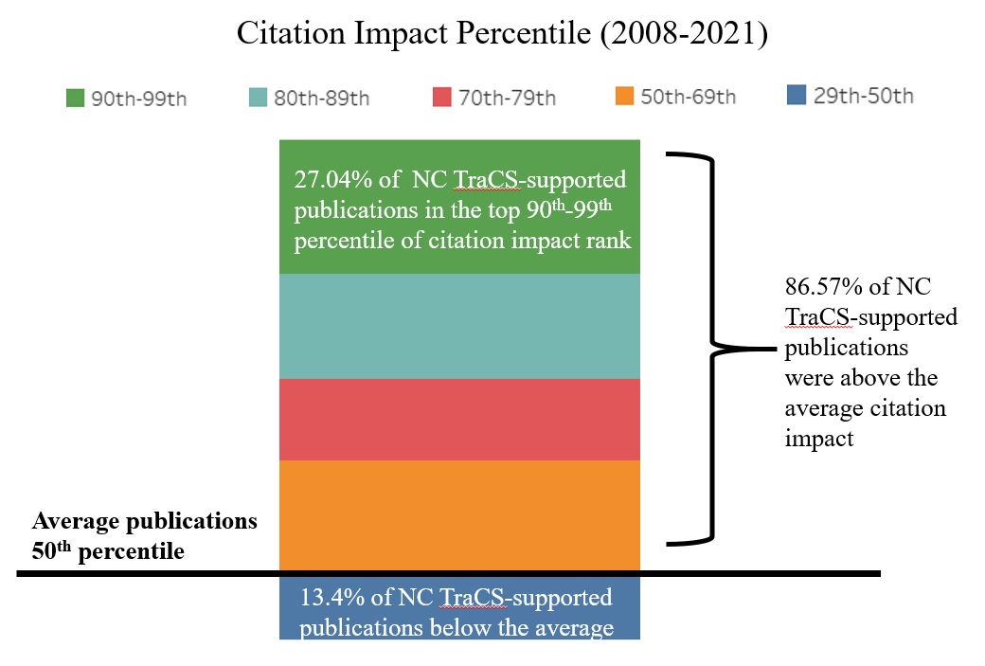
Supplementary Figure 2. Citation benchmarking (CB) of NC TraCS-supported publications (September 2008 – March 2021) (Note: 1,050 publications out of 1,115 have CB percentiles provided by Scopus; NC TraCS = North Carolina Translational and Clinical Science Institute).

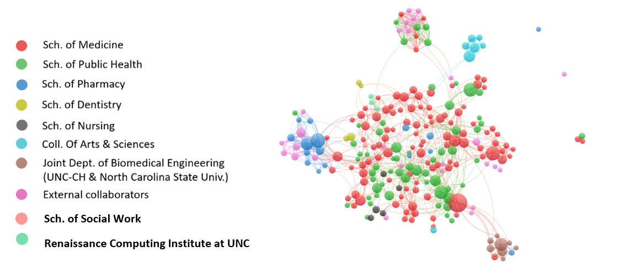
Supplementary Figure 3. The most published UNC author (each has >5 publications) collaboration network across internal units (2008-2021, N=234; Note: each node in the network produced at least 5 publications) (UNC = University of North Carolina at Chapel Hill)

Supplementary Table 1. The comparison of research collaboration with HBCUs (2017 pilot vs. 2021) (numbers below represent collaborated publications)
Collaborated HBCUs | Pilot study in 2017 [10] (N=754) | Current study in 2021 (N=1,154)
NC Central University | 2 | 5
NC A&T University | 1 | 2
Howard University | 0 | 2
Meharry Medical College | 0 | 1
GHUCCTS | 0 | 1
(Note: HBCUs, Historically Black Colleges and Universities; NC = North Carolina; NC A&T University = North Carolina Agriculture & Technical State University; GHUCCTS = Georgetown-Howard Universities Center for Clinical & Translational Science)

Supplementary Table 2. PlumX metrics results of NC TraCS-supported publications (September 2008 – March 2021)
PlumX metrics | Citations | Usage | Captures | Mentions | Social Media
Total | 52,269​ | 619,722​ | 108,360​ | 1,232​ | 25,389​
(Note: NC TraCS, North Carolina Translational and Clinical Science Institute)

Supplementary Table 3. Highlighted papers that have the highest PlumX metric scores
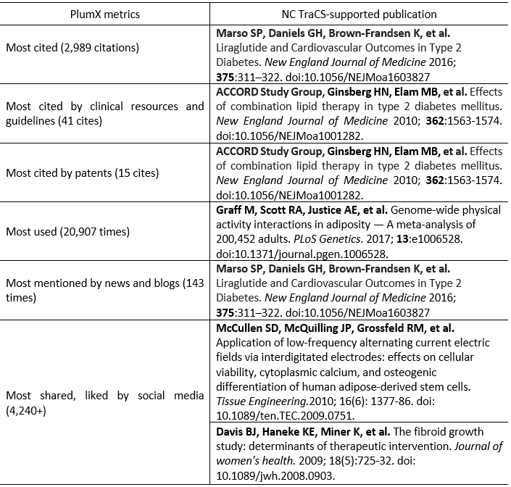
(Note: NC TraCS, North Carolina Translational and Clinical Science Institute)

Supplementary Table 4. Correlation output from SPSS.
