Developing an Engaging and Accessible Clinical Research Training Program for New Investigators: Supplementary Materials

Tufts CTSI Blue Star Investigator Evaluation Items

Pre-requisite Module

- On a scale of 0 to 10, with 0 being ‘no confidence’ and 10 being ‘total confidence’, how confident do you feel in leading your own clinical research study as of now?

Modules 1 – 8 Pre- and Post-Test Items

INSTRUCTIONS: The following items are tasks related to performing clinical research. For each item below, please indicate how confident you are that you can do these tasks as of now, based on the scale shown here.
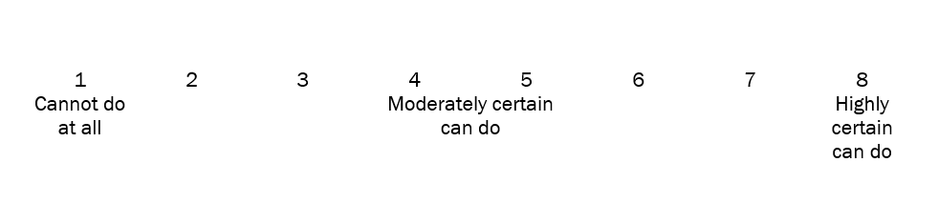
Module | Competency Statement | Source
2. Study Protocols and Budgets | Develop a logical rationale for a particular research idea. | CRAI #5
 | Articulate the purpose of the study. | JTF 1.2 A1
 | Identify the key elements of a clinical study protocol. | JTF 1.3 A1
 | Explain the concept of therapeutic misconception and its relationship to the research protocol. | JTF 2.2 B1 modified
 | Identify the component parts of a clinical trial budget. | Blue Star
3. Regulatory Review | Explain the importance of complying with global guidelines and recommendations, as well as local regulations regarding the safety, wellbeing, and rights of all subjects participating in a clinical trial anywhere. | JTF 2.3 A1
 | Identify the historical events which have led to the development of the current informed consent regulations. | JTF 2.4 A1
 | Write a human subjects consent form containing the appropriate elements using plain language. | CRAI #56
 | Describe roles and responsibilities of IRB and sponsors as set forth in federal regulations and GCPs. | JTF 4.2 B2
 | Identify the required levels of review at Tufts Medical Center. | Blue Star
4. Recruitment and Retention | Describe appropriate recruitment and retention methods used in clinical research. | CRAI #54
 | Explain how stakeholder and community engagement can support recruitment and retention in clinical research. | Blue Star
 | Innovate solutions to recruitment and retention challenges incorporating key ethical considerations. | JTF 5.4 C1
 | Identify tools, strategies, and procedures for implementation and tracking of participant recruitment and retention. | JTF 5.4 A2, modified
 | Describe the importance of incorporating strategies that account for regional and cultural diversity in the conduct of clinical research. | JTF 7.4 A1, modified
5. Adverse Event Reporting | Articulate the differences between the different types of adverse events. | JTF 4.6 A1, modified
 | Describe safety reporting requirements, timelines, and channels. | JTF 4.10 B1, modified
 | Identify when an SAE occurs during the conduct of a clinical trial and required reporting time frames. | JTF 4.6 A2, modified
 | Explain the role of grading scales for measuring event severity. | Blue Star
 | Differentiate between the sponsor and PI responsibilities in adverse event reporting. | Blue Star
6. Audit Readiness | Describe the steps taken to prepare for an audit/inspection. | JTF 4.9 A1
 | Distinguish between scope of audits conducted by sponsors, IRB and regulatory authority. | JTF 4.9 B1
 | Distinguish between routine and for-cause audits and inspections. | JTF 4.9 B3
 | Maintain study regulatory and grants/contracts documents for regulatory and institutional compliance audits. | JTF 5.5 A1, modified
 | Distinguish between corrective and preventive action plans. | Blue Star
7. Leading and Managing Research Teams | Set expectations and communicate them to project staff. | CRAI #48
 | Compare and contrast leadership and management within a clinical research team. | Blue Star
 | Manage personnel that are assigned to a clinical study. | Blue Star
 | Mentor study team and staff members concerning internal processes and procedures to ensure that all aspects of clinical studies are conducted within the bounds of ethical conduct. | JTF 7.3, revised
 | Identify each member of the team and their respective roles and responsibilities. | JTF 8.1, revised
8. Study Close-out and Next Steps | Discuss the required steps for appropriate study close-out. | Blue Star
 | Identify appropriate Tufts Medical Center policies related to study close-out. | Blue Star
 | Define a letter of intent and its relationship to study protocols. | Blue Star
 | Describe the steps for identifying study funding sources. | CRAI #31, modified
 | Identify methods for disseminating your research results to different audiences. | Blue Star
CRAI: Clinical Research Appraisal Inventory
JTF: Joint Task Force for Clinical Trial Competency
IRB: Institutional Review Board
GCP: Good Clinical Practice
SAE: Serious Adverse Event
PI: Principal Investigator

Program Evaluation Items
1. INSTRUCTIONS: Please indicate your level of agreement with each statement below. [scale: strongly disagree, disagree, neither agree nor disagree, agree, strongly agree]
- The material covered was relevant to my research, practice, or work.
- The Blue Star Program stimulated new ideas for my own research or practice.
- The blended synchronous/asynchronous format of the course was appropriate to the curriculum.
- The content of the Blue Star Program met my expectations.
- The pace of the Blue Star Program was appropriate for the curriculum.
- The pre-work adequately prepared me for the live sessions.
- The live sessions were an appropriate length.
- I was able to engage in active learning during the live sessions.
- The guest speakers contributed to my understanding of the material.
- The Tufts CTSI I LEARN platform was easy to use.
- Overall, the Blue Star Program was well organized.
- Overall, I am satisfied with the Blue Star Program.
- I would recommend the Blue Star Program to others.

2. On a scale of 0 to 10, with 0 being ‘no confidence’ and 10 being ‘total confidence’, how confident do you feel in leading your own clinical research study as of now?
3. Thinking about the entire Blue Star program, what worked well? [free response]
4. Thinking about the entire Blue Star program, what could be improved? [free response]
5. What other topics you would like to learn more about before you begin to conduct clinical research as a Principal Investigator? [free response]

