**A Framework and Road Map for Rapid Start-up and Completion of a COVID-19 Vaccine Trial: A Single Clinical Trial Site Experience**

**Supplementary Material**

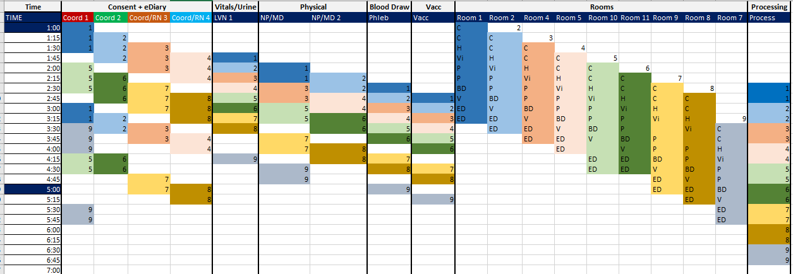



Supplementary Figure 1: Model for weekday flow of subjects, rooms, and resources

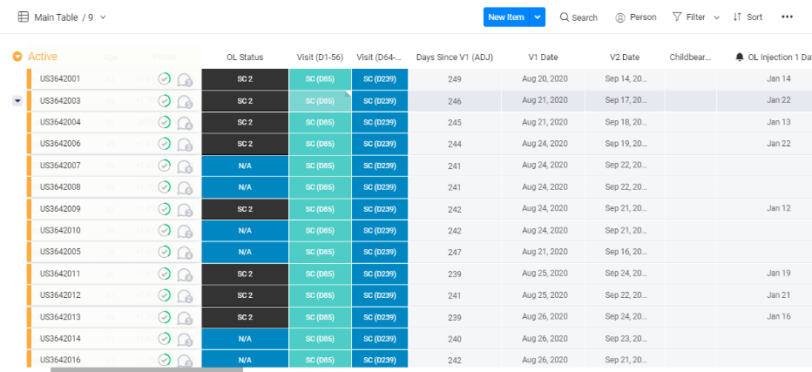

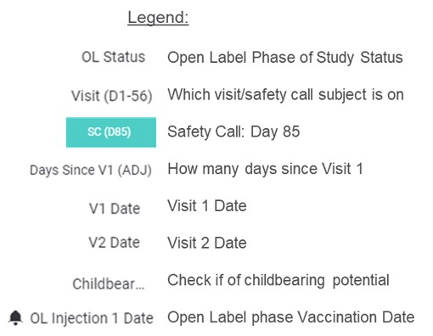

Supplementary Figure 2: Custom-built subject tracking tool on Monday.com

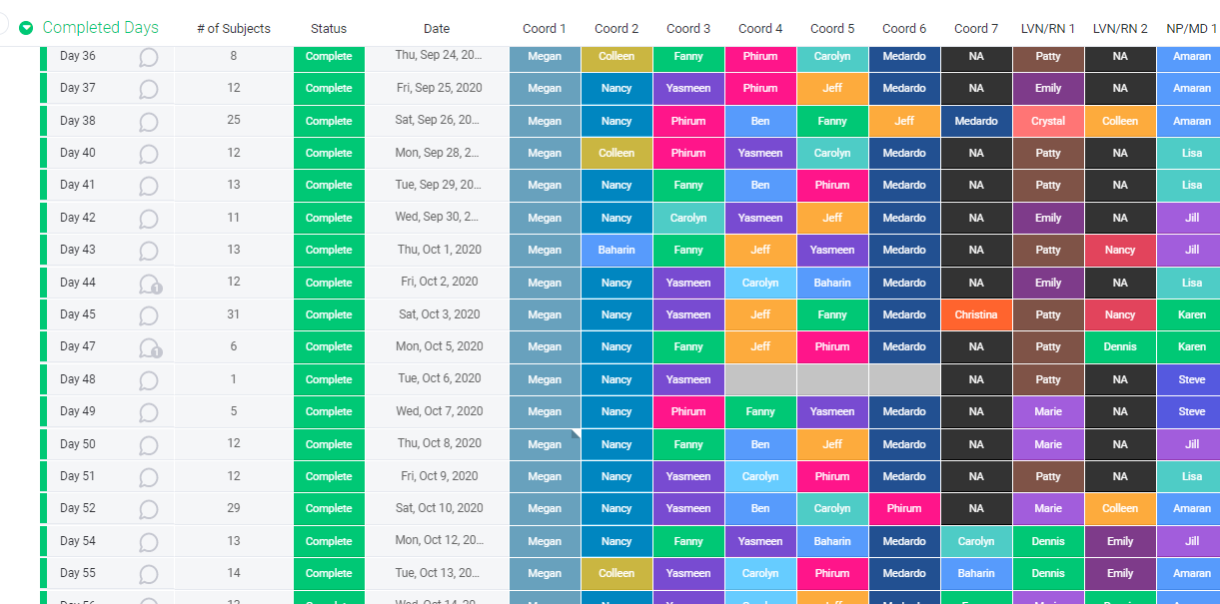

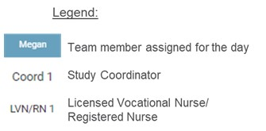

Supplementary Figure 3: Daily staffing calendar on Monday.com

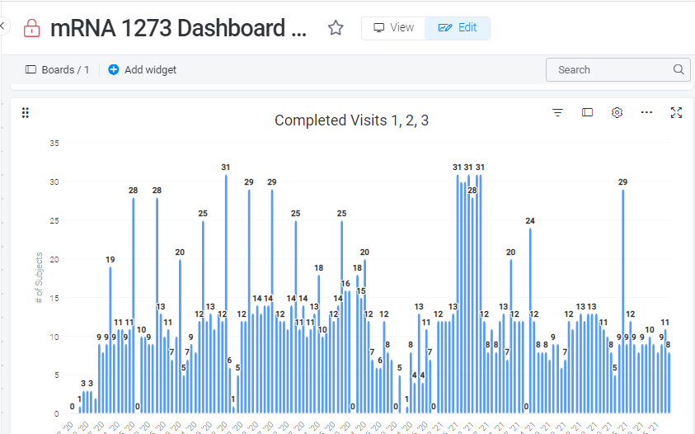

Supplementary Figure 4: Daily visit totals on Monday.com dashboard