Supplement 1. Needs assessment questions in entrance survey for trainees

Entrance survey questions
Q.1 Demographic: Name, Degree, Institution and Project Title | Q.4 What professional development-related topics would you most like to see included in the curriculum?
Q.2 What specific issues around Tobacco Regulatory Science (TRS) are you most interested in? | Q.5 What do you see as your most important areas for development as you start this fellowship?
Q.3 What scientific topics would you most like to see included in the curriculum? | Q.6 What would you define as successful outcomes for the fellowship?

*Questions given on the entrance survey completed by all trainees

Supplement 2. Program Components of the A-TRAC Fellowship

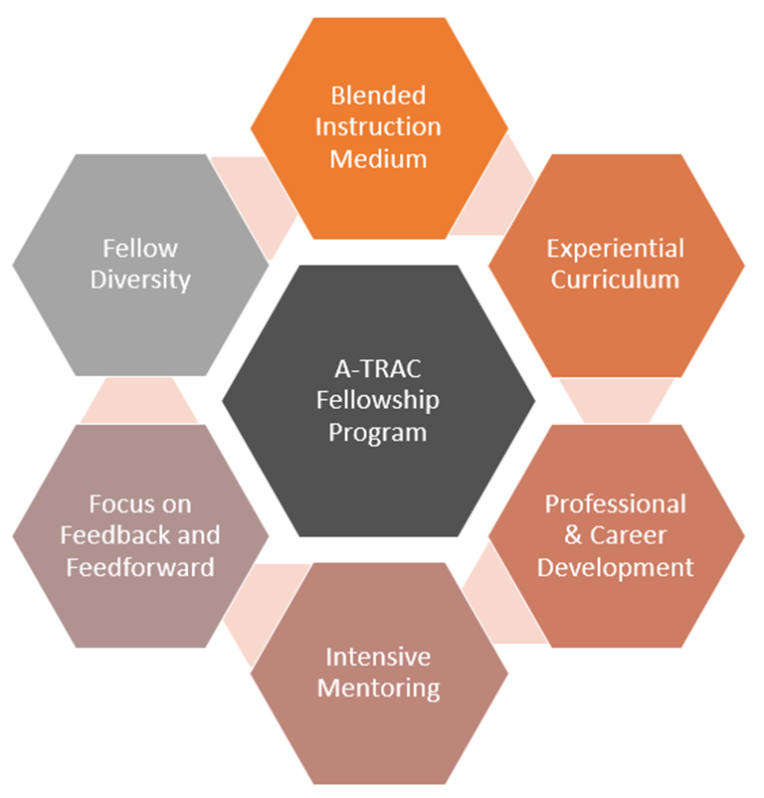

Supplement 3. A-TRAC Fellowship Program Facilitator’s guide

Session Title
Session Facilitator
Date
Learning Objectives
Related Competencies
Reading/
resources
Poem/quote/art/song*
Participant Preparation
Participant Commitment/
SMART Goal
Materials needed

Topic | Content | Activity/Pedagogy | Time

* Optional

