Recruiting Under-represented Individuals in a Double Pandemic, Lessons Learned in a Randomized Control Trial
Supplementary Material

Supplemental Table 1. Underrepresented Populations in the U.S. Biomedical, Clinical, Behavioral and Social Sciences Research Enterprise

Individuals from racial and ethnic groupsª

Blacks or African Americans, Hispanics or Latinos, American Indians or Alaska Natives, Native Hawaiians, and other Pacific Islanders

Individuals with disabilities

Those with a physical or mental impairment that substantially limits one or more major life activities, as described in the Americans with Disabilities Act of 1990, as amended.

Individuals from disadvantaged backgrounds

Meet two or more of the following:
- Were or currently are homeless, as defined by the McKinney-Vento Homeless Assistance Act
- Were in the foster care system, as defined by the Administration for Children and Families
- Were eligible for the Federal Free and Reduced Lunch Program for two or more years
- Have/had no parents or legal guardians who completed a bachelor’s degree
- Were or currently are eligible for Federal Pell grants
- Received support from the Special Supplemental Nutrition Program for Women, Infants and Children (WIC) as a parent or child

Grew up in one of the following areas: a) a U.S. rural area, as designated by the Health Resources and Services Administration (HRSA) or b) a Centers for Medicare and Medicaid Services-designated Low-Income and Health Professional Shortage Areas

Women^{b}

This table is created based on information from: National Institutes of Health Office of the Director Scientific Workforce Diversity. Underrepresented Populations in the U.S. Biomedical, Clinical, Behavioral and Social Sciences Research Enterprise. December 3, 2020, 2020. Updated February 7, 2020. Accessed April 19, 2021. https://diversity.nih.gov/about-us/population-underrepresented

ªUnderrepresentation can vary from setting to setting; individuals from racial or ethnic groups that can be demonstrated convincingly to be underrepresented by the grantee institution should be encouraged to participate in NIH programs to enhance diversity.
^{b}NIH encourages institutions to consider women for faculty-level, diversity-targeted programs to address faculty recruitment, appointment, retention or advancement
Supplemental Table 2. Institutions Onboarded by the University of Pittsburgh Institutional Review Board

Albert Einstein College of Medicine/Montefiore Medical Center
Children’s National Medical Center/The George Washington University
East Carolina University
Loyola University Medical Center
Massachusetts General Hospital
Mayo Clinic Rochester
Medical University of South Carolina
Northwestern University
Oregon Health and Science University
Penn State Health
Rush University Medical Center
Texas A&M University
Tufts University Health Sciences
University of Buffalo
University of California, Davis
University of Chicago
University of Colorado Denver Anschutz Medical Campus
University of Michigan
University of Minnesota
University of Pennsylvania Perelman School of Medicine
University of Southern California
University of Texas Health Science Center at San Antonio/University of Texas at Austin
University of Virginia
University of Wisconsin, Madison
Vanderbilt University Medical Center
Washington University at St. Louis School of Medicine

Supplemental Figure 1. Institution and Participant Flow Diagram for the Building Up Trial

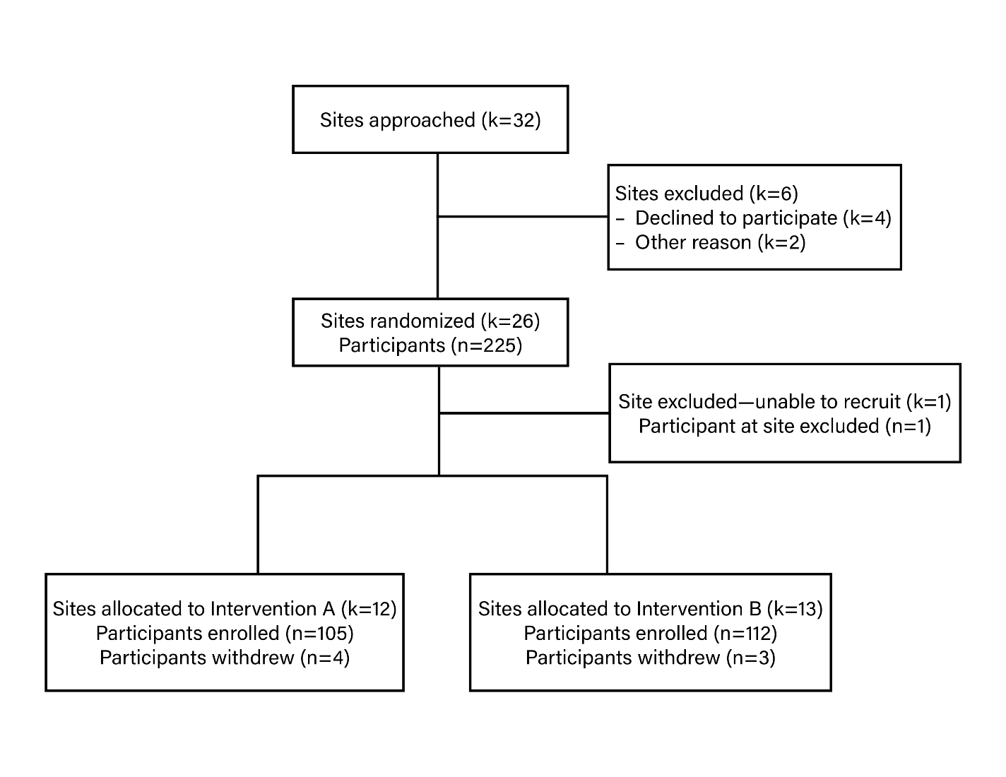
ª
^{b}
^{c}

ª Sites declined to participate: Institution AA, January 2020; Institution AB, February 2020; Institution AD, June 2020; Institution AE, June 2020.
^{b} Sites excluded for other reason: Institution AC (i.e., participating in similar research study), May 2020; Institution AF (i.e., delayed substantially because of COVID), June 2020.
^{c} Site excluded for low recruitment: Institution M, September 29, 2020.

