Supplementary Materials

Team Science Leadership Curriculum:
Rockefeller University has a long tradition of emphasizing experiential education. In this spirit, each Scholar is required to serve as the Principal Investigator (PI) of a human participants research protocol, ensuring that they have the experience of leading a translational team in designing, gaining Institutional Review Board (IRB) approval for, conducting, and reporting a research study. The Scholars’ Team Science Leadership training begins immediately upon entry into the program (Table 1), with Scholars training in Good Clinical Practice (GCP) and protection of human subjects, and entering the multidisciplinary Protocol Navigation¹ and Community Engaged Navigation² programs. These programs help Scholars develop their protocols, and where appropriate for their protocol, build relationships with patients, advocacy groups, community-based clinicians, and other community partners. Scholars are charged with constituting and developing their scientific team, which is led by the PI Scholar, and depending on the specific protocol, comprises one or more of the TSE/Es, clinical research nurses, clinical research coordinators, biostatisticians, bioinformaticians, external collaborators, community partners, and others. Tutorials led by the program leaders complement this experience, focusing on styles of leadership as described by John C. Maxwell in How Successful People Lead³ and other related literature. Specific aspects on how to organize teams, conduct team meetings, and build team spirit are also discussed, along with the role of diversity in team success, using the data from Valantine and Collins and the National Research Council publication Enhancing the Effectiveness of Team Science.⁴ In parallel, trainees develop a Pilot Project research proposal within the first two months using a template modeled on the NIH R01 proposal format, but with an abbreviated research plan, in which they delineate their study’s team structure. In addition, we have developed an Early Audit program in which Scholars’ execution of their protocols is formally audited after only a few participants have been enrolled to both ensure compliance with applicable regulations and reinforce the Scholars’ responsibility as PIs and team leaders for the overall conduct of their protocols, including the delegated responsibilities of all team members.
For Peer Review
TSE/Es provide personalized one-on-one teaching to the Scholars in their areas of expertise as part of our Protocol Navigation program,¹ Community-Engaged Navigation program,² Research Hospitalist initiative,⁵ Centralized Research Participant Recruitment program,^{6,7} Informed Consent for Next Generation DNA Sequencing initiative,⁸ and Clinical Research Nursing initiative.⁹ TSE/Es provide trainees with support and informal feedback continually throughout protocol development, implementation, and conduct.

Supplementary Figures
Figure 1. Development of Team Scienc Competencies

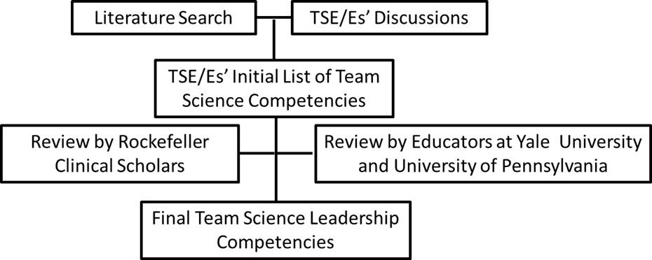

Figure 2. Evaluation of Clinical Scholars and Return of Results to Clincial Scholars

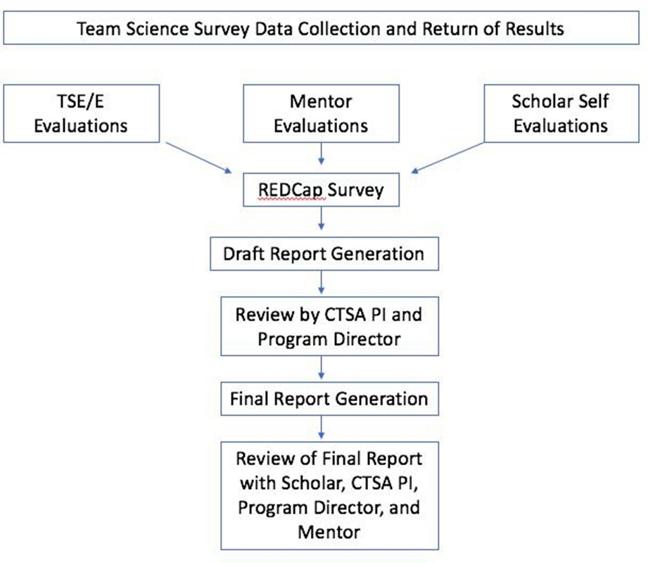

References

1. Brassil D, Kost RG, Dowd KA, Hurley AM, Rainer TL, Coller BS. The Rockefeller University Navigation Program: a structured multidisciplinary protocol development and educational program to advance translational research. Clin Trans Sci 2014; 7(1): 12-9.
2. Kost RG, Leinberger-Jabari A, Evering TH, et al. Helping basic scientists engage with community partners to enrich and accelerate translational research. Acad Med 2017; 92(3): 374-9.
3. Maxwell JC. How Successful People Lead: Taking Your Influence To The Next Level. New York: Center Street; 2013.
4. Valantine HA, Collins FS. National Institutes of Health addresses the science of diversity. Proceedings of the National Academy of Sciences 2015.
5. O'Sullivan B, Coller BS. The research hospitalist: Protocol enabler and protector of participant safety. Clin Trans Sci 2015; 8(3): 174-6.
6. Kost RG, Corregano LM, Rainer TL, Melendez C, Coller BS. A data-rich recruitment core to support translational clinical research. Clin Trans Sci 2015; 8(2): 91-9.
7. Corregano L, Bastert K, Correa da Rosa J, Kost RG. Accrual index: A real-time measure of the timeliness of clinical study enrollment. Clin Transl Sci 2015; 8(6): 655-61.
8. Kost RG, Poppel SM, Coller BS. Informed consent for next-generation nucleotide sequencing studies: Aiding communication between participants and investigators. J Clin Transl Sci 2017; 1(2): 115-20.
9. Eckardt P, Hammer M, Barton-Burke M, et al. All nurses need to be research nurses. J Clin Transl Sci 2017; 1(5): 269-70.

