Supplementary Appendix
Table S1. Features of Kern Scholars program compared to other local CDAs
Features | Kern Scholars | Other local CDAs
Size of cohort | 2-5 per cohort each year | 1 per award, 20+ awards per year^{b}
Protected time | 20-40%ª | Flexible, covered by total funding support
Length | 2-3 yearsª | 1-3 years
Research funding | $20,000 total | $50,000-100,000 per year
CDA core elements  Didactic coursework  Peer coaching  Career development  Mentoring | Per preference  Weekly sessions  Monthly sessions  Biannual retreats  Continuous, structured | Per preference  N/A  N/A  Continuous, semi-structured
a: Individuals in the Fellow track of the Kern Scholars program receive 90% protected time for 1 year
b: Number of available awards varies each year, but in 2020, 23 separate awards were funded

Table S2. Kern Scholars program details
Program eligibility
- Career clinical faculty (i.e. doctoral-trained clinicians actively engaged in clinical care) or clinical trainees (i.e. residents or fellows)
- Demonstrated interest and departmental support for pursuit of a career in health services research
- Not funded at the federal level as a principal investigator
- Typically Assistant Professor level with 10-30 publications; if more senior or more prolific, intent to change research directions toward health services research
Focus areas
- Patient-reported outcomes
- Secondary data analysis
- Systematic reviews and meta-analyses
- Shared decision-making
- Health disparities
- Quality improvement
- Behavioral interventions
- Comparative effectiveness research
- Implementation science
- Informatics and knowledge management
- Data science
- Economic evaluation
- Health systems engineering
- Innovation and design
- Qualitative research
Structured program elements
- Peer coaching
- Weekly 1-hour career development and works-in-progress sessions
- Monthly 3-hour intensive career development sessions
  - Topics include: Personal and professional career development, internal networking and visibility, external networking and visibility, local resources, health services research methods, and grant writing
- Mentoring by clinical and methodologic experts
- Biannual 1-day retreats
- Colocation in a dedicated space in the Mayo Clinic Center for the Science of Health Care Delivery

Table S3. Number of publications within five years for Kern scholars compared to Kern applicants and other CDA awardees adjusted for publications prior to the index date
Publication category | Adjusted RR (95% CI) | P-value
Kern Scholars compared to Kern applicants
Any publication | 3.1 (2.0, 5.0) | <0.001
First author publication | 2.5 (1.4, 4.4) | 0.002
Last author publication | 1.0 (0.6, 1.9) | 0.92
First or last author publication | 1.7 (1.0, 2.7) | 0.044
Kern Scholars compared to other CDA awardees
Any publication | 4.6 (3.5, 6.0) | <0.001
First author publication | 3.2 (2.2, 4.7) | <0.001
Last author publication | 1.7 (1.1, 2.6) | 0.011
First or last author publication | 2.2 (1.6, 3.1) | <0.001

Figure S1. Time to 15th new publication stratified by sex.
Upper panel: Time to 15th new publication between Kern Scholars and Kern applicants or other CDA awardees.
Lower panel: Time to 15th new first-/last-author publication between Kern Scholars and Kern applicants or other CDA awardees.
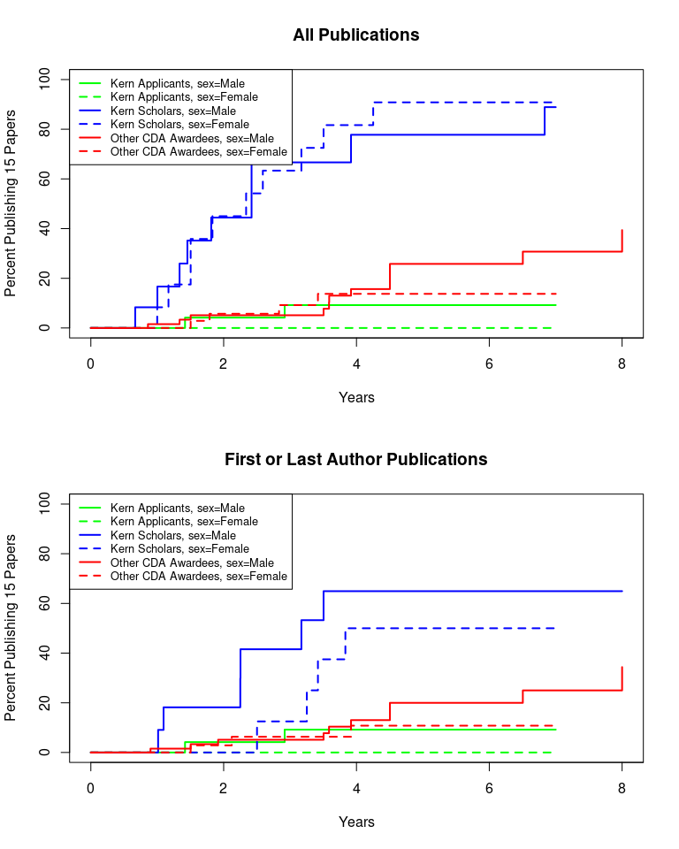

Figure S2. Time to 15th new publication stratified by race (white vs non-white).
Upper panel: Time to 15th new publication between Kern Scholars and Kern applicants or other CDA awardees.
Lower panel: Time to 15th new first-/last-author publication between Kern Scholars and Kern applicants or other CDA awardees.
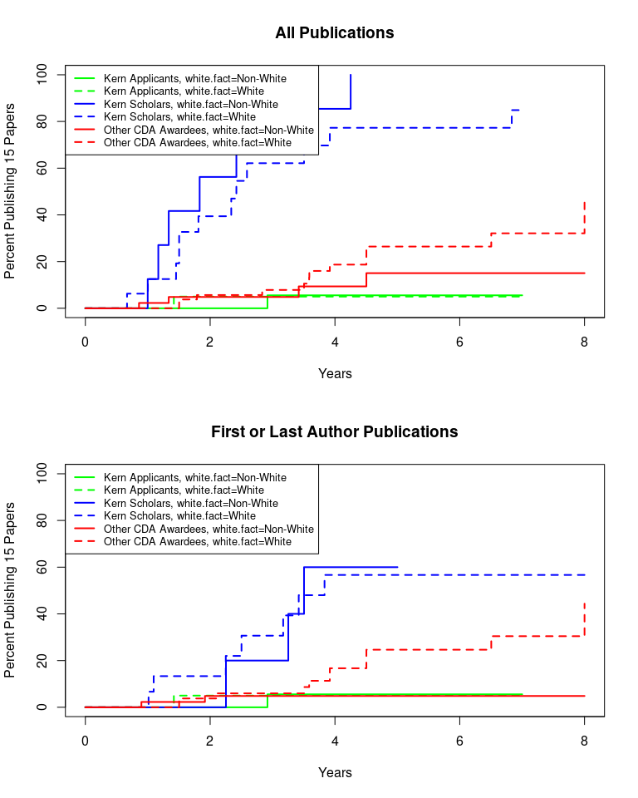
Figure S3. Time to 15th new publication stratified by specialty (surgical vs non-surgical).
Upper panel: Time to 15th new publication between Kern Scholars and Kern applicants or other CDA awardees.
Lower panel: Time to 15th new first-/last-author publication between Kern Scholars and Kern applicants or other CDA awardees.
