**APPENDIX 1: Descriptive statistics & supplemental predictions**

This appendix contains a list of the 17 service cores offered at ICTS. It also contains supplementary information on the coarsened exact matched samples used in the mixed effects models as well as average predicted numbers of grant applications, awards, and publications by academic characteristics for each model.

The 17 service cores of ICTS are: Bioethics Research Center, Biostatistics, Epidemiology, and Translational Research Design, Center for Administrative Data Research, Center for Community Health Partnership and Research, Clinical & Translational Imaging Unit, Clinical Research Training Center, Clinical Translational Research Unit, Dissemination & Implementation Research Core, Genome Technology Access Center, Institute for Informatics, Pediatric & Adolescent Ambulatory Research Consortium, Pediatric Clinical Research Unit, Proteomics & Mass Spectrometry Program, Recruitment Enhancement Core, Regulatory Support Center, Research Development Program, and Tissue Procurement Core.

Before modeling the relationships between engagement and productivity in mixed effects regression approach, we used coarsened exact matching to balance the datasets and reduce potential implicit bias. Figure A1 compares the observed dataset to each of the matched datasets on number of observations, unique individuals, and mean annual productivity rates. The *Original N* row at the top of Figure A1 displays the number of observations or member-years included in each group in the raw data. Each of the *Matched N* rows shows the same quantities for the matched datasets. The *Individuals* rows show the number of unique individuals included in each dataset, 1,746 in the original data and between 597 and 1,688 across the 15 matched datasets.

In the raw data, except for those engaged as mentees in ICTS, each group of members who were engaged had higher average rates of grant applications, awards, and publications when compared to those who were not engaged in the same way as seen in the top sets of (green) lines in each section of Figure A1. The largest difference was for mentors who averaged 8.9 publications versus 4.4 average publications annually. The smallest difference in the raw data were for internally funded members who averaged 1.7 grant awards versus members who were not funded who averaged 1.1 grant awards annually. After applying the matching strategy, the differences between engaged and non-engaged groups decreased across all productivity outcomes and engagement metrics in the matched samples from those in the original dataset.

Figures A2 – A4 supplement the figures in the article to illustrate and compare count estimates across the academic characteristics of rank, discipline, and experience (proxied by years since highest degree).

*Figure A1. Comparison of raw data to matched samples.*

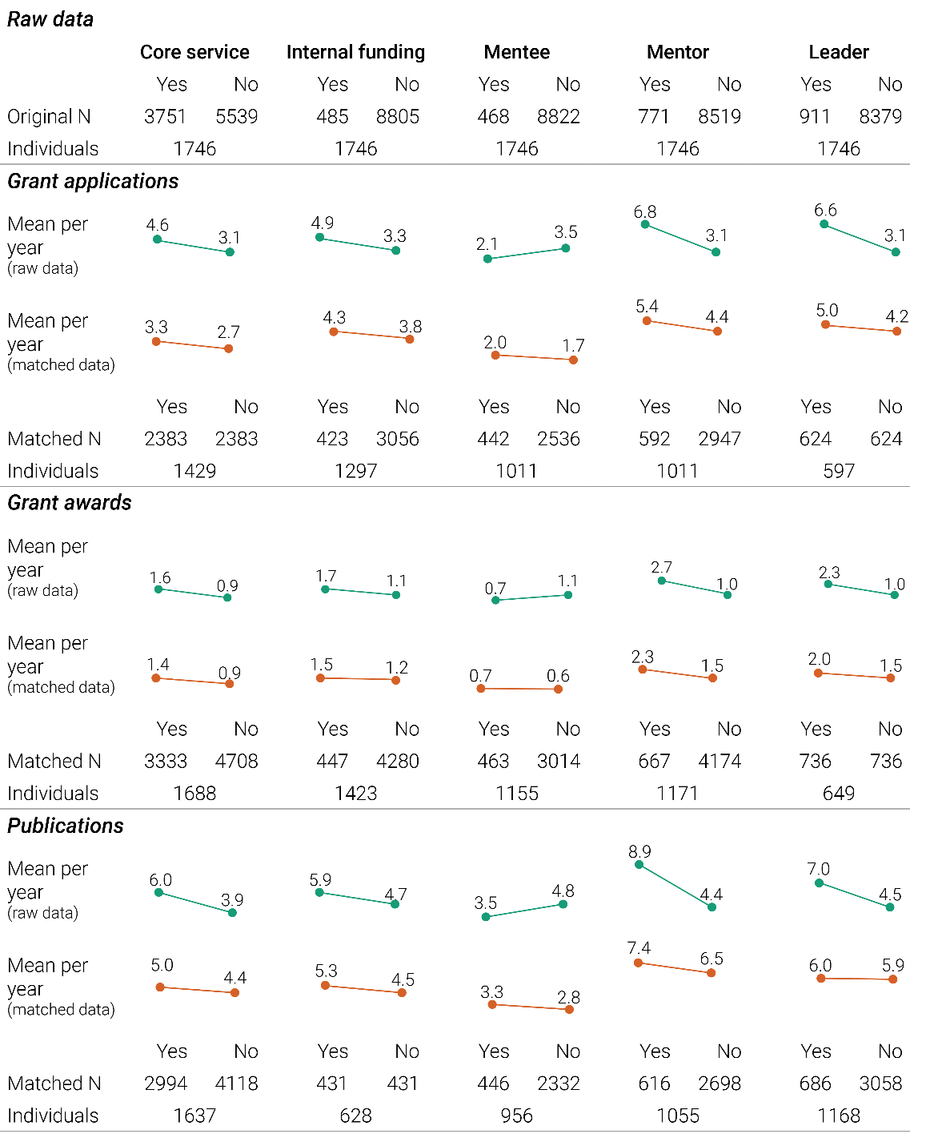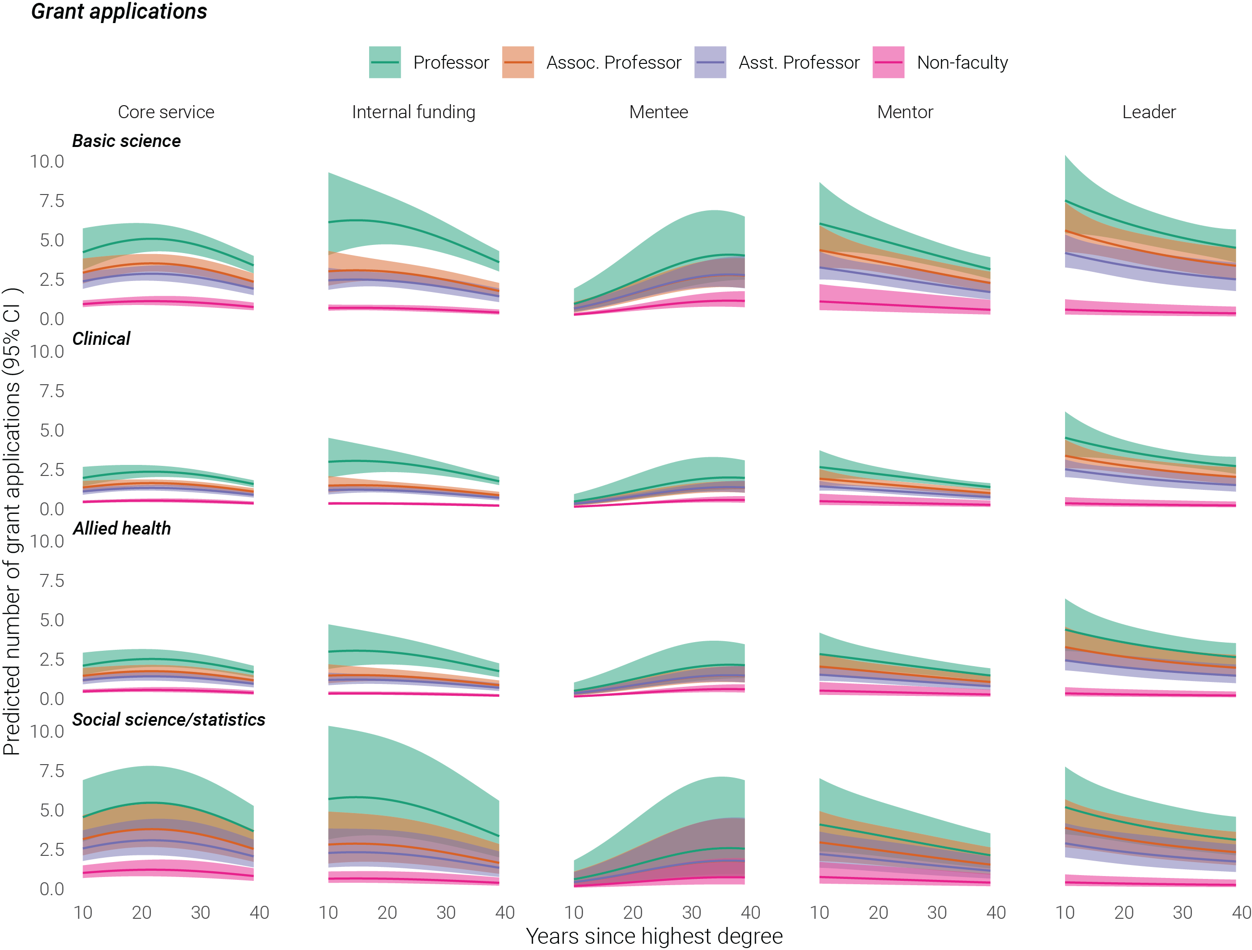

*Figure A2. Predicted number of grant applications by academic characteristics.*

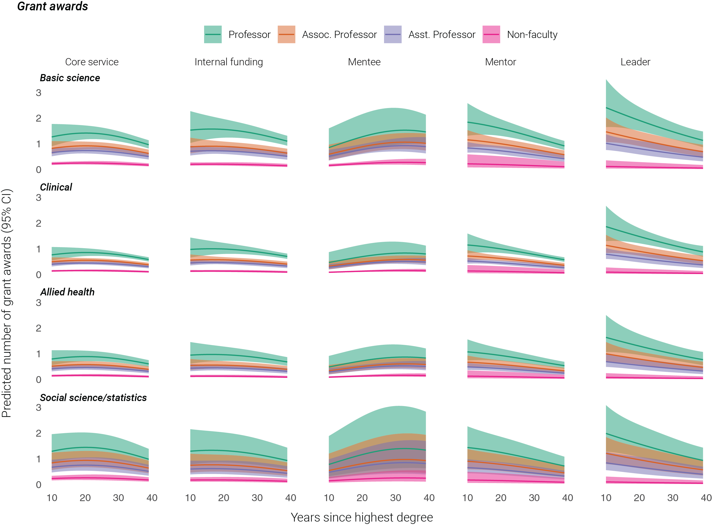

*Figure A3. Predicted number of grant awards by academic characteristics.*

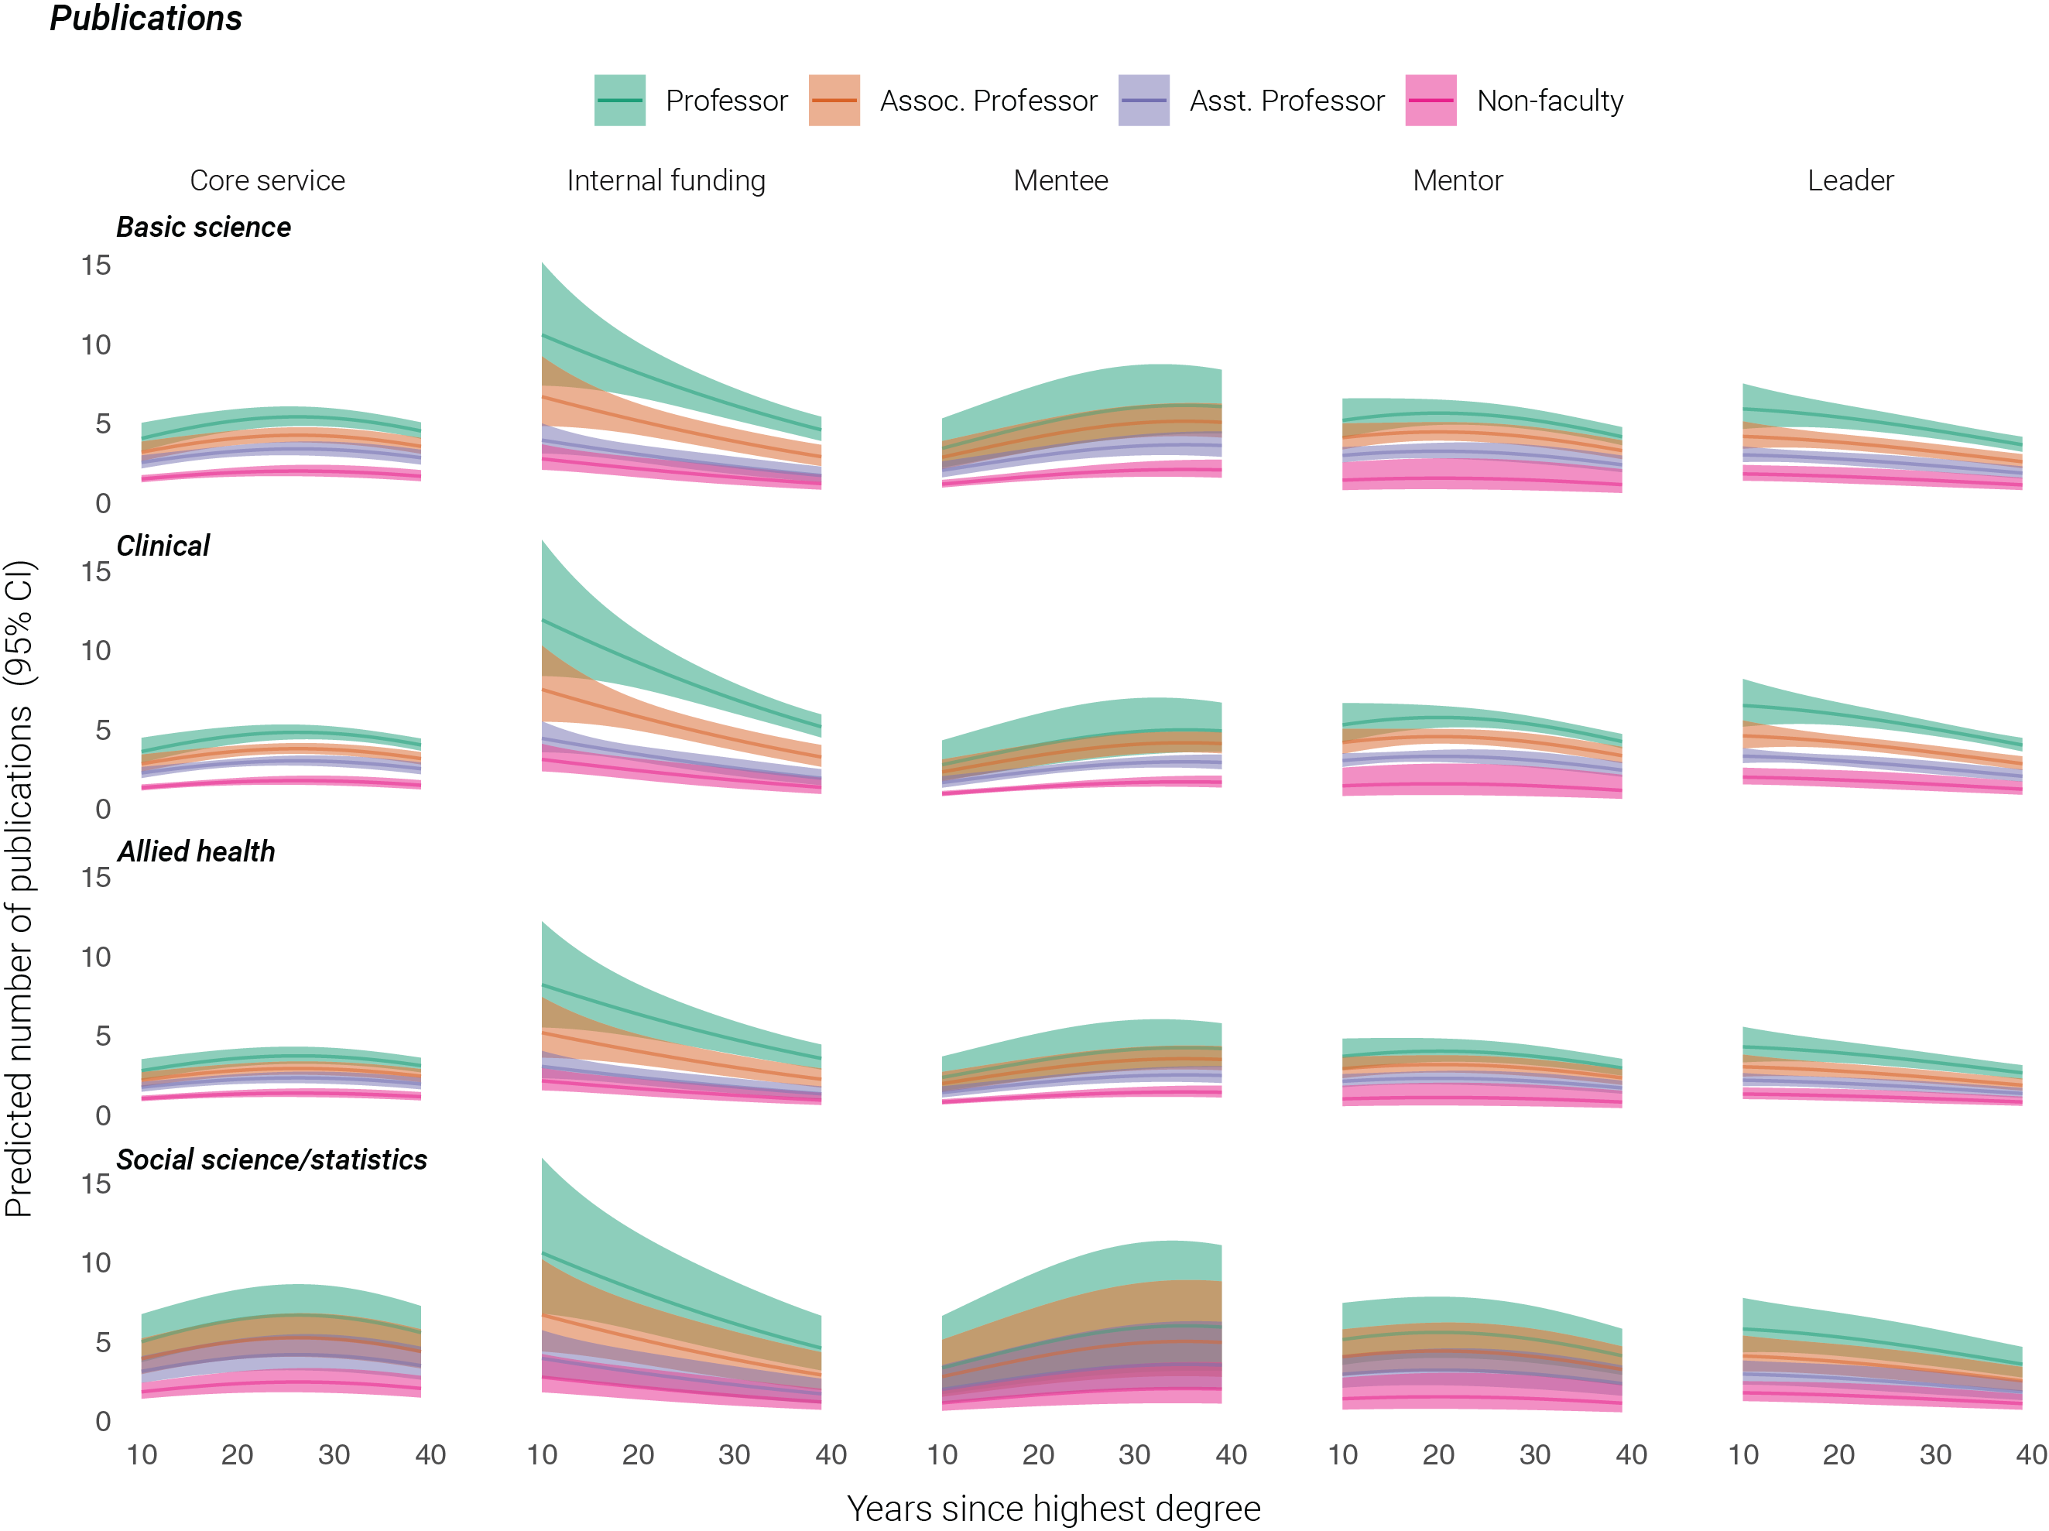

*Figure A4. Predicted number of publications by academic characteristics.*