Supplementary Figure 1: Wisconsin Collaborative for Healthcare Quality Publicly Reported Health Outcome and Care Measures
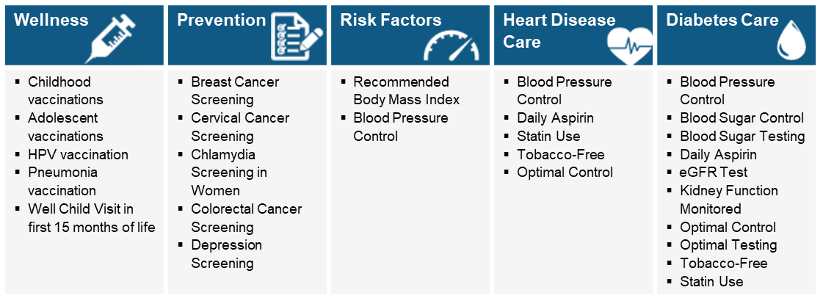

Supplementary Table 1: Neighborhood Health Partnerships Action Tools
.Making sense of the data and moving from data to action | Helps users interpret the data in the NHP reports, understand its uses and potential limitations on their journey toward action. Full text available at https://nhp.wisc.edu/data/
Aligning Community Priorities & Data | Helps users align data in the NHP reports with existing community priorities and provides recommendations to build and/or enhance community-academic partnerships. Full text available at https://nhp.wisc.edu/aligning-community-priorities-data/
Ideas for Taking Action | Helps users select and implement programs, policies and system changes that evidence indicates could be helpful in addressing opportunities for improvement identified in NHP reports. Full text available at https://nhp.wisc.edu/taking-action-cover-sheet/

Supplementary Figure 2: Neighborhood Health Partnerships Program Early Adopter Navigators and their wide ranging partnerships with organizations and individuals focused on community health and health equity improvement.

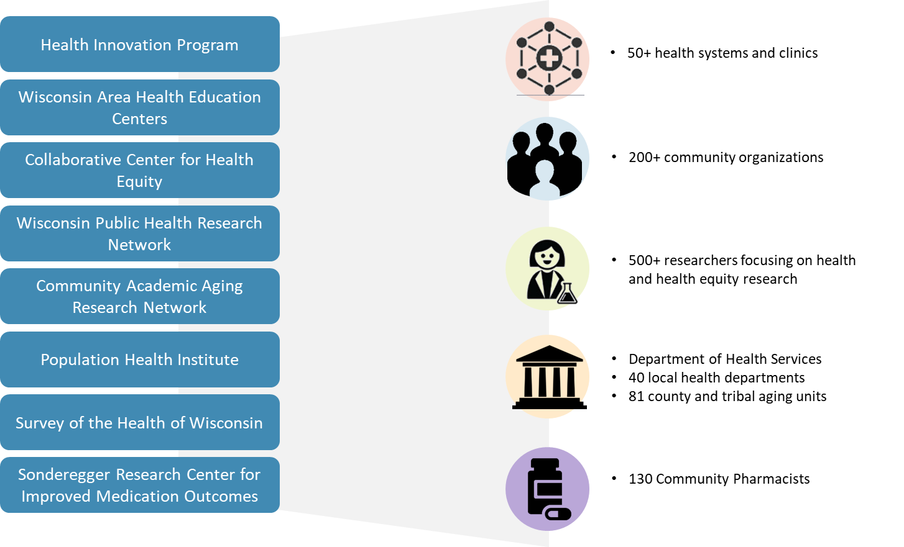

Supplementary Figure 3: Example persona from Neighborhood Health Partnerships Co-Design

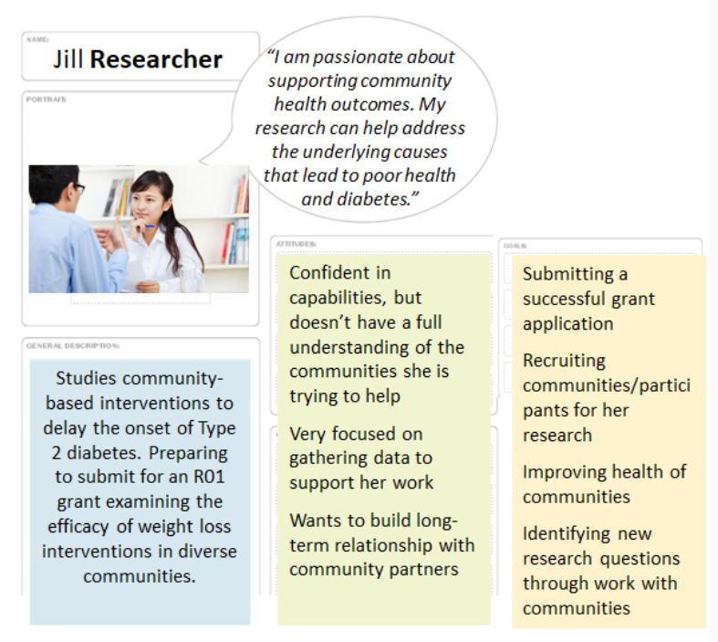

Supplementary Table 2: A summary of the improvements that were identified through co-design sessions and activities and were made prior to pilot launch.

- New visuals to clarify who is included in the reports
- Removed rankings between ZIPs and replaced with benchmarks in county/state
- A new report section to compare the demographics of those included to the demographics of the ZIP overall in terms of sex, age, insurance status, and race/ethnicity
- A new report section to provide social determinants of health (SDOH) context with supporting information on the NHP website
- Clarified policy on report use and sharing
- More detailed technical information about data added to Action Tools
- Heat maps to aid Navigators in finding measures and/or ZIPs for report requests
- Developed policy and process for custom data requests
- Created report overview tool with information about each section of the report
- Added context to make the “Ideas for Taking Action” tool more useful
- Built tool focused on aligning community priorities with data and building strong partnerships

Supplementary Figure 4: An example of mapping impact and effort on potential solutions after the conclusion of co-design Wave 1.
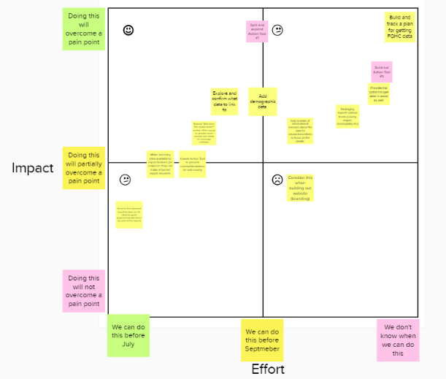

Supplementary Figure 5: An example of one heat map for the Recommended Body Mass Index measure.
