Online Supplement. Stepwise Instructions for Data Collection in our Critical Congenital Heart Disease Study

- Turn on Pi-TopTM – press and hold the power button
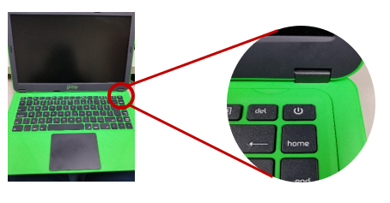
- Enter password
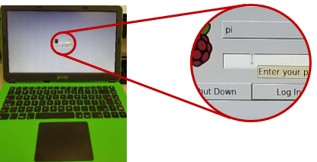

- Open the file “Healthcare” at the top left of the screen, then click “Execute” on the subsequent pop-up.

- To enter the unique identification code, press “Unlock” and enter the identification number ending in X or N
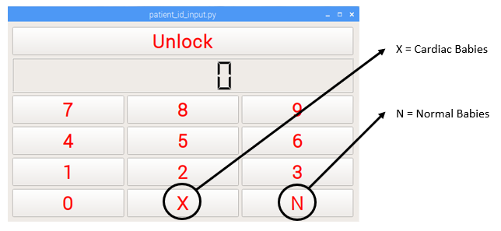

- Press unlock, enter the fraction of inspired oxygen (FiO₂) and press “Input FiO₂”.
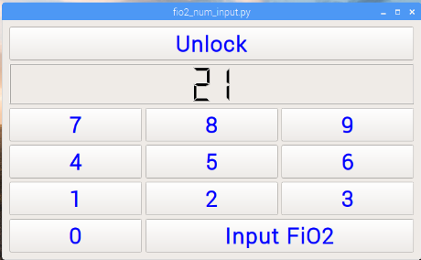

- Enter the alphanumeric label as specified by the study protocol to tag the data with this code.

- Attach the pulse oximeter probes onto the baby’s right hand and foot and connect the respective oximeters to the probes.
- Once the oxygen saturation (SpO₂) on the Nonin® oximeters has stabilized, press Unlock on the Pi-topTM screen and press start to start simultaneous data collection from the two oximeters.
- Check to see that both the Nonin® oximeters have started Bluetooth transmission.
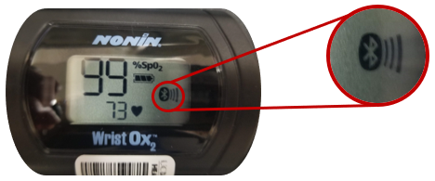

- The Pi-TopTM should start displaying waveforms for the hand and foot.
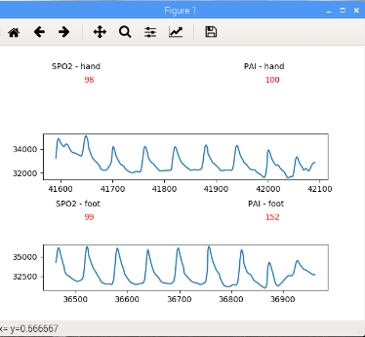

- To stop data collection, do not close the graphs, instead shut down the Pi-TopTM using the power button.

