Supplemental File
1. Figure 4 (mmol/L)
The graphs on the right panel of Figure 4 present the predicted risk of hypo- and hyper-glycemic excursions for the same three subjects mentioned above. We used $δ_{1}=3.3 mmol/L$and $δ_{2}=11.1 mmol/L$ for identifying hypoglycemia and hyperglycemia, respectively. The first patient (A and B) was at high risk of hyperglycemia for the whole day except 6-8am and 4pm-12am. Her risk of hypoglycemia was relatively low except for around 9pm-12am in the evening. The second patient (C and D) was at high risk of hyperglycemia in the afternoon, followed by decreased risk during between 6-10pm. Her risk of hypoglycemia was quite high around 9am in the morning. The third patient (E and F) was at high risk of hyperglycemia in the afternoon during 1-5.30pm and right before midnight from 11pm-12am. His risk of hypoglycemia was quite low except between 9-10pm in the evening.
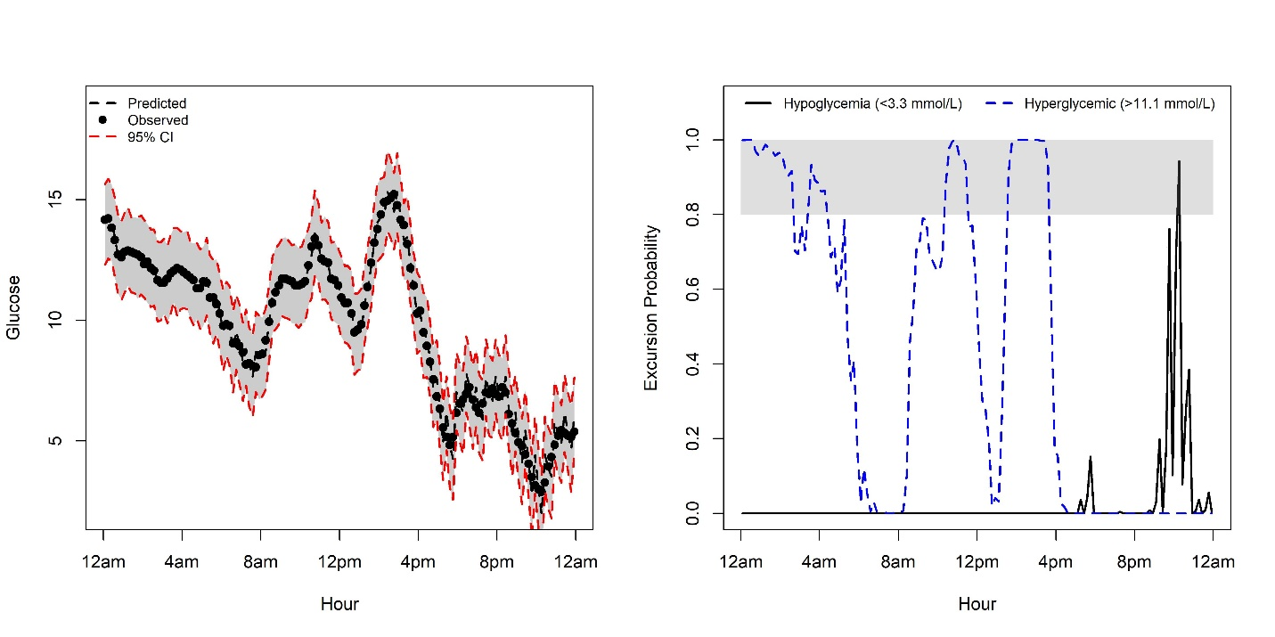
B)
A)
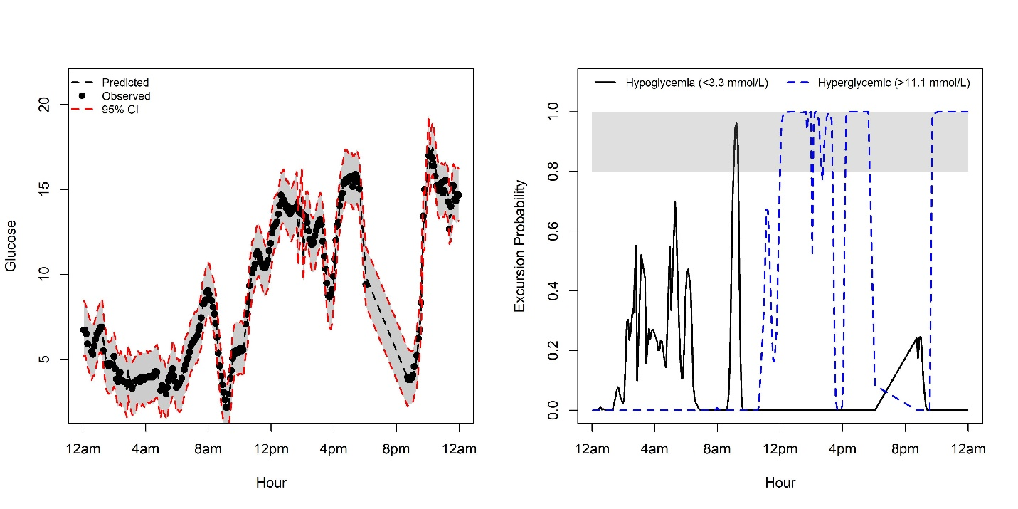
D)
C)
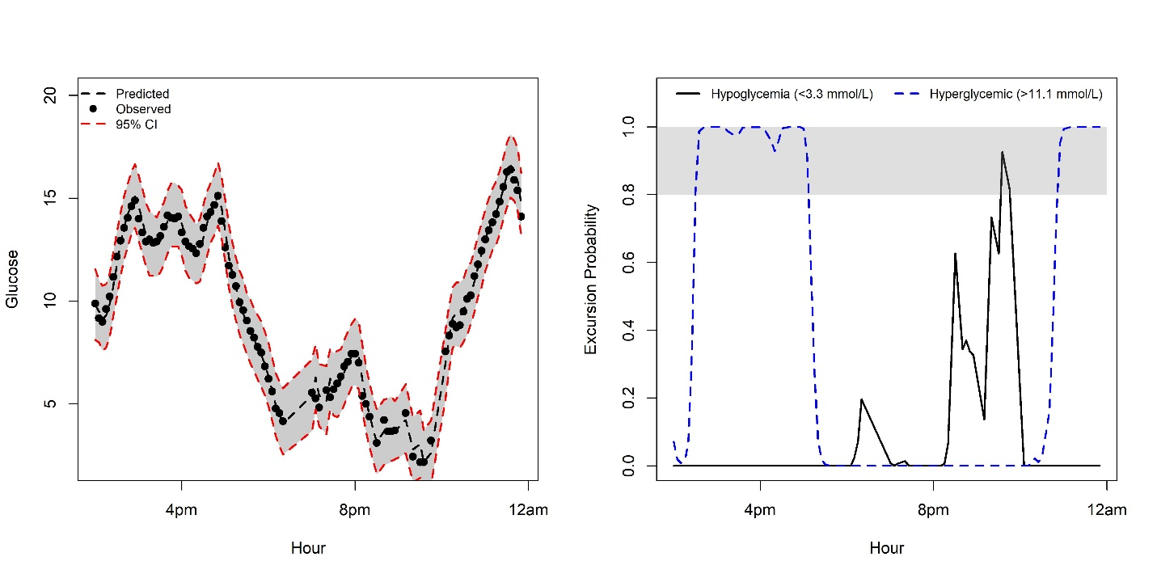Figure 4. Left panel: Observed glucose readings (y-axis) from CGM (black dots) over clock time (x-axis) are shown with FD prediction (dashed line) and 95% CI (gray band with red dashed lines); Right panel: real-time risk for glycemic excursions (black line is the probability of hypoglycemia; blue line is the probability of hyperglycemic: gray band is the area where probabilities > 0.80 or 80%). The 1st row is for a 62-year-old white female from the control group; height: 160 cm; weight: 68 kg. The 2nd row is for an 8-year-old white female from the control group; height: 140 cm; weight: 32.8 kg. The 3rd row is for a 41-year-old white male from the RT-CGM group; height: 168 cm; weight: 79 kg.
F)
E)

2. Computer code
The R and Matlab script below is based on the analysis of the CGM data and variables from the dataset are described in the manuscript.
2.1) R script for FPCA results presented in section 4.1 in manuscript.

#### R script for FPCA on CGM data ####
#load packages
library(fpca)
library(scales)

#load dataset
load("data.RData") #dataset

#hrweek is in terms of hr
data<-subset(data,select=c(PtID, Glucose,hr)) #subset the data
data1<-data
e_min <-min(data$hr)
e_max <- max(data$hr)

#scale hr to improve the convergence and efficiency of the algorithm
#to be scaled between 0 and 1 (i.e., the unit interval)
data$hr<- rescale(data$hr,to=c(0.0001,0.999))
data_use <- as.matrix(data)

## parameters for fpca.mle ##
ini.method = "EM"
basis.method = "bs"
sl.v = rep(0.5, 10)
max.step = 80
grid.l = seq(0, 1, 0.05)
grids = seq(0, 1, length = 125)

## fit candidate models by fpca.mle ##
result <- fpca.mle(data_use, M.set, r.set, ini.method, basis.method, sl.v, max.step, grid.l, grids)

## after getting the results ##
grids.new <- result$grid
M<-result$selected_model[1] #the selected M (number of basis functions)
r<-result$selected_model[2] # the selected r (dimension of the process)

muest<-result$fitted_mean # the estimated mean curve by local linear fitting evaluated at grid
evalest<-result$eigenvalues # the estimated eigenvalues under the selected model
sig2est<-result$error_var # the estimated error variance under the selected model
eigenfest<-result$eigenfunctions # the estimated eigenfunctions under the selected model evaluated at grid
## derive fpc scores and look at the predicted curve ## # fpc scores
fpcs <- fpca.score(data_use, grids.new, muest, evalest, eigenfest, sig2est, r) # get predicted trajectories on a fine grid: the same grid for which mean and eigenfunctions are evaluated
pred <- fpca.pred(fpcs, muest, eigenfest)

2.2) Matlab code for two-stage FPCA (section 4.2), the detail of this Matlab package can be found at http://anson.ucdavis.edu/~mueller/data/pace.html .
#Set directory
addpath(genpath('…'));
p = path;
isExist = regexp(p, 'PACE');
if isempty(isExist) == 1
addpath(genpath('../PACE/'));
end

#load data 'dataweek1.csv'
data_week=csvread('dataweek1.csv',1,1);
data_day =csvread('dataday1.csv',1,1);

nw=length(unique(data_week(:,1)));
wy_str=cell(1,nw);
wt_str=cell(1,nw);

nd=length(unique(data_day(:,1)));
dy_str=cell(1,nd);
dt_str=cell(1,nd);

for i=1:nw
wt_str{i}=( data_use(data_week(:,1)==uni(i),3))';
wy_str{i} =( data_use(data_week(:,1)==uni(i),2))';
end
for i=1:nd

dt_str{i}=( data_use(data_week(:,1)==uni(i),3))';
dy_str{i} =( data_use(data_week(:,1)==uni(i),2))';

end

% p = setOptions('yname','x', 'regular',regular,'method','IN','selection_k', 'FVE','FVE_threshold', 0.9,'screePlot',1, 'designPlot',1,'corrPlot',1,'numBins',0, 'verbose','on');
p = setOptions('yname','x', 'regular', regular, 'selection_k', 'FVE','FVE_threshold', 0.9,'screePlot',1, 'designPlot',1,'corrPlot',1,'numBins',0, 'verbose','on');

[week_result]= FPCA(wy_str,wt_str,p);
[day_result] = FPCA(dy_str,dt_str,p);

y1=day_result{19}(:,(1:nd))';
y1 = cellfun(@transpose,y1,'UniformOutput',false);

%t1=day_result{21}';
%t1 = cellfun(@transpose,t1,'UniformOutput',false);
%tval = [t1{:}];

yval = [y1{:}];

plot(yval) ;
day_pc=day_result{6};

median(day_pc(:,1));
median(day_pc(:,2));

2.3) R script for predicting real-time risk of glycemic events by using CGM data (section 3.3 and 4.3 in manuscript.)
#### R script for predicting real-time risk of glycemic events ####
#load packages
library(ngme)
library(tidyverse)
#load data
data<- readRDS("dataweek1.rds")

#subset the data; hrweek is in terms of hr
data<-subset(data,select=c(PtID, Glucose,hr,group))
fixed <- Glucose ~ hr+group

#fit model ##################################################
set.seed(123)
init_fit_normal <- ngme(fixed = fixed,
random = ~ 1|PtID,
data = data,
reffects = "Normal",
process = c("Normal", "fd2"),
error = "Normal",
timeVar = "hr",
nIter = 20000,
use.process = TRUE,
silent = TRUE,
mesh = list(cutoff = 3/365.25,
max.dist = 2/12,
extend = 0.01),
controls = list(pSubsample = 0.01,
subsample.type = 1,
step0 = 0.8,
estimate.fisher = FALSE,
polyak.rate = -1,
alpha = 0.01)
)

#check the convergence of the fixed effects and apply some polyak averaging to reduce variance ####
fit_normal <- polyak.ngme(init_fit_normal, polyak.rate = 0.0001, plot = TRUE, param = "fixed")
#same for random effects
fit_normal <- polyak.ngme(fit_normal, polyak.rate = 0.00015,
plot = TRUE, param = "random")
#for process
fit_normal <- polyak.ngme(fit_normal, polyak.rate = 0.0002,
plot = TRUE, param = "process")
#for error term
fit_normal <- polyak.ngme(fit_normal, polyak.rate = 0.0001,
plot = TRUE, param = "error")
summary(fit_normal)

######### ######## ######## Prediction and getting excursions ##############################
excursion_ids <- deid_data %>% select(PtID) %>% unique %>% slice(c(12)) %>% unlist

delta <- 0.01
Bf_pred <- Br_pred <- list()
for(i in 1:length(excursion_ids)){
data_i <- deid_data[deid_data$PtID == excursion_ids[i], ]
n_i <- nrow(data_i)
Br_pred_i <- matrix(1, nrow = n_i, ncol = 1)
Bf_pred_i <- cbind(data_i$hr+ delta,data_i$group
)
Br_pred[[i]] <- Br_pred_i
Bf_pred[[i]] <- Bf_pred_i
}

derivative_list <- list(Bfixed = Bf_pred,
Brandom = Br_pred,
delta = delta)

######### excursion for Y< 60 (to get predictive probabilities for hypo-glycaemia) ############
excursions_normal3 <-
predict(fit_normal,
id = excursion_ids,
controls = list(nSim = 1000,
nBurnin = 500,
silent = FALSE,
predict.derivatives = derivative_list,
excursions = list(list(type = '<',
level =60,
process = 'Y'))
),
type = "Nowcast"
)

pred_res3 <- excursions_normal3$pred.data[, c("id", "time", "observed")]
pred_res3$normal_excursions3 <- unlist(lapply(1:length(excursion_ids),
function(i) excursions_normal3$predictions$Y.summary[[i]]$excursions$P))

######### excursion for Y>200 (to get predictive probabilities for hyper-glycaemia) ############
excursions_normal4 <-
predict(fit_normal,
id = excursion_ids,
controls = list(nSim = 1000,
nBurnin = 500,
silent = FALSE,
predict.derivatives = derivative_list,
excursions = list(list(type = '>',
level =200,
process = 'Y'))
),
type = "Nowcast"
)

pred_res4 <- excursions_normal4$pred.data[, c("id", "time", "observed")]
pred_res4$normal_excursions4 <- unlist(lapply(1:length(excursion_ids),
function(i) excursions_normal4$predictions$Y.summary[[i]]$excursions$P))

################### getting prediction errors RMSE and MAE- see manuscript ###################
MAE<- c(excursions_normal[6],excursions_normal[8])
RMSE<- c(excursions_normal[10],excursions_normal[12])

#creating prediction and excursion plots
#plot for observed and predicted trajectory with confidence interval
par(mfrow = c(1, 2))
for(i in 1:length(excursion_ids)){
plot(pred_res[pred_res$id == excursion_ids[i], "time"],
pred_res[pred_res$id == excursion_ids[i], "observed"],
xlab = "Hour", ylab = "Glucose",xaxt = "n",
pch = 19, cex = 0.6, ylim=c(min(pred_res[pred_res$id == excursion_ids[i], "normal.lb"]),max(pred_res[pred_res$id == excursion_ids[i], "normal.ub"])))

polygon(c(pred_res[pred_res$id == excursion_ids[i], "time"],rev(pred_res[pred_res$id == excursion_ids[i], "time"])),c(pred_res[pred_res$id == excursion_ids[i], "normal.lb"],rev(pred_res[pred_res$id == excursion_ids[i], "normal.ub"])), col = 'grey80', border = NA)
points(pred_res[pred_res$id == excursion_ids[i], "time"], pred_res[pred_res$id == excursion_ids[i], "observed"], pch = 19,lwd =1)
lines(pred_res[pred_res$id == excursion_ids[i], "time"],
pred_res[pred_res$id == excursion_ids[i], "normal.Ymean"], lty = 2,lwd=2,xaxt = "n")
lines(pred_res[pred_res$id == excursion_ids[i], "time"], pred_res[pred_res$id == excursion_ids[i], "normal.ub"], lty = 'dashed', col = 'red',lwd=2)
lines(pred_res[pred_res$id == excursion_ids[i], "time"], pred_res[pred_res$id == excursion_ids[i], "normal.lb"], lty = 'dashed', col = 'red',lwd=2)
legend("topleft",
legend = c("Predicted", "Observed","95% CI"),
lty = c(2, NA,2),col=c("black","black","red"),pch = c(NA,19,NA), lwd=2 ,cex=0.8,bty = "n" )
axis(1, at=c(0,4,8,12,16,20,24),cex=0.3, labels=(c("12am","4am","8am","12pm","4pm","8pm","12am")))
legend("top",
legend = c("Mean predictor MAE= 7.4 (0.89)", "Mean predictor RMSE=11.2 (6.67)"),
cex=0.7, bty = "n" )
}

#plot for excursions
for(i in 1:length(excursion_ids)){
########## fitfh graph for W<60 vs hour ##################
plot(pred_res3[pred_res3$id == excursion_ids[i], "time"],
pred_res3[pred_res3$id == excursion_ids[i], "normal_excursions3"],
xlab = "Hour", ylab = "Excursion Probability",
type = "l", lty = 1, ylim = c(0, 1.1),lwd=2,xaxt = "n")
#
rect(0,0.8,24,1,col = rgb(0.5,0.5,0.5,1/4),border = NA)

legend("top", legend =c("Hypoglycemia (<60 mg/dL)","Hyperglycemic (>200 mg/dL)"),horiz=TRUE,col=c("black","blue"), lty = c(1,2),cex=0.8,lwd=2,bty = "n")

lines(pred_res4[pred_res4$id == excursion_ids[i], "time"],pred_res4[pred_res4$id == excursion_ids[i], "normal_excursions4"],lty = 'dashed', col = 'blue',lwd=2)

axis(1, at=c(0,4,8,12,16,20,24),cex=0.3, labels=(c("12am","4am","8am","12pm","4pm","8pm","12am")))
}

