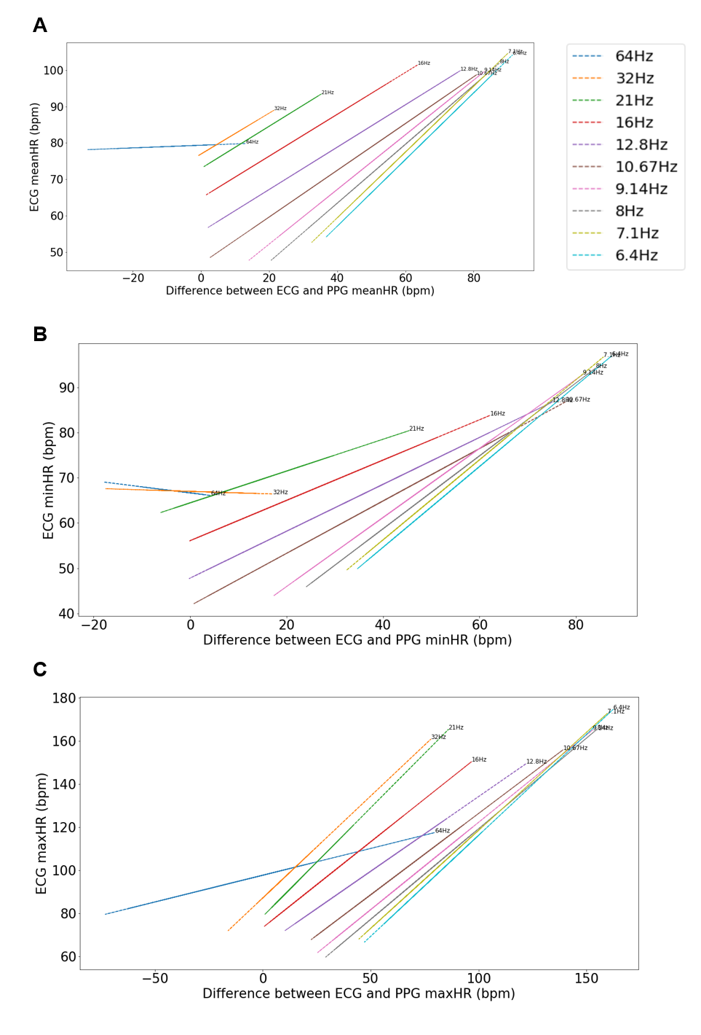
Supplementary Figure 1. Linear regressions between ECG metric and the difference between ECG and PPG of that metric for Mean HR (A), Minimum HR (B), and Maximum HR (C) for each sampling rate 6.4-64 Hz (shown in legend and labeled on the plot).
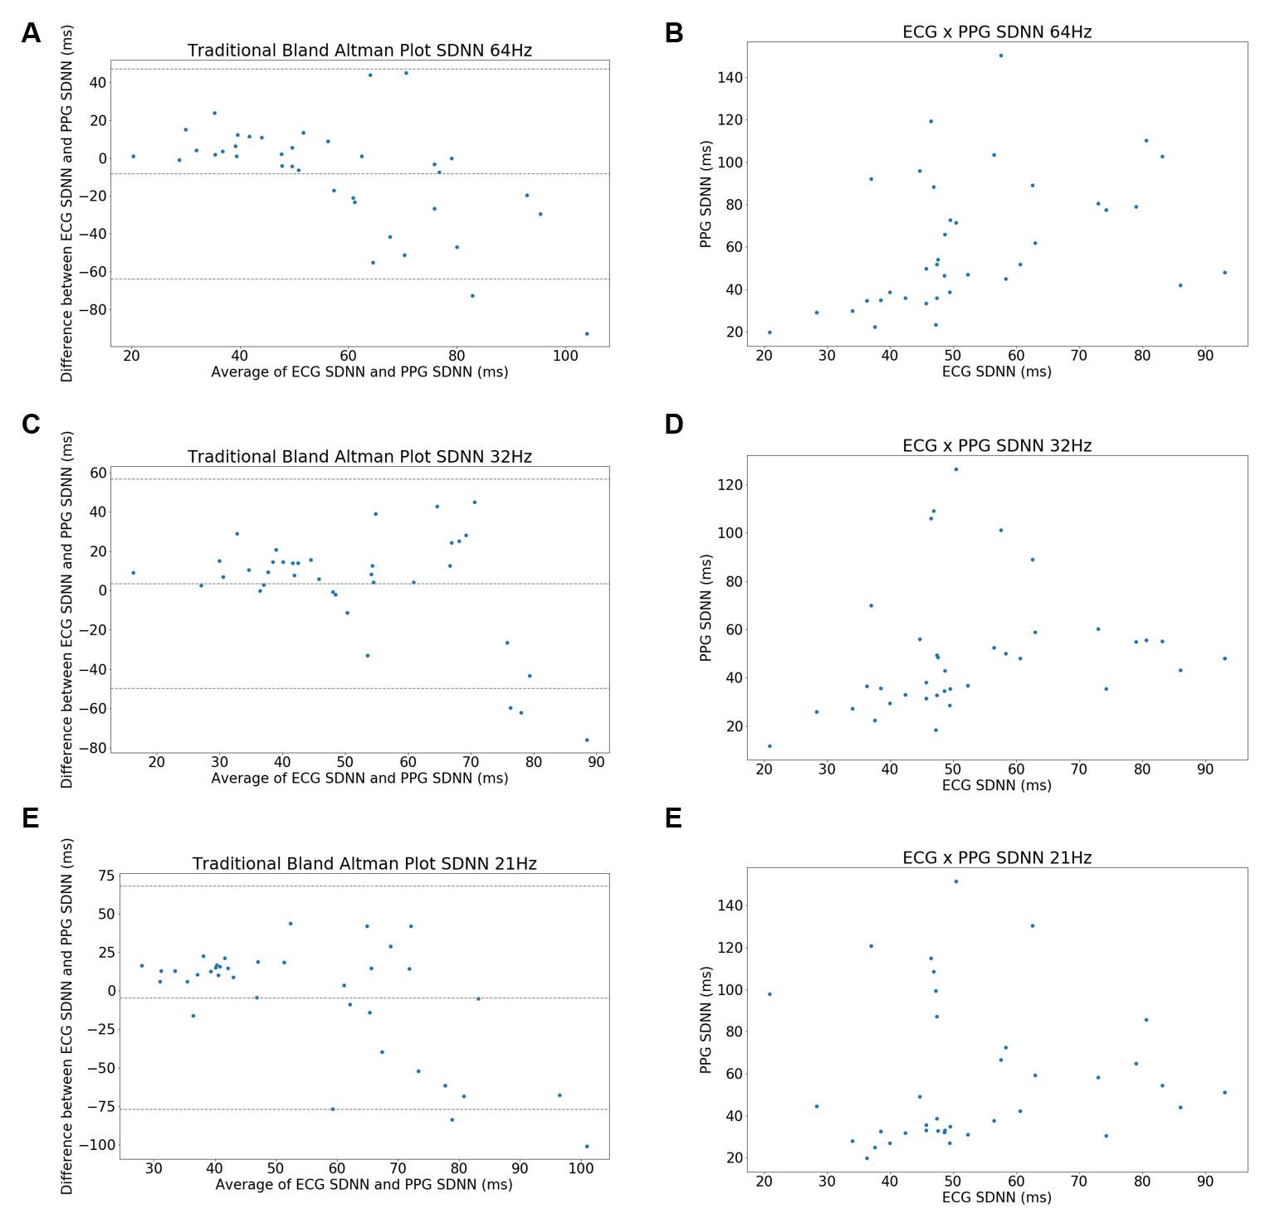

Supplementary Figure 2. Traditional Bland Altman plot for SDNN at 64Hz (A), 32Hz (C), and 21Hz (E). PPG SDNN by ECG SDNN at 64Hz (B), 32Hz (D), and 21Hz (F).

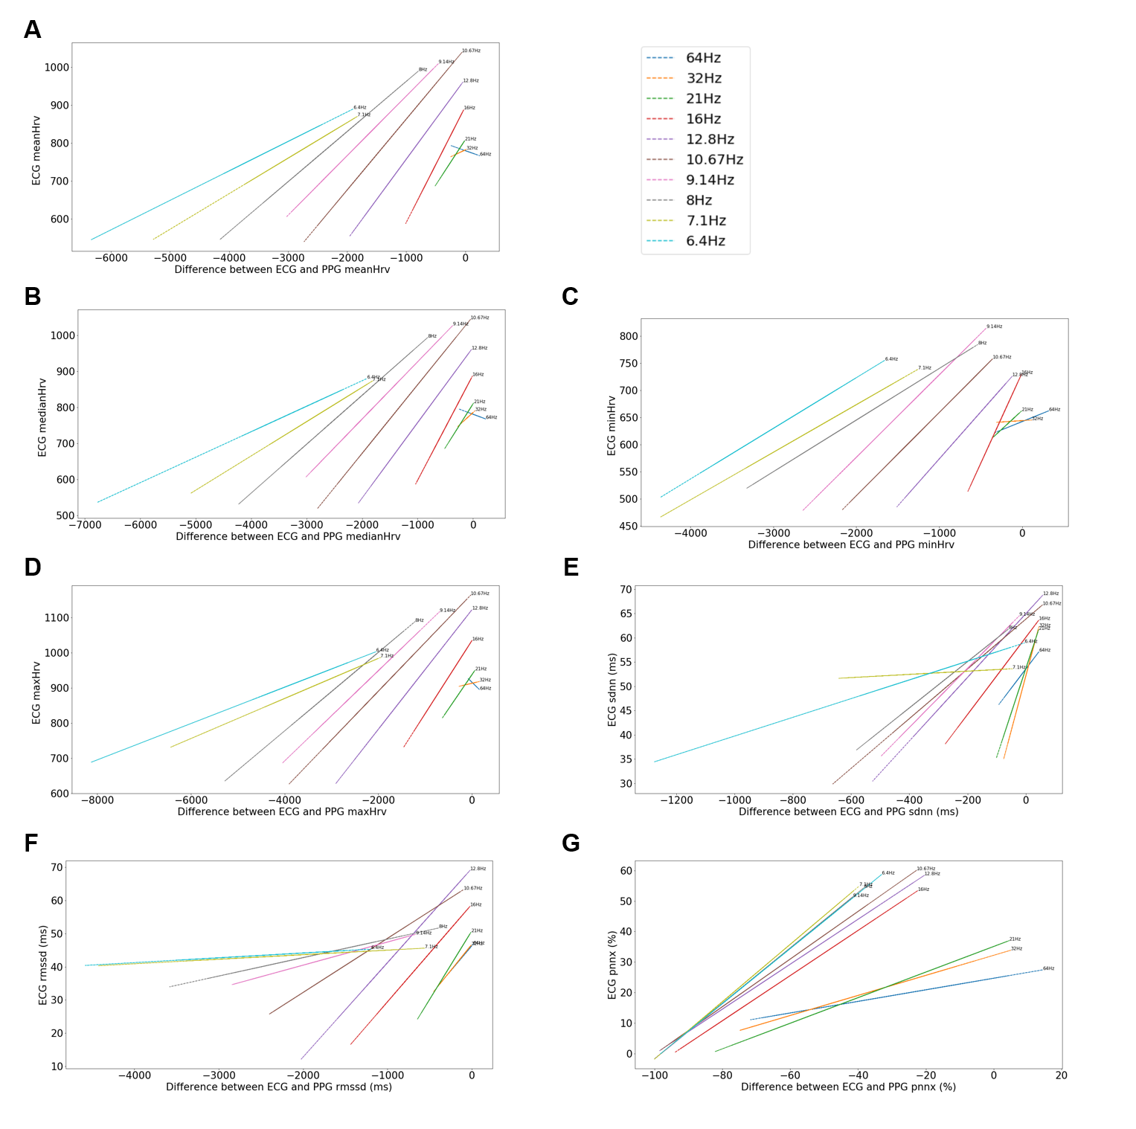
Supplementary Figure 3. Linear regressions between ECG metric and the difference between ECG and PPG of that metric for Mean HRV (A), Median HRV (B), Minimum HR (C), Maximum HR (D), SDNN (E), RMSSD (F), and pNN50 (G) for each sampling rate 6.4-64 Hz (shown in legend and labeled on the plot).

Supplementary Table 1. Bland Altman Analysis Mean Bias and LOA for each sampling rate and each HR/HRV metric.
Sampling Rate | HR/HRV Metric | Mean Bias (Mean ± SD) | Upper LOA | Lower LOA
64Hz | Mean HR | -3.46 ± 9.52 | 15.19 | -22.11
64Hz | Minimum HR | -2.43 ± 4.55 | 6.49 | -11.35
64Hz | Maximum HR | -6.61 ± 28.08 | 48.42 | -61.64
64Hz | Mean HRV | 20.59 ± 79.48 | 176.38 | -135.19
64Hz | Median HRV | 20.16 ± 83.83 | 184.47 | -144.14
64Hz | Maximum HRV | 27.62 ± 55.33 | 136.08 | -80.83
64Hz | Minimum HRV | 17.39 ± 142.86 | 297.4 | -262.62
64Hz | SDNN | -8.46 ± 28.36 | 47.11 | -64.04
64Hz | RMSSD | -94.98 ± 102.46 | 105.85 | -295.8
64Hz | pnn50% | -27.58 ± 22.6 | 16.71 | -71.87
32Hz | Mean HR | 4.09 ± 5.01 | 13.91 | -5.73
32Hz | Minimum HR | 0.33 ± 6.4 | 12.87 | -12.2
32Hz | Maximum HR | 9.45 ± 13.59 | 36.08 | -17.18
32Hz | Mean HRV | -43.35 ± 59.1 | 72.49 | -159.19
32Hz | Median HRV | -42.89 ± 61.69 | 78.03 | -163.8
32Hz | Maximum HRV | -12.67 ± 87.52 | 158.87 | -184.2
32Hz | Minimum HRV | -69.17 ± 81.4 | 90.37 | -228.7
32Hz | SDNN | 3.33 ± 27.2 | 56.65 | -49.99
32Hz | RMSSD | -103.87 ± 115.15 | 121.83 | -329.58
32Hz | pnn50% | -38.77 ± 20.6 | 1.6 | -79.14
21Hz | Mean HR | 10.78 ± 9.71 | 29.82 | -8.26
21Hz | Minimum HR | 7.18 ± 11.19 | 29.13 | -14.76
21Hz | Maximum HR | 17.39 ± 14.35 | 45.53 | -10.74
21Hz | Mean HRV | -125.94 ± 124.31 | 117.70 | -369.59
21Hz | Median HRV | -123.81 ± 125.65 | 122.46 | -370.07
21Hz | Maximum HRV | -126.08 ± 192.09 | 250.41 | -502.56
21Hz | Minimum HRV | -137.72 ± 87.75 | 34.27 | -309.72
21Hz | SDNN | -4.63 ± 37.07 | 68.03 | -77.29
21Hz | RMSSD | -178.16 ± 175.82 | 166.45 | -522.76
21Hz | pnn50% | -37.29 ± 23.83 | 9.41 | -83.99
16Hz | Mean HR | 25.0 ± 17.31 | 58.92 | -8.92
16Hz | Minimum HR | 24.44 ± 17.01 | 57.78 | -8.91
16Hz | Maximum HR | 28.5 ± 20.14 | 67.97 | -10.98
16Hz | Mean HRV | -384.06 ± 280.75 | 166.21 | -934.33
16Hz | Median HRV | -377.52 ± 289.33 | 189.56 | -944.6
16Hz | Maximum HRV | -584.92 ± 436.64 | 270.90 | -1440.74
16Hz | Minimum HRV | -265.8 ± 165.68 | 58.93 | -590.54
16Hz | SDNN | -90.55 ± 93.59 | 92.88 | -273.99
16Hz | RMSSD | -522.58 ± 351.35 | 166.07 | -1211.23
16Hz | pnn50% | -68.22 ± 19.03 | -30.93 | -105.51
12.8Hz | Mean HR | 40.68 ± 19.24 | 78.39 | 2.96
12.8Hz | Minimum HR | 36.98 ± 16.7 | 69.72 | 4.24
12.8Hz | Maximum HR | 45.02 ± 24.43 | 92.89 | -2.86
12.8Hz | Mean HRV | -899.19 ± 490.71 | 62.59 | -1860.98
12.8Hz | Median HRV | -893.59 ± 500.11 | 86.62 | -1873.80
12.8Hz | Maximum HRV | -1231.06 ± 655.46 | 53.65 | -2515.76
12.8Hz | Minimum HRV | -595.94 ± 361.21 | 112.04 | -1303.91
12.8Hz | SDNN | -184.66 ± 121.12 | 52.74 | -422.07
12.8Hz | RMSSD | -921.05 ± 408.28 | -120.83 | -1721.27
12.8Hz | pnn50% | -73.34 ± 19.2 | -35.7 | -110.97
10.67Hz | Mean HR | 50.51 ± 17.59 | 84.98 | 16.05
10.67Hz | Minimum HR | 43.65 ± 15.01 | 73.06 | 14.24
10.67Hz | Maximum HR | 59.87 ± 23.59 | 106.11 | 13.63
10.67Hz | Mean HRV | -1451.31 ± 567.03 | -339.93 | -2562.69
10.67Hz | Median HRV | -1435.47 ± 564.43 | -329.19 | -2541.75
10.67Hz | Maximum HRV | -1838.42 ± 770.85 | -327.55 | -3349.29
10.67Hz | Minimum HRV | -1102.14 ± 466.76 | -187.29 | -2016.98
10.67Hz | SDNN | -211.75 ± 140.43 | 63.5 | -487.0
10.67Hz | RMSSD | -1311.63 ± 542.55 | -248.24 | -2375.02
10.67Hz | pnn50% | -74.74 ± 18.09 | -39.28 | -110.19
9.14Hz | Mean HR | 56.0 ± 14.97 | 85.34 | 26.65
9.14Hz | Minimum HR | 47.56 ± 11.51 | 70.12 | 25.01
9.14Hz | Maximum HR | 67.71 ± 22.38 | 111.57 | 23.84
9.14Hz | Mean HRV | -1923.9 ± 550.88 | -844.17 | -3003.62
9.14Hz | Median HRV | -1922.7 ± 550.06 | -844.57 | -3000.82
9.14Hz | Maximum HRV | -2280.77 ± 651.42 | -1003.99 | -3557.55
9.14Hz | Minimum HRV | -1559.62 ± 480.06 | -618.69 | -2500.55
9.14Hz | SDNN | -207.88 ± 121.89 | 31.02 | -446.78
9.14Hz | RMSSD | -1569.86 ± 560.38 | -471.51 | -2668.21
9.14Hz | pnn50% | -76.56 ± 15.66 | -45.87 | -107.26
8Hz | Mean HR | 59.5 ± 14.04 | 87.02 | 31.99
8Hz | Minimum HR | 50.25 ± 11.0 | 71.82 | 28.69
8Hz | Maximum HR | 72.41 ± 21.51 | 114.57 | 30.26
8Hz | Mean HRV | -2390.23 ± 616.09 | -1182.70 | -3597.77
8Hz | Median HRV | -2395.39 ± 609.97 | -1199.86 | -3590.92
8Hz | Maximum HRV | -2789.91 ± 745.41 | -1328.91 | -4250.91
8Hz | Minimum HRV | -2017.97 ± 590.56 | -860.47 | -3175.46
8Hz | SDNN | -239.42 ± 140.42 | 35.8 | -514.64
8Hz | RMSSD | -1869.55 ± 676.15 | -544.29 | -3194.8
8Hz | pnn50% | -76.69 ± 16.1 | -45.13 | -108.24
7.1Hz | Mean HR | 61.93 ± 12.68 | 86.78 | 37.07
7.1Hz | Minimum HR | 52.11 ± 9.96 | 71.63 | 32.59
7.1Hz | Maximum HR | 75.32 ± 20.3 | 115.10 | 35.54
7.1Hz | Mean HRV | -2801.9 ± 630.87 | -1565.40 | -4038.40
7.1Hz | Median HRV | -2796.02 ± 609.53 | -1601.34 | -3990.69
7.1Hz | Maximum HRV | -3248.52 ± 806.85 | -1667.10 | -4829.94
7.1Hz | Minimum HRV | -2343.04 ± 616.79 | -1134.14 | -3551.94
7.1Hz | SDNN | -272.26 ± 156.18 | 33.85 | -578.37
7.1Hz | RMSSD | -2115.48 ± 758.26 | -629.30 | -3601.67
7.1Hz | pnn50% | -77.36 ± 15.55 | -46.87 | -107.84
6.4Hz | Mean HR | 64.15 ± 12.56 | 88.77 | 39.53
6.4Hz | Minimum HR | 53.85 ± 9.99 | 73.44 | 34.26
6.4Hz | Maximum HR | 78.51 ± 19.82 | 117.36 | 39.66
6.4Hz | Mean HRV | -3327.1 ± 723.4 | -1909.23 | -4744.97
6.4Hz | Median HRV | -3330.72 ± 794.75 | -1773.0 | -4888.43
6.4Hz | Maximum HRV | -3792.86 ± 949.17 | -1932.50 | -5653.23
6.4Hz | Minimum HRV | -2855.17 ± 599.44 | -1680.28 | -4030.07
6.4Hz | SDNN | -320.27 | 98.46 | -739.01
6.4Hz | RMSSD | -2460.55 ± 773.11 | -945.24 | -3975.85
6.4Hz | pnn50% | -76.56 ± 16.1 | -45.0 | -108.12

