Evaluation of Initial Progress to Implement Common Metrics across the NIH Clinical and Translational Science Awards (CTSA) Consortium

SUPPLEMENTAL MATERIALS

Supplemental Figure
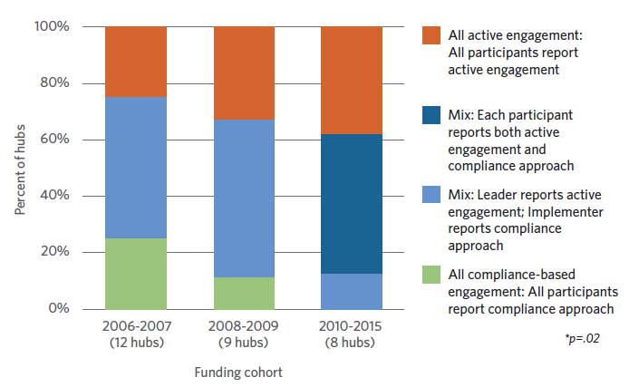
Supplemental Figure 1. Clinical and Translational Science Award hubs’ approaches to engaging with Common Metrics by funding cohort.

Supplemental Tables
Supplemental Table 1. Initial CTSA Consortium Common Metrics
Title | Purpose
Careers in Clinical and Translational Research | To enhance training and support for scientists to remain engaged in clinical and translational research
Median Institutional Review Board (IRB) Review Duration | To shorten the time it takes to begin conducting a study, thereby shortening the time until benefits of clinical and translational research findings can be realized
Pilot Funding Publications and Subsequent Funding | To ensure that findings from research studies supported by CTSA Pilot Programs are being disseminated

Supplemental Table 2. Data collection instruments and chronology
Instrument | Data collection period
Implementation Group assignment survey | 2016 March
Baseline survey | 2016 July – September (by Implementation Group)
Follow-up survey 1 | 2016 October – 2017 March (by Implementation Group)
Qualitative interview guide* | 2017 November – 2018 March
Follow-up survey 2 | 2018 January – February
*Adapted for three participant roles at each hub: Principal Investigator, Administrator/Executive Director/Common Metrics champion, Common Metrics implementer

Supplemental Table 3. Baseline and follow-up survey topics
Topic | Baseline | Follow-up 1 | Follow-up 2
 | One Local  Metric* | Any Common Metric | All Common Metrics
Performance improvement activities
  - Completion of each activity per metric
  - Date of completion of activity, if applicable
  - Reason for lack of completion of each activity, if applicable
  - Documentation of activities in software platform
- Open-ended comments on status of data collection and performance improvement |  | optional | optional
Self-assessment
- Overall ability to manage performance
Assessment of Tufts Implementation Program
  - Amount and time allocated to components
  - Knowledge and proficiency gained
  - Overall effectiveness and satisfaction
Other
- General open-ended comments |  |  | optional
*For the baseline survey, hubs were instructed to choose any one metric that best exemplified how the hub used metric data in the prior five months.

Supplemental Table 4. Semi-structured interview topics
Topic
Background information on the participant and the hub
Initial perceptions of the Common Metrics and the performance improvement framework
Preparation for implementation and order in which hubs addressed the metrics (if not simultaneously)
Experience, facilitators, and challenges for implementing Common Metrics
- Probing for contextual characteristics that may have influenced the experience
  - Hub characteristics
  - Local institutional characteristics
  - Role of Tufts Implementation Program and the National Center for Advancing Translational Sciences (NCATS)
  - Environmental characteristics external to the local institution
- Probing for type of experience
  - Evolution of implementation over time
Meaningfulness and added value of implementing Common Metrics
Recommendations
- Common Metrics Initiative
- Advice for a new hub starting to implement the Common Metrics

Supplemental Table 5. Semi-structured interviews: final sample of hubs (N=30)
Prior experience  Number of prior performance improvement activities* completed for any metric  (Baseline survey) | Initial progress on a Common Metric  Number of performance improvement activities* completed for one Common Metric by the end of the coaching period  (Follow-up survey 1)
 | Minimal | Moderate | Significant
Minimal | 4 | 4 | 5
Moderate | 2 | 4 | 4
Significant | 0 | 4 | 3
* Activities range from 0-10. Minimal = 0.0–4.5, moderate=5.0-8.5, significant=9.0-10.0.

Supplemental Table 6. Hub attributes and related experience, overall and by Implementation Group (N=59 hubs*)
Characteristic | All Hubs | Implementation Group |  |  | p-value
 |  | 1  (n=20) | 2  (n=17) | 3  (n=22***)
Basic attributes (n, %)
Size at start of CMI program, (2015-2016), by tertile**, *** |  |  |  |  | 0.23
< $4.56 million | 20 (34.5) | 8 (40.0) | 3 (17.6) | 9 (42.9)
$4.56-8.04 million | 19 (32.8) | 6 (30.0) | 9 (52.9) | 4 (19.0)
≥$8.05 million | 19 (32.8) | 6 (30.0) | 5 (29.4) | 8 (38.1)
Initial funding cohort, by tertile*** |  |  |  |  | 0.02
2010-2015 | 18 (31.0) | 5 (25.0) | 3 (17.6) | 10 (47.6)
2008-2009 | 19 (32.8) | 9 (45.0) | 9 (52.9) | 1 ( 4.8)
2007 or earlier | 21 (36.2) | 6 (30.0) | 5 (29.4) | 10 (47.6)
Previous experience with metric-based performance improvement (mean, SD)
Variables comprising factor called “Maturity of performance management system”
Extent data were collected for performance metrics (range: 1-4) | 3.4 (0.75) | 3.2 (0.83) | 3.6 (0.70) | 3.4 (0.68) | 0.24
Degree metrics were used to quantify progress (range: 1-4) | 3.3 (0.71) | 3.3 (0.75) | 3.3 (0.67) | 3.4 (0.74) | 0.90
Number of CTSA components monitored with metrics (range 0-4) | 3.4 (0.97) | 3.4 (1.23) | 3.6 (0.70) | 3.4 (0.92) | 0.67
Number of stakeholder groups for which procedures were in place to review results (range: 0-3) | 1.4 (1.10) | 1.6 (1.15) | 1.2 (0.92) | 1.4 (1.21) | 0.56
Extent of reliance on metrics for operations decisions (range: 1-4) | 3.1 (0.80) | 3.1 (0.78) | 3.1 (0.94) | 3.1 (0.73) | 0.92
Extent of reliance on metrics for strategy decisions (range: 1-4) | 3.1 (0.75) | 3.0 (0.75) | 2.9 (0.85) | 3.2 (0.68) | 0.56
Self-rated capability of hub to use metrics to monitor/manage (range: 1-5) | 3.2 (1.09) | 3.5 (1.07) | 3.3 (1.02) | 2.9 (1.14) | 0.25
Other variables in factor analysis
Degree data collection was automated (range: 1-3) | 1.9 (0.34) | 1.8 (0.37) | 2.0 (0.35) | 1.9 (0.30) | 0.39
Extent of data storage in centralized CTSA database (range: 1-5) | 3.2 (0.98) | 3.0 (1.00) | 3.5 (1.01) | 3.1 (0.94) | 0.33
Current use of performance method (range: 0-1) | 0.7 (0.47) | 0.8 (0.42) | 0.6 (0.50) | 0.6 (0.50) | 0.43
SD=Standard Deviation; CMI=Common Metrics Implementation
* One hub did not respond to the follow-up survey and is excluded from analyses.
** CTSA size is defined as total funding from U, T, K, and/or R grants for 2015-2016.
*** Data for CTSA size and initial funding year are missing for one hub.

Supplemental Table 7. Strategies for engaging stakeholders
Main themes with illustrative quotations*
Identifying the diversity of stakeholders and demonstrating benefit
For each metric, you have to think through that process, which would be who is going to be in charge of the data? Who are the stakeholders that should be most interested in this and who is sort of that organization or program official that kind of cares about the metric and will push the team to turn the curve. So it does take some thought about what is the team for each metric and being intentional about getting people together. –Principal Investigator
So, that helps us in terms of engaging our partners, because they see, "Whoa, we benefit. Our trainees are getting into your mentor career development program and benefitting from that...” –Principal Investigator
Developing dialogue and feedback with stakeholders
As far as engaging stakeholders, that’s one of the bonuses of having metrics and it has definitely had us take a deeper dive with our leadership of the IRB… it definitely was through the engagement of the stakeholders that some of that creativity was allowed to come out. –Principal Investigator
A general point would be to always ensure that there's dialogue and that you're listening to the people who are at the ground level, because they have important perspectives. –Principal Investigator
Persistence
Because, again, we don’t control the IRB, we end up sort of nagging the IRB or other groups where we’re trying to influence what they do. –Principal Investigator
Building bridges outwards and inwards
Well, most of the stakeholders, like I said, the head of our IRB is involved in our CTSA. …The [senior leader] at the School of Medicine is one of the co-PIs of our CTSA. The [senior leader] of one of our hospital affiliates runs our [Program name]. I mean most of the people we need to grease the wheels are at the table with us as part of the organization, so we don't have too many issues. –Principal Investigator
* Unless stated otherwise, themes manifest in more than one way; a quotation represents one manifestation.

