SUPPLEMENTAL MATERIALS

Supplementary Figure 1. Distribution of Good Clinical Practice Knowledge Test Scores 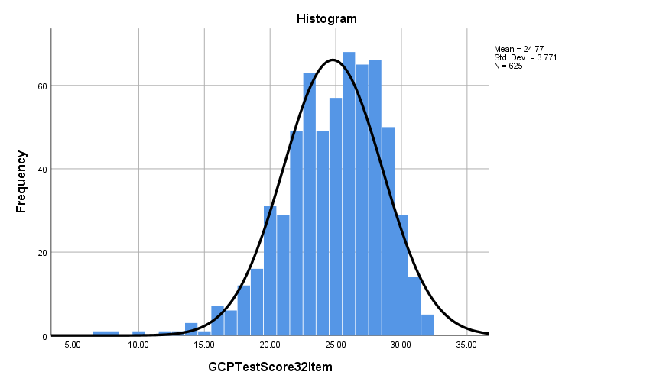
ª
ª

ª GCPTestScore32item stands for Good Clinical Practice Knowledge Test Score 32 item test

