Supplementary Figure 1 – CONSORT Diagram of search and review.
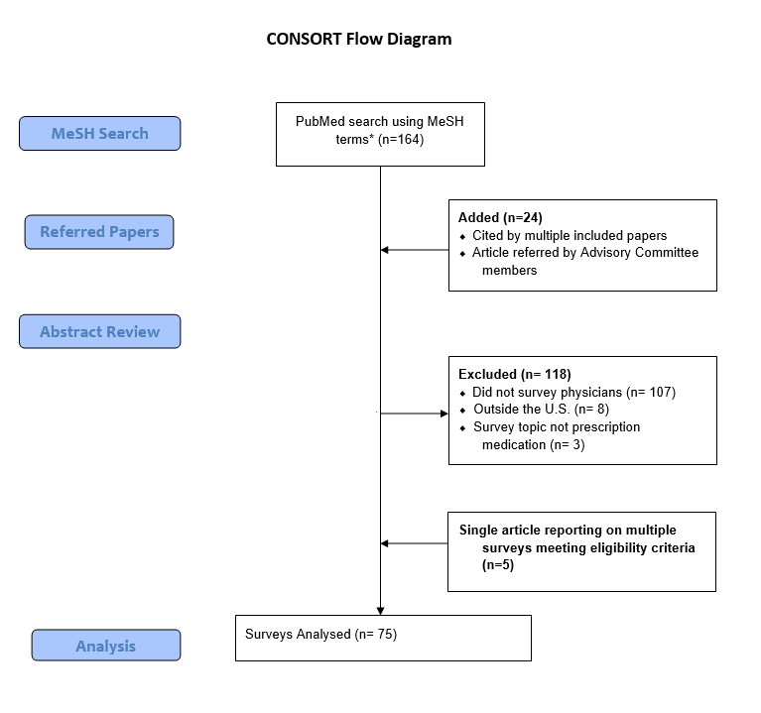
*Note: MeSH and keyword search terms: (((((((((((((("Health Care Surveys"[Mesh] OR "Health Surveys"[Mesh] OR "Data Collection"[Mesh] OR Nonrespondents OR Nonrespondent OR Respondents OR Respondent OR Surveys OR Survey OR "Questionnaires"[Mesh] OR "Questionnaires" OR Questionnaire))))))

AND
((("Physicians"[Mesh] OR physicians OR physician OR "Health Personnel"[Mesh] OR "Health Care Providers" OR "Health Care Provider" OR "Healthcare Providers" OR "Healthcare Provider"))))

AND
((("response rate" OR "response rates"))))

AND
((("United States"[Mesh] OR "United States")))))

AND
("Pharmacy"[Mesh] OR "Pharmacy" OR OR "Prescriptions"[Mesh] OR "Prescriptions")))
AND
( "2000/01/01"[PDat] : "2014/12/31"[PDat] ) AND English[lang]))

AND
(United States[ad] OR US[ad] OR America[ad] OR USA[ad])

