Supplemental material:
S1. Focus group script and activity description.
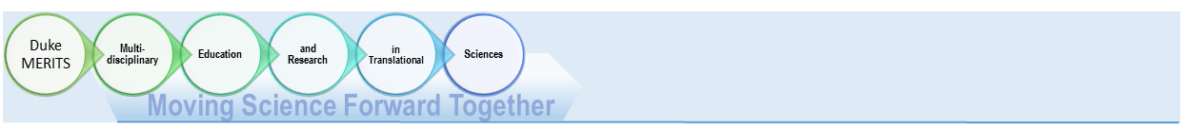
Date of participation: ________________________

Please circle your professional title:
Basic/
Discovery
Health Services
Policy
Intervention
studies
Drug or device trial
Animal studies
Validation or phenotyping
Instructor Assistant Professor Associate Professor Professor Staff Other
Activity 1: Describing our landscape
- 3 min: Discuss your research with a partner.
- 1 min: On your own.
  - Mark on the chart above: 1) where your research falls on the spectrum of research (write “me”), and 2) where you think your partner falls on the spectrum (write “them”). Feel free to write in categories not currently included.
  - Using vertical lines, mark on the spectrum above where you think “translational science” begins and where you think it ends.
- 2 min: go up to the 3 flip charts and copy from your paper where your research falls (Who we are), where your partner’s research falls (Who others think we are), and your beginning and ending lines (borders of translational science).

Activity 2: Defining translational science
- 1 min: based on the pictograph, write down a simple definition of translational science—this can be a bullet list of key elements.
- 10 min: Discuss definitions with the larger group. Facilitator will record key elements of translational science on flip chart.

Activity 3: Identifying Pros and Cons of translational science at Duke.
- 10 min: Group will be divided in half: one group come up with a list of benefits (pros)of translational science for quality research and investigator success at Duke, the second group will come up with a list of detriments of or barriers (cons) to translational science that may impede quality research and investigator success at Duke.
- 10 min: lists will be shared and discussed and a master list created by rating top 3 pros and tops 3 cons

Activity 4: Addressing translational science needs
- 10 min: Group will be divided in half differently: One half will create a list of existing resources (persons, offices, programs, finances, etc) that may enhance the pros or alleviate the cons of translational science. The other half will discuss gaps in or needs for resources that limit our ability to achieve the pros or alleviate the cons.
- 10 min: Together the group will discuss their lists. Identify remaining gaps and share ideas for addressing these gaps.

Activity 5: Brainstorming measurements of success
- 1 min: List here what factors could be measured to assess success of translational science at Duke
- Remaining time: Write here any additional thoughts or ideas you would like to share about translational science at Duke.

