Supplementary Figure 1: Black-and-white version of the visual aid tool for informed consent before procedural sedation in the emergency department (usable for both pediatric and adults).
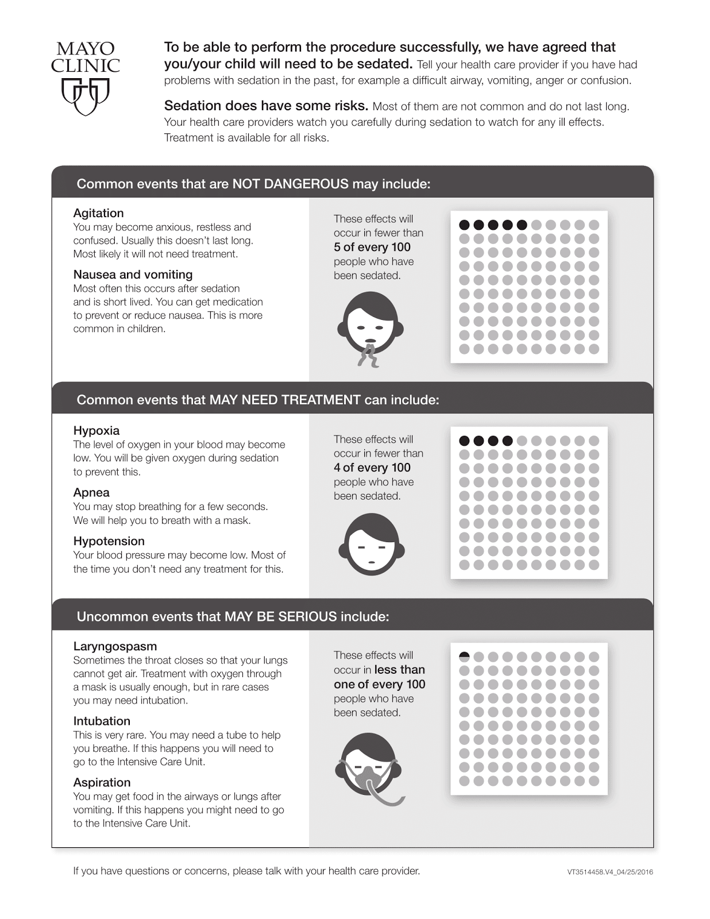

Supplementary Figure 2: Prior versions of the visual aid tool for informed consent before procedural sedation in the emergency department (usable for both pediatric and adults).
