Supplementary Information.
Surface Functionalization of Ordered Mesoporous Hollow Carbon Spheres with Ru Organometallic Compounds as Supports of Low-Pt Content Nanocatalysts for Alkaline Hydrogen and Oxygen Evolution Reactions.

J.C. Martínez-Loyola¹, I.L. Alonso-Lemus², M.E. Sánchez-Castro¹, B. Escobar-Morales³, J.R. Torres-Lubián⁴, F.J. Rodríguez-Varela^{1,*}
¹ Sustentabilidad de los Recursos Naturales y Energía, Cinvestav Unidad Saltillo, Av. Industria Metalúr-gica 1062, Parque Industrial Ramos Arizpe, Ramos Arizpe, Coah. C.P.25900, México.
² CONACyT-Sustentabilidad de los Recursos Naturales y Energía, Cinvestav Unidad Saltillo.
³ CONACyT-Centro de Investigación Científica de Yucatán, Calle 43 No. 130 Col. Chuburná de Hidal-go, Mérida, Yucatán, C.P. 97200, México.
⁴ Centro de Investigación en Química Aplicada, Blvd. Enrique Reyna No. 140, Saltillo, Coah. C.P. 25294, México.
*E-mail: javier.varela@cinvestav.edu.mx

Number of figures: 2.

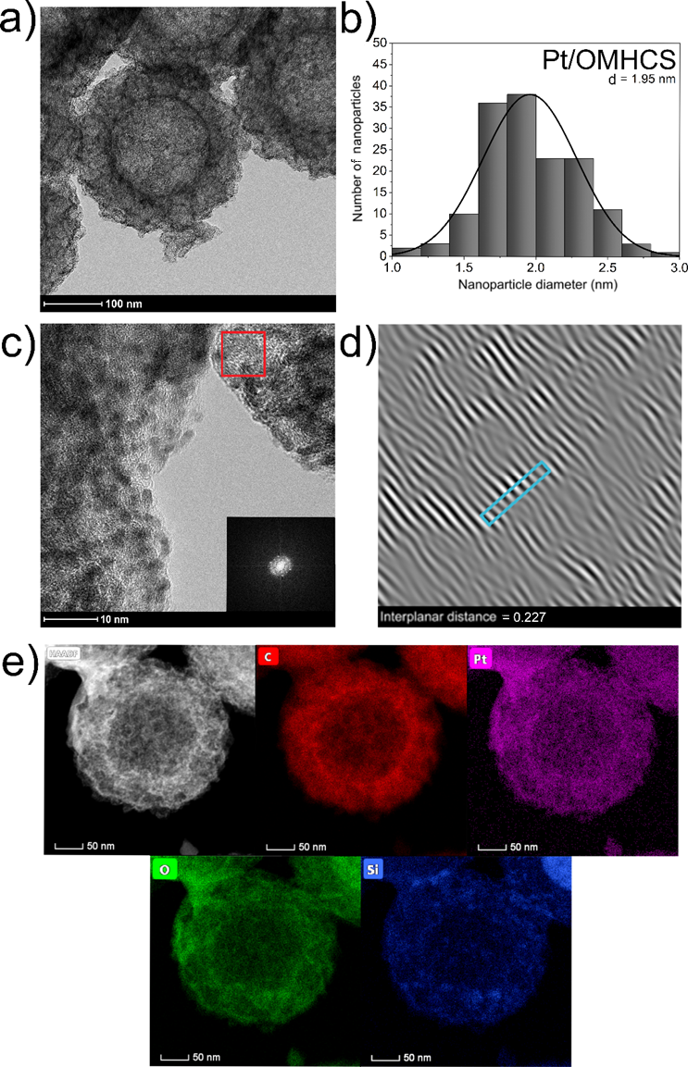
Figure S1. Analysis of Pt/OMHCS: a) TEM micrograph, b) particle size distribution histogram, c) HR-TEM micrograph with SAED pattern (inset), d) reconstructed iFFT image from the SAED pattern, e) STEM-HAADF chemical mapping.

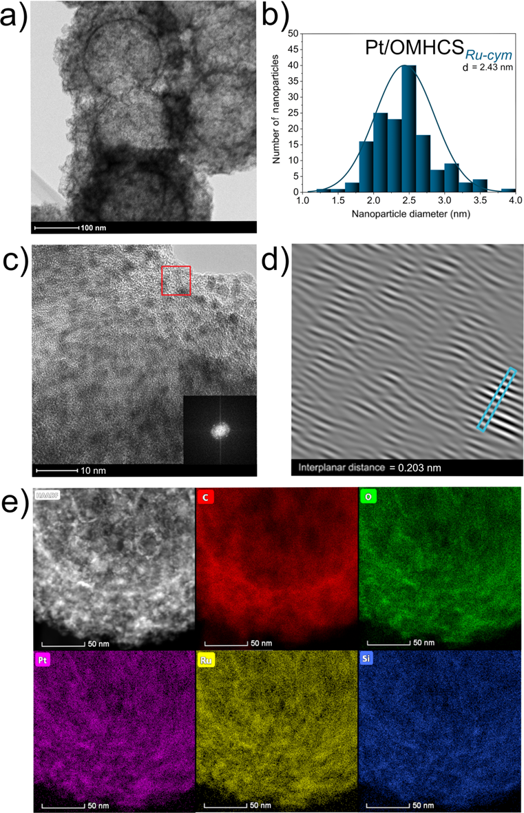
Figure S2. Analysis of Pt/OMHCS_{Ru-cym}: a) TEM micrograph, b) particle size distribution histogram, c) HR-TEM micrograph with SAED pattern (inset), d) reconstructed iFFT image from the SAED pattern, e) STEM-HAADF chemical mapping.

