maskSupplementary Materials
Silicon Nanowire Arrays Coated with Ag and Au Dendrites for Surface-Enhanced Raman Scattering
Nikita Grevtsov¹, Aliaksandr Burko¹, Sergey Redko¹, Nadzeya Khinevich^{1,2}, Siarhei Zavatski^{1,3}, Stanislau Niauzorau⁴, Hanna Bandarenka^{1,4}
¹ Micro- and Nanoelectronics Department, Belarusian State University of Informatics and Radioelectronics, Minsk, Belarus
² Institute of Materials Science, Kaunas University of Technology, Kaunas, Lithuania
³ Nanophotonics and Metrology Laboratory, Swiss Federal Institute of Technology Lausanne (EPFL), Lausanne 1015, Switzerland
⁴ The Polytechnic School, Arizona State University, Mesa, AZ, United States
Section 1. Effect of the MACE conditions on the parameters of Si structures
Morphological parameters of resulting Si structures are strongly dependent on a number of MACE conditions [12–20]. A concentration of noble metal ions in the solution for metal deposition affects sizes of catalytic particles as well as distance between them [13]. If metal particles are well-separated, each of them will interact with Si in all directions except upwards during the etching stage. In a case of more densely-packed particles, however, their horizontal displacement is limited by each other, leading to joint downward movement [14]. As a concentration of oxidant in the solution is increased, so is the oxidation rate of Si atoms adjacent to the metal particles, which leads to an increase in the horizontal etching rate and a decrease in the diameter of forming SiNWs [15]. Extension of metal deposition stage leads to an increase in the size and a decrease in the distance between the noble metal particles formed on the Si surface. At a certain threshold nanoparticles overlap, forming dendritic structures. Increasing Si etching time results in a higher thickness of the SiNWs layer. This dependence has a linear nature; the diameter of the forming SiNWs also increases almost linearly with the etching time [16]. As a doping level of Si increases, the sidewalls of the forming SiNWs become rougher, gradually acquiring a porous structure [17]. Higher doping level of Si will also cause greater density, diameter and length of SiNWs if p-Si wafers with (111) orientation are used as initial substrates. Moreover, such Si substrates were found to promote tilted growth of SiNWs in relation to the wafer’s surface [18]. The length of the formed SiNWs is strongly dependent on a type of noble metal used, increasing in the order of Ag, Au, and Pt, which suggests different catalytic activities of these metals in a reduction of oxidant [19]. Pt and Cu morphology also differs significantly from that of their Ag and Au counterparts: a continuous metal film is formed on the wafer’s surface at long deposition times, obstructing HF from accessing the substrate and thus preventing further etching [20]. The rate of chemical etching rises with ambient temperature increase and subjecting samples to illumination. The number of holes generated by room light, however, is negligible comparing to a huge amount of holes injected through H₂O₂ reduction, and its effect on the Si etching acceleration is insignificant, albeit present [12].
Section 2. Fabrication of the experimental samples
The Si wafers used for the SiNWs formation were preliminarily cleaned in a mixture of 17.8 M H₂SO₄ and 0.1 M K₂Cr₂O₇ followed by the removal of a surface SiO₂ in a water-diluted HF (4.5 %). The MACE process was performed in two stages. At the first stage, silver structures were formed on the Si wafers’ surface via immersion deposition from a water-based solution of 0.03 M AgNO₃, 2.64 M HF and 1.28 M C₂H₅OH for 0.25–10 min. The silvered samples were rinsed with water for 30 s and with ethyl ethanol for 5 s. At the second stage, the silver-coated Si was kept in a water-based solution of 4.36 M HF and 0.23 M H₂O₂ for 60 min. During this stage, a layer of the silver structures played a role of a catalyst for the Si etching, which led to the fabrication of SiNWs. After that, the samples were rinsed with water for 30 s, with ethyl ethanol for 5 s and dried in the air atmosphere of a closed fume hood. After the second MACE stage, silver structures of different morphologies varying from quasi-spherical and elongated particles to dendrites remained on/between SiNWs. These silver remains were removed in a water-based solution of 4.4 M HNO₃ for 20 min to prepare samples for the reflectance spectroscopy. Residue silver was not etched from the SiNWs’ samples used for the SERS-measurements. A growth of gold dendrites on the SiNWs with silver remains was carried out by immersion technique from a water-based solution of 0.003 M HAuCl₄, 0.15 M HF and 0.0015 M C₂H₅OH. The Au deposition lasted for 40 min and then the samples were rinsed with water for 30 s, with ethyl alcohol for 5 s and dried in the air atmosphere of the closed fume hood.
Section 3. Structural and optical parameters of the experimental samples
The mean diameter of quasi-spherical particles is nearly the same for all the samples and varies about 75 nm. The elongated structures of 100–300 nm length grow from these particles and then coalesce into dendrites’ trunks of 300–500 nm diameter, which branch out while extended deposition time.
It should be noted that arrays of SiNWs without any silver remains formed on either type of substrate exhibit extremely low optical reflectance (Figure S1). Lower values are characteristic of the samples on p-type wafers. The reflectance spectra of the samples formed at various deposition times do not have any significant qualitative differences. The reflectance value tends to be lower for arrays of longer wires, but the exact dependence is difficult to establish with sufficient accuracy due to the non-uniformity of the formed structure as well as the presence of residual silver particles, a combination of which leads to mismatching results in different points of the sample’s surface area.
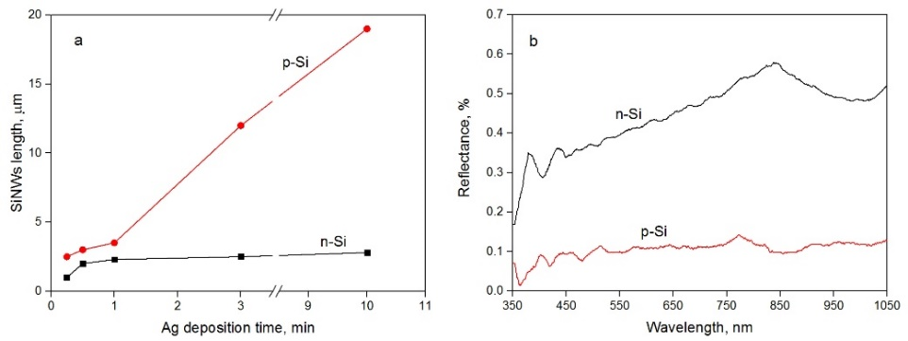
Figure S1 – (a) Length of SiNWs obtained after the second stage of MACE vs. time of silver deposition on the first stage of MACE. (b) SiNWs reflectance vs. excitation wavelength. Reflectance spectra were collected after the removal of silver from SiNWs.
Section 4. The Si etching process at the second MACE stage
The difference in etching rates can be attributed to a lower concentration of free holes available for the Si oxidation. During the etching stage, the previously deposited Ag particles act as microscopic cathodes where the reduction of the oxidant occurs [12]:

H₂O₂ + 2H⁺ → 2H₂O + 2h⁺ (Eq. 1)
Holes generated as a result of this process are then injected into the Si wafer. Due to additional holes’ injection, Si atoms directly underneath the noble metal particles are oxidized at a much higher rate compared to other areas, and the forming oxide is dissolved in HF, resulting in selective etching:

Si + 2H₂O + 4h⁺ → SiO₂ + 4H⁺ (Eq. 2)
SiO₂ + 6HF → SiF₆²⁻ + 2H₂O + 2H⁺ (Eq. 3)
A higher concentration of free holes present in p-type Si wafers means a higher oxidation and etching rate. This would suggest that p-type wafers tend to be the better choice for the forming SiNWs with high aspect ratios by the MACE method.
Section 5. Conclusions
The results of this study indicate that in the case of two-stage MACE increasing the deposition time for both n- and p-type Si wafers leads to an increase in (i) the silver particle size and a decrease in the distance between adjacent particles (which soon results in their complete overlapping and the formation of metallic dendrites); (ii) the thickness of the forming the Ag dendrites (only present at higher AgNO₃ concentrations); (iii) the depth of the porous layer formed at the deposition stage (in cases of deposition solutions that include HF); (iv) in aspect ratio (length) of the nanowires formed at the etching stage; (v) optical reflectance of uncoated wires due to higher surface area; (vi) Raman signal enhancement of deposited organic analytes.
We believe that an increase in wire aspect ratio with deposition time is attributed to the contribution of a thick dendrite layer into the redeposition of silver. The dendrites’ significant mass can also lead to closer adherence of smaller metal particles (which directly participate in the etching process) to the wafer’s surface. This, however, would also imply a gradually increasing limitation to the reagent and byproduct transfer, meaning that after a certain threshold any further increase in deposition time will no longer affect the nanowire length.
The comparison of samples obtained on lightly doped n- and p-type Si wafers allows us to draw a conclusion that p-type wafers are more preferable for obtaining longer wires using MACE due to a higher concentration of free holes necessary for the Si oxidation process.

