Supporting information for
Controllable Synthesis of Cobalt Porphyrin Nanocrystals through Micelle Confinement Self-Assembly
Sudi Chenª, Xitong Renª, Shufang Tian^{a*}, Jiajie Sun^{b}*, Feng Bai^{a*}
ªKey Laboratory for Special Functional Materials of Ministry of Education, National & Local Joint Engineering Research Center for High-efficiency Display and Lighting Technology, School of Materials Science and Engineering, and Collaborative Innovation Center of Nano Functional Materials and Applications, Henan University, Kaifeng 475004, China
^{b}School of Physics and Electronics, Henan University, Kaifeng 475004, China
EXPERIMENTAL DETAILS:
1. Materials:
Cobalt meso-tetra (4-pyridyl) porphyrin (CoTPyP) was purchased from Frontier
Scientific, Inc., cetryltrimethyl ammonium bromide (CTAB), myristyltrimethyl ammonium bromide (MTAB), sodium dodecyl sulfate (SDS) and N, N-dimethyl formamide (DMF) were purchased from J&K, sodium dodecylbenzene sulfonate (SDBS) was purchased from Aladdin, sodium hydroxide (NaOH 1N) standard solution and polyvinylpyrrolidone K30 (PVP) was purchased from Chengdu Kelong Reagent. Hydrochloric acid (HCl 1N) was used self-made by concentrated hydrochloric acid. All the chemicals were used without further purification. All the solutions were prepared in ultrapure water from a Thermo Scientific water system.

2. Morphology controlled synthesis:
1. Synthesis of CoTPyP nanoparticles:
CoTPyP (0.0085 g) was dissolved in 240 μL HCl (1N), stirring for 5 min and then 960 μL ultrapure H₂O was added, further stirring for 30 min to prepare the 0.01 mol/L CoTPyP/HCl solution. Then, 0.5 mL CoTPyP/HCl solution was immediately injected into 9.5 mL aqueous solution containing 4 mL CTAB (2.5 mM), 4.5 mL ultrapure H₂O and 180 μL NaOH standard solution (1N) under continuous stirring, the pH value was about 11.7. The solution was stirred continuously for 56 days at different temperature (25°C，60°C and 150°C). Finally, the solution was centrifuged at 8000 rpm to collect the porphyrin nanoparticles and washed with ultrapure water to remove free surfactants.

2. Synthesis of CoTPyP nanopolyhedrons:
0.5 mL CoTPyP/HCl solution was immediately injected into 9.5 mL aqueous solution containing 4 mL MTAB (2.5 mM), 4.5 mL ultrapure H₂O and 180 μL NaOH standard solution (1N) under continuous stirring, the pH value was about 11.7. The solution was stirred continuously for 7 days at 25°C and then setting. After 36 days, the solution was centrifuged at 13000 rpm to collect the nanopolyhedrons and washed with ultrapure water to remove free surfactants, and the supernatant was deep red after centrifugation.

3. Synthesis nanowires of CoTPyP:
0.3 mL CoTPyP/HCl solution was immediately injected into 5.6 mL aqueous solution containing 2.4 mL CTAB (2.5 mM), 3.2 mL ultrapure H₂O, 5 μL DMF and 80 μL NaOH standard solution (1N) under continuous stirring for 1 hour, the pH value was about 11.7. The solution was then transferred to 20 mL teflon-sealed autoclave and heated at 150°C for 10 hours and then cooled to room temperature naturally. The solution was centrifuged at 8000 rpm to collect the nanorods and washed with ultrapure water to remove free surfactants. The precipitated nanowires were redispersed into DI water for further use. The volume of DMF was systematically tuned by 5 μL, 10 μL, 20 μL, 40 μL, 80 μL and 120 μL.
Figure S1. The chemical structure of CoTPyP
3. Characterizations:
The Nova Nano SEM 450 and JEM 2100 were used for morphology images of the samples. The X-ray diffraction patterns were collected using D8-ADVANCE. The UV-vis absorption spectra were collected using PE Lambda 950. The Fourier transform infrared spectra were collected using VERTEX 70.

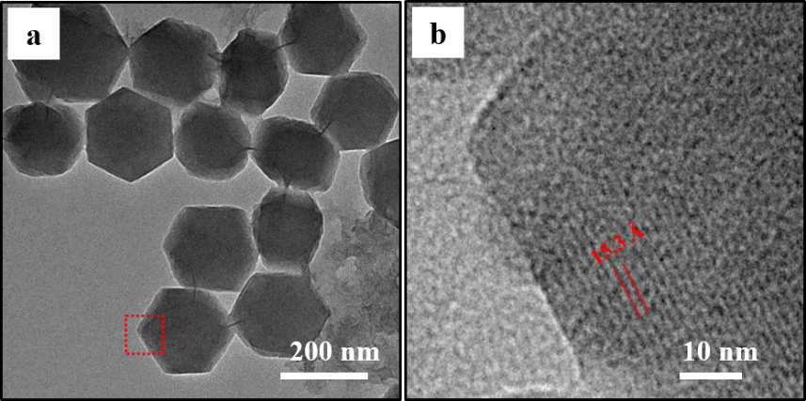
Figure S2. (a) TEM image of the nano polyhedrons that were prepared using 0.5 mM
CoTPyP and 10.0 mM MTAB at pH 11.7 stirring for 56 day. (b) Corresponding HR-TEM image of the nano polyhedrons.
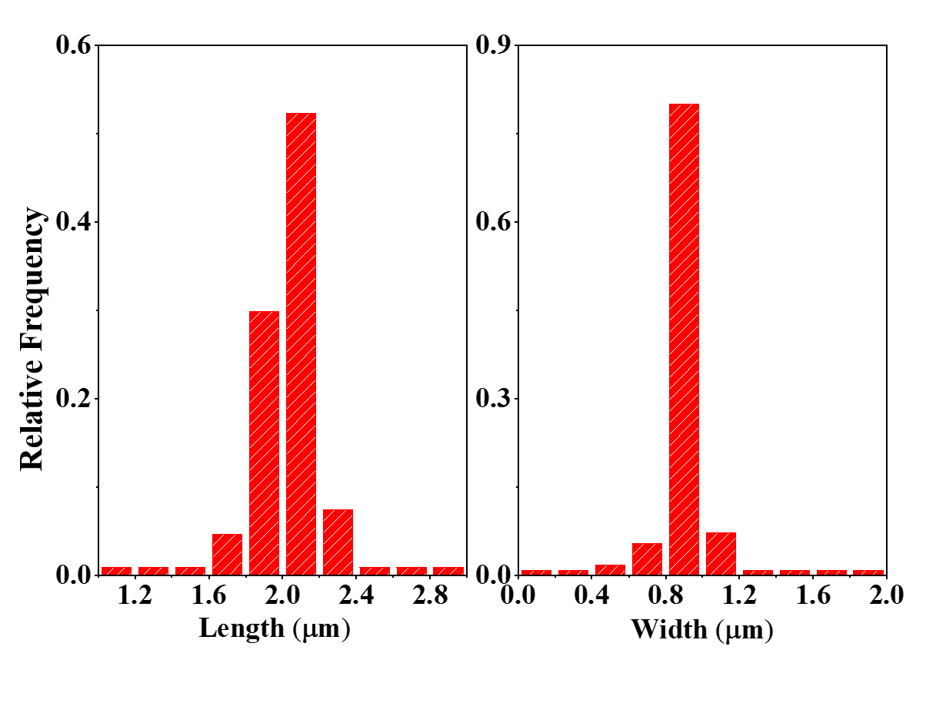
Figure S3. Statistical analysis of the length and width of the nano hexagonal prisms that were prepared using 0.5 mM CoTPyP and 10 mM CTAB at pH 11.7 heating at 150 °C for 10 h.

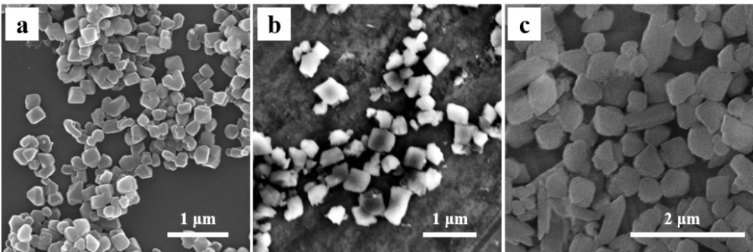
Figure S4. SEM images results of CoTPyP nanocrystals tuned by different types of surfactant at 150°C. The pH of the reaction solutions was kept at around 11.7 and the CoTPyP concentration was kept at 0.5 mM. (a) SDS, (b) SDBS, (c) PVP
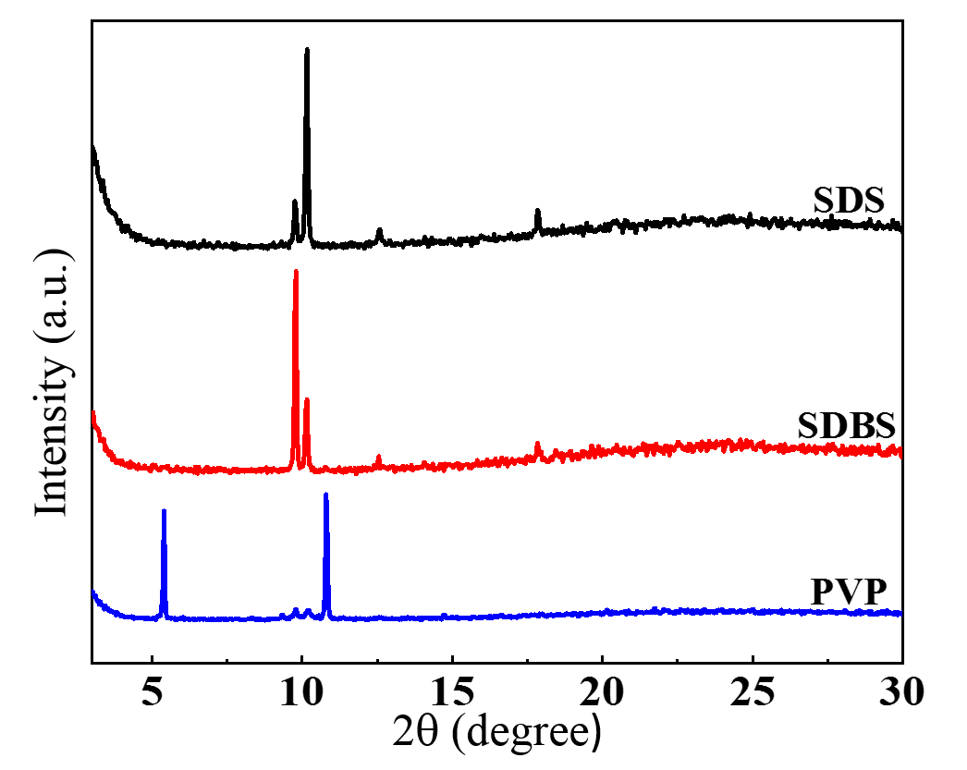
Figure S5. X-ray diffraction results of CoTPyP nanocrystals tuned by different types of surfactant at 150°C. The pH of the reaction solutions was kept at around 11.7 and the CoTPyP concentration was kept at 0.5 mM.
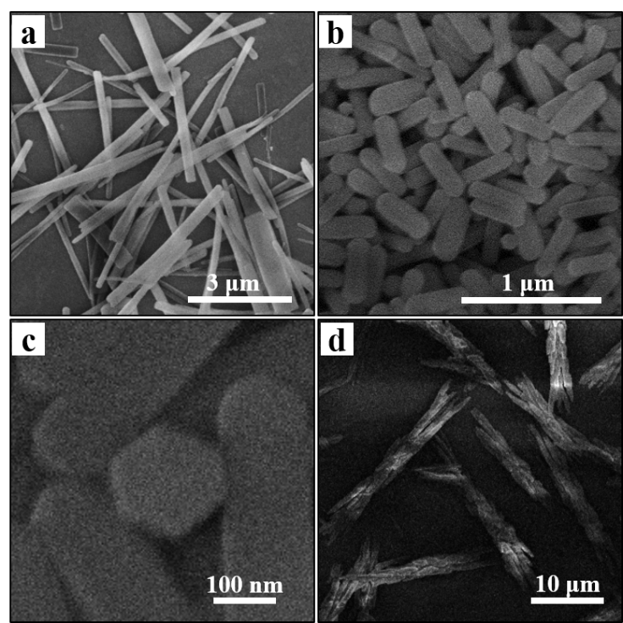
Figure S6. SEM images CoTPyP nanocrystals tuned by different DMF ratio at 150°C, the CoTPyP and CTAB concentrations were kept at 0.5 mM and 10 mM, respectively and the pH of the reaction solutions was kept at around 11.7: (a) 5 μL DMF added, (b) 120 μL DMF added, (c) 80 μL DMF added; (d) 900 μL DMF added.

Table S1: Statistical analysis of the length and width of the CoTPyP nanocrystals tuned by different DMF ratio
