supporting information:
Electrospun Fibre Composite for Controlled Drug Release
Shadi Houshyar¹*, Ryan Go¹, Kate Fox^{1,2}, Yen Bach Truong³*
¹ School of Engineering, RMIT University, Melbourne, Vic 3000, Australia
² Center for Additive Manufacturing, RMIT University, Melbourne, Vic 3000, Australia
³ Manufacturing and Health division, Commonwealth Scientific Institute and Research Organization
E-mail: Yen.Truong@csiro.au and Shadi.houshyar@rmit.edu.au

Analysis of the PEI4, PEI5 and PEI6 under the optical microscope is conducted to investigate the quality and uniformity of the developed microfiber (Fig. S1). Using UV spectrophotometry to analyze the drug release of the microfibers, a standard curve of the drug is created to use for comparison of drug concentration as well as show the relationship of absorption and concentration of a substance in solution (Fig. S2). Ibuprofen standard curve was developed by only measuring the absorption of 1ml buffer containing a certain amount of the ibuprofen in ethanol, 0.05, 0.05, 0.1, 0.25, 0.5 and 1wt%.

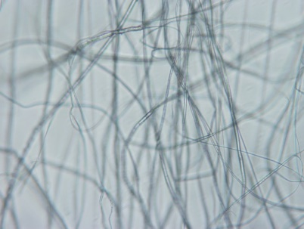 | 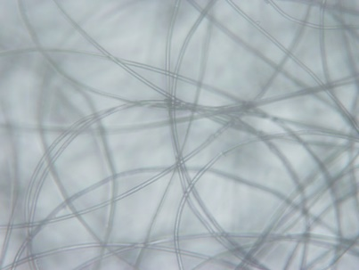 | 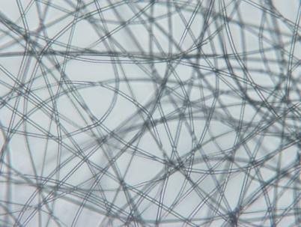
PEI4 | PEI5 | PEI6

Figure S1. Morphology of the developed microfiber scaffold under an optical microscope (1378.4 x 1037.84 µm)

Figure S2. Standard curve of Ibuprofen absorption vs concentration

