Supplementary Information
Meniscus Guide Slot-Die Coating For Roll-to-Roll Perovskite Solar Cells
Daniel Burkitt, Peter Greenwood, Katherine Hooper, David Richards, Vasil Stoichkov, David Beynon, Eifion Jewell,Trystan Watson
SPECIFIC, Swansea University, Swansea, SA1 8EN, United Kingdom
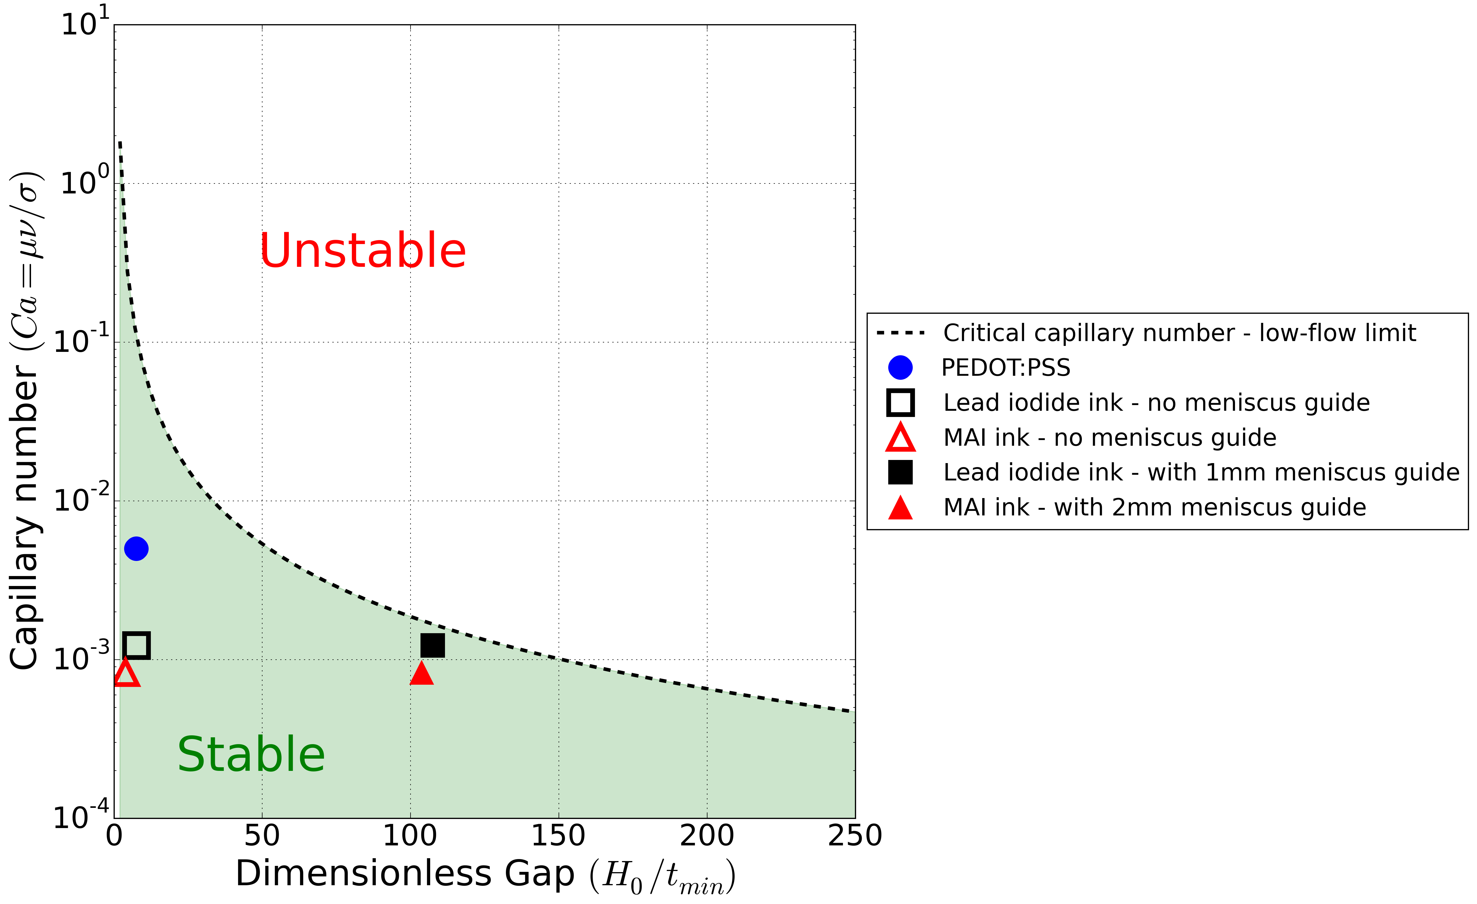
Figure S1. Dimensionless gap vs. capillary number showing the critical capillary number boundary between stable and unstable coatings in terms of the low-flow limit. The positions of coatings made using the inks at a coating speed of 1m/min and a gap between the slot-die head lips or meniscus guide tab bottom edge of 75µm are shown. The coatings of lead iodide and MAI inks without meniscus guide are in the stable region in terms of low-flow limit, but suffer from flooding.

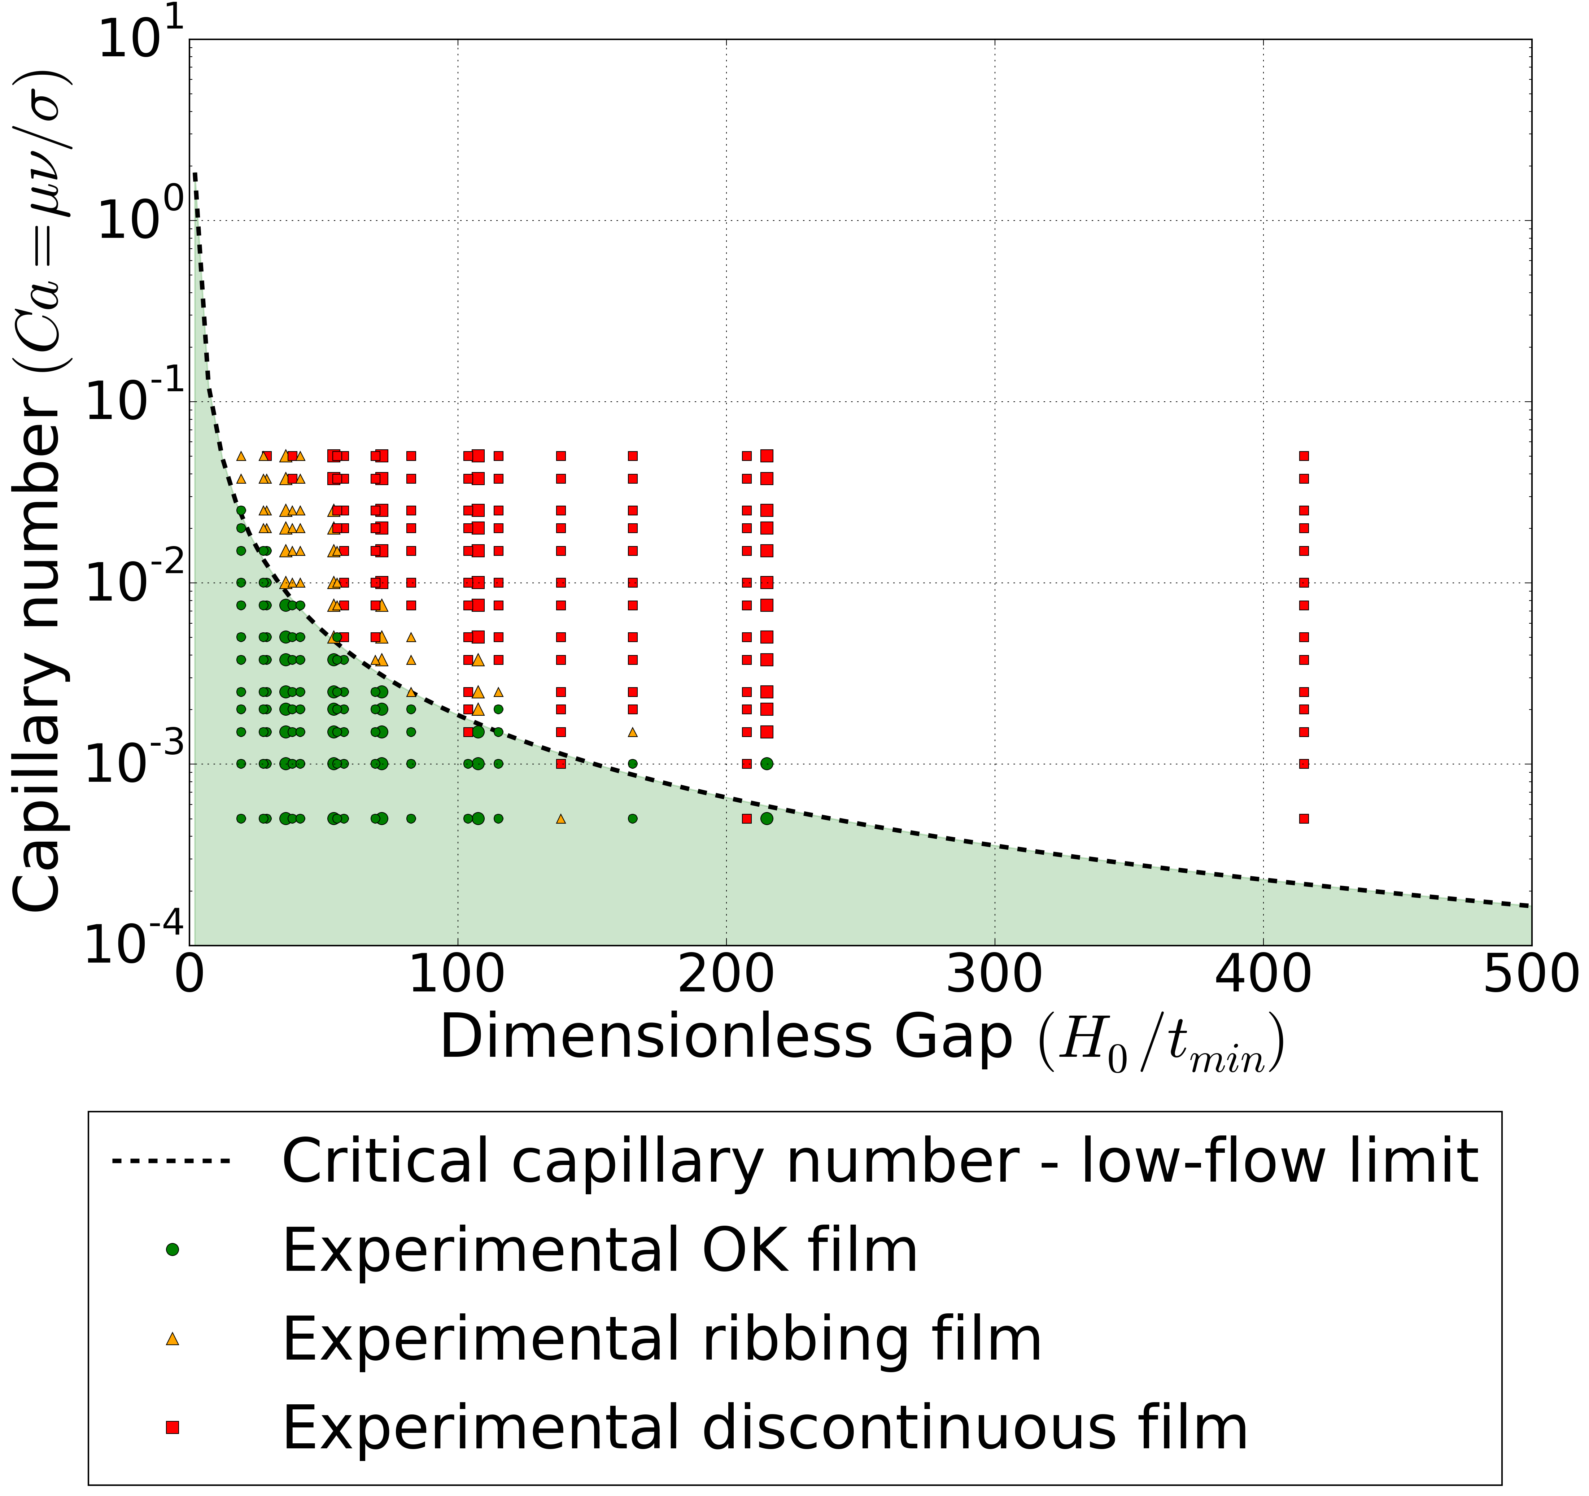
Figure S2. Dimensionless gap vs. capillary number showing critical capillary number boundary between stable and unstable coatings in terms of the low-flow limit. Experimental observations using a range of meniscus guide lengths, wet film thicknesses and coating speeds with PEDOT:PSS ink. Meniscus guides of 500, 750, 1000 and 2000µm were used.
﻿

Figure S3. Box-plots of JV scan photovoltaic parameters. The boxes (grey reverse and white forwards scan directions) represent the first and third quartiles, the horizontal black line the median, the upper whisker the data within 1.5 times the inter quartile range of the upper quartile and the lower whisker 1.5 times the inter quartile range of the lower quartile, red square the mean, black circles above the whiskers show outliers. Blue dots to the side of the boxes show the results for individual pixels for the corresponding scan direction. Scans showing short circuits e.g. from scratches to films during handling and measurements failures due to e.g. poor contact to pixel electrodes have been excluded from the measured data set.

