Supplementary Information
Dry Process for Fabricating Low Cost and High Performance Electrode for Energy Storage Devices
Qiang Wu¹, Jim P. Zheng¹, Mary Hendrickson², and Edward J. Plichta²
¹Department of Electrical and Computer Engineering, Florida A&M University and Florida State University, Tallahassee, FL 32310, USA
²Army Power Division, RDER-CCA, 5100 Magazine Road, Aberdeen Proving Ground, MD 21005, USA
Experimental
Materials:
Several types of graphite were obtained from Imerys Graphite & Carbon Switzerland SA (TIMREX graphite (SFG 15), Superior Graphite Co., USA (SLC 1520P), ConocoPhillips., USA (CPreme® G8) and Shanshan Tech, China (MGS graphite). active carbon (AC) was from Kuraray Chemical Co. Japan (YP-50F). NMC 622 powder was obtained from BASF, Germany. PTFE binder was obtained from Dupont, USA. Nipol® nitrile NBR elastomers were supplied from ZEON Corporation, USA (DN 631). The materials were used as received.
Electrode preparation:
For electrode using PTFE as binder, active materials were mixed with PTFE binder in a Waring® blender for 10 minutes. The compositions are shown in TABLE S1. A schematic diagram of the dry electrode-making process is shown in Figure S1. In the case of using NBR as binder, the NBR binders were first dissolved in the acetone and mixed with anode active materials. After drying the slurry, the dried mixture was simply mixed in a Waring® blender to form homogeneous powder. The compositions of electrodes are shown in TABLE S1. The well mixed powder was fed into two-roll mill passing the gap between two rolls to form free standing electrode sheet. (Figure S2) The thickness of electrode sheets can be adjusted by controlling gap, temperature of rolls and multiple pressing. Finally, the electrode sheets with certain thickness and aluminium foil or copper foil were passing two-rolls to form cathode and anode electrode, respectively. The current collector aluminum foil and copper foil were coated a layer carbon conducting layer for binding electrode to the current collector. Although, solvent acetone were used in the current work due to the small quantity need in the lab scale, rubber mills and Banbury mixers can be used for mass production. Figure S3 shows the comparison of adhesion stability of electrodes made by dry process (up) and commercial electrode (down) in the electrolyte solution. After submerged in the electrolyte solution for three days, the electrode film on commercial electrode detached from the current collector. Therefore, the electrodes made by our dry method have good binding and solvent resistance.

TABLE 1: The composition of electrodes made with dry method
Description | Graphite (%) | NMC 622 (%) | Active carbon (%) | PTFE (%) | XNBR (%)
Anode for LIBs | 96 |  |  |  | 4
Anode for LIBs | 96 |  |  | 4
Cathode for LIBs |  | 90 | 5 | 5

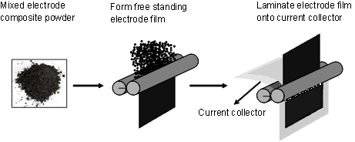
Figure S1: A schematic diagram showing the dry electrode-making process, which consists of the mixed electrode powder materials, the pressing of the mixed powder forming a free standing electrode film and laminating an electrode film onto a current collector by a two-roll mill.
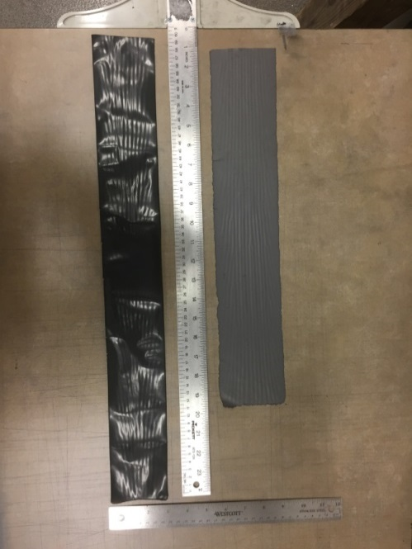
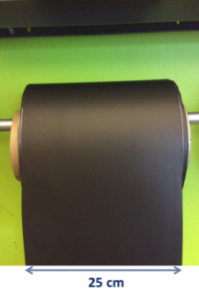
a
b

Figure S2. a) Free standing electrode sheets, graphite anode (up) and NMC cathode (down), b) A roll of electrode made by dry method
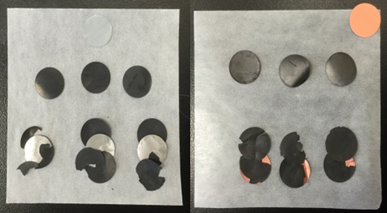
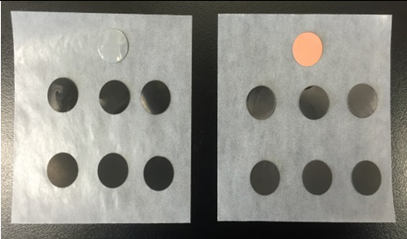
a
b
Figure S3. Adhension stability of electrodes in electrolyt: dry process (up), wet process commercial (down), a) initial and b) after submurged in electrolyte

Cell fabrication:
Half-cell using CR2032-type coin cell were assembled in argon filled glovebox (VAC NEXUS) with water and oxygen levels below 0.5 ppm. Lithium metal disc (MTI Corporation) was used as counter/reference electrode. A piece of poly-propylene membrane (Celgard 2400) was used as the separator. The electrolyte was 1.2 M LiPF₆ in ethylene carbonate (EC): ethyl-methyl carbonate (EMC) at a ratio of 3:7 by weight.
The pouch cells were assembled by stacking multiple single-side or double-side coated anode electrodes and double-side coated cathode electrode. The test cell was charged-discharged under various currents in order to obtain the relevant electrochemical properties, such as the relationship between energy density and power density using a Neware Battery Testing Unit.
Cyclic voltammetry (CV) was measured by a Gamry Instruments between 0.005 and 5 V at a scanning rate of 1 mV/s ⁻¹.

