Supplementary Information

Quantum Dots as Photocatalysts for Bicarbonate Reduction to Solar Fuels: Formate Production from CuS, CuInS₂, and CuInS₂/ZnS

Hanqing Pan¹, Ruwini Rajapaksha¹, and Michael D. Heagy¹*

Department of Chemistry, New Mexico Institute of Mining and Technology, 801 Leroy Place, Socorro, NM 87801
e-mail: michael.heagy@nmt.edu*

Table of contents

Apparent quantum efficiency (AQE) calculations…………………………………………….S2
Figure S1. XRD spectrum of CuS………………………………………….………………….S3
Figure S2. XRD spectrum of CuInS₂……………………………………………………….…S3
Figure S3. XRD spectrum of CuInS₂/ZnS…………………………………………………….S4

To calculate AQE, we use an Ophir Photonics Nova II laser energy meter and measure the energy output of the solar simulator (1000 W/m²). This power measurement was converted to moles of photons per second. This photon flux was then used to calculate the apparent quantum efficiency (AQE) of the catalyst using equations (1) and (2).

$$n mol photons ∙ \frac{1 mol e^{-}}{mol photons } ∙ \frac{mol formate}{2 mol e^{-}} =theoretical (1)$$
$$\frac{actual mol formate}{theoretical mol formate } ∙100 =\%AQE (2)$$

Another way to calculate the number of photons reaching the reaction matrix is by determining the area of the curve of the solar spectrum provided by NASA¹, we find that the number of photons is 5.25x10²¹ photons/s/m². We multiply this by the surface area of the quartz tube and account for 8 hours of irradiation.

$$\frac{5.25x{10}^{21}\frac{photons}{s}}{m^{2}}∙0.0004 m^{2}=2.01x{10}^{18}\frac{photons}{s}$$

$$2.01x{10}^{18}\frac{photons}{s} ∙ \frac{60s}{1min } ∙ \frac{60min}{1hr} ∙8hr ∙ \frac{1mol}{6.02x{10}^{23}photons}=0.096 mol photons$$

$$0.096 mol photons ∙ \frac{1 mol e^{-}}{mol photons} ∙ \frac{mol formate}{2 mol e^{-}}=0.048 mol formate (theoretical)$$

To calculate the actual moles of formate we convert the ppm formate value to moles. Using the example of CuS in glycerol under solar irradiation, which produced 61 ppm of formate, it is converted to 0.0016 moles formate. By using Eqn. 2:

$$\frac{0.0016 actual mol formate}{0.048 theoretical mol formate} ∙100= 3.4\%$$

References:
- Mecherikunnel, A. T.; Richmond, J. C. Spectral Distribution of Solar Radiation. NASA Technical Memorandum 82021.

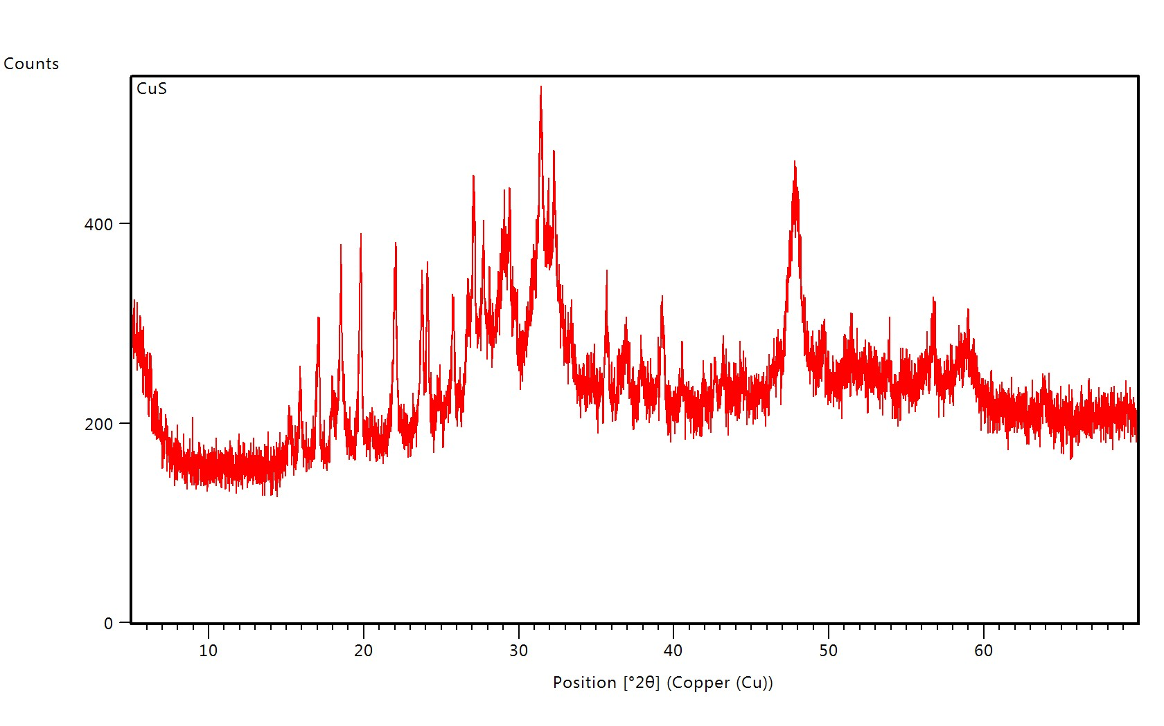
Figure S1. XRD spectrum of CuS.
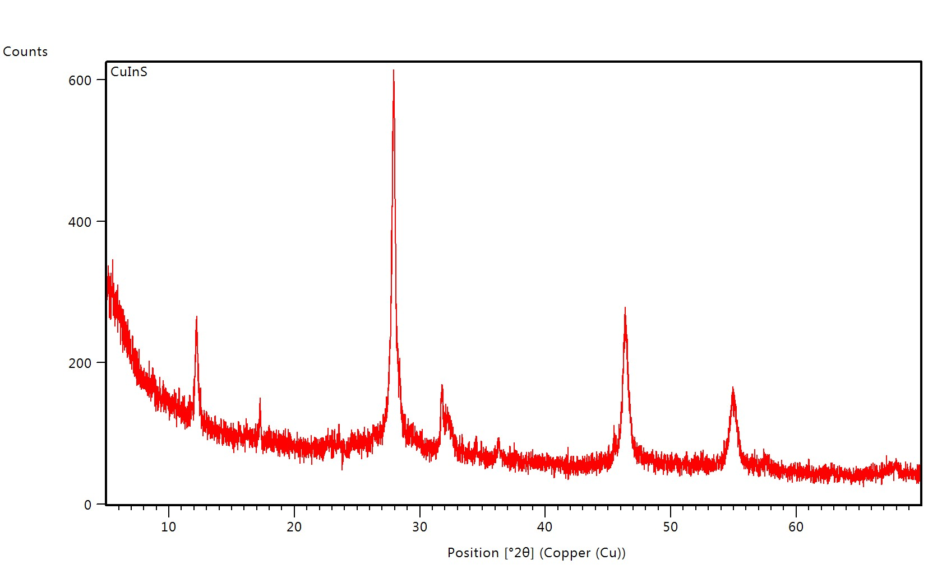
Figure S2. XRD spectrum of CuInS₂.
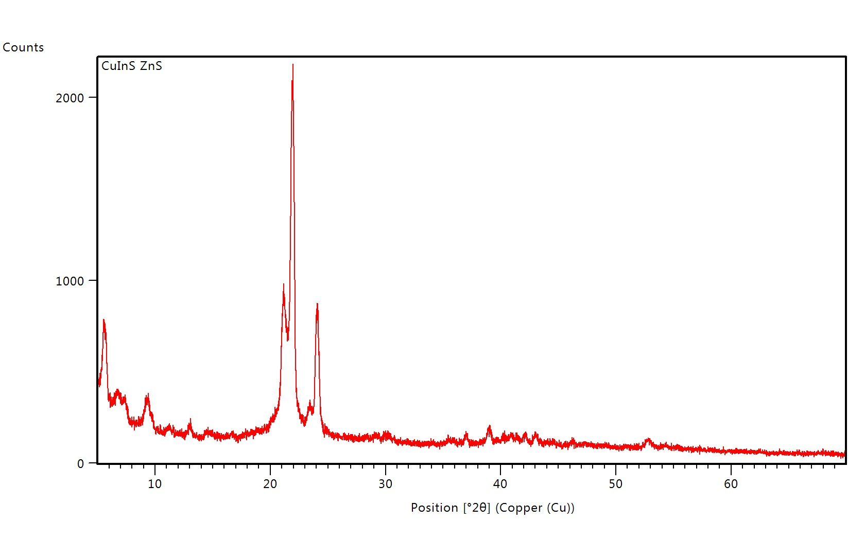
Figure S3. XRD spectrum of CuInS₂/ZnS.

