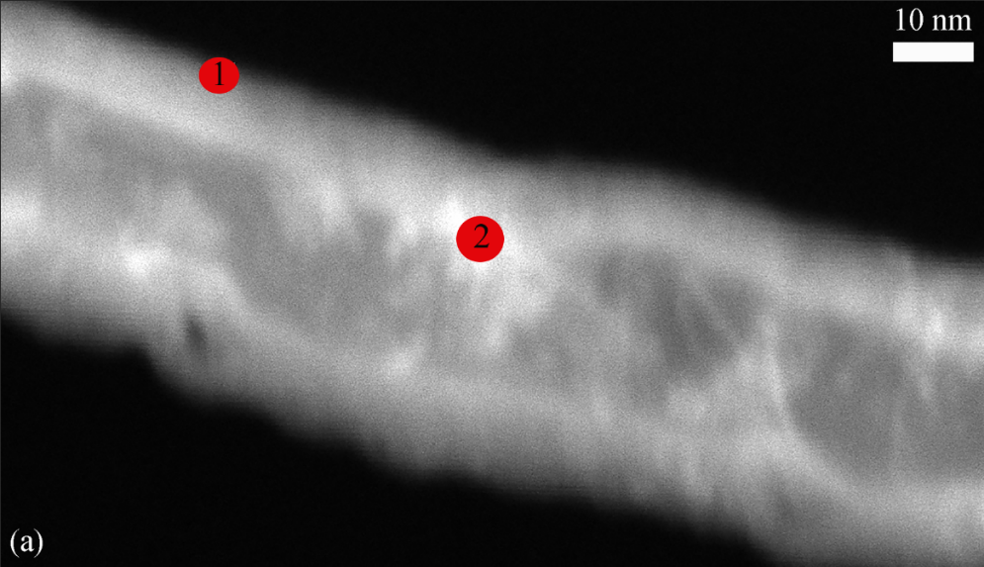**Supplemental Images**

C:\Users\Asus\Desktop\MRS Advances Revision\Supplemetal Images\Modified\b.tif

**C:\Users\Asus\Desktop\MRS Advances Revision\Supplemetal Images\Modified\c.tif**

**Supplemental Figure 1**: (a) A TEM image of coated CNT turfs, and (b-c) EDS analysis showing Cu and Ni on the surface. Numbers 1 and 2 in (a) refer to the EDS point analysis that are shown in (b) and (c) respectively.