Supplementary Information

Biomimetic calcium phosphates-based coatings deposited on binary Ti-Mo alloys modified by laser beam irradiation for biomaterial/clinical applications

Marcio Luiz dos Santos¹, Carla dos Santos Riccardi², Edson de Almeida Filho³, Antonio C. Guastaldi³

¹Federal University of ABC – UFABC, Center of Natural and Human Sciences, 09210-580 Santo André, São Paulo, Brazil
²Paulista State University – UNESP, College of Agricultural Sciences, 18610-307
Botucatu, São Paulo, Brazil;
³ Paulista State University – UNESP, Institute of Chemistry, 14800-060, Biomaterials Group,
Araraquara, Brazil.

Table S1. Fluency obtained by irradiation of the laser beam.
SAMPLES | 1 | 2
FLUENCY (J/cm²) | 1,91 | 5,54

Table S2. Shows the ionic concentrations of the solution SBFm (mml.dm⁻³)
 | Na⁺ | K⁺ | Mg²⁺ | Ca²⁺ | Cl⁻ | HPO₄²⁻ | SO₄²⁻ | HCO₃⁻
SBFm | 140,4 | - | - | 3,1 | 142,9 | 1,86 | - | -

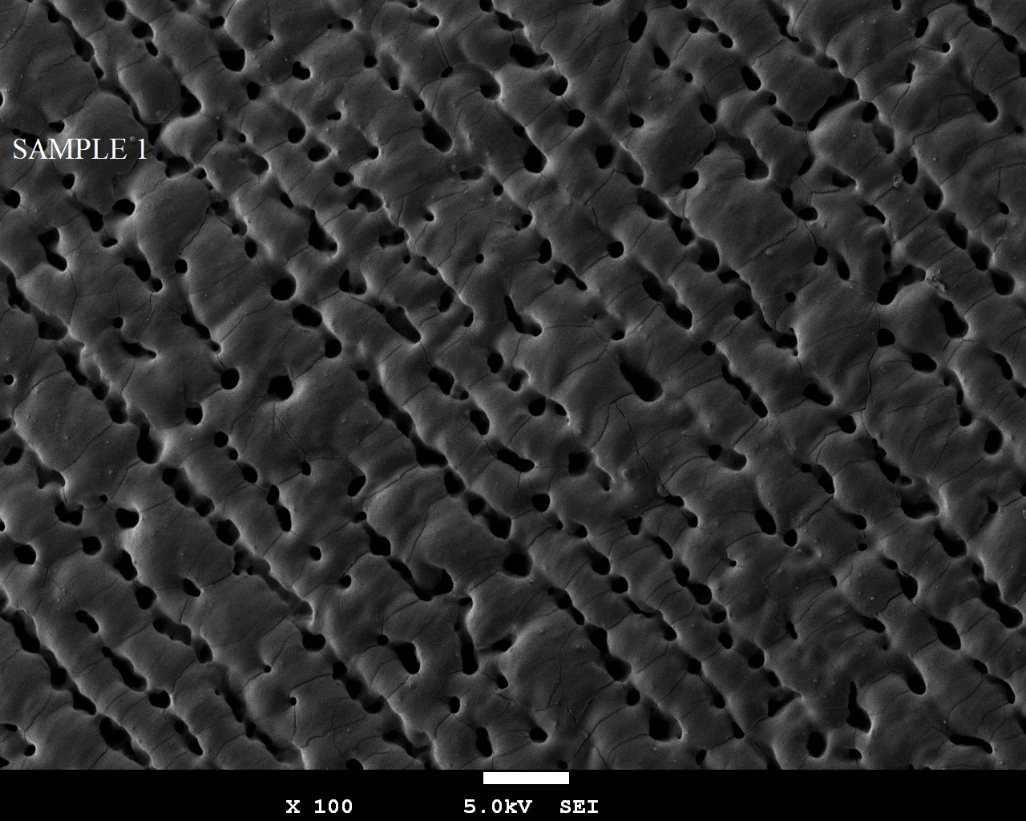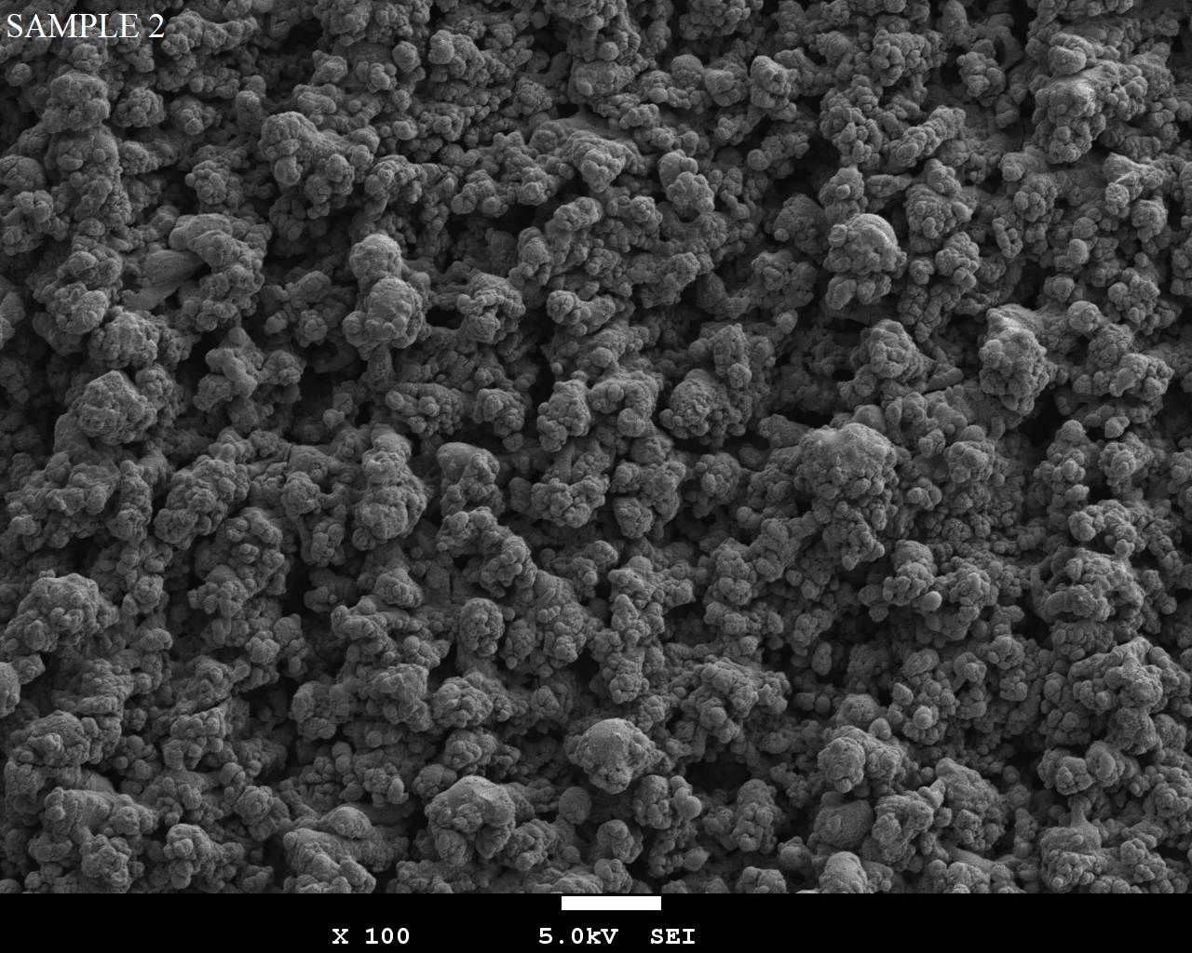

Figure S1. SEM of the Ti-15Mo alloy submitted to laser beam using fluences (1)1.91 and (2) 5.54 J/cm². Magnitude 100x.

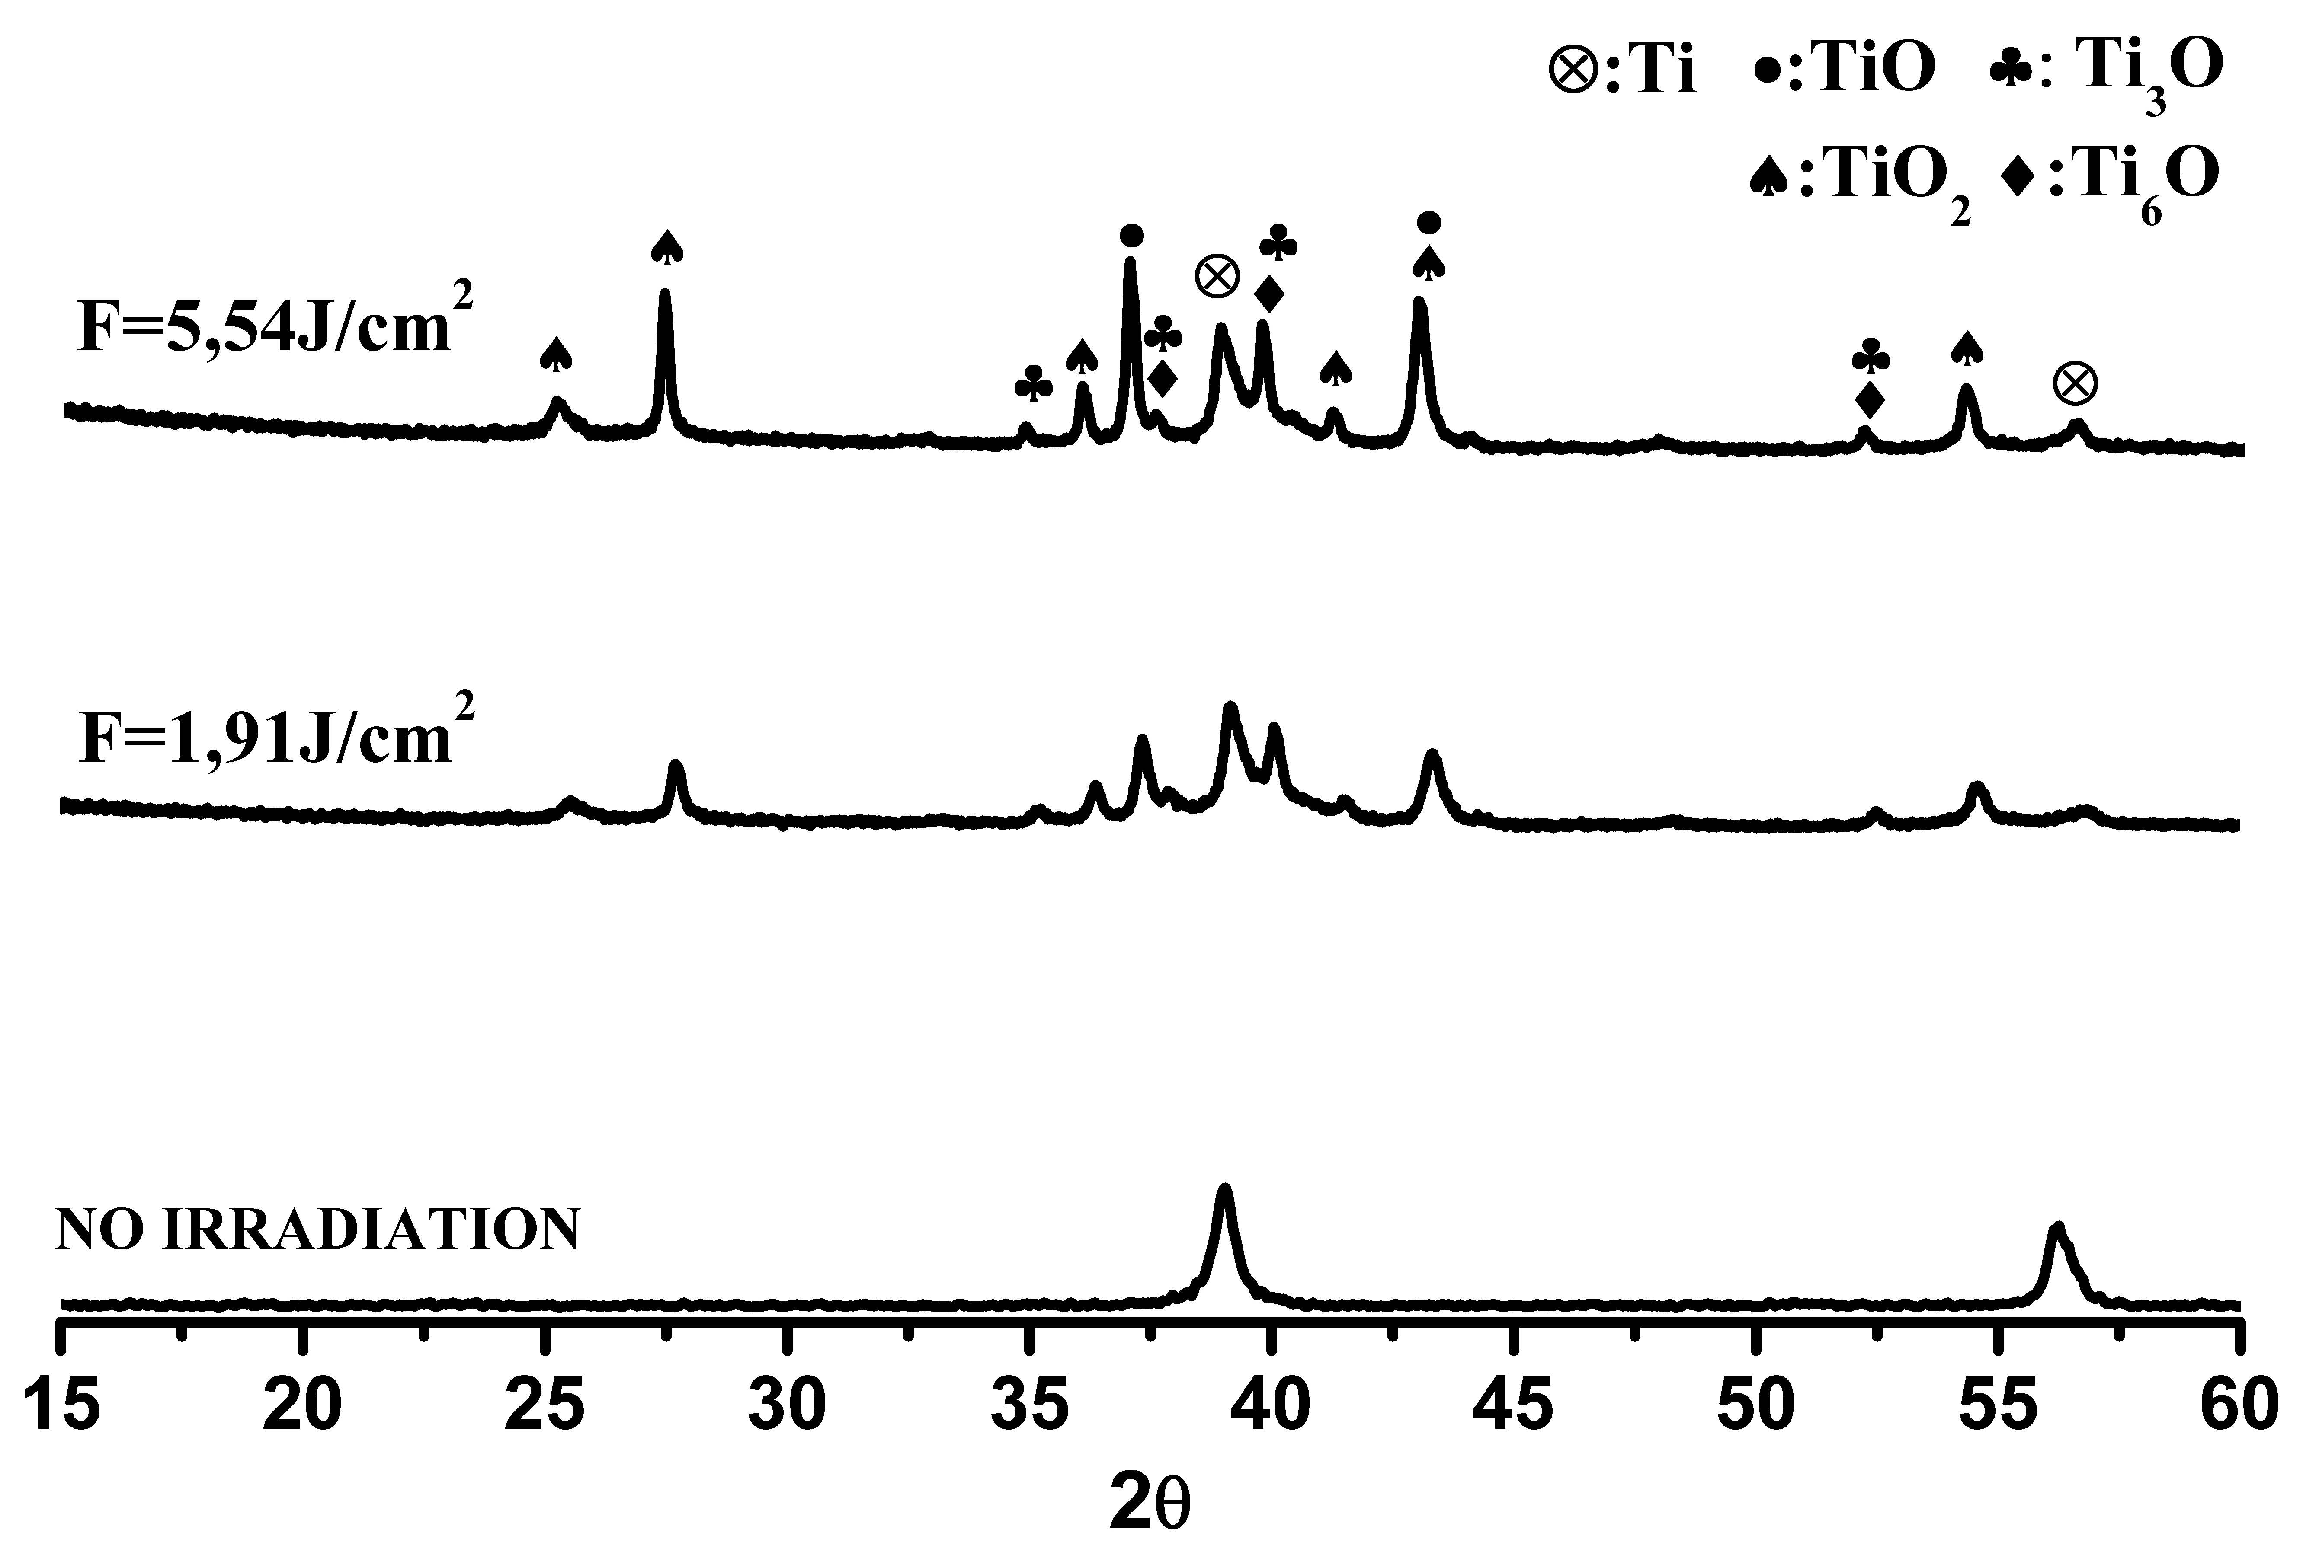
Figure S2 X-ray diffraction sample (0) no irradiation, samples (1)1.91and (2) 5.54 J/cm².

Table S3: Percentage of phases composed of Ti and O after refinement by Rietveld
 | Fluency (J.cm⁻²)
 | 1,91 | 5,54
Phases | Sample 1 (%) | Sample 2 (%)
Ti₃O₅ | - | 37,75
Ti₃O | 48,57 | 19,05
Ti₆O | 22,19 | 21,11
TiO₂ | 19,89 | 11,35
β -TiO | 9,35 | 10,74

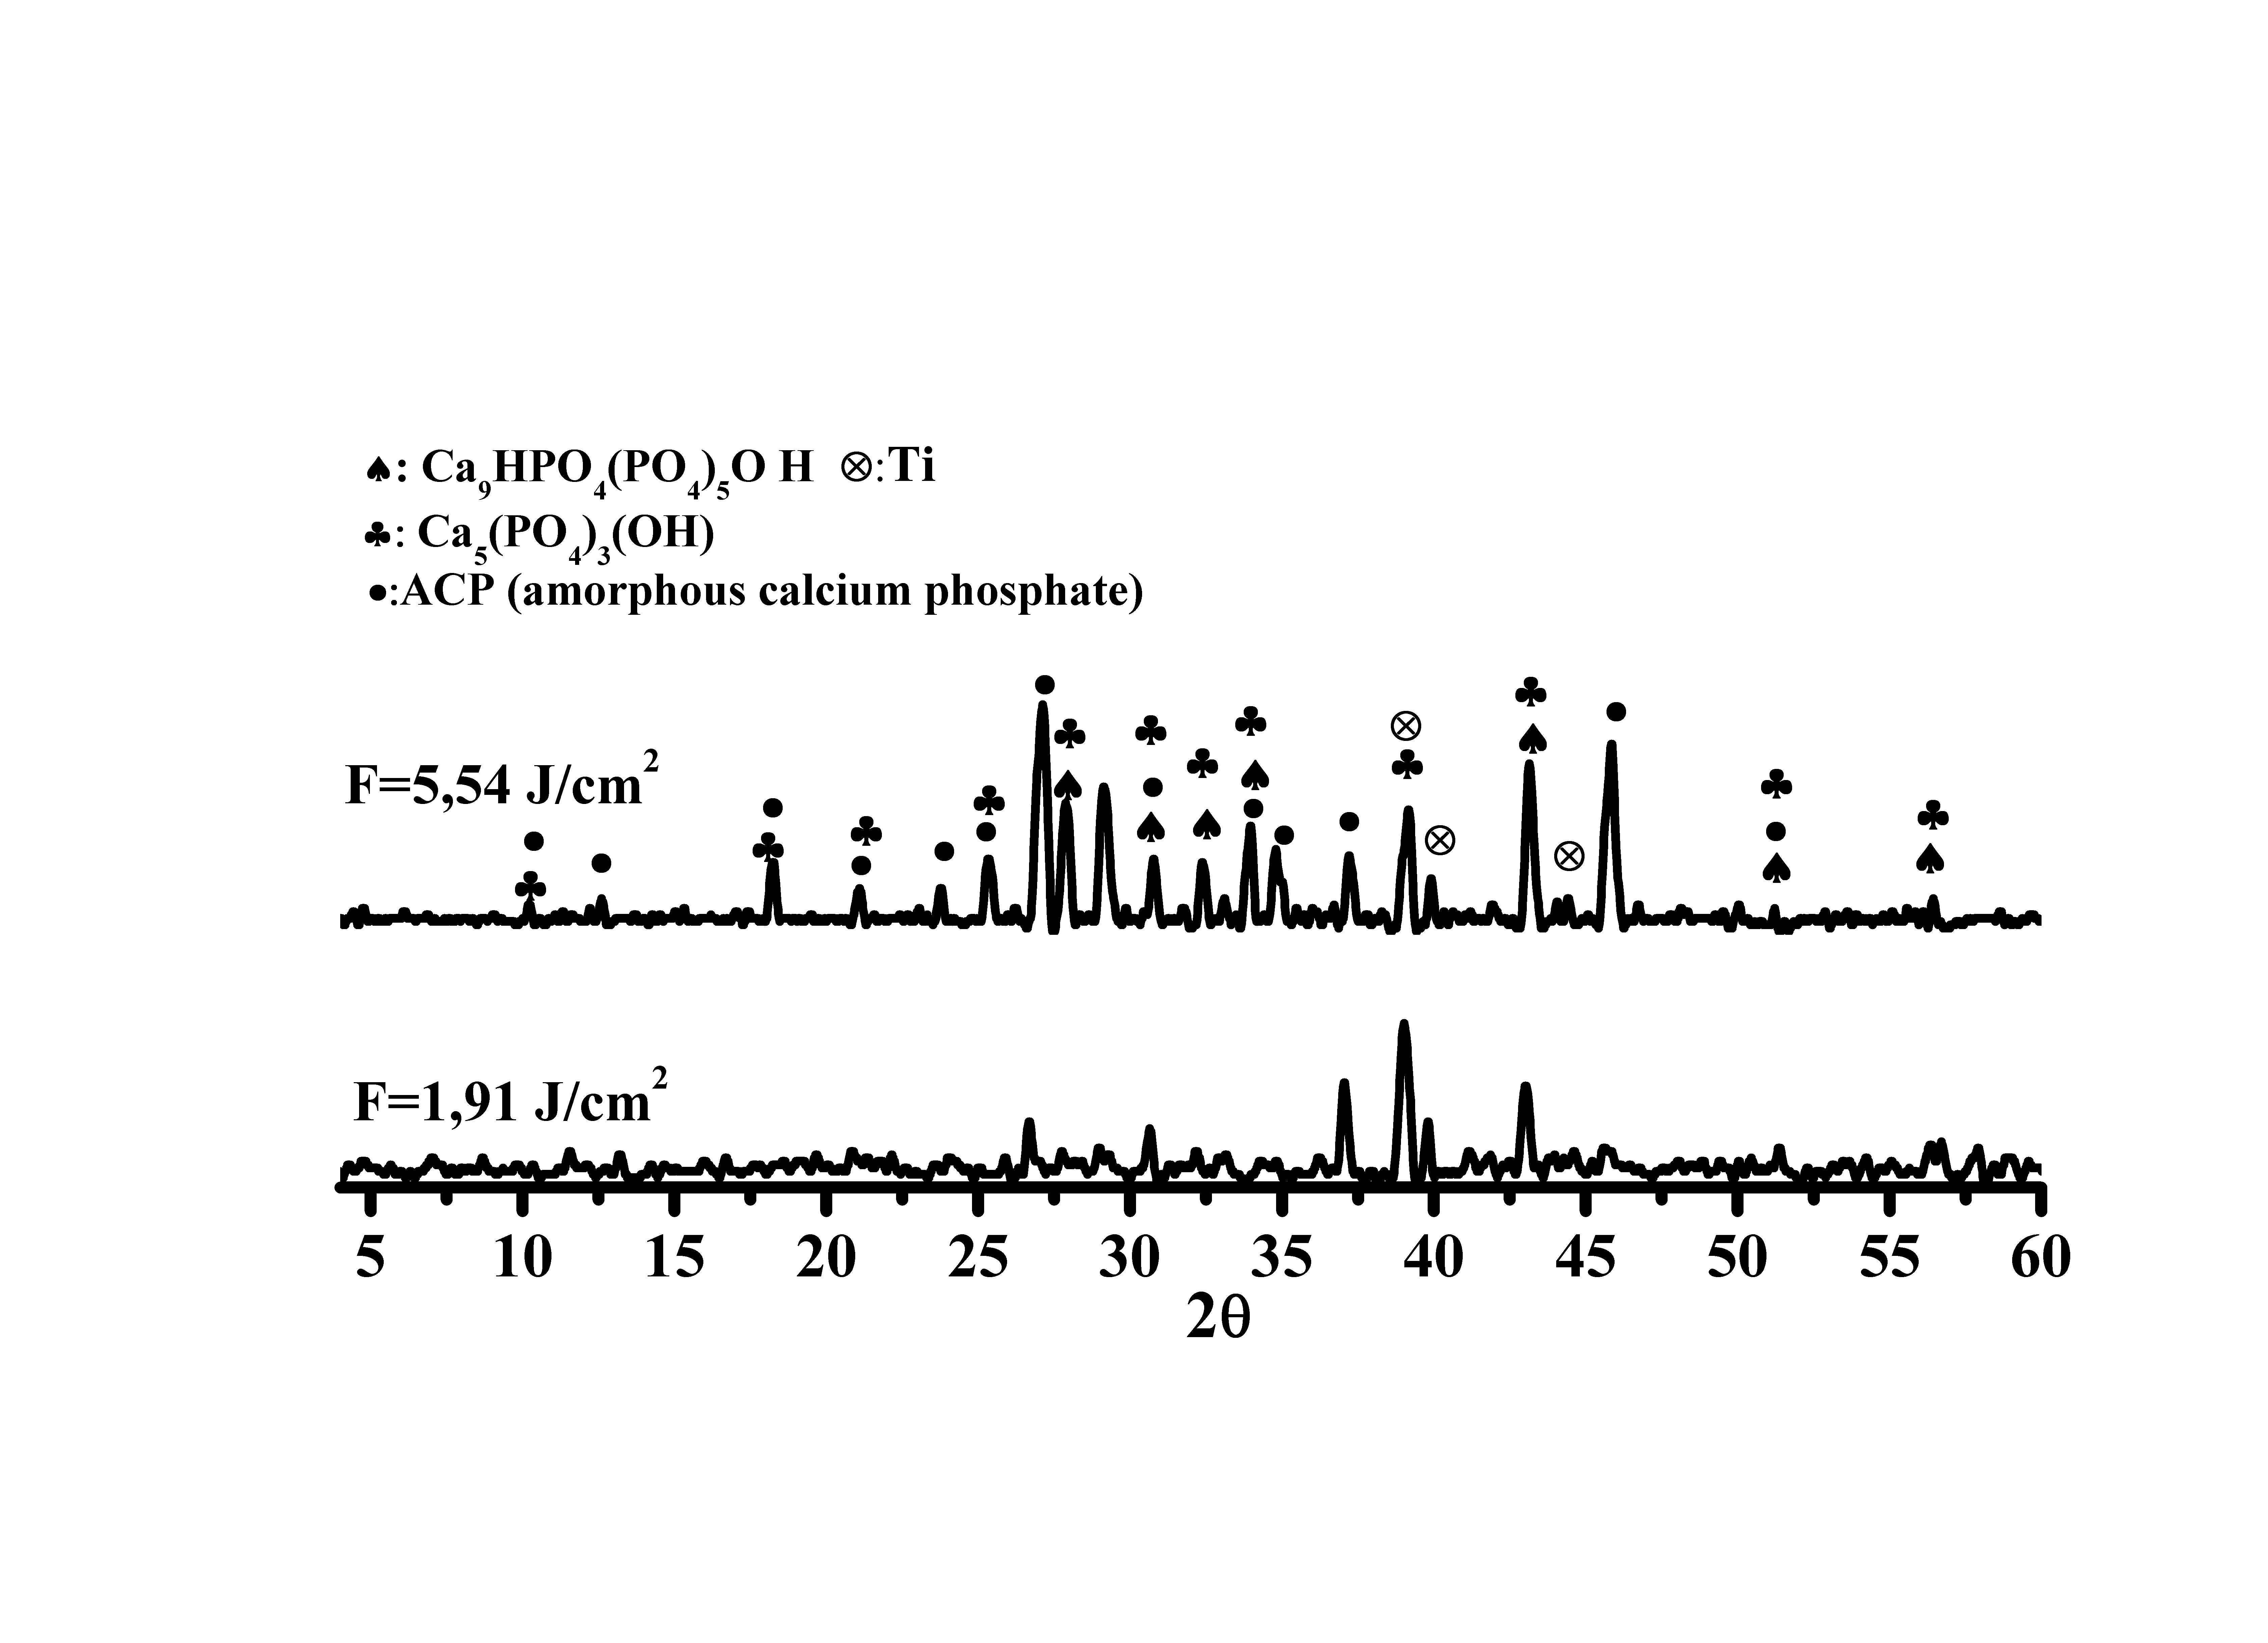
Figure S3. X-ray diffraction of samples (1 and 2) after calcium phosphate coatings obtained by immersion in SBFm solution and heat treated at 350°C.

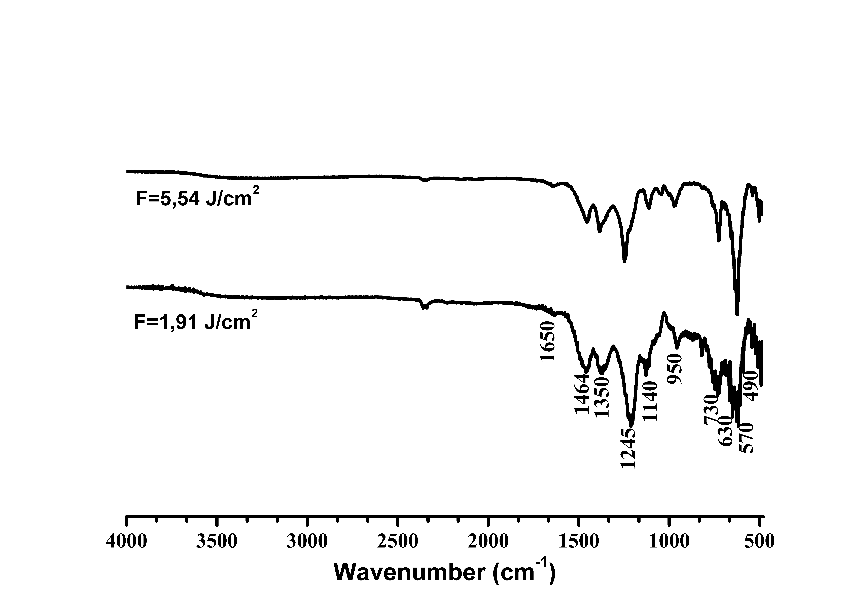
Figure S4. Absorption spectrum in the medium infrared (FTIR) region of the samples (1 and 2), after calcium phosphate coatings obtained by immersion in SBFm solution and heat treated at 350°C.


Figure S5. Micrographies of the samples (1 and 2), after calcium phosphate coatings obtained by immersion in SBFm solution and heat treated at 350°C. 50,000X.

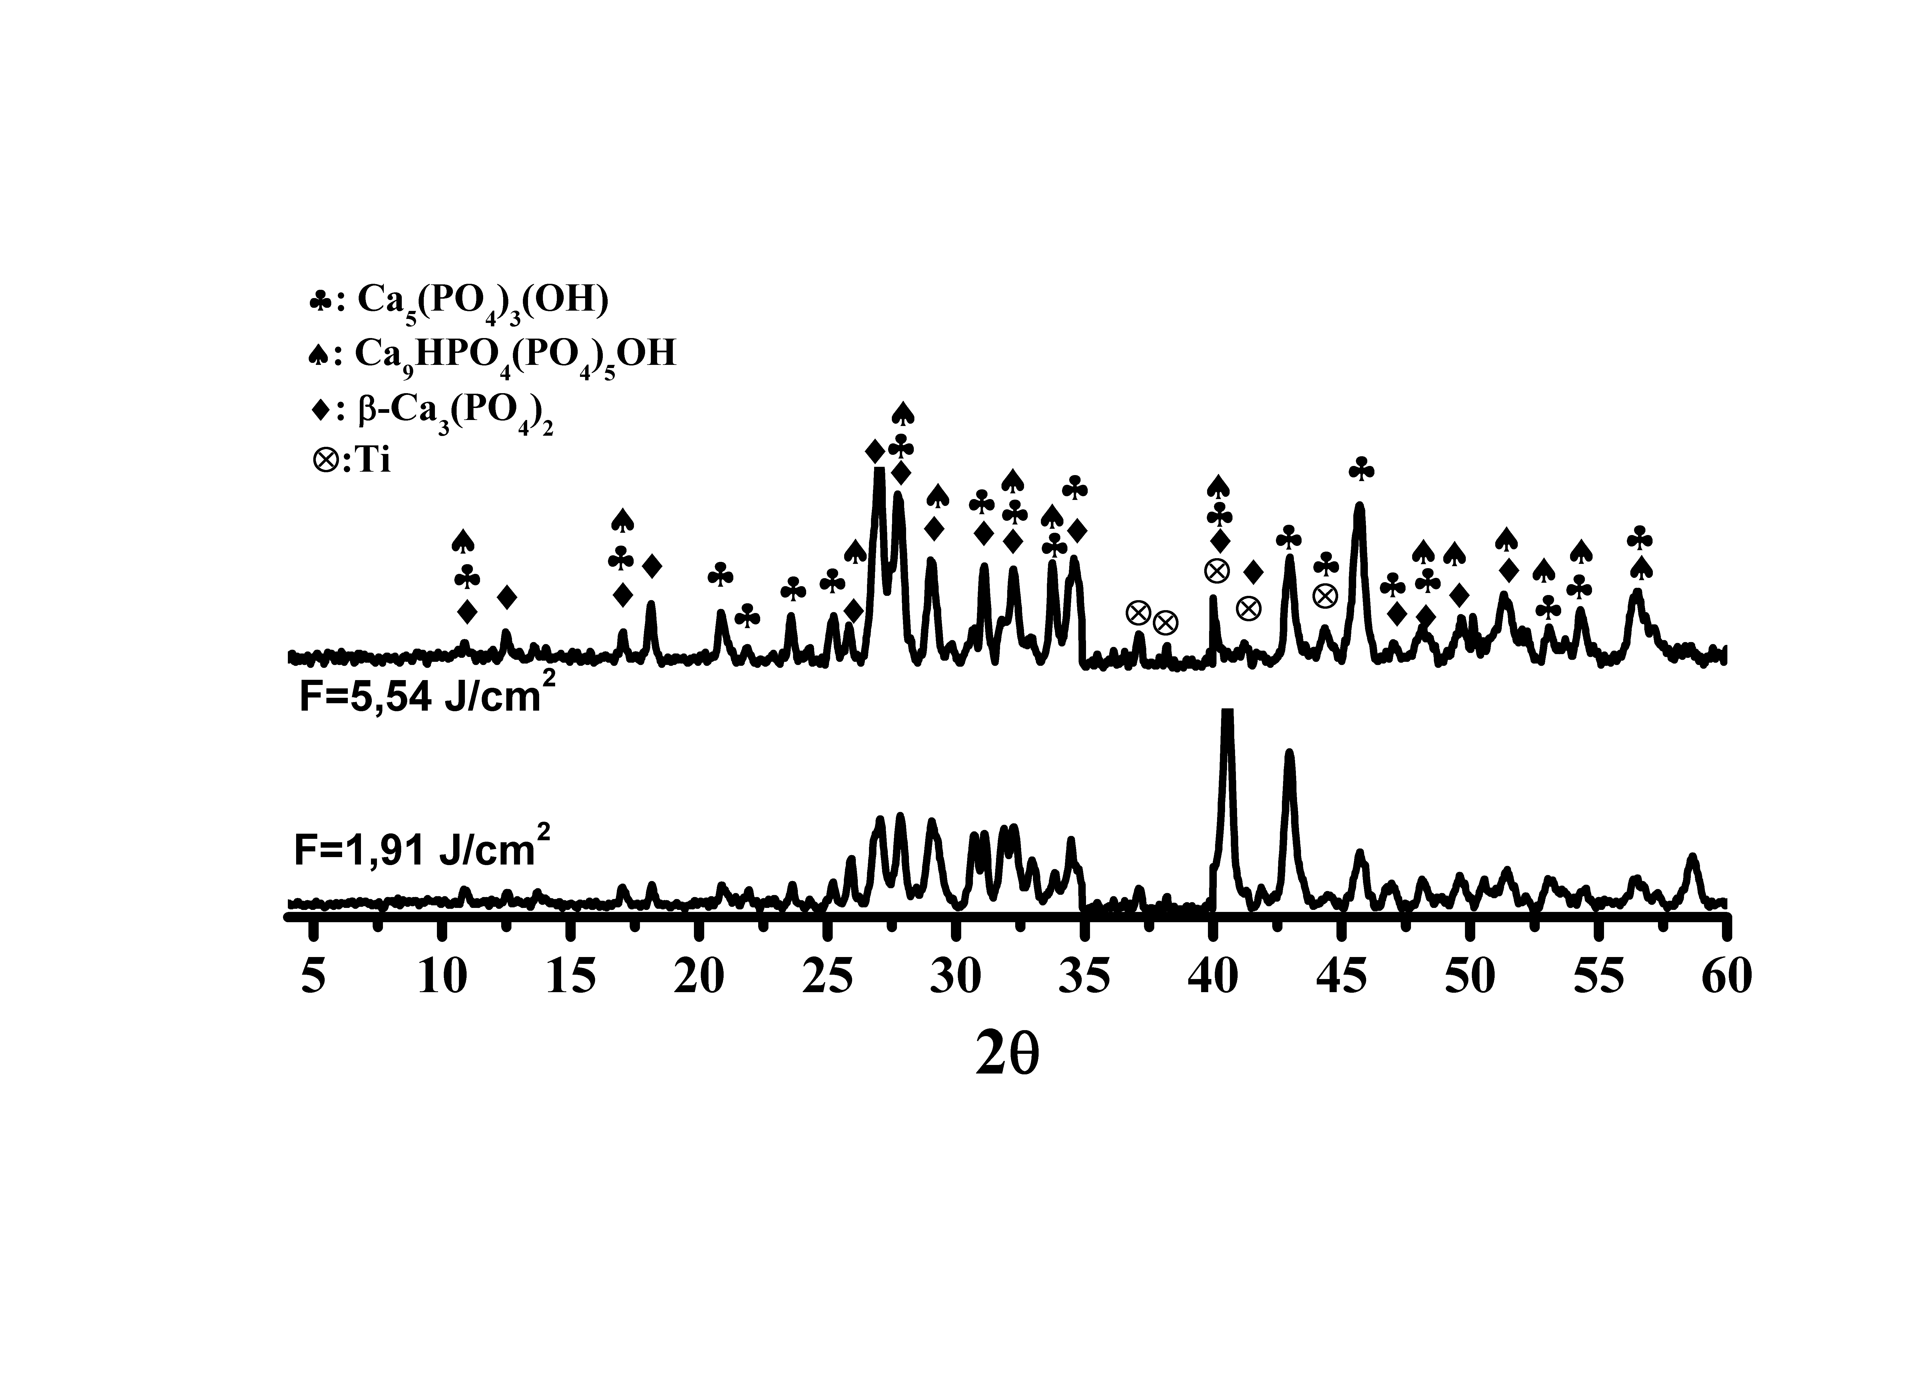
Figure S6. X-ray diffraction of samples (1 and 2) after calcium phosphate coatings obtained by immersion in SBFm solution and heat treated at 600°C.

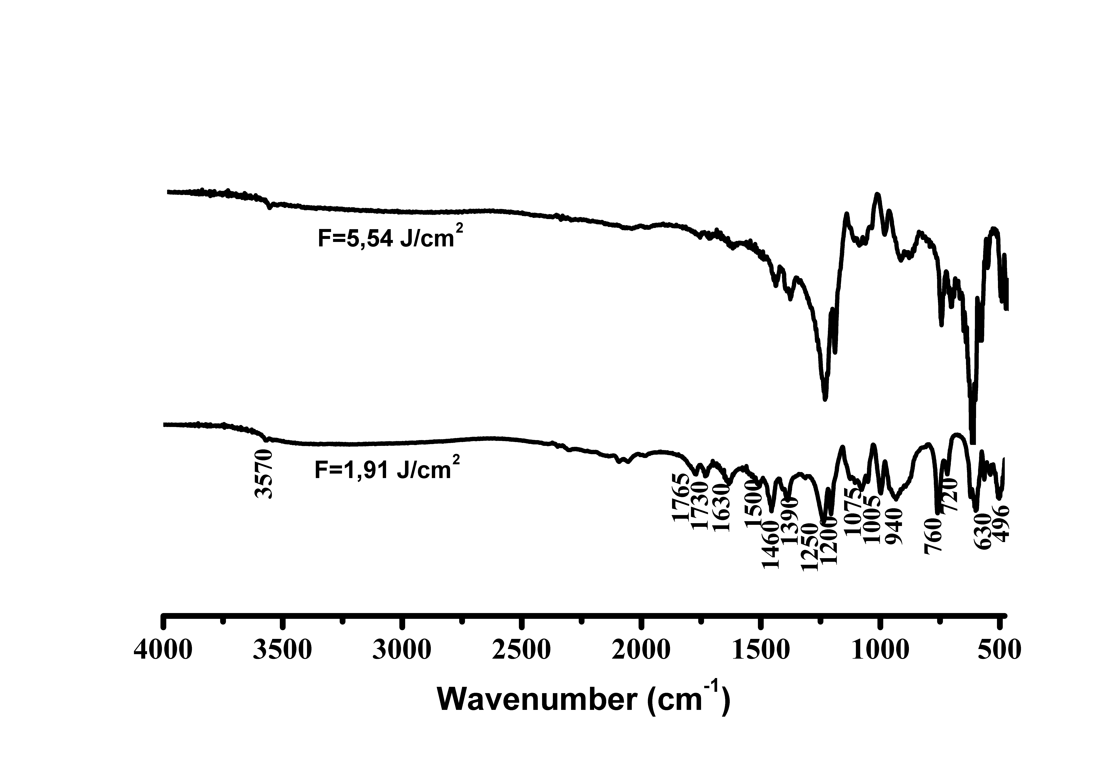
Figure S7. Absorption spectrum in the medium infrared (FTIR) region of the samples (1 and 2), after calcium phosphate coatings obtained by immersion in SBFm solution and heat treated at 600°C.


Figure S8. Micrographies of the samples (1 and 2), after calcium phosphate coatings obtained by immersion in SBFm solution and heat treated at 600°C. 20,000X.

