Supplementary Information

Comparison and correlation of structural disorder caused by anion Frenkel in affecting ion conduction of La₂Hf₂O₇ and La₂Mo₂O₉ as high performance electrolytes in SOFCs

Mingzi Sun and Bolong Huang*

Department of Applied Biology and Chemical Technology, The Hong Kong Polytechnic University, Hung Hom, Kowloon, Hong Kong SAR, China

*Email: bhuang@polyu.edu.hk

Crystal Structure
Based on the experimental data of La₂Hf₂O₇ crystal structure from Subramanian et al. and Sleight^{[1, 2]}, we build a basic cubic crystal with symmetry group of Fd-3m comes with a lattice parameter of 10.770 Å (As Figure S1). The La atoms occupied 16d sites with Hf atoms at 16c sites. Oxygen atoms show two different positions that O1 are at 8b sites (0, 0, 0) and O2 at 48f sites (0.302, 0, 0). Lacorre et al.^{[3, 4]} have used the neutron diffraction to prove that the La₂Mo₂O₉ is cubic crystal structure of symmetry group of P213 with a lattice parameter of 7.2014 Å (shown in Figure S2a). The La atoms and Mo atoms occupied the 4a. In their work, two models of La₂Mo₂O₉ with different occupancies of oxygen atoms have been introduced, which we have named with La₂Mo₂O₉(4_10) and La₂Mo₂O₈(7327), respectively and we will compare their thermodynamic results. For 7323 model (shown in Figure S2b), the O1 positions are fully occupied. The occupancies of O2 and O3 have been fixed to 73% and 23% through computer settings. The positions of O2 are (0.983, 0.168, 0.330) and O3 are at (0.911, 0,612, 0.554). We use La₂Mo₂O₉(4_10) model as our calculation model to simulate the formation of a-Fr pairs. For 4_10 model, we manually set up the number of oxygen atoms in the cell at three different positions, that 4 O1 at 4a sites (0.312, 0, 0) with full occupancy (100%), 10 O2 at 12b sites (0.987, 0.179, 0.332) with 83% occupancy and 4 O3 at 12b sites (0.923, 0,621, 0.558) with 33% occupancy. The La and Mo atoms are isolated to each other and connected through O atoms.
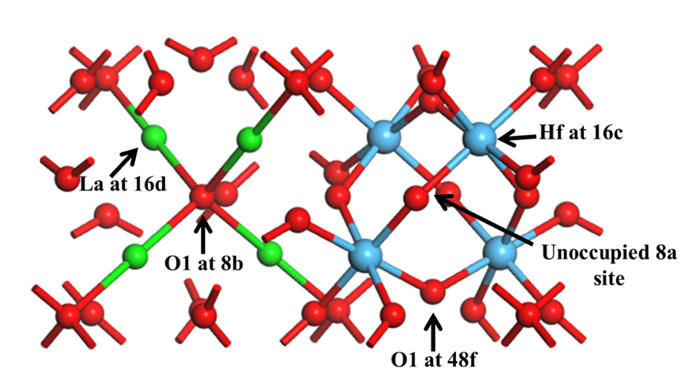
Figure S1. Local structure of ground state relaxed La₂Hf₂O₇ pyrochlore lattice (La=green, Hf=blue, and O=red).

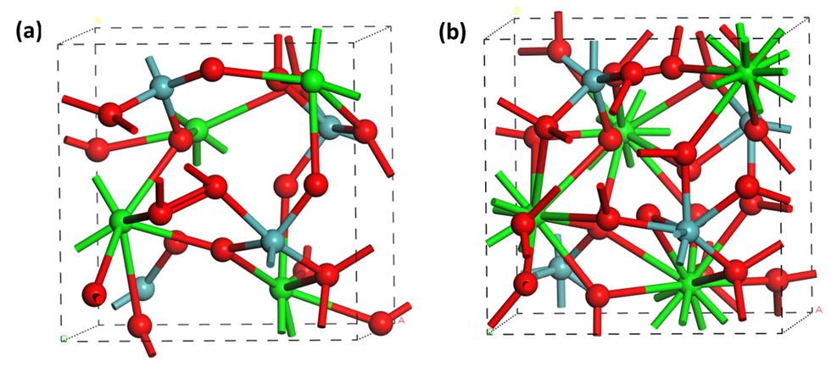
Figure S2. (a) Local view of relaxed structure of La₂Mo₂O₉ (4_10). (b) Local view of relaxed structure of La₂Mo₂O₉ (7327) (La=green, Mo=cyan, O= red).

Calculation Setup
The lattice relaxation of La₂Hf₂O₇ and La₂Mo₂O₉ at the ground states are remained at the PBE or PBE+U level by CASTEP codes^{[5]}. Theoretical studies show that the pseudopotential based f-level solids have a minor or negligible variation on the lattice parameters by DFT or DFT+U^{[6-11]}. However, the Hubbard U parameters do induce an extra error in lattices when we need it for improving the accuracies of electronic structures, if we carelessly chose or it comes without self-consistent determination^{[6-11]}.

For the plan-wave basis set, it is highly recommended to carefully extend the cutoff energy to 750 eV to describe five different orbital components of valence electrons of La³⁺, as well as the strongly localized states induced by 2p orbitals of O. To guarantee the convergence and avoid the charge-spin out-sync sloshing, we uniformly choose the ensemble DFT (EDFT) method of Marzari et al.^{[12]}. For the k-point sampling mesh, we choose a grid of 2 × 2 × 2 for all related reciprocal space integration for cubic unit cell of La₂Hf₂O₇. By the above setting, the convergence tolerance of total energy calculations is set to no higher than 5.0 × 10⁻⁷ eV per atom, and the optimizations of Hellmann-Feynman forces in defect calculations are accomplished to lower than the level of 0.01 eV/Å. For supercell based defects calculations, 88-atom sized 2 × 2 × 2 supercell for La₂Hf₂O₇ and 208- or 288-atom sized La₂O₂O₉ have been used respectively. The Baldereschi special k-point (¼, ¼, ¼) ^{[13]} with Gamma-center-off was self-consistently selected. Regarding the geometry relaxation, the algorithm based on Broyden-Fletcher-Goldfarb-Shannon (BFGS) method has been used through all bulk and defect supercell calculations. DFT+U calculations have been performed on the norm-conserving pseudopotential theoretical scheme. This will help us to reflect all-electron behaviors of the valence electrons especially for the subtle effect of the 4f electrons and outer 6s electrons.
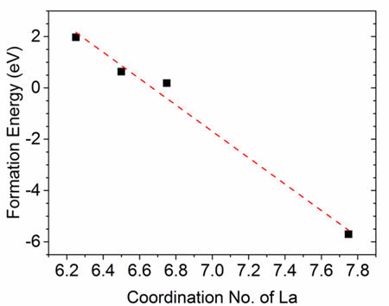
Figure S3. The fitting linear relationship between average coordination numbers of La atoms and formation energies of a-Fr pairs in La₂Mo₂O₉

Electronic Properties
A good candidate for electrolyte material in SOFCs should be electronically insulated^{[14]}. Thus, it is necessary to investigate their electronic properties in terms of gap states that influence the electronic inter-level transitions.

The total electronic density of states (TDOS) of a-Fr pairs of La₂Hf₂O₇ and La₂Mo₂O₉ are shown in Figure S4a and S4b. For La₂Hf₂O₇, the TDOSs of three types of defect sites are distinct from each other (shown in Figure S4a). For the one given by type 1 model, an empty symmetric gap states have been discovered near conduction band minimum (CBM) with position at E_{V} + 4.2 eV (E_{V} denotes the level of valence band maximum, VBM). This gap state could be considered as a deep hole trap, which is induced by the interstitial oxygen while the O vacancies are passivated by the surrounding distortion. The energy barrier for de-ionizing the bounded electron into delocalized states in the conduction band should be at least 4.2 eV acting as an intermediate hopping path. It is showing a good electronic insulating behavior remaining even with lattice distortion (a-Fr formed) under a high temperature. In the TDOS of type 2, two hole traps and two electron levels are observed near the CBM and VBM, respectively. Two localized electron levels are located at E_{V} + 0.3 eV and E_{V} + 2.8 eV, respectively. The two holes located near the CBM are E_{V} + 3.6 eV and E_{V} + 4.6 eV, respectively. The minimum requested energy barrier for electronic hopping into delocalized levels is actually about 1 eV. The type 2 is thus to be unsuitable insulating state for electrons. For the case in type 3, four pairs of symmetric electronic traps in host lattice are shown in the TDOS. The states that pined at Fermi level are deep donor trap level that also reduced energy barrier to CBM to about 1 eV. The one near CBM at E_{V} + 5.1 eV are localized hole states. In La₂Hf₂O_{7,} through the gap states reflected in TDOS, electrons can overcome the large energy barriers through hopping from VBM to gap states and further to CBM within a short lifetime in the gap state. The appearance of mid-gap states can decrease the barriers for electrons from host to delocalization. Thus, the defect or impurity free lattice of La₂Hf₂O₇ is suggested to be doped with suitable element to reduce the electronic conductions via transitions between mid-gap states.

Figure S4b displays the TDOSs of La₂Mo₂O₉, which show similarity in most a-Fr pair models at different positions. In the TDOSs, a dominant pair of symmetric gap state that pinned at Fermi level is found in most models. Except model 8, most of the gap states are located at the mid-gap that can slightly decrease the energy barrier of electronic hopping in La₂Mo₂O₉ between VBM and CBM. For model 8, a pair of electronic levels are locating at the top of VBM at the position of E_{V} + 0.3 eV, which is the most stable structure that consistent with the formation energy results. The gap state is also induced through the interstitial O with main contribution from O-2p orbitals. During the high temperature working cycles, the short-range disorder in La₂Mo₂O₉ will become more apparent that lead to lattice rearrangement and bury the effect of a-Fr in the lattice, which will lower the electronic conductivity. Hence, it is suggested that more La sites participated in the La-O bonding will not just decrease the system energy but also enlarge the energy barrier for electronic inter-level hopping between the mid-gap state and conduction band minimum.
.
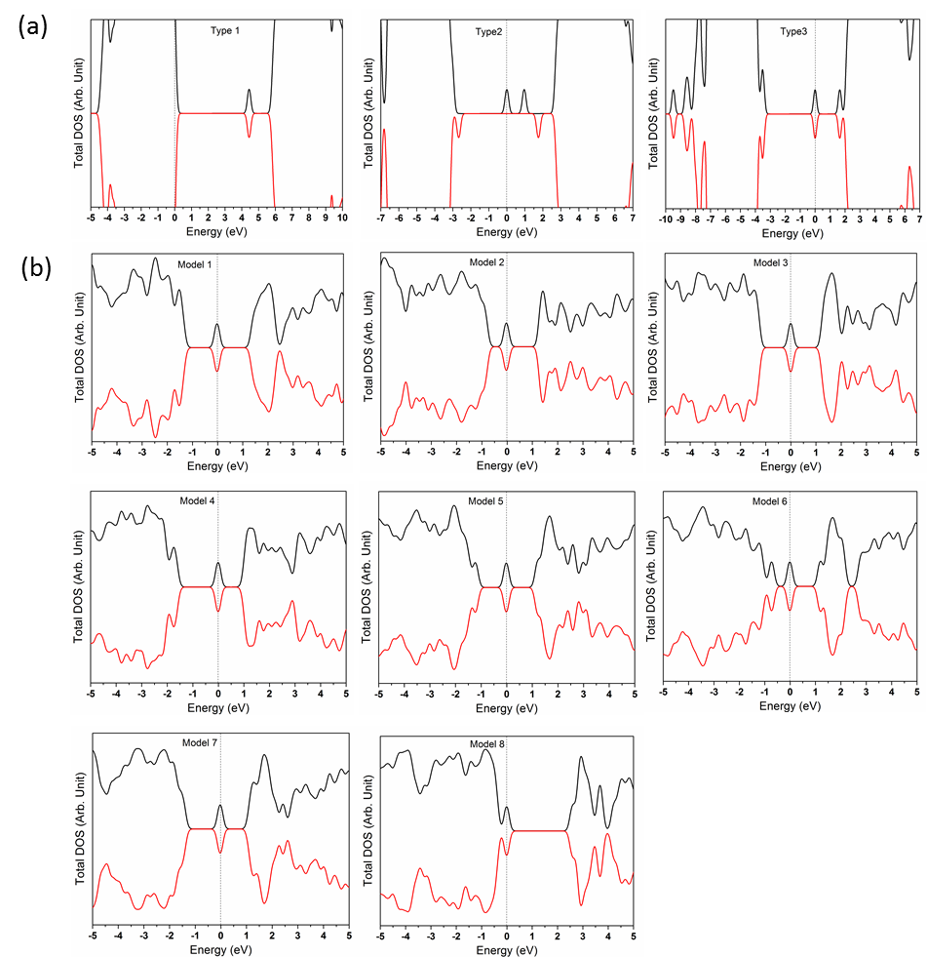
Figure S4. (a) Total density of states (TDOSs) of the three types of the anion Frenkel pairs (V_{O (48f)} + I_{O}) in La₂Hf₂O₇. (b) TDOSs of 8 models of the anion Frenkel pairs (V_{O (O3)} + I_{O}) in La₂Mo₂O₉.

References
1. A. W. Sleight, Inorganic Chemistry 9(7), 1704-1708.(1968).
2. M. A. Subramanian, G. Aravamudan and G. V. Subba Rao, Progress in Solid State Chemistry 2(15), 55-143.(1983).
3. P. Lacorre, F. Goutenoire, O. Bohnke, R. Retoux and Y. Laligant, Nature 6780(404), 856-858.(2000).
4. F. Goutenoire, O. Isnard and R. Retoux, Chem. Mater. 9(12), 2575-2580.(2000).
5. S. J. Clark, M. D. Segall, C. J. Pickard, P. J. Hasnip, M. I. J. Probert, K. Refson and M. C. Payne, Zeitschrift für Kristallographie - Crystalline Materials 5/6(220), 2005).
6. T. Zacherle, A. Schriever, R. A. De Souza and M. Martin, Physical Review B 13(87), 2013).
7. P. R. L. Keating, D. O. Scanlon, B. J. Morgan, N. M. Galea and G. W. Watson, The Journal of Physical Chemistry C 3(116), 2443-2452.(2011).
8. B. Huang, R. Gillen and J. Robertson, The Journal of Physical Chemistry C 42(118), 24248-24256.(2014).
9. B. Huang, Philosophical Magazine 26(94), 3052-3071.(2014).
10. B. Huang, Journal Of Computational Chemistry 9(37), 825-835.(2016).
11. B. Huang, Solid State Commun. 230), 49-53.(2016).
12. N. Marzari, D. Vanderbilt and M. C. Payne, Phys. Rev. Lett. 7(79), 1337-1340.(1997).
13. M. I. J. Probert and M. C. Payne, Physical Review B 7(67), 075204.(2003).
14. A. J. Jacobson, Chem. Mater. 3(22), 660-674.(2010).

