SUPPLEMENTARY MATERIAL: Pump-probe thermoreflectance measurements of critical interfaces for thermal management of HAMR heads

Gregory T. Hohensee¹, Mousumi M. Biswas¹, Ella Pek², Chris Lee¹, Min Zheng¹, Yingmin Wang¹, and Chris Dames³
¹Western Digital Corporation, 1250 Reliance Way, Fremont CA 94539, U.S.A.
²Department of Materials Science and Engineering, Materials Research Laboratory, University of Illinois at Urbana-Champaign, Urbana, IL 61801, U.S.A.
³Department of Mechanical Engineering, University of California Berkeley, Berkeley CA 94720, U.S.A.

THERMOREFLECTANCE BACKGROUND

Time-domain thermoreflectance (TDTR) is an established ultrafast pump-probe technique for measuring thermal transport properties.[1-3] For measurements of thermal conductivity by TDTR, the sample is typically coated with an approximately 80 nm metal transducer film. The pump laser pulses heat the surface, and the subsequent probe pulses monitor the change in reflectance over time due to the temperature rise and subsequent cooling. A thermal model for the TDTR signal is generated from a solution to the heat diffusion equation for a multi-layered sample, where each layer is assigned a thickness, heat capacity, and thermal conductivity.[3] The thermal model is fitted to the TDTR signal by varying one or two unknown thermal parameters, for example the thermal conductivity of a bulk isotropic substrate, and the interface thermal conductance between the metal transducer and the sample.
Frequency-domain thermoreflectance (FDTR) is similar to TDTR, except the pump and probe are CW beams instead of ultrafast pulse trains.[4] The basic principle remains the same: a sample is coated with a metal transducer, this transducer is heated by the pump beam, and its thermoreflectance response is detected with the probe beam. As in TDTR, the pump beam is modulated, and the periodic temperature response detected by the probe beam is extracted by RF lock-in. While TDTR collects data versus time delay, FDTR collects data versus pump modulation frequency. In our FDTR system, this range is from 40 kHz to 25 MHz, according to the limitations of our RF lock-in and electro-optic modulator (EOM); other research groups have engaged in FDTR measurements with pump modulation as low as 1 Hz[5] and as high as 200 MHz.[6] Our FDTR system uses a 532 nm diode laser as the probe beam to take advantage of the high thermoreflectance coefficient of Au at 532 nm.[7] The typical TDTR system would have to use a second-harmonic generator to achieve a similar probe wavelength.

SAMPLE PREPARATION AND CHARACTERIZATION

Across all three studies in this paper, our sample substrates were commercial [001] Si (P-type (Boron), 3-50 W cm resistivity) wafer coupons with either native oxide, or 300 nm thermal oxide. Metallic films were deposited by sputtering or ion beam deposition. SiO2 films were deposited by sputtering, the media carbon film was deposited by CVD, and the head carbon film was deposited by sputtering.
The structure and content of amorphous carbon influences the volumetric heat capacity and thermal conductivity, which influences our thermal models.[8-9] The carbon films representing media overcoat were deposited by CVD, contained between 15-20% each of N₂ and H₂, and 30% of the carbon component was sp³-bonded.[10] The carbon films representing head overcoat were sputtered, contained no N₂ or H₂, and had about 70% sp³ bonding.
For the head-media interface (HMI) sample series, films of nominal thickness of 10 nm or less had their thicknesses estimated according to the deposition rate of their respective deposition tools. For the Ru oxidation series, nominal thicknesses of layers below the Cr transducer were checked by TEM cross-section. For the Au/Ru/Au metallic conductance sample set, the thin Ru layers were characterized by TEM. Transducer layer thicknesses in all cases were confirmed by XRR, XRF, TDTR measurement on a control sample coated in the same deposition, or picosecond acoustics.[11]
Many samples, including all the FDTR samples for our head-media interface study, used Au transducers which conventionally have no piezo-optic response, hence no picosecond acoustic signal, at the 785 nm probe wavelength of a two-tint TDTR system. The Cahill group at UIUC developed a beam-offset clipping method for Au transducers that converts Au surface displacement (due to acoustic waves) to a modulation in probe intensity.[12] The method consists of slightly offsetting the pump and probe beams on the sample along one axis, and then clipping the returning probe beam along the same axis on its way to the photodetector, with an approximate 20-30% loss of signal in each step. Though the offset is large compared to the Au film thickness, the acoustic wave is launched at normal incidence with a wide wavefront from the large pump spot size. Thus there is no significant contribution to the observed Au acoustic travel time from laterally-propagating acoustic signal associated with the few-micron pump-probe offset applied in this method. Figure S1 shows a typical example of TDTR data from an Au-coated sample after beam-offset clipping. The probe signal’s thermal information is highly distorted, but it carries a clear picosecond acoustic signal with a period corresponding to the acoustic travel time in the Au film with the [111] Au speed of sound, v = 3:24 m/s.

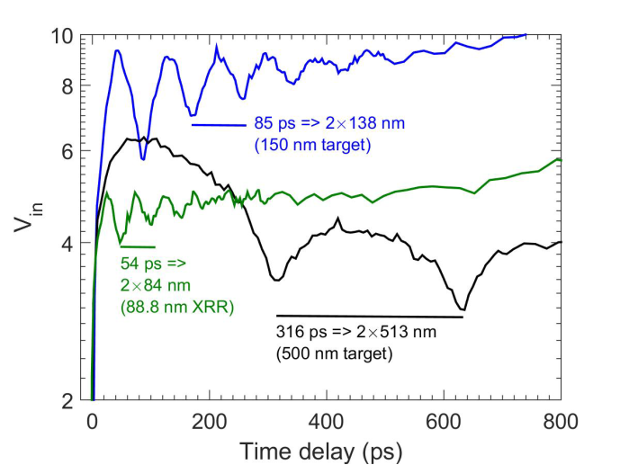
Figure S1. Picosecond acoustics from Au recorded with a near-IR probe beam by a beam-offset clipping method from Cahill group at UIUC. The Au thickness is derived from the [111] Au speed of sound and the observed acoustic period. We see good correspondence with the 80, 150, and 500 nm target thicknesses, and also agreement with XRR measurement. This method was used to obtain Au film thicknesses for the head-media study in this paper (study #1, main text).

STUDY 1: FDTR Control Samples

The fitted FDTR data and results for SiO₂ and media carbon control samples are shown in Figure S2. The 500 nm Au layer on top of the 300 nm SiO₂ / Si substrate creates structure in the FDTR data above 1 MHz by reducing the magnitude of phase lag near 5-10 MHz. The films between the Au layers are the limiting resistance in this FDTR frequency range, which enhances our sensitivity to their net thermal resistance.

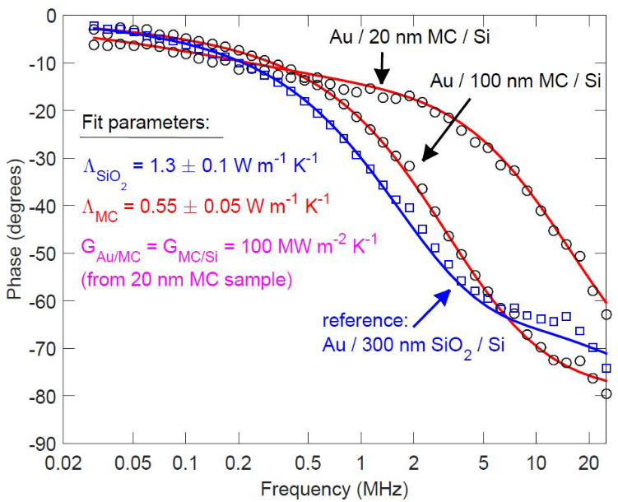
Figure S2. FDTR on media carbon control samples. Two media carbon (MC) control samples were measured (black circles), alongside a standard thermal SiO₂ reference (blue squares). The 100 nm MC was thick and resistive enough that the interface conductances were unimportant FDTR fit parameters, so that LMC could be obtained. The 20 nm MC sample was then used to extract the interfacial thermal conductances, which were assumed to be roughly equal.

STUDY 2: TDTR Thermal Model Parameters

The TDTR measurements were done at 8.05 MHz pump modulation frequency and r = 11.7 micron 1/e² radius pump and probe spot sizes. Although annealing of room-temperature sputtered Ru and Au do increase their thermal conductivities, the TDTR sensitivity to those parameters was negligible. Other TDTR model parameters include the Cr, Ru, and Au thermal conductivities, the Cr/Ru thermal conductance, and the Ru/Au thermal conductance. From four-point probe resistivity data and the Wiedemann-Franz Law, we found that the Cr, 16 nm Ru, and Au thermal conductivities were 50, 35, and 150 W/m-K, respectively.
Because these are derived from in-plane electrical resistivity data, they represent in-plane thermal conductivities; we are assuming here that these thin films have isotropic thermal conductivities or nearly so. Cr and Au have cubic crystal structures, so their conductivities should be isotropic. Ru is hcp, and defect-free single-crystal Ru can have electrical resistivity anisotropy (hence, thermal conductivity anisotropy) as high as 30% at 273 K.[13] However, Our Ru is thin-film polycrystalline with no dominant grain orientation or texture, and the in-plane electrical resistivity 3x higher than for single-crystal Ru, so we assume the anisotropy is entirely suppressed by disorder. Annealing the Ru and Au will increase their thermal conductivities, but the TDTR model already has negligible sensitivity to these parameters. Finally, we fixed G(Ru/Au) = 12 GW m⁻² K⁻¹, according to TDTR results on Au/Ru/Au multilayer samples discussed in Study #3 of this paper.
The Cr, Ru, and Au film thicknesses were determined by picosecond acoustics (for Cr) and TEM cross-sections for Ru and Au, such as Figure 4(b) in the main text. We then have a single fit parameter for all samples, G(Cr/Ru), with adequate sensitivity in the TDTR model below 1 GW m⁻² K⁻¹, and poor sensitivity above 2 GW m⁻² K⁻¹. TDTR sensitivities are quantified as d(log R)/d(log X), where R is the TDTR ratio signal and X is the fit parameter. For this particular sample system, we define “poor sensitivity” as d(log R)/d(log G) < 0.1 at all TDTR time delays, small compared to the sensitivities of other model parameters such as the Cr transducer thickness and thermal conductivity. In the poor sensitivity regime, a 2x or more increase in G(Cr/Ru) has very little impact on the goodness of fit to the data.

STUDY 3: MTL vs. WFL and TDTR Thermal Model Parameters

We have two competing theories for predicting metal/metal interface thermal conductance: the Wiedemann-Franz Law (WFL) based on measured or calculated specific electrical resistances (AR), and the Maximum Transmission Limit (MTL). The WFL and MTL theories are not equivalent, and in general predict different conductances G which can be compared to TDTR experiments (Table S1).

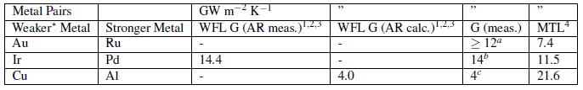
Table S1. Comparison of metallic thermal conductances as measured by TDTR and predicted by the Wiedemann-Franz Law (WFL) and Maximum Transmission Limit (MTL). Legends are as follows:
(*): Here “weaker” and “stronger” refer to the irradiance in the MTL picture.
(1-2): Refs. [13] and [14]
(3): The interfacial WFL is given by G_{e} = (AR)⁻¹L₀T; see Ref. [15]
(4): MTL calculated by Ref. [5], using [111] Fermi velocities from Ref. [16]
(a): this paper
(b): Ref. [17]
(c): Ref. [15]

Au has one of the lowest irradiances in the MTL model, so the MTL predicts that an Au/metal interface should be fairly independent of the second metal’s properties and have a high thermal resistance, which implies relatively high TDTR measurement sensitivity. Au/metal interfaces are also very relevant for HAMR heat sinking, Au being the prototypical HAMR near-field transducer (NFT). The second metal should be a good diffusion barrier for Au, both to maintain multilayer integrity and to be relevant to HAMR devices, where interdiffusion between the Au NFT and heatsink at high temperature is undesirable for plasmonic performance. We chose Ru as the second metal for this reason.[18]
We’ve seen that TDTR has difficulty measuring G for a single metal/metal bilayer, and that multilayers as in the Pd/Ir studies are advisable for good sensitivity.[14,17] However, for few-nanometer interlayers, depending on the interlayer’s exact thickness and continuity, it’s not clear in advance whether it will behave as a fractional interface (for example, with some Au-Au interpenetration), a single interface, or two full interfaces on either side of the interlayer. In the case of Pd/Ir, the specific electrical resistance (AR) increased linearly with the number of nominal interfaces up to n = 120 Pd/Ir repetitions in a 360 nm total [Pd/Ir]_{n} multilayer, above which the AR of the multilayer plateaued. Each additional pair of Pd/Ir layers added two interfaces and two interface resistances to the multilayer, until a threshold was reached when each Pd and Ir layer was 1.5 nm thick. Past this threshold, the resistance of the multilayer saturated at a value independent of the number of Pd/Ir layers. As such we will limit our study to layer thicknesses of 2 nm and greater.
For our TDTR thermal model, we use our measured Wiedemann-Franz thermal conductivity of 260 W/m-K for the Au layers. For the Ru transducer, we allow an additional 5 W/m-K for the phonon contribution to the thermal conductivity, for a total of 45 W/m-K. The exact amount of phonon-contributed L in a metal can be estimated from the Leibfried-Schlomann equation or low-temperature thermal conductivity data, but is generally a few W/m-K; insignificant for Au, but significant for Ru.[19] Because our Ru films are polycrystalline with random grain orientation and no dominant texture, we assert that our measured in-plane Wiedemann-Franz thermal conductivity applies to the cross-plane thermal conductivity as well: the electrical anisotropy of single-crystal hcp Ru is suppressed.
The TDTR measurements for the three samples were done at 8.05 MHz and 1.77 MHz pump modulation frequencies. In this experiment, we measured the TDTR pump and probe individual spot sizes as r = 12.7 micron 1/e² radius. The Ru/Au multilayer measurements were preceded by reference measurements on Al/SiO₂/Si standard samples, from which we obtained SiO₂ thermal conductivities of 1.23 and 1.33 W/m-K at 8.05 and 1.77 MHz, respectively. By fitting the normalized V(out) signal on the reference samples, we also noted a 7% effective linear pump/probe spot size increase vs. delay time, which is accounted for in our TDTR model and has negligible impact on the -V(in)/V(out) ratio signal.
Figure S3 shows TEM cross sections from the X = 4 nm and X = 8 nm Ru multilayer samples, from which we extracted thicknesses for all the metal layers. Note that at 4-8 nm, the Ru layers are continuous and not penetrated by Au. In both TEM samples, the Ru transducer is 48 nm, the Au layers are 65 nm, the Ru interlayers are on-target at 4 and 8 nm, and the Au heat sink is 390 nm. Figure 6 in the main text shows Wiedemann-Franz electronic thermal conductivities (resistivity measured by four-point-probe and TEM) for our Au and Ru depositions, as a function of thickness below 200 nm. The Lorenz numbers for Au and Ru in the Wiedemann-Franz calculation are different: L₀ = 2.45 x 10⁻⁸ W Ω K⁻² (the Sommerfeld value) and L_{Ru} = 2.75 x 10⁻⁸ W Ω K⁻², respectively.[20]

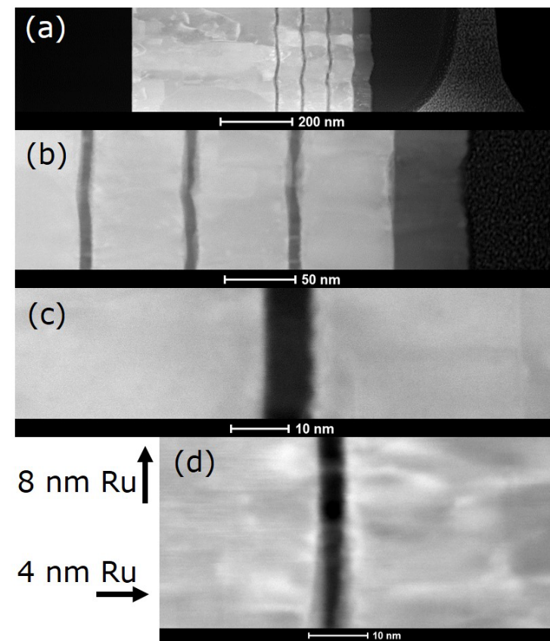
Figure S3. Selected TEM cross-sections of Au/Ru/Au multilayers. Film thicknesses for TDTR thermal modeling were taken from TEM data for the (a-c) X = 8 nm and (d) X = 4 nm Ru multilayer samples. The X = 2 nm sample was not cross-sectioned, and the Ru transducer and Au thicknesses in X = 2 were assumed to be consistent with the X = 4, 8 nm cases. These are crops of representative high-angle annular dark-field (HAADF) TEM images, from a complete set of bright- and dark-field TEM data. We do not observe discontinuity in or Au penetration of the thin Ru interlayers from TEM.

SUPPLEMENTARY REFERENCES

- D.G. Cahill, Rev. Sci. Instrum. 75, 5119–5122 (2004).
- D.G. Cahill et al., J. Appl. Phys. 93, 793–818 (2003).
- D.G. Cahill et al., Appl. Phys. Rev. 1, 011305 (2014).
- A.J. Schmidt, R. Cheaito, M. Chiesa, Rev. Sci. Instrum. 80(9), 094901 (2009).
- T. Tong, J. Karthik, L.W. Martin, D.G. Cahill, Phys. Rev. B 90, 094116 (2014).
- K.T. Regner, S. Majumdar, J.A. Malen, Rev. Sci. Instrum. 84(6) 064901 (2013).
- G. Tessier, S. Hole, D. Fournier, Appl. Phys. Lett. 78, 2267–2269 (2001).
- M. Hakovirta, J.E. Vuorinen, X.M. He, M. Nastasi, R.B. Schwarz, Appl. Phys. Lett. 77, 2340–2342 (2000).
- A.J. Bullen, K.E. O’Hara, D.G. Cahill, O. Monteiro, A. von Keudell, J. Appl. Phys. 88, 6317–6320 (2000).
- J. Robertson, Mat. Sci. Eng.: R: Reports 37, 129 – 281(2002).
- G.T. Hohensee, W.-P. Hsieh, M.D. Losego, D.G. Cahill, Rev. Sci. Instrum. 83(11), 114902 (2012).
- M.D. Losego, M.E. Grady, N.R. Sottos, D.G. Cahill, P.V. Braun, Nat. Mater. 11, 502-506 (2012).
- J.W. Arblaster, Johnson Matthey Technol. Rev. 60, 179–185 (2016).
- R. Acharyya et al., Appl. Phys. Lett. 94, 022112 (2009).
- B.C. Gundrum, D.G. Cahill, R.S. Averback, Phys. Rev. B 72, 245426 (2005).
- D.A. Papaconstantopoulos, in Handbook of the Band Structure of Elemental Solids (Springer, 1986).
- R.B. Wilson and D.G. Cahill, Phys. Rev. Lett. 108, 255901 (2012).
- T.N. Arunagiri et al., Appl. Phys. Lett. 86, 083104 (2005).
- M. Roufosse and P.G. Klemens, Phys. Rev. B 7, 5379–5386 (1973).
- R. Powell, R. Tye, M.J. Woodman, J. Less-Common Met. 12, 1-10 (1967).

