Supplementary:

High-performance Porous Carbon/CeO₂ Nanoparticles Hybrid Super-capacitors for Energy Storage
Figure S1 describes how a coin cell for experiment was assembled with different PC and PC-CON electrodes.
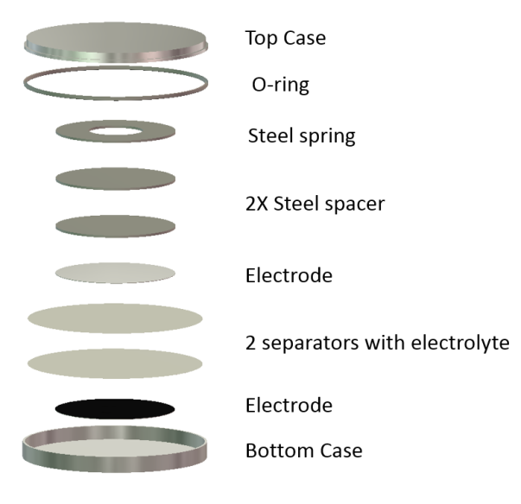

Figure S1. Schematic view of coin cell assembly

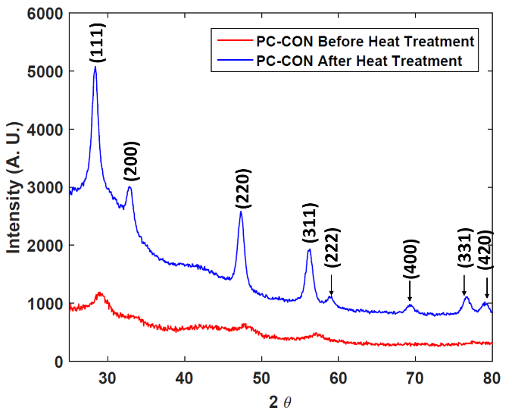

Figure S2. XRD results for PC-CON before and after heat treatment.
In order to determine the chemical composition and oxidation state of the electrode materials before and after the electrochemical testing, X-ray photoelectron spectroscopy (XPS) measurements were carried out in the region of 0-1200 eV. The nomalized XPS spectra of the Ce 3d core electrons for the before and after testing electrodes are shown in Figure S3. For both spectra, the first three well resolved peaks in the range of 880-898 eV correspond to Ce 3d_{5/2}, whereas the last two peaks in the range of 900-917 eV correspond to Ce3d_{3/2}. Although, most of the Ce were in Ce⁺⁴ state, the presence of Ce⁺³ is clearly revealed from the XPS spectra of the before and after testing electrode.

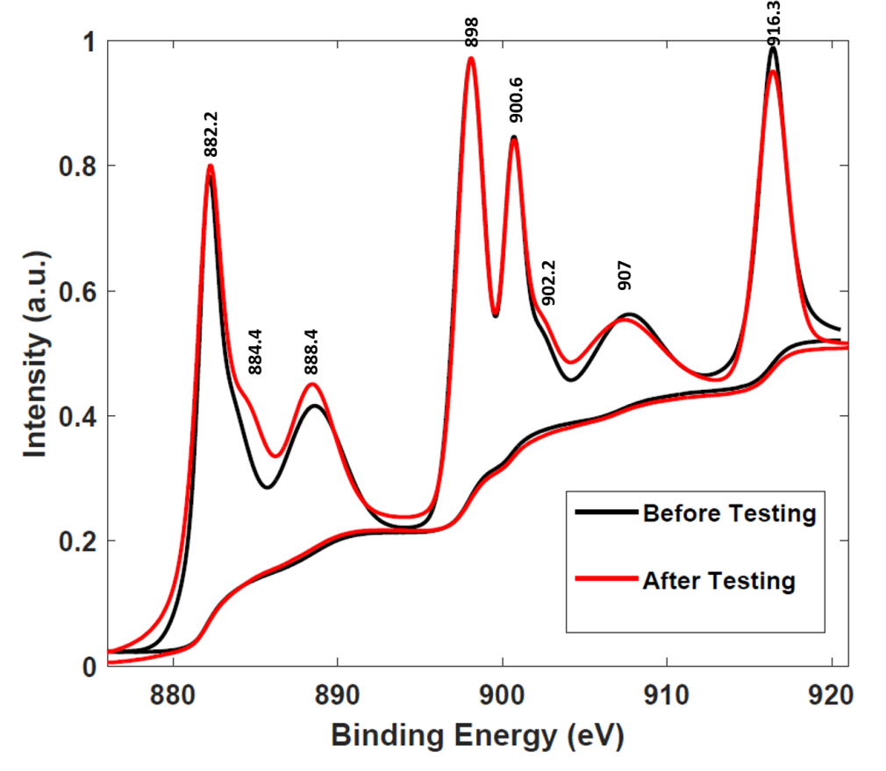

Figure S3. High resolution XPS spectrum of Ce 3d for before and after testing electrodes.
From XRD result, it was clear that CeO₂ possesses a cubic fluorite structure (space group: Fm-3m). The Ce⁺⁴ cation are surrounded by O²⁻ anions in the cubic crystal, each of which is coordinated to four Ce⁺⁴ cation. The shoulder satellite peak at ~884.4 eV and a tiny peak at ~902.2 eV in the Ce 3d spectrum, corresponding to Ce⁺³ state, suggests the presence of oxygen vacancies in CeO₂. The quantitative investigation revealed that the concentration of Ce⁺³ in the before testing sample was ~13.6% and the concentration of Ce⁺³ (~13%) in the after testing sample are almost similar.

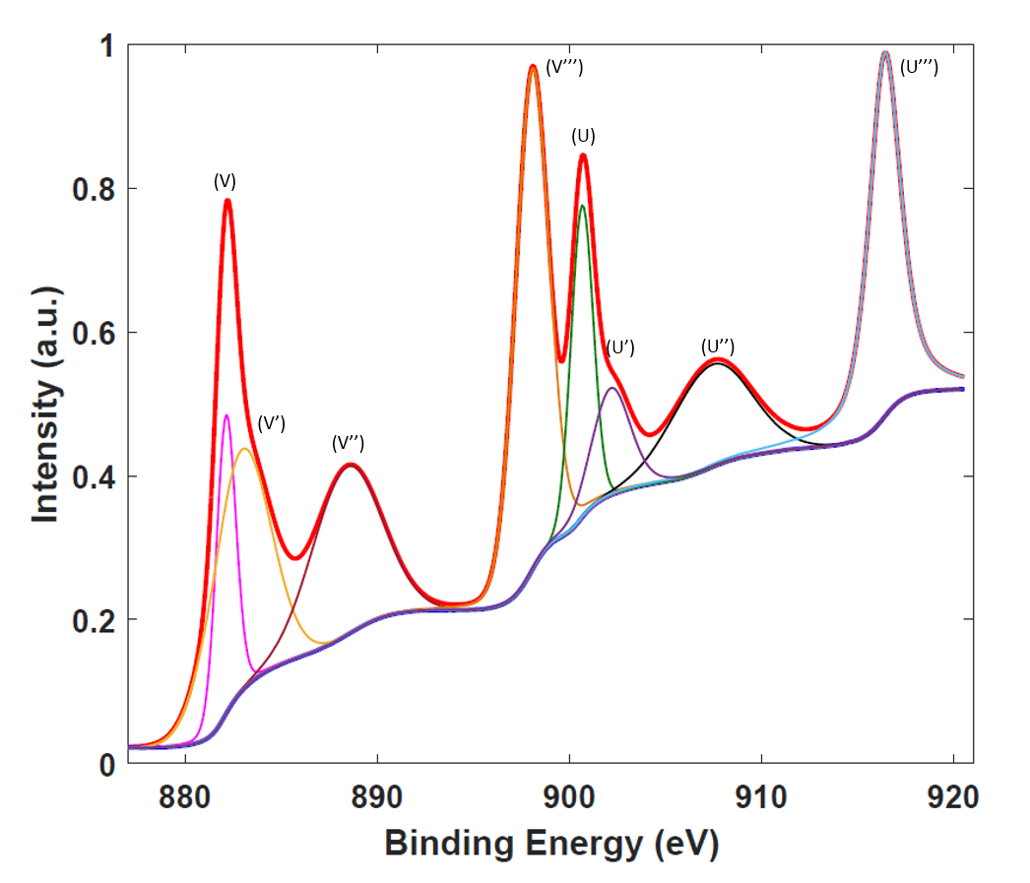

Figure S4. XPS Ce 3d spectra of before testing electrode.
The quantitative analysis for the concentration of Ce⁺³ in before and after testing samples has been done. As shown in Figure S4 and S5, high resolution XPS spectra of Ce3d core were deconvoluted by mean of Gaussian-Lorentzian shape fitting using XPS peak fit software. The Ce 3d XPS spectra exhibit multiple states which arise from different Ce 4f level occupancies in the final state and can be marked according to the convention established by Burroughs et al. ^{[1]}, where V and U refer to the 3d_{5/2} and 3d_{3/2} spin-orbital components.

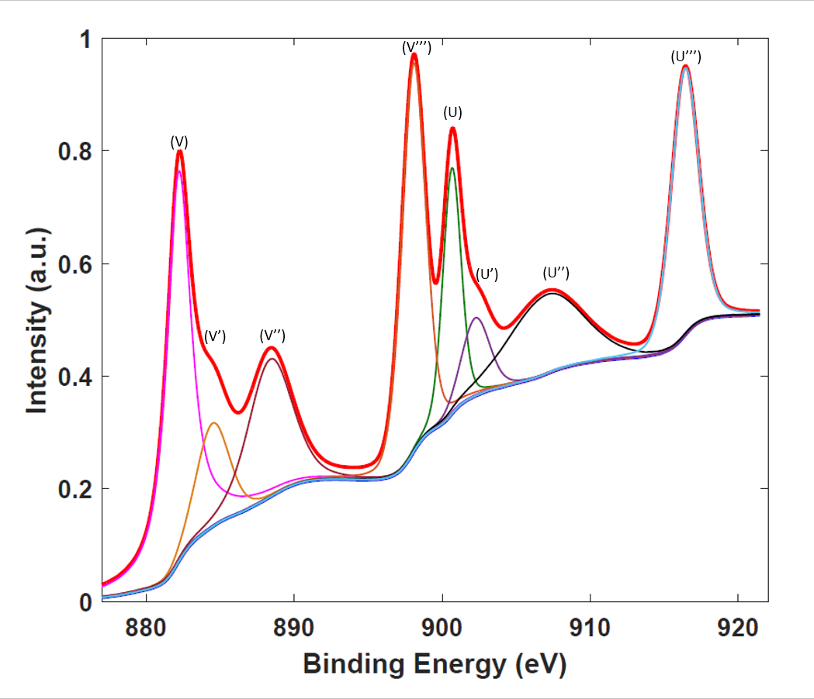

Figure S5. XPS Ce 3d spectra of after testing electrode.
The peaks labeled as U, U’’, U’’’, V, V’’, and V’’’ are corresponding to the features of Ce⁴⁺, whereas; peaks referred to V’ and U’ are corresponding to Ce⁺³ was calculated by taking the ratio of the integrated peak areas corresponding to the Ce⁺³ to the total area under the whole Ce 3d spectrum. Our estimate of Ce⁺³ concentrations in before and after testing samples was determined using the following equation ^{[2]}:

$${Ce}^{+3}= \frac{A_{vo}+A_{v'}{+ A}_{uo}+A_{u'}}{A_{vo}+A_{v'}{+ A}_{uo}+A_{u'}+A_{v}+A_{v''}{+ A}_{v'''}+A_{u}{+ A}_{u''}+A_{v'''}}$$

where, A denotes the area of the corresponding peaks marked as the subscript in the spectrum. The relatively higher concentration of Ce⁺³ suggests the higher oxygen vacancies in the samples.
References
1. P. Burroughs, A. Hamnett, A. F. Orchard and G. Thornton, J. of Chem. Soc., Dal. Tran. 1686-1698 (1976).
2. M. Škoda, M. Cabala, V. Cháb, K. Prince, L. Sedláček, T. Skála, F. Šutara and V. Matolín, Appl. Sur. Sci. 254, 4375-4379 (2008).

