Supplementary Information

ATPS Deserves Plausible Real-World Modeling for the Structure and Function of Living Cells

Kanta Tsumoto1 and Kenichi Yoshikawa2
1Graduate School of Engineering, Mie University, 1577 Kurimamachiya-cho, Tsu, Mie 514-8507, Japan
2Faculty of Life and Medical Sciences, Doshisha University, 1-3 Tatara Miyakodani, Kyotanabe, Kyoto 610-0394, Japan

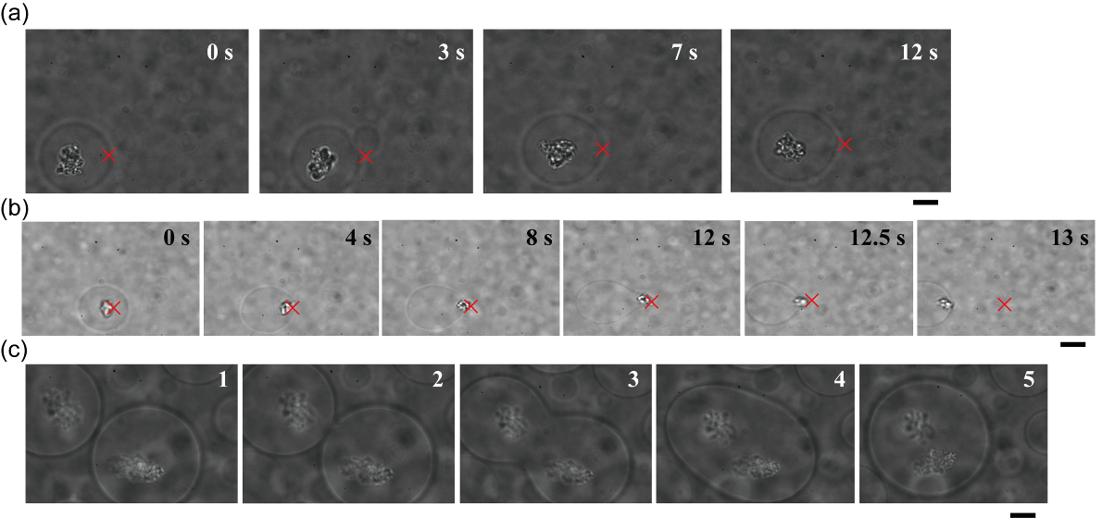
Figure S1. Dextran-rich microdroplets entrapping DNA aggregates in the PEG/dextran (7%/1.5%) ATPS. The details are also described in the text. (a) The target microdroplet could be transferred with the laser tweezers while the microdroplet entrapped DNA aggregates. (b) A DNA aggregate trapped by the laser tweezers could not be moved across the interface between a dextran-rich microdroplet and the outer PEG-rich solution. (c) Two DNA-entrapping microdroplets spontaneously fused with each other. The numbers in the upper right are the time after trapping (a, b); the numbers indicate the order in which images were captured (c). The focus point of the laser tweezers is marked by crosses as a guide (a, b). Bar: 10 µm. The figure was originally published as Figure 4 in our previous study cited as Ref.11 in the text (Kanta Tsumoto, Masafumi Arai, Naoki Nakatani, Shun N. Watanabe and Kenichi Yoshikawa, ” Does DNA Exert an Active Role in Generating Cell-Sized Spheres in an Aqueous Solution with a Crowding Binary Polymer?” Life 2015, 5(1), 459-466; http://dx.doi.org/10.3390/life5010459) and reprinted here under CC BY 4.0 (https://creativecommons.org/licenses/by/4.0/).

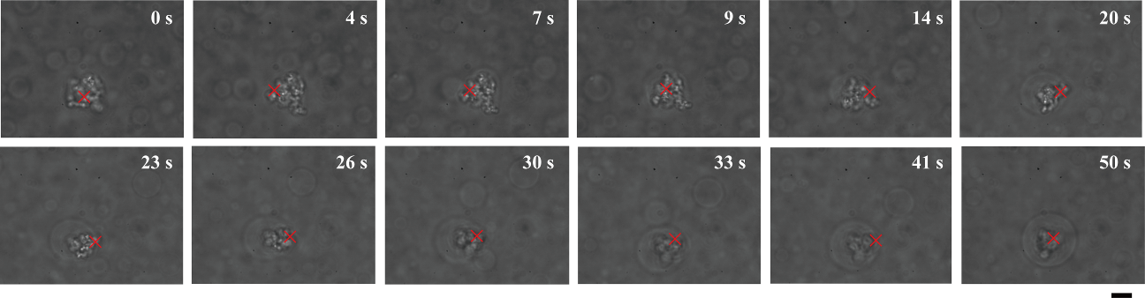
Figure S2. Growth of a dextran-rich microdroplet in PEG/dextran (7%/1.5%) around a core of DNA aggregates that were trapped under laser radiation. The focus point of the laser tweezers is marked by crosses as a guide. Times after trapping are indicated. Bar: 10 µm. The figure was originally published as Figure 5 in our previous study cited as Ref.11 in the text (Kanta Tsumoto, Masafumi Arai, Naoki Nakatani, Shun N. Watanabe and Kenichi Yoshikawa, ” Does DNA Exert an Active Role in Generating Cell-Sized Spheres in an Aqueous Solution with a Crowding Binary Polymer?” Life 2015, 5(1), 459-466; http://dx.doi.org/10.3390/life5010459) and reprinted here under CC BY 4.0 (https://creativecommons.org/licenses/by/4.0/).

