Global environmental and social spillover effects of EU’s food trade

SUPPLEMENTARY INFORMATION

Arunima Malik^{1,2*}, Guillaume Lafortune³, Salma Dahir³, Zachary A. Wendling³, Christian Kroll⁴, Sarah Carter⁵, Mengyu Li¹, Manfred Lenzen¹
¹ISA, School of Physics, The University of Sydney, NSW, Australia
²Discipline of Accounting, Sydney Business School, The University of Sydney, NSW, Australia
³Sustainable Development Solutions Network (SDSN), Paris Office, France
⁴IU International University of Applied Sciences, Germany
⁵Thermal Ergonomics Laboratory, Sydney School of Health Sciences, Faculty of Medicine and Health, NSW, Australia

*Corresponding author: Dr Arunima Malik, arunima.malik@sydney.edu.au, +61 2 9351 5451

Mathematical formulation – measuring spillovers
The starting point for quantification of spillover effects is a set of MRIO matrices – intermediate demand (T), final demand (Y) and value-added (v). These are monetary matrices that are based on data collected by statistical agencies. For example, each country has their own statistical agency. In Australia, the Australian Bureau of Statistics produces and makes available input-output tables for further use by government, academia and industry (ABS, 2019). An explanation of the fundamentals for input-output analysis are explained in detail elsewhere (Miller & Blair, 2010). Here we briefly explain the three key matrices that feature in MRIO databases:
The intermediate demand matrix captures intra-industry and inter-industry transactions between regions; the value-added matrix contains information on primary inputs needed for the production of goods and services (e.g., labour input); and the final demand matrix captures expenses related to the final consumption of goods and services. The T and Y matrices of a MRIO database harbour data on imports and exports by region and sector, for example if any of the EU member states import food from an Asian economy for further processing, then this transaction is captured in the T matrix; and final consumption of a processed food item imported from the USA is captured directly in the Y matrix. MRIO databases therefore capture supply chains that originate in the RoW and feed into supply chains in the EU, before finally ending up with final consumers in the EU; and also supply chains that originate and form part of further processing in the RoW and end up in the EU. The MRIO database used for this study is obtained from (Lenzen et al., 2021).
Input-output calculations proceed by calculating the total output x of an MRIO database by using row summation operators (i.e., summing all elements in a row to obtain a column vector): $=T1^{T}+ y1^{y}$ , where $1^{T}$ is the row summation operator for the matrix T, and $1^{y}$ the row summation operator for matrix y. Next, the direct coefficients matrix A (inputs needed to produce 1$ of output of a sector) is calculated using $A=T{\hat{x}}^{-1}$, where ${\hat{x}}^{-1}$ is the inverse of the diagonal total output vector x. We integrate a new matrix – Q (physical accounts) – with the economic input system. This matrix is essential for featuring data on environmental, social and economic indicators into an economic dataset. Each row of the Q matrix holds data on a specific indicator. This study features data on seven distinct indicators: carbon dioxide (CO₂), sulphur dioxide (SO₂), nitrous oxide (NO_{X}), particulate matter (PM), land, employment, and income, taken from the Hotspot Analysis Tool for Sustainable Consumption and Production (SCP-HAT (2021)). Further details on the construction of these indicators are provided in the “Measuring Spillovers” section of the article.
The direct intensities matrix q (impacts per dollar of output x) is calculated as: $=Q{\hat{x}}^{-1}$ . The power of input-output analysis lies in the ability to capture all upstream supply chains using a total requirements matrix $L={(I-A)}^{-1}$. The matrix L can be used to calculate the total intensities $m=qL$. The total intensities hold information on both the direct and indirect impacts (e.g., in kg CO₂e) embodied in 1$ of final demand/final consumption of a commodity. The impacts embodied in the food products bought by the EU can be calculated by taking the final demand of crops, livestock, aquaculture, meat and fish products, cereal-based products, food crop products, cocoa, chocolate, sugar, oil and fats, dairy products, alcoholic and other beverages and tobacco products by each of the 27 EU member states. This specific final demand vectors for each EU country $y_{EU_c_food}$ can be post-multiplied by the total intensities to calculate consumption-based footprints as $f_{1}=my_{EU_c_food}$ , where ⊗ denotes element-wise multiplication or impacts according to last point of sale and final consumption; and $f_{2}=q{Ly}_{EU_c_food}$ as impacts from producing region/sector to final consumption. We calculate both domestic impacts (i.e., impacts that happen within EU, or between EU countries) or spillover effects (i.e., impacts that take place outside of EU’s borders).
A list of sectors considered in the assessment are mentioned below:
Growing Wheat
Growing Maize
Growing cereals n.e.c
Growing leguminous crops and oil seeds
growing rice (paddy)
Growing of vegetables melons, roots, tubers, non-perennial fruits
Growing of sugar cane
Growing of tobacco
Growing of fibre crops
Growing of non-perennial crops n.e.c.
Growing of grapes
Growing of perennial /tree fruits
Growing of beverage crops
Growing of spices, aromatic, drug, and pharmaceutical crops
Growing perennial crops n.e.c. and plant propagation
Raising of ruminant animals
Raising of swine/pigs
Raising of poultry
Raising of animals n.e.c. - support for animal production - mixed farming - Hunting gathering and related services
Post-harvest and support activities for crop production
Wood production
Wood production related services
Wild fish capture
Aquaculture
Hard coal production
Lignite and peat production
Extraction of petroleum
Extraction of natural gas
Ferrous ores extraction
Mining of uranium ores
Mining of Aluminium ore
Mining of copper dominated ores
Mining of gold dominated ores
Mining of lead/zinc/silver dominated ores
Mining of nickel dominated ores
Mining of tin dominated ores
Mining of other non-ferrous ores n.e.c.
Quarrying of stone, sand and clay
Mining of chemical and fertilizer minerals
Extraction of salt
Mining and quarrying n.e.c. and support for petroleum natural gas and mining
Processing, preserving, and manufacture of meat and fish-based products
Processing and manufacture of cereal based products
Processing, preserving, and manufacture of food crop products n.e.c - mixed food and feeds n.e.c
Sugar refining and Manufacture of cocoa, chocolate, and sugar confectionery
Processing and manufacture of fibre-based products and hide (natural or other) based products
Manufacture of vegetable and animal oils and fats
Manufacture of dairy products
Manufacture of Alcoholic and other beverages
Manufacture of tobacco products
Sawmilling and planning of wood - Wood based manufacturing excl. pulp and paper
Wood pulp and paper production and printing
Manufacture of coke oven products
Manufacture of refined petroleum products
Manufacture of nitrogenous fertilizers
Manufacture of non-nitrogenous and mixed fertilizers
Manufacture of basic petrochemical products n.e.c.
Manufacture of basic inorganic chemicals n.e.c.
Manufacture of pharmaceuticals, medicinal chemical and botanical products
Manufacture of rubber and plastic products n.e.c.
Manufacture of clay building materials
Manufacture of other ceramics n.e.c.
Manufacture of cement, lime and plaster and articles made there-of
Manufacture of other non-metallic mineral products n.e.c.
Manufacture and casting of basic iron and steel
Manufacture and casting of basic Aluminium
Manufacture and casting of basic Copper
Manufacture and casting of basic Gold
Manufacture and casting of basic Lead/Zinc/Silver
Manufacture and casting of basic nickel
Manufacture and casting of basic tin
Manufacture of basic non-ferrous metals n.e.c.
Manufacturing of fabricated metal products, machinery and transport equipment n.e.c., and repair and installation of machinery and equipment
Manufacture of computer, electronic, and optical products
Manufacture of electrical equipment including metal wiring and cables
Manufacture of motor vehicles, trailers, and semi-trailers
Manufacture of furniture and other manufacturing n.e.c
Electric power generation, transmission, and distribution
Manufacture of gas; distribution of gaseous fuels through mains
Water collection, treatment and supply, Sewerage, and Steam and air conditioning supply
Waste collection, treatment, and disposal
Materials recovery
Construction of all buildings
Construction of roads and railways, utilities, and other civ. engineering inc. demolition and site preparation
All Wholesale and retail trade, plus repair of motor vehicles and motorcycles
Land transport and transport except via pipelines
Transport via pipeline and n.e.c, Warehousing, and support activities for transportation
Water transport
Air transport
Accommodation and food service activities
Publishing activities, Telecommunications, Information, and communication n.e.c.
Financial, Insurance, and Real estate activities
Professional, scientific, and technical activities
Public administration, Social security, Defence and public order, and Administrative and support service activities n.e.c.
Education
Human health and social work activities
Arts, entertainment and recreation, Repair of computers, personal and household goods, and Other service activities n.e.c.

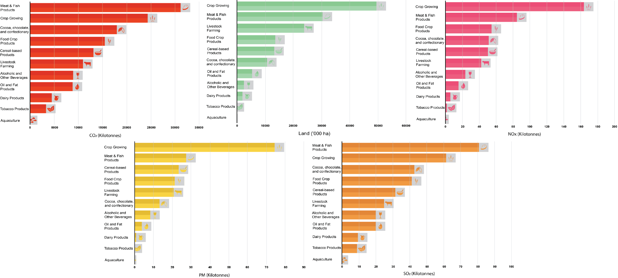Figure S1 Environmental impacts embodied in the final demand of key agricultural and food manufacturing commodities. The values shown in the bar graphs capture all direct and indirect supply chain impacts for the final demand of food, e, g., energy, fuel, and transportation-related carbon dioxide emissions embodied in ‘Meat and Fish product’ manufacturing are captured in the bar for this category.

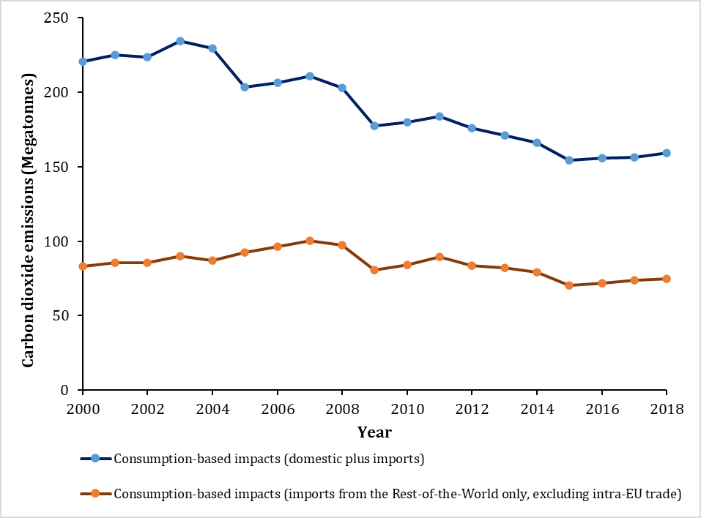

Figure S2 Trends in consumption-based impacts, both domestic and imports. Impacts taking place outside of the EU (from imports, excluding exports) are called ‘Spillovers’ in this study.

Table S1 Comparison of per-capita spillover effects for the European Union with two economies (USA and Russia) across all seven indicators.
Region/Country | Carbon dioxide  (Kg per capita) | Sulphur dioxide  (Kg per capita) | Nitrous oxide  (Kg per capita) | Particulate Matter  (Kg per capita) | Land  (ha per capita) | Employment  (people per capita) | Income  (USD per capita)
European Union | 168 | 0.5 | 0.6 | 0.3 | 0.2 | 0.04 | 156
United States of America | 63 | 0.2 | 0.3 | 0.1 | 0.1 | 0.02 | 107
Russia | 31 | 0.1 | 0.1 | 0.04 | 0.06 | 0.01 | 47

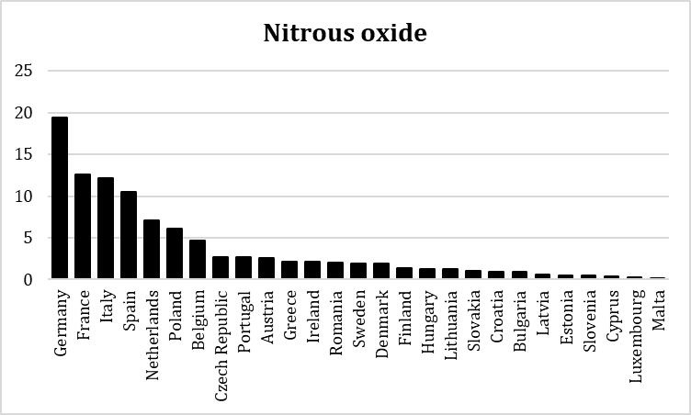
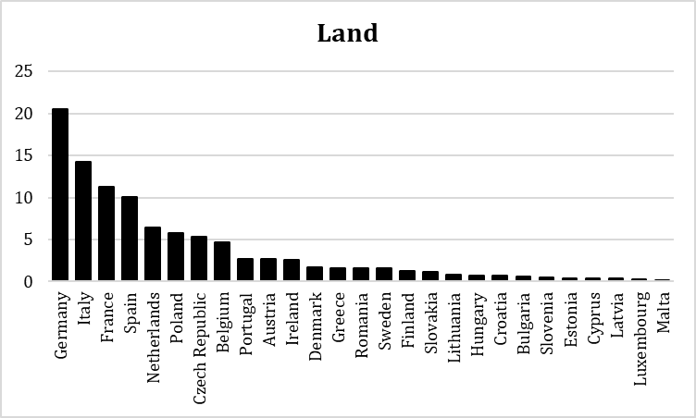
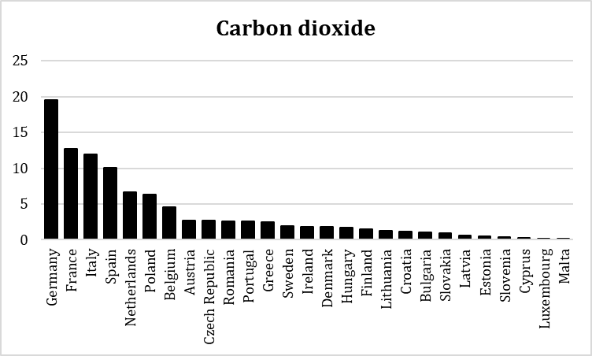
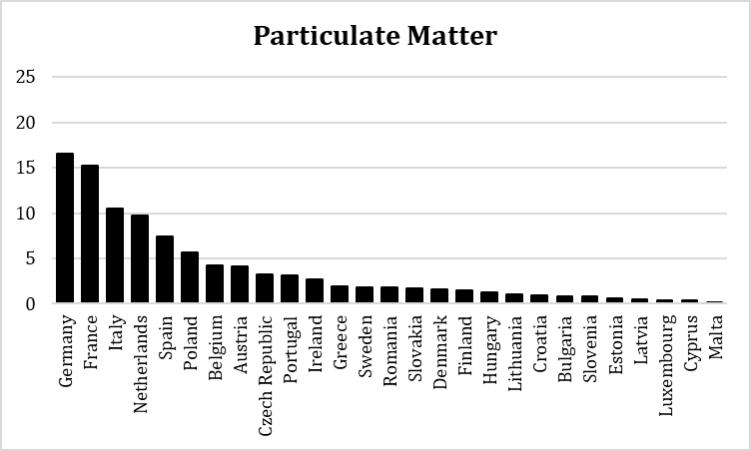
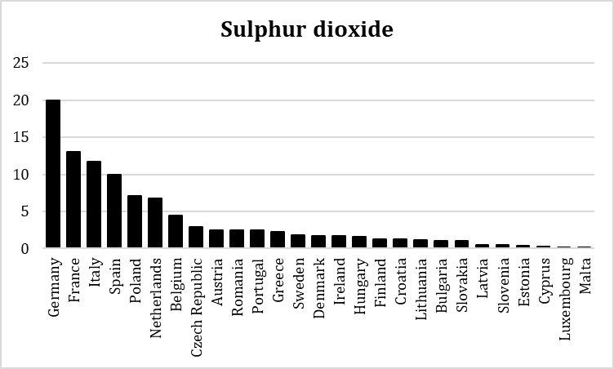

Figure S3. Contribution of 27 European Union Member states to international spillover effects. The numbers reflect percentages for the role of EU states in driving spillover effects in countries outside of the EU, calculated using the total footprints of the EU for various indicators. (Source: Authors’ illustration).

Table S2 An overview of intra-EU trade – an example of two key EU member states for selected commodities (ATLAS, 2021)
EU member state | Imports (intra-EU trade)
Germany | Avocadoes (Spain); Grapes (Italy); Onions and shallots (Netherlands); Peaches and nectarines (Spain); Tomatoes (Belgium); Carrots and turnips (Belgium);
France | Apples (Italy); Apricots (Spain); Bananas and plantains (Netherlands); Barley (France); Cherries (Austria); Cocoa (France)

Box S1. The Four Pillar Framework for food companies’ alignment with the SDGs
The Four Pillar Framework published by SDSN and partners emphasizes the importance of four major pillars to monitor and address negative environmental (and social) impacts of food companies:
- Pillar 1 highlights the impact of a company’s products, services, and strategies on human wellbeing and the planet’s sustainability. For the food processing companies, this Pillar helps bring into focus the contributions to healthy and sustainable dietary patterns through their products and strategies. This includes whether food products are healthful, whether product marketing promotes health, and whether product use is conducive to well-being and supportive of improved living standards

- Pillar 2 includes the environmental and social impacts of business operations and the responsibility of companies to respect human rights, which improves the livelihoods of communities, workers, producers, and their families.

- Pillar 3 highlights the company’s role in and responsibility to drive sustainable development across its value chain, including suppliers, producers, clients, and other business relationships, and in the broader ecosystems of which it is part. This Pillar focuses on company activities to support the realization of the SDGs through interactions with these actors, and collaboration to promote, incentivize, and ensure more sustainable practices and better livelihoods within its own value chain as well as within the relevant industries, sectors, and communities that its operations and business relationships influence.

- Pillar 4 brings into focus how companies are governed and how they engage with the systems and rules that govern them. Good corporate citizenship is the foundation for the holistic changes in corporate practices needed to align with the SDGs. This pillar highlights company strategies that contribute to or diminish social goods or societal well-being, and activities that support or undermine the crafting and effective deployment of law and policy that advances sustainable development. It considers company engagement in responsible tax and litigation practices, and the extent to which corporate governance and management systems are geared towards incentivizing SDG-aligned conduct.
Figure B1. The four-pillar framework for agri-food companies’ alignment with the SDGs
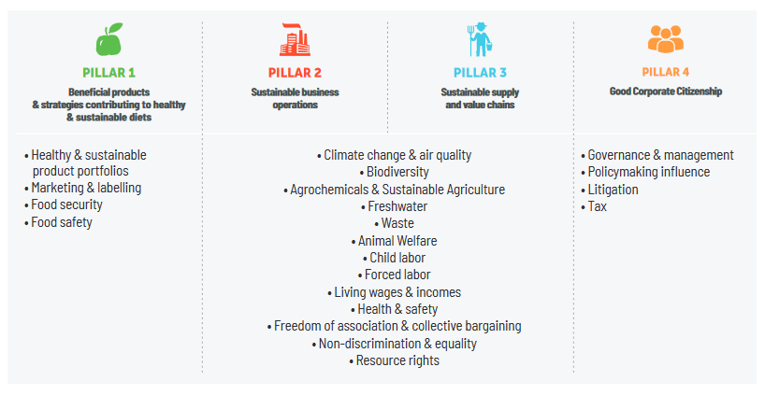
Source: Sachs J. et al., 2021. “Fixing the Business of Food 2021: Aligning food company practices with the SDGs”, Barilla Center for Food & Nutrition, UN Sustainable Development Solutions Network, Columbia Center on Sustainable Investment, Santa Chiara Lab University of Siena.
References
ABS. (2019). Australian National Accounts: Input-Output Tables (5209.0). Retrieved from Canberra, Australia:
ATLAS. (2021). The Atlas of Economic Complexity: http://atlas.cid.harvard.edu/ (Vol. 2021).
Lenzen, M., Geschke, A., West, J., Fry, J., Malik, A., Giljum, S., . . . Schandl, H. (2021). Implementing the Material Footprint to measure progress towards SDGs 8 and 12. Nature Sustainability, accepted.
Miller, R. E., & Blair, P. D. (2010). Input-Output Analysis: Foundations and Extensions. Englewood Cliffs, NJ, USA: Prentice-Hall.
SCP-HAT. (2021). Hotspot analysis tool for sustainable consumption and production: http://scp-hat.lifecycleinitiative.org/.

