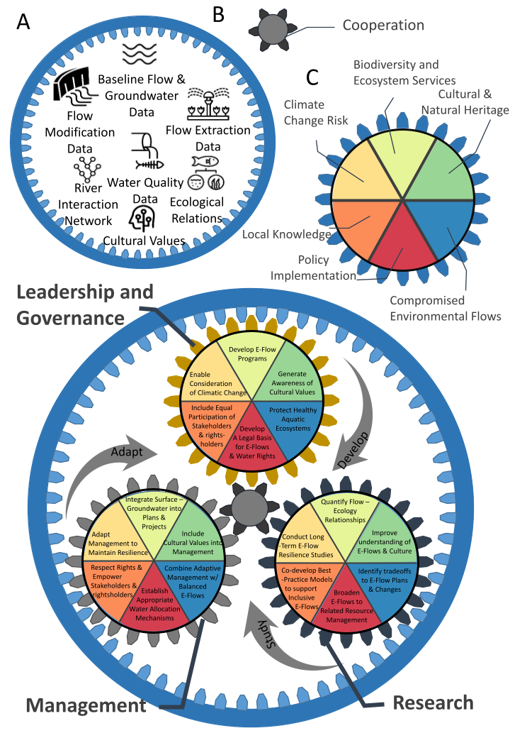
Figure S2.1 An illustrated version of the Brisbane Declaration, depicted as a planetary gear system to solve planetary problems. The upper panel (a, b, c) shows the primary components of a "planetary" gear system and how each component relates to the Brisbane Declaration. Gear A is the "Ring" gear responsible for supporting the gear system. The analogy to the Brisbane declaration is the multiple sources of data needed to inform environmental flow guidance. Gear B is the "sun" gear, which is responsible for ensuring all other gears maintain position and spin synchronously. For the Brisbane Declaration, this gear is synonymous with cooperation. Gear C is a "planet" gear, responsible for governing the speed and output of the system. The Brisbane Declaration outlines six primary themes (shown in colored wedges) and that are scaled to three different organizations as planet gears: Leadership & Governance, Management, and Research.The lower panel shows the fully constructed planetary gear system and the specific objectives relative to each organization. The arrows indicate the primary action that each organization performs. In turn, cooperation controls the pace at which the planets spin together. Similarly, the ring gear allows all the planet gears and their categories to rotate in a stable manner. The pinions (C, three smaller gears) within the annular gears (A, larger outer gear) are metaphors for data integrity and institutional support. If specific pinions are missing, the system is at risk to operate less efficiently, and if entire gears or whole sections of pinions are missing, the system will fail.

