**Appendix for Spatialising state practices through transnational repression**

**Tajikistan Political Exiles descriptive statistics**

|  |  |  |
| --- | --- | --- |
| **Statistics** | | |
| Alleged affiliations | | |
| N | Valid | 68 |
| Missing | 0 |

|  |  |  |  |  |  |
| --- | --- | --- | --- | --- | --- |
| **Alleged affiliations** | | | | | |
|  | | Frequency | Percent | Valid Percent | Cumulative Percent |
| Valid | Regime Insider | 3 | 4.4 | 4.4 | 4.4 |
| IRPT | 9 | 13.2 | 13.2 | 17.6 |
| Group24 | 33 | 48.5 | 48.5 | 66.2 |
| Other opposition | 9 | 13.2 | 13.2 | 79.4 |
| RelgExtrem | 11 | 16.2 | 16.2 | 95.6 |
| Journalist | 3 | 4.4 | 4.4 | 100.0 |
| Total | 68 | 100.0 | 100.0 |  |

Cross tab analysis

|  |  |  |  |  |  |  |
| --- | --- | --- | --- | --- | --- | --- |
| **Case Processing Summary** | | | | | | |
|  | Cases | | | | | |
| Valid | | Missing | | Total | |
| N | Percent | N | Percent | N | Percent |
| Host countries * Alleged affiliations | 68 | 100.0% | 0 | 0.0% | 68 | 100.0% |

|  |  |  |  |  |  |  |  |  |  |  |  |
| --- | --- | --- | --- | --- | --- | --- | --- | --- | --- | --- | --- |
| **Host countries * Alleged affiliations Crosstabulation** | | | | | | | | | | | |
|  | | | Alleged affiliations | | | | | | | Total | |
| Regime Insider | IRPT | Group24 | Other opposition | RelgExtrem | Journalist |  | |
| Host countries | EU | Count | 0 | 5 | 3 | 1 | 0 | 2 | 11 | |
| % within Host countries | 0.0% | 45.5% | 27.3% | 9.1% | 0.0% | 18.2% | 100.0% | |
| % within Alleged affiliations | 0.0% | 55.6% | 9.1% | 11.1% | 0.0% | 66.7% | 16.2% | |
| Russia | Count | 2 | 2 | 25 | 7 | 10 | 0 | 46 | |
| % within Host countries | 4.3% | 4.3% | 54.3% | 15.2% | 21.7% | 0.0% | 100.0% | |
| % within Alleged affiliations | 66.7% | 22.2% | 75.8% | 77.8% | 90.9% | 0.0% | 67.6% | |
| Turkey | Count | 0 | 2 | 5 | 0 | 0 | 1 | 8 | |
| % within Host countries | 0.0% | 25.0% | 62.5% | 0.0% | 0.0% | 12.5% | 100.0% | |
| % within Alleged affiliations | 0.0% | 22.2% | 15.2% | 0.0% | 0.0% | 33.3% | 11.8% | |
| Other | Count | 1 | 0 | 0 | 1 | 1 | 0 | 3 | |
| % within Host countries | 33.3% | 0.0% | 0.0% | 33.3% | 33.3% | 0.0% | 100.0% | |
| % within Alleged affiliations | 33.3% | 0.0% | 0.0% | 11.1% | 9.1% | 0.0% | 4.4% | |
| Total | | Count | 3 | 9 | 33 | 9 | 11 | 3 | 68 | |
| % within Host countries | 4.4% | 13.2% | 48.5% | 13.2% | 16.2% | 4.4% | 100.0% | |
| % within Alleged affiliations | 100.0% | 100.0% | 100.0% | 100.0% | 100.0% | 100.0% | 100.0% | |

|  |  |  |  |  |  |  |  |  |  |  |  |  |  |  |  |  |  |  |  |  |  |  |  |  |  |  |  |  |  |  |  |  |  |  |  |  |  |  |  |  |  |  |  |  |  |  |  |  |  |  |  |  |  |  |  |  |  |  |  |  |  |  |  |  |  |  |  |  |  |  |  |  |  |  |  |  |  |  |  |  |  |  |  |  |  |  |  |  |  |  |  |  |  |  |  |  |  |  |  |  |  |  |  |  |  |  |  |  |  |  |  |  |  |  |  |  |  |  |  |  |  |  |  |  |  |  |  |  |  |  |  |  |  |  |  |  |  |  |  |  |  |  |  |  |  |  |  |  |  |  |  |
| --- | --- | --- | --- | --- | --- | --- | --- | --- | --- | --- | --- | --- | --- | --- | --- | --- | --- | --- | --- | --- | --- | --- | --- | --- | --- | --- | --- | --- | --- | --- | --- | --- | --- | --- | --- | --- | --- | --- | --- | --- | --- | --- | --- | --- | --- | --- | --- | --- | --- | --- | --- | --- | --- | --- | --- | --- | --- | --- | --- | --- | --- | --- | --- | --- | --- | --- | --- | --- | --- | --- | --- | --- | --- | --- | --- | --- | --- | --- | --- | --- | --- | --- | --- | --- | --- | --- | --- | --- | --- | --- | --- | --- | --- | --- | --- | --- | --- | --- | --- | --- | --- | --- | --- | --- | --- | --- | --- | --- | --- | --- | --- | --- | --- | --- | --- | --- | --- | --- | --- | --- | --- | --- | --- | --- | --- | --- | --- | --- | --- | --- | --- | --- | --- | --- | --- | --- | --- | --- | --- | --- | --- | --- | --- | --- | --- | --- | --- | --- | --- | --- | --- |
| **Worst stage experienced * Alleged affiliations Crosstabulation**   |  |  |  |  |  |  |  | | --- | --- | --- | --- | --- | --- | --- | | **Case Processing Summary** | | | | | | | |  | Cases | | | | | | | Valid | | Missing | | Total | | | N | Percent | N | Percent | N | Percent | | Worst stage experienced * Alleged affiliations | 67 | 98.5% | 1 | 1.5% | 68 | 100.0% |  |  |  |  |  |  |  |  |  |  |  | | --- | --- | --- | --- | --- | --- | --- | --- | --- | --- | |  | | | Alleged affiliations | | | | | | Total | | Regime Insider | IRPT | Group24 | Other opposition | RelgExtrem | Journalist | | Worst stage experienced | notice | Count | 0 | 3 | 1 | 0 | 0 | 2 | 6 | | % within Worst stage experienced | 0.0% | 50.0% | 16.7% | 0.0% | 0.0% | 33.3% | 100.0% | | % within Alleged affiliations | 0.0% | 33.3% | 3.0% | 0.0% | 0.0% | 66.7% | 9.0% | | detention arrests | Count | 1 | 1 | 21 | 2 | 7 | 1 | 33 | | % within Worst stage experienced | 3.0% | 3.0% | 63.6% | 6.1% | 21.2% | 3.0% | 100.0% | | % within Alleged affiliations | 33.3% | 11.1% | 63.6% | 25.0% | 63.6% | 33.3% | 49.3% | | extradition | Count | 2 | 5 | 11 | 6 | 4 | 0 | 28 | | % within Worst stage experienced | 7.1% | 17.9% | 39.3% | 21.4% | 14.3% | 0.0% | 100.0% | | % within Alleged affiliations | 66.7% | 55.6% | 33.3% | 75.0% | 36.4% | 0.0% | 41.8% | | Total | | Count | 3 | 9 | 33 | 8 | 11 | 3 | 67 | | % within Worst stage experienced | 4.5% | 13.4% | 49.3% | 11.9% | 16.4% | 4.5% | 100.0% | | % within Alleged affiliations | 100.0% | 100.0% | 100.0% | 100.0% | 100.0% | 100.0% | 100.0% | |

|  |  |  |  |  |  |  |  |  |  |  |  |  |  |  |  |  |  |  |  |  |  |  |  |  |  |  |  |  |  |  |  |  |  |  |  |  |  |  |  |  |
| --- | --- | --- | --- | --- | --- | --- | --- | --- | --- | --- | --- | --- | --- | --- | --- | --- | --- | --- | --- | --- | --- | --- | --- | --- | --- | --- | --- | --- | --- | --- | --- | --- | --- | --- | --- | --- | --- | --- | --- | --- |
| **Worst stage experienced * Host countries Crosstabulation**   |  |  |  |  |  |  |  | | --- | --- | --- | --- | --- | --- | --- | | **Case Processing Summary** | | | | | | | |  | Cases | | | | | | | Valid | | Missing | | Total | | | N | Percent | N | Percent | N | Percent | | Worst stage experienced * Host countries | 67 | 98.5% | 1 | 1.5% | 68 | 100.0% | | | | | | | | |
|  | | | Host countries | | | | Total |
| EU | Russia | Turkey | Other |
| Worst stage experienced | notice | Count | 4 | 0 | 2 | 0 | 6 |
| % within Worst stage experienced | 66.7% | 0.0% | 33.3% | 0.0% | 100.0% |
| % within Host countries | 36.4% | 0.0% | 25.0% | 0.0% | 9.0% |
| detention arrests | Count | 3 | 24 | 4 | 2 | 33 |
| % within Worst stage experienced | 9.1% | 72.7% | 12.1% | 6.1% | 100.0% |
| % within Host countries | 27.3% | 52.2% | 50.0% | 100.0% | 49.3% |
| extradition | Count | 4 | 22 | 2 | 0 | 28 |
| % within Worst stage experienced | 14.3% | 78.6% | 7.1% | 0.0% | 100.0% |
| % within Host countries | 36.4% | 47.8% | 25.0% | 0.0% | 41.8% |
| Total | | Count | 11 | 46 | 8 | 2 | 67 |
| % within Worst stage experienced | 16.4% | 68.7% | 11.9% | 3.0% | 100.0% |
| % within Host countries | 100.0% | 100.0% | 100.0% | 100.0% | 100.0% |

|  |  |  |  |  |  |  |  |  |  |  |  |  |  |  |  |  |  |  |  |  |  |  |  |  |  |  |  |  |  |  |  |  |  |  |  |  |  |  |  |  |
| --- | --- | --- | --- | --- | --- | --- | --- | --- | --- | --- | --- | --- | --- | --- | --- | --- | --- | --- | --- | --- | --- | --- | --- | --- | --- | --- | --- | --- | --- | --- | --- | --- | --- | --- | --- | --- | --- | --- | --- | --- |
| **Violence experienced * Host countries Crosstabulation**   |  |  |  |  |  |  |  | | --- | --- | --- | --- | --- | --- | --- | | **Case Processing Summary** | | | | | | | |  | Cases | | | | | | | Valid | | Missing | | Total | | | N | Percent | N | Percent | N | Percent | | Worst stage experienced * Host countries | 67 | 98.5% | 1 | 1.5% | 68 | 100.0% | | | | | | | | |
|  | | | Host countries | | | | Total |
| EU | Russia | Turkey | Other |
| Violence experienced | uknown | Count | 7 | 38 | 7 | 3 | 55 |
| % within Violence experienced | 12.7% | 69.1% | 12.7% | 5.5% | 100.0% |
| % within Host countries | 70.0% | 82.6% | 87.5% | 100.0% | 82.1% |
| phys_attack | Count | 2 | 7 | 0 | 0 | 9 |
| % within Violence experienced | 22.2% | 77.8% | 0.0% | 0.0% | 100.0% |
| % within Host countries | 20.0% | 15.2% | 0.0% | 0.0% | 13.4% |
| assass_attempt | Count | 1 | 1 | 0 | 0 | 2 |
| % within Violence experienced | 50.0% | 50.0% | 0.0% | 0.0% | 100.0% |
| % within Host countries | 10.0% | 2.2% | 0.0% | 0.0% | 3.0% |
| death | Count | 0 | 0 | 1 | 0 | 1 |
| % within Violence experienced | 0.0% | 0.0% | 100.0% | 0.0% | 100.0% |
| % within Host countries | 0.0% | 0.0% | 12.5% | 0.0% | 1.5% |
| Total | | Count | 10 | 46 | 8 | 3 | 67 |
| % within Violence experienced | 14.9% | 68.7% | 11.9% | 4.5% | 100.0% |
| % within Host countries | 100.0% | 100.0% | 100.0% | 100.0% | 100.0% |

|  |  |  |  |  |  |  |  |  |  |  |  |  |  |  |  |  |  |  |  |  |  |  |  |  |  |  |  |  |  |  |  |  |  |
| --- | --- | --- | --- | --- | --- | --- | --- | --- | --- | --- | --- | --- | --- | --- | --- | --- | --- | --- | --- | --- | --- | --- | --- | --- | --- | --- | --- | --- | --- | --- | --- | --- | --- |
| |  |  |  |  |  |  |  | | --- | --- | --- | --- | --- | --- | --- | | **International arrest warrants * Alleged affiliations Crosstabulation**  **Case Processing Summary** | | | | | | | |  | Cases | | | | | | | Valid | | Missing | | Total | | | N | Percent | N | Percent | N | Percent | | International arrest warrants * Alleged affiliations | 67 | 98.5% | 1 | 1.5% | 68 | 100.0% | |

|  |  |  |  |  |  |  |  |  |  |
| --- | --- | --- | --- | --- | --- | --- | --- | --- | --- |
| **International arrest warrants * Alleged affiliations Crosstabulation** | | | | | | | | | |
|  | | | Alleged affiliations | | | | | | Total |
| Regime Insider | IRPT | Group24 | Other opposition | RelgExtrem | Journalist |
| International arrest warrants | unknown | Count | 2 | 5 | 28 | 6 | 3 | 3 | 47 |
| % within International arrest warrants | 4.3% | 10.6% | 59.6% | 12.8% | 6.4% | 6.4% | 100.0% |
| % within Alleged affiliations | 66.7% | 62.5% | 84.8% | 66.7% | 27.3% | 100.0% | 70.1% |
| interpol | Count | 1 | 2 | 3 | 2 | 0 | 0 | 8 |
| % within International arrest warrants | 12.5% | 25.0% | 37.5% | 25.0% | 0.0% | 0.0% | 100.0% |
| % within Alleged affiliations | 33.3% | 25.0% | 9.1% | 22.2% | 0.0% | 0.0% | 11.9% |
| other | Count | 0 | 1 | 2 | 1 | 8 | 0 | 12 |
| % within International arrest warrants | 0.0% | 8.3% | 16.7% | 8.3% | 66.7% | 0.0% | 100.0% |
| % within Alleged affiliations | 0.0% | 12.5% | 6.1% | 11.1% | 72.7% | 0.0% | 17.9% |
| Total | | Count | 3 | 8 | 33 | 9 | 11 | 3 | 67 |
| % within International arrest warrants | 4.5% | 11.9% | 49.3% | 13.4% | 16.4% | 4.5% | 100.0% |
| % within Alleged affiliations | 100.0% | 100.0% | 100.0% | 100.0% | 100.0% | 100.0% | 100.0% |

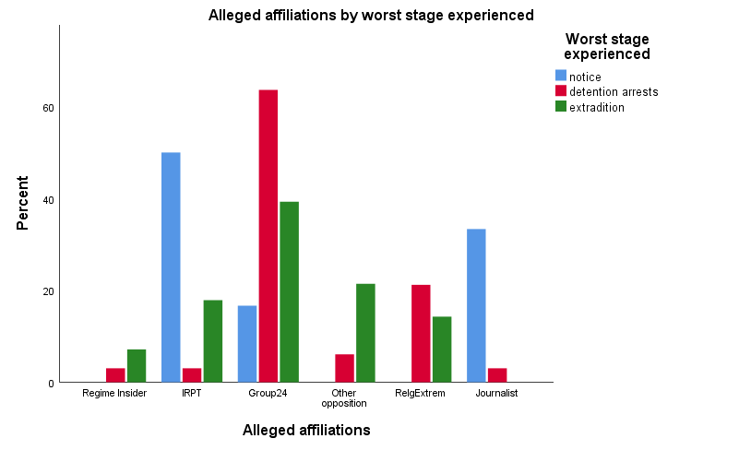

**CAPE Cross-Country Analysis**

|  |  |  |
| --- | --- | --- |
| **Statistics** | | |
| Worst stage experienced | | |
| N | Valid | 273 |
| Missing | 5 |

|  |  |  |  |  |  |
| --- | --- | --- | --- | --- | --- |
| **Worst stage experienced** | | | | | |
|  | | Frequency | Percent | Valid Percent | Cumulative Percent |
| Valid | on notice | 34 | 12.2 | 12.5 | 12.5 |
| detention/arrest | 128 | 46.0 | 46.9 | 59.3 |
| rendit/kidnap | 111 | 39.9 | 40.7 | 100.0 |
| Total | 273 | 98.2 | 100.0 |  |
| Missing | System | 5 | 1.8 |  |  |
| Total | | 278 | 100.0 |  |  |

|  |  |  |  |  |  |  |
| --- | --- | --- | --- | --- | --- | --- |
| **Worst stage experienced * States of Concern Crosstabulation**  **Case Processing Summary** | | | | | | |
|  | Cases | | | | | |
| Valid | | Missing | | Total | |
| N | Percent | N | Percent | N | Percent |
| Worst stage experienced * States of Concern | 273 | 98.2% | 5 | 1.8% | 278 | 100.0% |

|  |  |  |  |  |  |  |  |  |
| --- | --- | --- | --- | --- | --- | --- | --- | --- |
|  | | | | | | | | |
|  | | | States of Concern | | | | | Total |
| TKM | TAJ | KYR | UZB | KZK |
| Worst stage experienced | on notice | Count | 9 | 6 | 3 | 16 | 0 | 34 |
| % within Worst stage experienced | 26.5% | 17.6% | 8.8% | 47.1% | 0.0% | 100.0% |
| % within States of Concern | 23.7% | 9.0% | 20.0% | 12.2% | 0.0% | 12.5% |
| detention/arrest | Count | 17 | 33 | 8 | 56 | 14 | 128 |
| % within Worst stage experienced | 13.3% | 25.8% | 6.3% | 43.8% | 10.9% | 100.0% |
| % within States of Concern | 44.7% | 49.3% | 53.3% | 42.7% | 63.6% | 46.9% |
| rendit/kidnap | Count | 12 | 28 | 4 | 59 | 8 | 111 |
| % within Worst stage experienced | 10.8% | 25.2% | 3.6% | 53.2% | 7.2% | 100.0% |
| % within States of Concern | 31.6% | 41.8% | 26.7% | 45.0% | 36.4% | 40.7% |
| Total | | Count | 38 | 67 | 15 | 131 | 22 | 273 |
| % within Worst stage experienced | 13.9% | 24.5% | 5.5% | 48.0% | 8.1% | 100.0% |
| % within States of Concern | 100.0% | 100.0% | 100.0% | 100.0% | 100.0% | 100.0% |

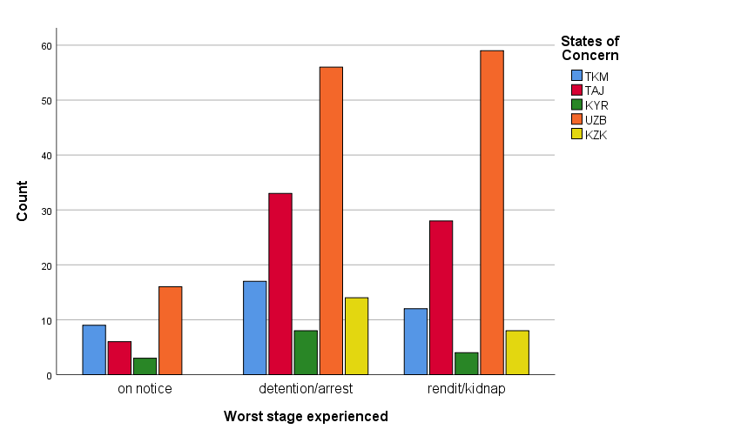

**International arrest warrants * States of Concern Crosstabulation**

|  |  |  |  |  |  |  |
| --- | --- | --- | --- | --- | --- | --- |
| **Case Processing Summary** | | | | | | |
|  | Cases | | | | | |
| Valid | | Missing | | Total | |
| N | Percent | N | Percent | N | Percent |
| International arrest warrants * States of Concern | 274 | 98.6% | 4 | 1.4% | 278 | 100.0% |

|  |  |  |  |  |  |  |  |  |
| --- | --- | --- | --- | --- | --- | --- | --- | --- |
|  | | | | | | | | |
|  | | | States of Concern | | | | | Total |
| TKM | TAJ | KYR | UZB | KZK |
| International arrest warrants | unknown | Count | 35 | 47 | 11 | 102 | 11 | 206 |
| % within International arrest warrants | 17.0% | 22.8% | 5.3% | 49.5% | 5.3% | 100.0% |
| % within States of Concern | 89.7% | 70.1% | 73.3% | 77.9% | 50.0% | 75.2% |
| Interpol | Count | 2 | 8 | 0 | 7 | 7 | 24 |
| % within International arrest warrants | 8.3% | 33.3% | 0.0% | 29.2% | 29.2% | 100.0% |
| % within States of Concern | 5.1% | 11.9% | 0.0% | 5.3% | 31.8% | 8.8% |
| other | Count | 2 | 12 | 4 | 22 | 4 | 44 |
| % within International arrest warrants | 4.5% | 27.3% | 9.1% | 50.0% | 9.1% | 100.0% |
| % within States of Concern | 5.1% | 17.9% | 26.7% | 16.8% | 18.2% | 16.1% |
| Total | | Count | 39 | 67 | 15 | 131 | 22 | 274 |
| % within International arrest warrants | 14.2% | 24.5% | 5.5% | 47.8% | 8.0% | 100.0% |
| % within States of Concern | 100.0% | 100.0% | 100.0% | 100.0% | 100.0% | 100.0% |

**Table: Comparing Islamic Revival Party of Tajikistan and Group of 24**

|  |  |  |  |  |  |  |  |  |
| --- | --- | --- | --- | --- | --- | --- | --- | --- |
|  | Number of TR cases | Estimated TR rate[1] | EU | Non-EU | Stage 1 | Stage 2 | Stage 3 | Names |
| Islamic Revival Party of Tajikistan members targeted between  (2015-2018) | 9 | 13% | 5 | 4 | 3 | 1 | 5 | Kabiri, Muhiddin  Kuzov, Mirzorahim  Saidov, Shamsiddin  Kayumov, Bobojon  Saidov, Islomiddin  Ghozi, Said Kiyomiddin  Sharipov, Namunjon [Numoniddin]  Kayumov, Bobojon  Zubaydullozoda, Khisom Zubaydullo (Rozikov, Hiaomiddin) |
| Group of 24 – members targeted between  (2013-2016) | 33 | 48.5% | 3 | 30 | 1 | 21 | 11 | Valiev, Sobir  Kuvatov [Quvatov], Umarali  Abdunazarov, Sohibnazar  Abdurakhmonova, Rosiya  Bafoev, Nuriddin  Chabirov, Sulaymon  Davlatov, Sulaiman  Gadoev, Sharofiddin  Gilyayev, Oyatullo  Ibragimov, Maksud  Jobirov, Makhmadali  Kholov, Ismoil  Khudoydodova, Shabnam  Komilov, Sheroz  Kurbonov, Nematullo  Loikov, Firuz  Mukhiddinov, Firdavs  Salikhov, Umedjon  Sattarov, Mehrobon  Sattori, Bakhtiyor  Sharifov, Sulton  Vosiyev, Abdurahim  Odinaev, Vaisiddin  Yusupov, Abdurahim  Yusupov, Firuz  Yusupov, Furkat  Buriev, Dalerdzhon  Khamidov, Abdurashid  Odinaev, Ehson  Gadoeva, Hafizamo  Sharipov, Nasim (Nasimjon)  Suhrob, Zafar  Tagoymurod, Mahmadiev |

1. Total number of Tajik population in exile as reported by CAPE is 68/number of TR repression cases of exiles