Supplemental Appendix
“Explaining Extremism: Western Women in Daesh” European Journal of International Security
Meredith Loken and Anna Zelenz

Appendix 1: Selecting and confirming accounts
To confirm that the self-identified muhajirat are in IS-controlled territory and to determine their region of origin we gathered evidence of online interactions with social media users, referenced photographs, and examined post content. Examples of confirming factors include primary language, use of Arabic phrases and idioms, self-identification as a Western migrant, references to Western states and their laws, witness testimony of coalition airstrikes, photographs of Raqqa and Mosul, discussion of Ramadan within the Islamic State, conversation with and reference to other muhajirat on social media, answering questions about life in IS, and reflection on their journeys to the Middle East. Furthermore, communication between muhajirat, their photographs of one another and their daily lives, and their linguistic style enable us to recognize them as young women.

We used the rubric below to standardize our selection process.

 | Selection/Confirmation Rubric
Confirmed | Muhajirat is a Western migrant living in Daesh:  · Identified as a Muslim woman through snowball method and  · Self-identities as living in Syria, Iraq, Sham, the Islamic State, Daesh, or the Caliphate and  · Self-identifies as originating from Europe (excluding Russia and Turkey), the United States of America, Canada, Australia, or New Zealand or  · Self-identifies as originating, moving from, or missing “the West,” or  · Makes repeated references to a Western country and speaks a primary or secondary language suggesting Western origin and  · Posts information indicating a life under Daesh, including witness testimony of coalition airstrikes, photographs of people and places in Raqqa and Mosul, references to husbands and reactions to martyrdom, discussion of Ramadan within the Islamic State, answering questions about life in Daesh, and reflection on hijra and  · Has social media interactions with other muhajirat and/or known Daesh fighters and male foreign migrants and  · Confirmed independently by authors through coder-reliability checks and  · When possible, verifiable by counterterrorism researchers and/or journalists
Confirmed but  not Western | Muhajirat is a non-Western migrant living in the Daesh:  · Identified as a Muslim woman through snowball method and  · Self-identities as living in Syria, Iraq, Sham, Daesh, or the Caliphate and  · Self-identifies as originating from a country that is not in Europe (excluding Russia and Turkey), the United States of America, Canada, Australia, or New Zealand or  · Self-identifies as originating, moving from, or missing a non-Western country or  · Makes repeated references to a non-Western country and speaks a primary or secondary language suggesting non-Western origin and  · Posts information indicating a life under Daesh, including witness testimony of coalition airstrikes, photographs of people and places in Raqqa and Mosul, references to husbands and reactions to martyrdom, discussion of Ramadan within Daesh, answering questions about life in Daesh, and reflection on hijra and  · Has social media interactions with other muhajirat and/or known IS fighters and male foreign migrants and  · Confirmed independently by authors through coder-reliability checks and  · When possible, verifiable by counterterrorism researchers and/or journalists
Unconfirmed | Account author is not living in Daesh or has unverifiable whereabouts and origin:  · Identified as a woman through snowball method and  · May or may not self-identify as living in Syria, Iraq, Sham, the Islamic State, Daesh, or the Caliphate and  · May or may not self-identify as originating from a Western state or  · May or may not self-identify as originating, moving from, or missing a Western country and  · May or may make repeated references to a Western state and may or may not speak a primary language suggesting Western origin and  · Does not post information or posts inconclusive information indicating a life under Daesh or making hijra and  · Has social media interactions with muhajirat and/or known Daesh fighters and male foreign migrants and  · Rejected independently by authors through coder-reliability checks and  · Not verifiable by counterterrorism researchers and/or journalists

Appendix 2.1: Code Cloud and Description of Data
The following code cloud includes both the deductive and inductive codes used to assess this data. The deductive codes are labeled with color by theoretical framework (erotomania = red; deception = orange; isolation = blue; religion/ideology = green). The emergent, inductively produced codes are bracketed in gray. This provides a visual representation of code frequency and dominance within the complete dataset.

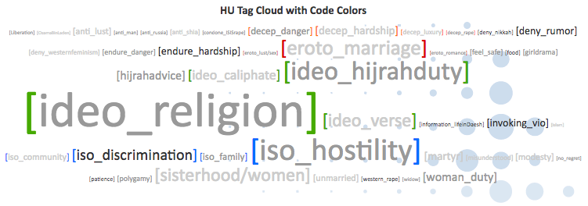

Beginning with the deductive codes, the overwhelming presence of religious language dominated the data. This includes references to Islam, invocations of religious phrases, and propagation of Islamist ideas. The idea that hijra is a duty was also quite present. Beyond these concepts, hostility towards the West and references to discrimination against Muslims was a strong theme. While conversation or references to marriage occurred often (and are analyzed in this paper), it should be noted that reference to romance, love, lust, and sex were not frequent.

Codes that ‘emerged’ from the data with consistency across cases include references to newfound sisterhood and women friendships. This supplements our theory about isolation and the desire for community driving migration. The gendered nature of these posts is also clear in the frequency with which women’s duties are explicitly discussed. Many of these posts are also religiously oriented. Furthermore, many of the posts invoke violence (against the West). While the data do discuss hardship and danger, it is important to note that they also include references to the importance of enduring hardship and danger – themes that emerged from the data. Finally, the code “hijrahadvice” is evident in this cloud. It was quite common for posts to give advice regarding how to travel to Iraq or Syria, what to bring, how to avoid detection, etc. The emergence of this code is not surprising, considering the focus of the dataset is largely on migration.

Appendix 2.2: Descriptive statistics regarding deductive code

The following table provides key information on the frequency of the deductive codes within each case. Importantly, 46% of posts include one or more of the “ideology” codes (caliphate, hijrah duty, religion, or verse). Comparatively, “erotomania” and “deception” codes combined appear in less than 20% of all posts. If we account for the number of marriage posts that are religious rather than erotic, or the hardship posts that encourage women to endure, this number would be even smaller.
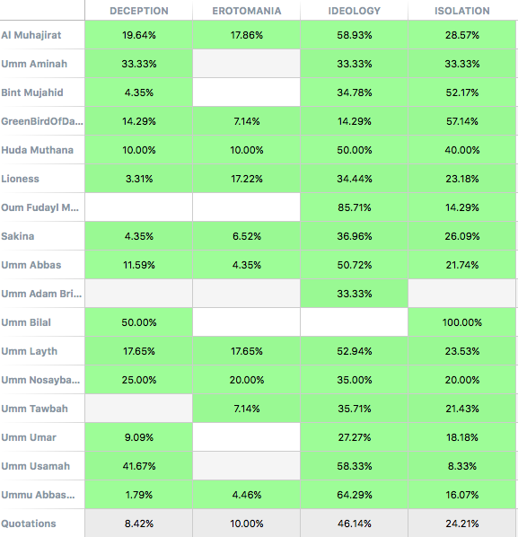

A single researcher hand coded this data. Future work should re-code the same data for reliability, and/or seek out new data sets on which to test the codes generated here. Because this work is exploratory, we feel there is still much to be learned from even this first look at the new data.
“Erotomania” codes reflect the sex and romance hypotheses laid out in the article.
A single researcher hand coded this data. Future work should re-code the same data for reliability, and/or seek out new data sets on which to test the codes generated here. Because this work is exploratory, we feel there is still much to be learned from even this first look at the new data.

