Online Appendices for “Divisive or Descriptive?: How Americans Understand Critical Race Theory”

Contents

Appendix A: Question Wording

Appendix B: Regression Tables and Supplementary Figures Appendix C: Results Among White Respondents Only Appendix D: Additional Open-Ended Results
Appendix E: Open-Ended Coding

Appendix A: Question Wording
*CRT Questions appeared in the exact order printed here. Notes on randomization are contained in brackets.

How concerned, if at all, are you with how American history is currently taught in K-12 public schools?[Randomly reversed order of response options]
- Very concerned
- Somewhat concerned
- Not very concerned
- Not at all concerned

Do you support or oppose teaching [Randomly present each statement to half of respondents: Critical Race Theory (CRT)/ how racism continues to impact American society today] in public schools?
[Randomly reversed order of response options]
- Strongly support
- Somewhat support
- Neither support nor oppose
- Somewhat oppose
- Strongly oppose

How familiar are you with Critical Race Theory (CRT)? [Randomly reversed order of response options]
- Extremely familiar
- Very familiar
- Not very familiar
- Not at all familiar

How well do you believe Critical Race Theory (CRT) describes how American society works?
- Extremely well
- Very well
- Not very well
- Not at all well
- Don’t know

In your own words, please describe what Critical Race Theory (CRT) means to you: [open-ended]

Appendix B: Regression Tables and Supplementary Figures

Appendix Table B1. Support for Teaching CRT versus Teaching the Legacy of Racism in Public Schools

Dependent variable:

Ordinal Support (5 pt) Binary Support

Unweighted |  | Weighted | Unweighted | Weighted
(1) |  | (2) | (3) | (4)
CRT -0.143***  Condition |  | -0.138*** | -0.250*** | -0.249***
(0.005) |  | (0.005) | (0.007) | (0.007)
Constant 0.624*** |  | 0.617*** | 0.531*** | 0.522***
(0.003) |  | (0.003) | (0.005) | (0.005)
Observation 19,032 s |  | 19,032 | 19,032 | 19,032
R² 0.044 |  | 0.041 | 0.065 | 0.065
Adjusted R² 0.044 |  | 0.041 | 0.065 | 0.065
Residual 0.333 |  | 0.338 | 0.475 | 0.478
Std. Error (df = 19030)
F Statistic (df = 1;  19030) | 874.600*** | 809.900*** | 1,319.000*** | 1,316.000***
Notes: *p<0.1; **p<0.05; ***p<0.01. OLS Estimates. Standard errors in parentheses. Ordinal dependent variable is coded 0=Strongly oppose, 0.25=Somewhat oppose, 0.5=Neither support nor oppose, 0.75= Somewhat support, 1= Strongly support. Binary dependent variable is coded 1=Strongly/ somewhat support, 0=otherwise. CRT condition is coded 1 if respondents were asked `Do you support or oppose teaching Critical Race Theory (CRT) in public schools?' CRT condition is coded as 0 if respondents were asked ' Do you support or oppose teaching how racism continues to impact American society today in public schools?

Appendix Table B2. Support for Teaching CRT versus Teaching the Legacy of Racism in Public Schools By Race.

Dependent variable:

Binary Support

 | All | All | Whites | Whites | Blacks | Blacks | Hisp. | Hisp. | Asian | Asian
Weights? | (N) | (Y) | (N) | (Y) | (N) | (Y) | (N) | (Y) | (N) | (Y)
CRT  Condition | -0.289*** | -0.290*** | -0.282*** | -0.276*** | -0.293*** | -0.300*** | -0.268*** | -0.287*** | -0.335*** | -0.326***
 | (0.027) | (0.028) | (0.011) | (0.011) | (0.023) | (0.023) | (0.029) | (0.030) | (0.035) | (0.036)
Black | 0.148*** | 0.146***
 | (0.024) | (0.024)
Hisp. | 0.024 | 0.014
 | (0.025) | (0.023)
Other Race | -0.082** | -0.042
 | (0.037) | (0.039)
White | -0.122*** | -0.124***
 | (0.020) | (0.020)
CRT  Condition*B lack | -0.005 | -0.013
 | (0.034) | (0.034)

CRT  Condition*H ispanic | 0.006 | 0.011
 | (0.036) | (0.033)
CRT  Condition*O ther | 0.053 | -0.010
 | (0.052) | (0.054)
CRT  Condition* White | 0.050* | 0.064**
 | (0.029) | (0.029)
Independent |  |  | -0.287*** | -0.276*** | -0.112*** | -0.129*** | -0.221*** | -0.270*** | -0.298*** | -0.256***
 |  |  | (0.014) | (0.014) | (0.035) | (0.035) | (0.037) | (0.037) | (0.044) | (0.045)
Republican/ Lean Republican |  |  | -0.487*** | -0.497*** | -0.391*** | -0.364*** | -0.367*** | -0.395*** | -0.378*** | -0.345***
 |  |  | (0.011) | (0.011) | (0.053) | (0.048) | (0.042) | (0.041) | (0.048) | (0.046)
CRT  Condition*I ndependent |  |  | 0.015 | 0.019 | -0.063 | -0.058 | -0.045 | 0.006 | 0.076 | 0.032
 |  |  | (0.020) | (0.020) | (0.049) | (0.049) | (0.054) | (0.052) | (0.067) | (0.066)
CRT  Condition*R epublican |  |  | 0.130*** | 0.142*** | 0.093 | 0.049 | -0.019 | 0.027 | 0.063 | 0.037
 |  |  | (0.016) | (0.016) | (0.075) | (0.070) | (0.059) | (0.057) | (0.071) | (0.069)

Constant 0.600***  (0.019) | 0.581***  (0.019) | 0.710***  (0.008) | 0.699***  (0.008) | 0.801***  (0.016) | 0.786***  (0.016) | 0.745***  (0.021) | 0.743***  (0.021) | 0.750***  (0.025) | 0.723***  (0.025)
Observation 19,032 | 19,032 | 13,391 | 13,391 | 2,276 | 2,276 | 1,698 | 1,698 | 1,160 | 1,160
s
R² 0.094 | 0.093 | 0.229 | 0.226 | 0.132 | 0.140 | 0.177 | 0.185 | 0.176 | 0.167
Adjusted R² 0.093 | 0.092 | 0.228 | 0.226 | 0.131 | 0.138 | 0.175 | 0.183 | 0.173 | 0.163
Residual 0.468 (df | 0.471 (df = | 0.421 (df = | 0.400 (df = | 0.458 (df = | 0.482 (df = | 0.454 (df = | 0.602 (df = | 0.454 (df = | 0.449 (df =
Std. Error = 19022) | 19022) | 13385) | 13385) | 2270) | 2270) | 1692) | 1692) | 1154) | 1154)
F Statistic 218.433* | 216.257*** (df | 792.990*** (df | 783.351*** (df | 69.331*** (df | 74.011*** (df | 72.886*** (df | 76.961*** (df | 49.465*** (df | 46.249*** (df
** (df = | = 9; 19022) | = 5; 13385) | = 5; 13385) | = 5; 2270) | = 5; 2270) | = 5; 1692) | = 5; 1692) | = 5; 1154) | = 5; 1154)
9;
19022)

Notes: *p<0.1; **p<0.05; ***p<0.01. OLS Estimates. Standard errors in parentheses. Binary dependent variable is coded 1=Strongly/ somewhat support, 0=otherwise. CRT condition is coded 1 if respondents were asked `Do you support or oppose teaching Critical Race Theory (CRT) in public schools?' CRT condition is coded as 0 if respondents were asked ' Do you support or oppose teaching how racism continues to impact American society today in public schools?'

Appendix Table B3. CATE on Support for Teaching CRT/ The Legacy of Racism by Party Identification and Negative Affect Toward Black People

Dependent variable:

Binary Support Binary Support Ordinal Support (5 pt)

 | Unweighted | Weighted | Unweighted | Weighted | Unweighted | Weighted
 | (1) | (2) | (3) | (4) | (5) | (6)
CRT Condition | -0.284*** | -0.285*** | 0.039 | 0.033 | -0.202*** | -0.196***
 | (0.009) | (0.009) | (0.024) | (0.024) | (0.018) | (0.018)
Independent | -0.261*** | -0.255***
 | (0.012) | (0.012)
Republican/Lean Republican | -0.489*** | -0.490***
 | (0.010) | (0.010)
CRT  Condition*Indepen dent | 0.004 | 0.005
 | (0.017) | (0.016)
CRT  Condition*Republi can | 0.117*** | 0.124***
 | (0.014) | (0.015)
Negative Affect |  |  | 0.622*** | 0.647*** | -0.801*** | -0.786***
 |  |  | (0.033) | (0.032) | (0.025) | (0.024)
CRT  Condition*Negativ e Affect |  |  | 0.050 | 0.042 | 0.117*** | 0.117***
 |  |  | (0.047) | (0.047) | (0.035) | (0.035)
Constant | 0.731*** | 0.724*** | -0.076*** | -0.079*** | 1.021*** | 1.003***

(0.006) | (0.006) | (0.017) | (0.017) | (0.013) | (0.012)
Observations 18,972 | 18,972 | 17,432 | 17,432 | 17,432 | 17,432
R² 0.220 | 0.217 | 0.046 | 0.049 | 0.134 | 0.130
Adjusted R² 0.220 | 0.216 | 0.046 | 0.048 | 0.133 | 0.129
Residual Std. Error 0.434 (df = | 0.438 (df = | 0.430 (df = | 0.434 (df = | 0.319 (df = | 0.324 (df =
18966) | 18966) | 17428) | 17428) | 17428) | 17428)
F Statistic 1,069.596*** | 1,049.298*** | 282.483*** | 296.398*** | 895.982*** | 864.394***
(df = 5; | (df = 5; | (df = 3; | (df = 3; | (df = 3; | (df = 3;
18966) | 18966) | 17428) | 17428) | 17428) | 17428)
Notes: *p<0.1; **p<0.05; ***p<0.01. OLS Estimates. Standard errors in parentheses. Binary dependent variable is coded 1=Strongly/ somewhat support, 0=otherwise. Ordinal dependent variable is coded 0=Strongly oppose, 0.25=Somewhat oppose, 0.5=Neither support nor oppose, 0.75= Somewhat support, 1= Strongly support. CRT condition is coded 1 if respondents were asked `Do you support or oppose teaching Critical Race Theory (CRT) in public schools?' CRT condition is coded as 0 if respondents were asked ' Do you support or oppose teaching how racism continues to impact American society today in public schools?' Negative affect is coded 0 to 1.

Appendix Figure B1. CATE of CRT Condition by Negative Affect (Ordinal Dependent Variable).
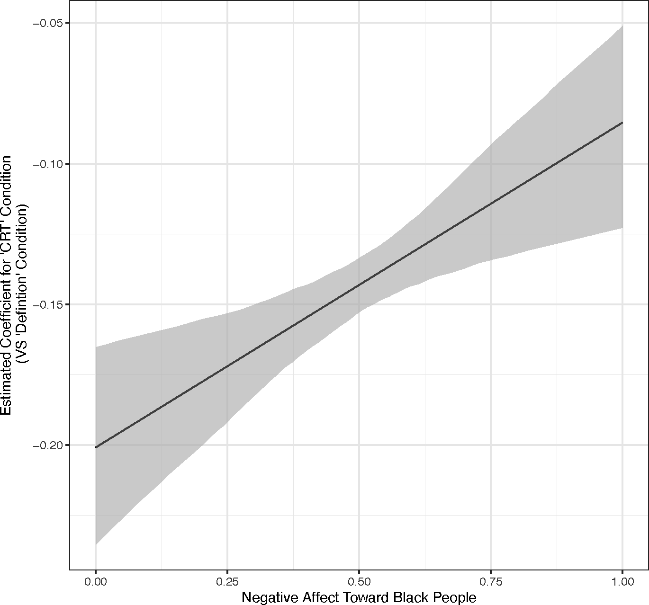
Note: Produced with unweighted estimates.

Appendix Figure B2. Predicted Probabilities of Teaching ‘CRT’ and ‘Legacy of Racism’ by Party Identification (Ordered Probit).
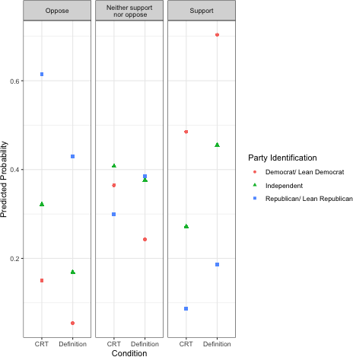
Note: Produced with unweighted estimates.

Appendix Figure B3. Predictors of Support for Teaching CRT/ the Impact of Racism in Schools.
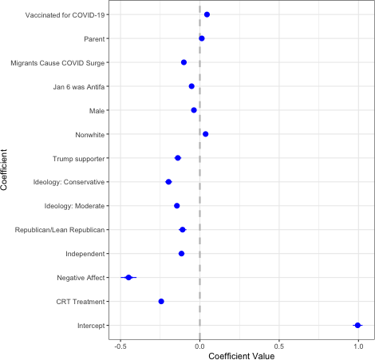
Note: We added an additional control item (agreement that the January 6th Capitol storming was Antifa) to the model in addition to the items specified in the pre-analysis plan. Results using unweighted estimates. Weighted estimates are similar (see table below).

Appendix Table B4. Predictors of Support for Teaching CRT/ The Impact of Racism in Public Schools.
Dependent variable:

Support Teaching CRT/ Legacy of Racism In Public Schools

 | Unweighted | Weighted
 | (1) | (2)
CRT Condition | -0.335*** (0.035) | -0.238*** (0.006)
Negative Affect |  | -0.424*** (0.024)
Independent | -0.298*** (0.044) | -0.115*** (0.009)
Republican/Lean Republican | -0.378*** (0.048) | -0.122*** (0.012)
Ideology: Moderate | 0.076 (0.067)
Ideology: Conservative | 0.063 (0.071)
Trump supporter |  | -0.128*** (0.008)
Nonwhite |  | -0.175*** (0.011)
Male |  | -0.144*** (0.011)
Jan 6 was Antifa |  | 0.030*** (0.007)
Migrants Cause COVID Surge |  | -0.031*** (0.006)
Parent |  | -0.051*** (0.007)
Vaccinated for COVID-19 |  | -0.102*** (0.007)
parent |  | 0.013** (0.007)
VaccinatedVaccinate d |  | 0.039*** (0.008)
Constant | 0.750*** (0.025) | 0.974*** (0.015)

Observations 1,160 17,218

R2 | 0.176 | 0.292
Adjusted R² | 0.173 | 0.291
Residual Std. Error | 0.454 (df = 1154) | 0.416 (df = 17204)
F Statistic | 49.465*** (df = 5; 1154) | 544.826*** (df = 13; 17204)
Notes: *p<0.1; **p<0.05; ***p<0.01. OLS Estimates. Standard errors in parentheses. Binary dependent variable is coded 1=Strongly/ somewhat support, 0=otherwise. CRT condition is coded 1 if respondents were asked `Do you support or oppose teaching Critical Race Theory (CRT) in public schools?' CRT condition is coded as 0 if respondents were asked ' Do you support or oppose teaching how racism continues to impact American society today in public schools?' Negative affect is coded 0 to 1. Antifa and Migrants are coded 0=Innacurate, 1=Accurate/ Not sure. Election Stolen coded 0=disagree/neither, 1= agree. All independent variables are coded between 0 and 1.

Appendix Table B5. Predictors of Saying CRT Describes Society Extremely/Very Well.

Dependent variable:

CRT Describes Society Extremely/Very Well

 | Unweighted | Weighted | Unweighted | Weighted
 | (1) | (2) | (3) | (4)
Independent | -0.150*** (0.008) | -0.139*** (0.008) | -0.124*** (0.009) | -0.115*** (0.009)
Republican/Lea n Republican | -0.184*** (0.009) | -0.166*** (0.009) | -0.118*** (0.011) | -0.111*** (0.011)
Ideology: Moderate | -0.170*** (0.007) | -0.173*** (0.007) | -0.129*** (0.008) | -0.126*** (0.008)
Ideology: Conservative | -0.199*** (0.010) | -0.201*** (0.009) | -0.141*** (0.011) | -0.137*** (0.010)
Nonwhite | 0.037*** (0.006) | 0.042*** (0.006) | 0.018*** (0.007) | 0.022*** (0.007)

Age |  |  | -0.001*** (0.0002) | -0.001*** (0.0002)
Male |  |  | 0.057*** (0.006) | 0.047*** (0.006)
Negative Affect |  |  | -0.240*** (0.023) | -0.212*** (0.023)
Trump supporter |  |  | -0.056*** (0.010) | -0.052*** (0.010)
Jan 6 was Antifa |  |  | -0.087*** (0.006) | -0.089*** (0.006)
Migrants Cause COVID Surge |  |  | -0.019*** (0.007) | -0.024*** (0.007)
Parent |  |  | 0.038*** (0.007) | 0.033*** (0.006)
Vaccinated for COVID-19 |  |  | 0.044*** (0.007) | 0.044*** (0.007)
Constant | 0.418*** (0.005) | 0.403*** (0.006) | 0.561*** (0.016) | 0.530*** (0.016)
Observations | 18,860 | 18,860 | 17,186 | 17,186
R2 | 0.142 | 0.134 | 0.173 | 0.163
Adjusted R² | 0.142 | 0.134 | 0.173 | 0.163
Residual Std. | 0.384 (df = | 0.384 (df = | 0.382 (df = | 0.383 (df =
Error | 18854) | 18854) | 17172) | 17172)
F Statistic | 624.019*** (df =  5; 18854) | 585.713*** (df =  5; 18854) | 277.220*** (df =  13; 17172) | 257.754*** (df =  13; 17172)
Notes: *p<0.1; **p<0.05; ***p<0.01. OLS Estimates. Standard errors in parentheses. Binary dependent variable is coded 1=CRT describes society well, 0=otherwise. Negative affect is coded 0 to 1. Antifa and Migrants are coded 0=Inaccurate, 1=Accurate/ Not sure. All independent variables are coded between 0 and 1.

Appendix Figure B4. Weighted Open Ended Responses (All Respondents).
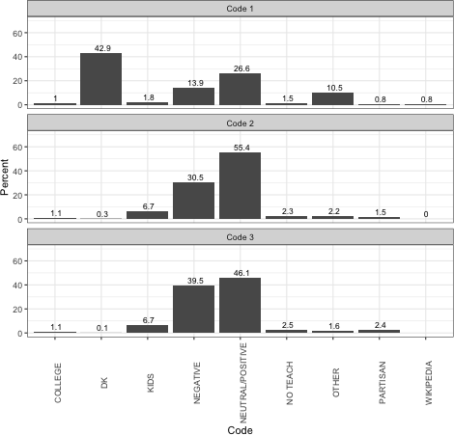
Notes: Weighted estimates. Each non-blank response was given at least one and up to three codes.

Appendix Figure B5. Open Ended Responses By Race.
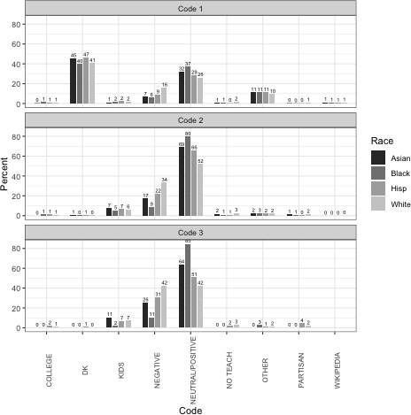
Notes: Unweighted estimates. Each non-blank response was given at least one and up to three codes.

As discussed in the main text of the paper, Black respondents are more likely than other racial and ethnic groups to provide neutral or positive definitions of CRT. White respondents, in contrast, are least likely to define CRT in neutral or positive ways. Black and White respondents are also slightly less likely to say they “don’t know” what CRT is, relative to Asian and Hispanic respondents. The breakdown of open-ended responses using hand-coding is shown in Appendix Figure B9 (above).

Appendix C. Results Among White Respondents Only.

Appendix Table C1. Support for Teaching CRT versus Teaching the Legacy of Racism in Public Schools (among White Respondents only).

Dependent variable:

 | Ordinal Support (5 pt) | Binary Support
 | (1) | (2)
CRT Condition | -0.145*** | -0.239***
 | (0.006) | (0.008)
Constant | 0.582*** | 0.478***
 | (0.004) | (0.006)
Observations R2  Adjusted R² | 13,429  0.045  0.045 | 13,429  0.062  0.062
Residual Std. | 0.334 | 0.465
Error (df = 13427)  F Statistic (df = 1; | 633.000*** | 885.700***
13427)

Notes: *p<0.1; **p<0.05; ***p<0.01. Among White respondents. OLS Estimates. Standard errors in parentheses. Ordinal dependent variable is coded 0=Strongly oppose, 0.25=Somewhat oppose, 0.5=Neither support nor oppose, 0.75= Somewhat support, 1= Strongly support. Binary dependent variable is coded 1=Strongly/ somewhat support, 0=otherwise. CRT condition is coded 1 if respondents were asked `Do you support or oppose teaching Critical Race Theory (CRT) in public schools?' CRT condition is coded as 0 if respondents were asked ' Do you support or oppose teaching how racism continues to impact American society today in public schools?'

Appendix Figure C1. Conditional Average Treatment Effect of ‘CRT Condition’ by Party Identification (Binary DV) among White Respondents.
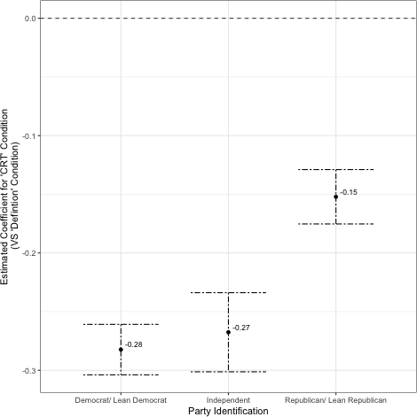
Notes: OLS Estimates among White respondents. Error bars are 95% confidence intervals. Dependent variable is support for teaching “Critical Race Theory (CRT)”/ “How racism continues to impact American society today” in public schools. Dependent variable is coded 1=Strongly/somewhat support, 0=Strongly/somewhat oppose and neither support nor oppose.

Appendix Figure C2. Conditional Effects Across Terciles of Negative Affect Among White Respondents.
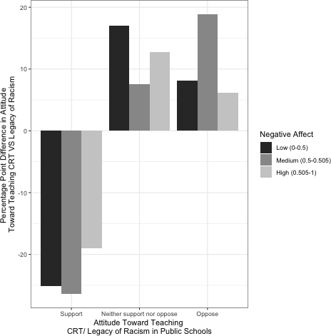
Notes: Negative differences indicate respondents rated CRT lower than for teaching the legacy of racism in public schools. Positive differences indicate CRT rated higher.

Appendix Figure C.3. CATE by Negative Affect Among White Respondents.
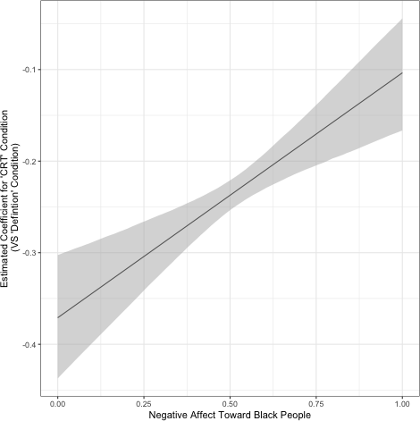
Notes: OLS Estimates among White respondents. Error bars are 95% confidence intervals. Dependent variable is support for teaching “Critical Race Theory (CRT)”/ “How racism continues to impact American society today” in public schools. Dependent variable is coded 1=Strongly/somewhat support, 0=Strongly/somewhat oppose and neither support nor oppose.

Appendix Table C2. CATE on Support for Teaching CRT/ The Legacy of Racism by Party Identification and Negative Affect Toward Black People (Among White Respondents).

Dependent variable:

Binary Support
(1) (2)

CRT Condition -0.282*** -0.371***
(0.011) (0.035)

Independent -0.287***
(0.014)

Republican/Lean Republican -0.487*** (0.011)
CRT Condition*Independent 0.015
(0.020)
CRT Condition*Republican 0.130*** (0.016)
Negative Affect -1.066***
(0.046)

CRT Condition*Negative Affect |  | 0.267***  (0.065)
Constant | 0.710*** | 1.031***
 | (0.008) | (0.025)
Observations | 13,391 | 12,401
R2 | 0.229 | 0.118
Adjusted R² | 0.228 | 0.118
Residual Std. Error | 0.421 (df = 13385) | 0.452 (df = 12397)
F Statistic | 793.000*** (df = 5; 13385) | 552.600*** (df = 3; 12397)

Notes: *p<0.1; **p<0.05; ***p<0.01. Among White respondents. OLS Estimates. Standard errors in parentheses. Binary dependent variable is coded 1=Strongly/ somewhat support, 0=otherwise. CRT condition is coded 1 if respondents were asked `Do you support or oppose teaching Critical Race Theory (CRT) in public schools?' CRT condition is coded as 0 if respondents were asked ' Do you support or oppose teaching how racism continues to impact American society today in public schools?' Negative affect is coded 0 to 1.

Appendix Figure C.4. Predictors of Familiarity with CRT.
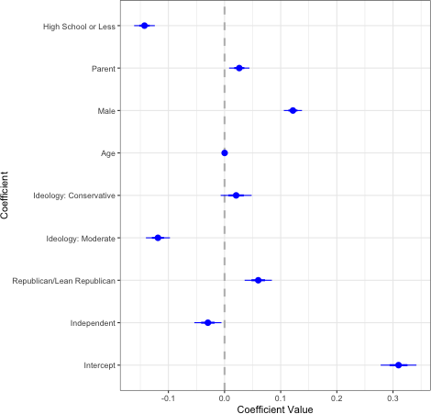

Notes: OLS estimates among White respondents. Error bars are 95% confidence intervals.

Appendix Figure C.5. Perceptions of Critical Race Theory (CRT) in Open-Ended Responses Among White Respondents.
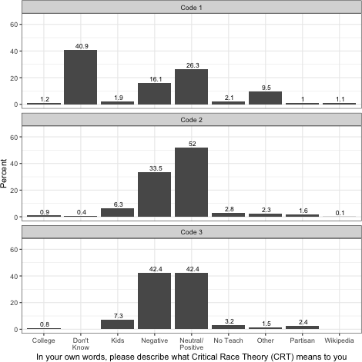
Notes: Unweighted estimates among White respondents. Each non-blank response was given at least one and up to three codes.

Appendix Figure C.6. Understandings of CRT by Partisanship Among White Respondents.
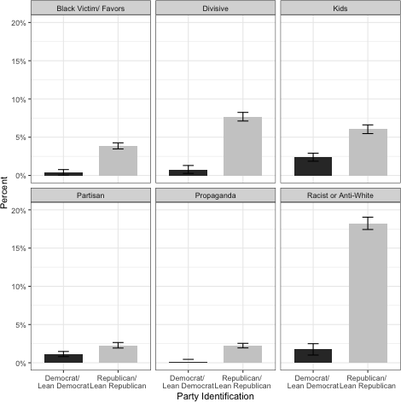
Notes: Unweighted estimates among White respondents. Error bars are 95% confidence intervals.

Appendix D: Additional Open-Ended Results
In conjunction with our qualitative evaluation of respondents’ open-ended responses to the question of what “Critical Race Theory” means to them, we conduct a quantitative analysis using pivoted text scaling (Hobbs 2019). Pivoted text scaling is a form of principal components analysis performed on a truncated word co-occurrence matrix, such that latent dimensions are inferred using frequently-occurring words and then all words are scaled based on their
co-occurrence with these relatively more frequent words. Like principal components analysis, the method identifies orthogonal latent dimensions in word co-occurrence that explain decreasing shares of variation in word co-occurrence. Each word is scaled with respect to each dimension, and documents can therefore be scaled with respect to each dimension by averaging their component word scores. This approach is especially useful for the analysis of short text documents, such as responses to open-ended survey questions, where infrequent words can complicate the interpretation of other unsupervised approaches such as topic modeling.
Before implementing pivoted text scaling, we pre-process written responses to make them suitable for quantitative analysis. This includes some standard steps such as removing punctuation, special characters, numbers, and stopwords, as well as stemming. It also includes some steps specific to our analysis, including expanding contractions and abbreviations of Critical Race Theory (i.e. “CRT” would be converted to “Critical Race Theory”) before concatenating commonly occuring multi-word phrases that carry distinct meaning – “Critical Race Theory,” “do not know,” and “not sure.” We also remove 267 documents that were

identified in qualitative evaluation as using language that closely resembled the Wikipedia entry for Critical Race Theory.
Table D1 shows the top “pivot” tokens, or frequently-occuring words that the poles of given dimension, for each of the first three dimensions. As in principal components analysis, the signs of the poles are not themselves interpreted (i.e. “positive” and “negative” are not meaningful and can be reversed). As each set of pivot tokens anchors a pole of a dimension, this means that dimensions are interpreted relationally – a document that scores high on a given dimension is emphasizing some aspect of the target concept over another aspect of it – unlike the results of topic models where a document that has a high topic proportion can be said to be “about” that topic itself.
For example, the first dimension contrasts documents that emphasize Critical Race Theory as an intellectual movement at the intersection of race and law (positive pole) with documents that express unfamiliarity and at times weakly negative sentiment (negative pole). Indeed, the respondent with the lowest-scoring document on this dimension made this explicit, writing “I don't know enough about it to have an opinion. From what I have heard it seems
one-sided to make while children feel bad about themselves. I feel bad for what happened in the past. It was before our time.” The second dimension contrasts distinctly negative sentiments – such as Critical Race Theory being a lie, or overtly anti-White – with clear unfamiliarity (capturing “do not know,” “no clue,” and “not sure.” Finally, the third dimension contrasts varying emphases on different aspects of Critical Race Theory – that race is a social construct (positive pole) and that legacies of oppression continue to influence our society today (negative pole).

Table D1. Top Pivot Tokens, First Three Dimensions
Dimension 1 |  | Dimension 2 |  | Dimension 3
(-) | (+) | (-) | (+) | (-) | (+)
Unfamiliar / Negative | Intellectual  / Legal Framework | Unfamiliar | Negative / Anti-White | Past Discrimintion’s Present Effects | Race is a Social Construct
anyth | legal | donotknow | victim | event | construct
kid | institut | heard | oppressor | present | movement
realli | social | clue | oppress | impact | promot
never | examin | familiar | racist | accur | social
hate | movement | enough | divis | throughout | embed
know | justic | notsur | lie | histori | someth
bad | prejudic | term | promot | truth | prejudic
happen | law | realli | nation | histor | idea
noth | embed | describ | white | affect | legal

heard | studi | honest | skin | play | individu

This is further shown by examining the document scores along each of these dimensions for respondents who report varying degrees of familiarity with Critical Race Theory in closed-ended survey responses. Those who report that they are “not at all” familiar with Critical Race Theory tend to provide open-ended responses that are lower on the first two dimensions, where low scores tend to indicate a lack of familiarity with the concept.

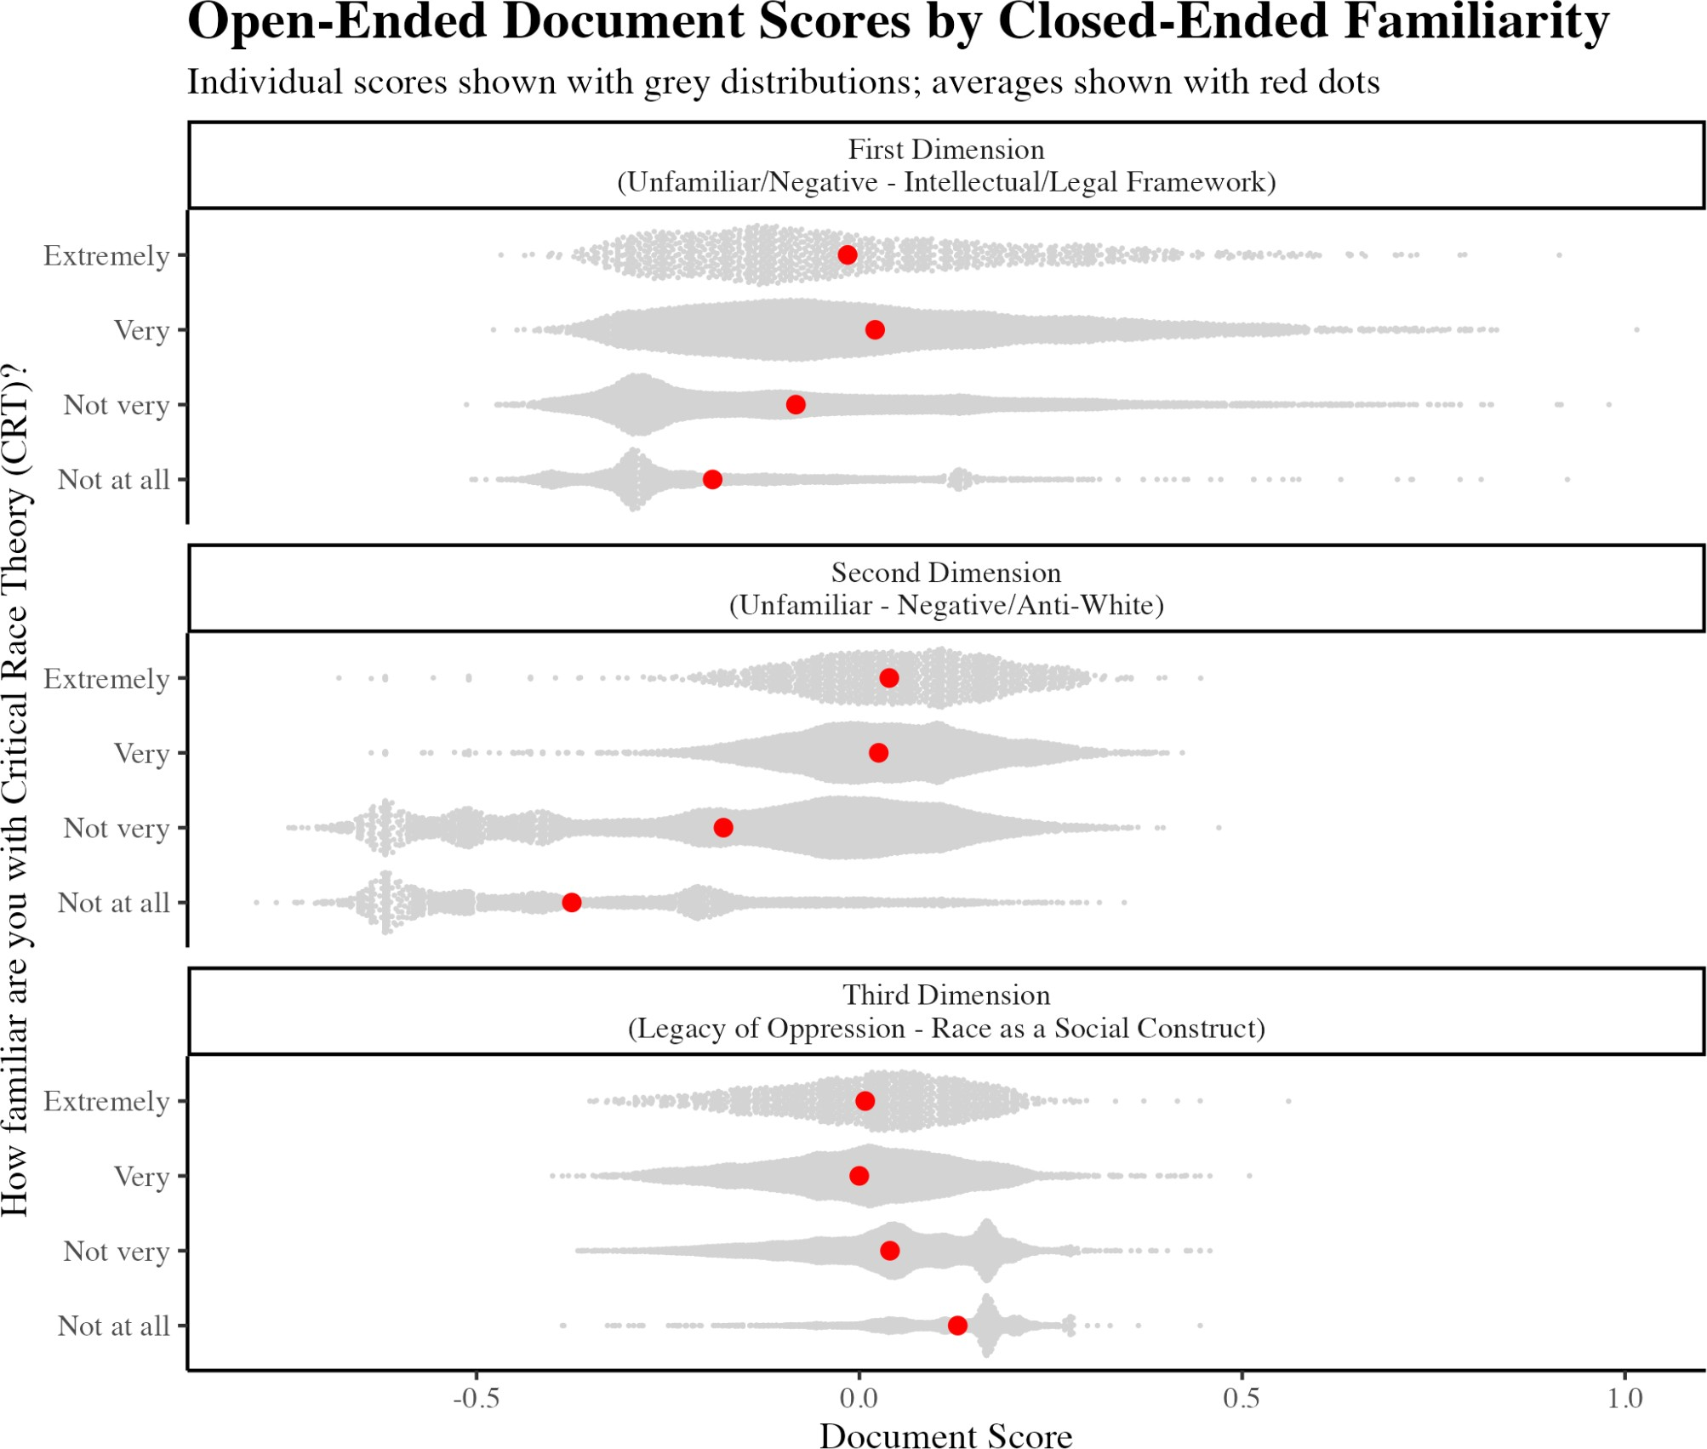

Figure D1. Average Document Scores by Closed-Ended Familiarity

These distinctions are also apparent in average document scores among respondents who offer differing closed-ended perceptions of how well Critical Race Theory describes present-day society, as shown in Figure D2.

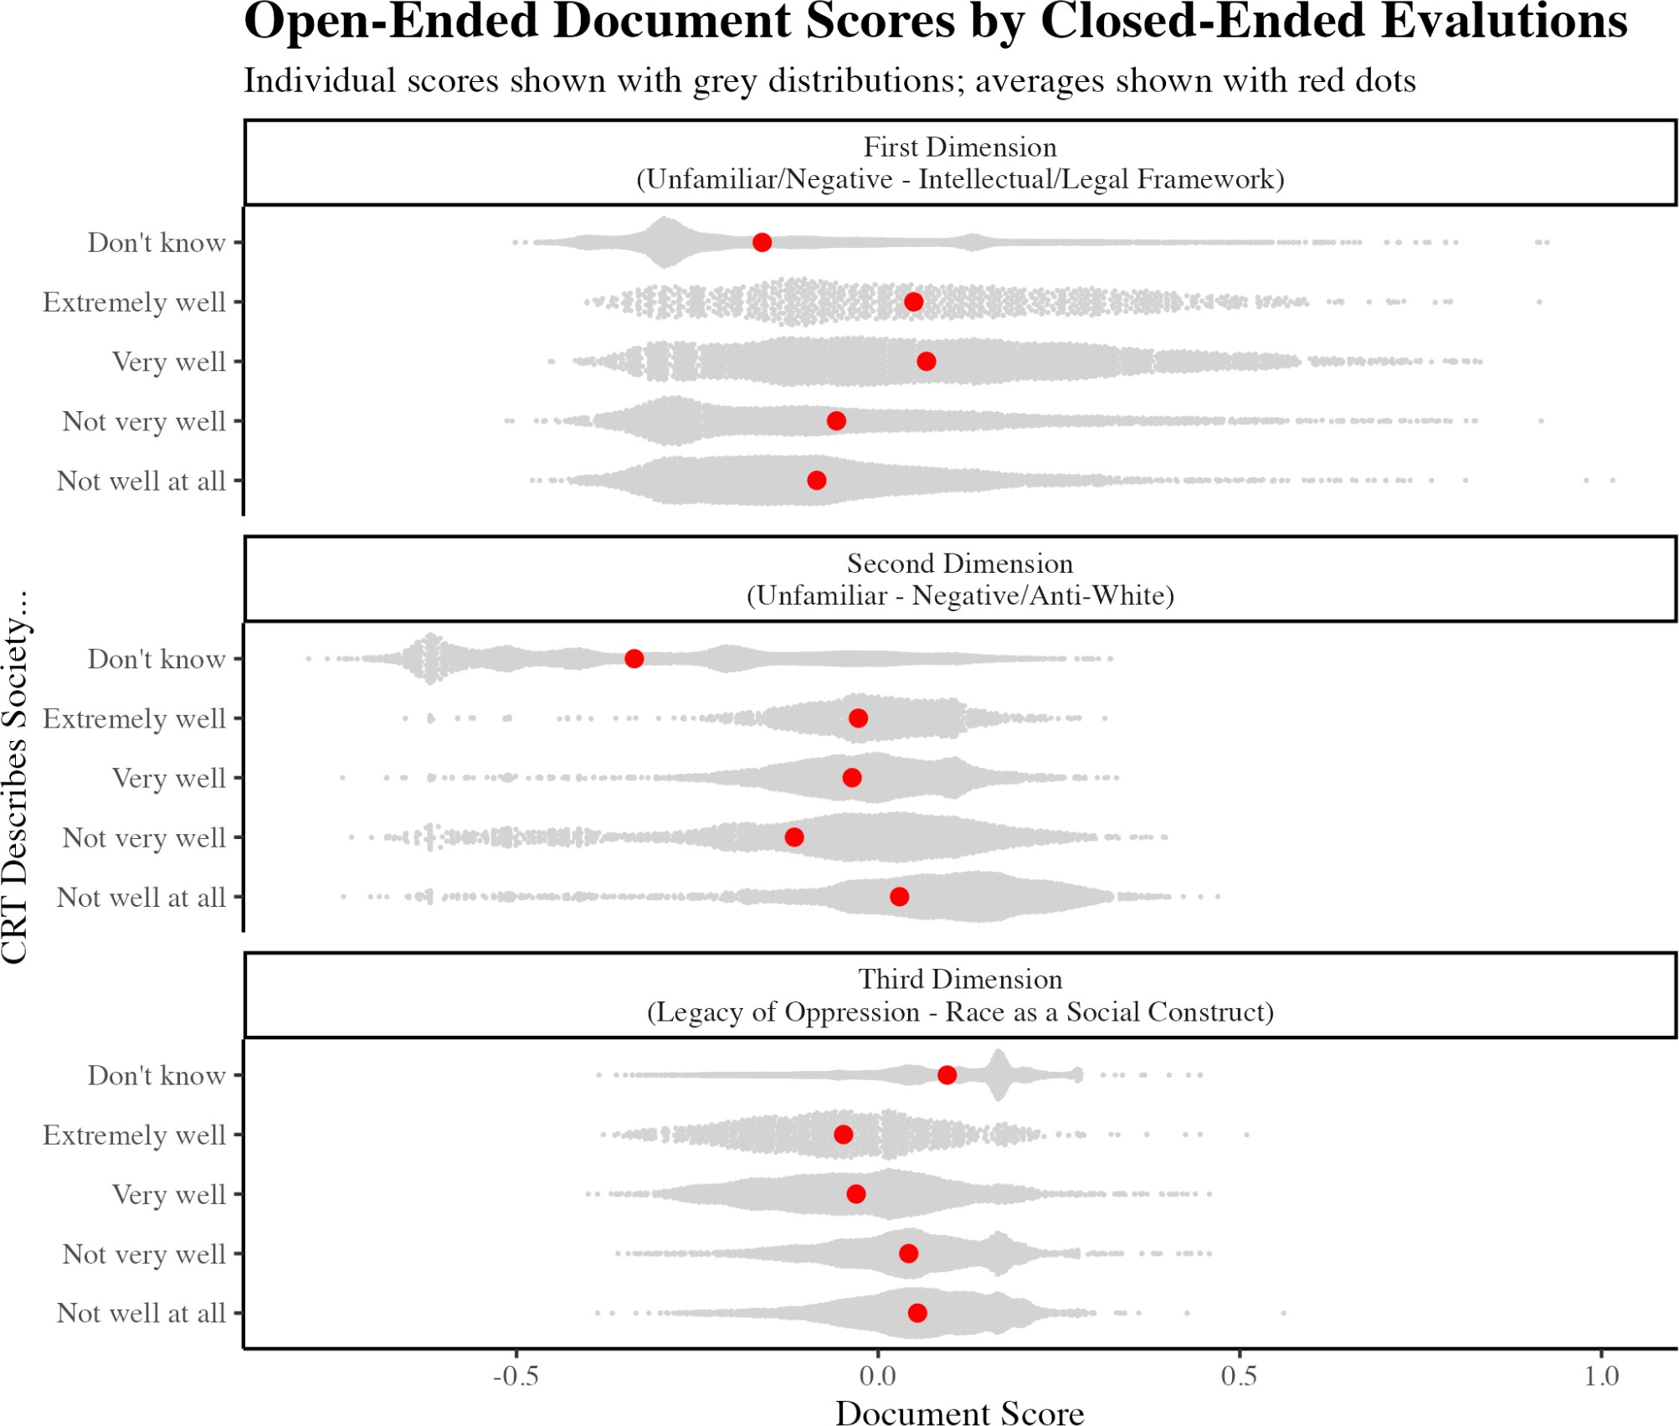

Figure D2. Average Document Scores by Closed-Ended Endorsement
We next show the extent to which respondents with different partisan affiliations vary in how they tend to describe what Critical Race Theory means to them. In particular, we find that Strong Republicans and Independents who lean Republican are less likely to emphasize unfamiliarity with the concept, relative to negative sentiments such as CRT being racist or explicitly anti-White. Strong Democrats and Independents who lean Democrat who were familiar with CRT were slightly more likely to emphasize its status as an intellectual/legal framework (Dimension 1) and legacies of systemic oppression (Dimension 3).

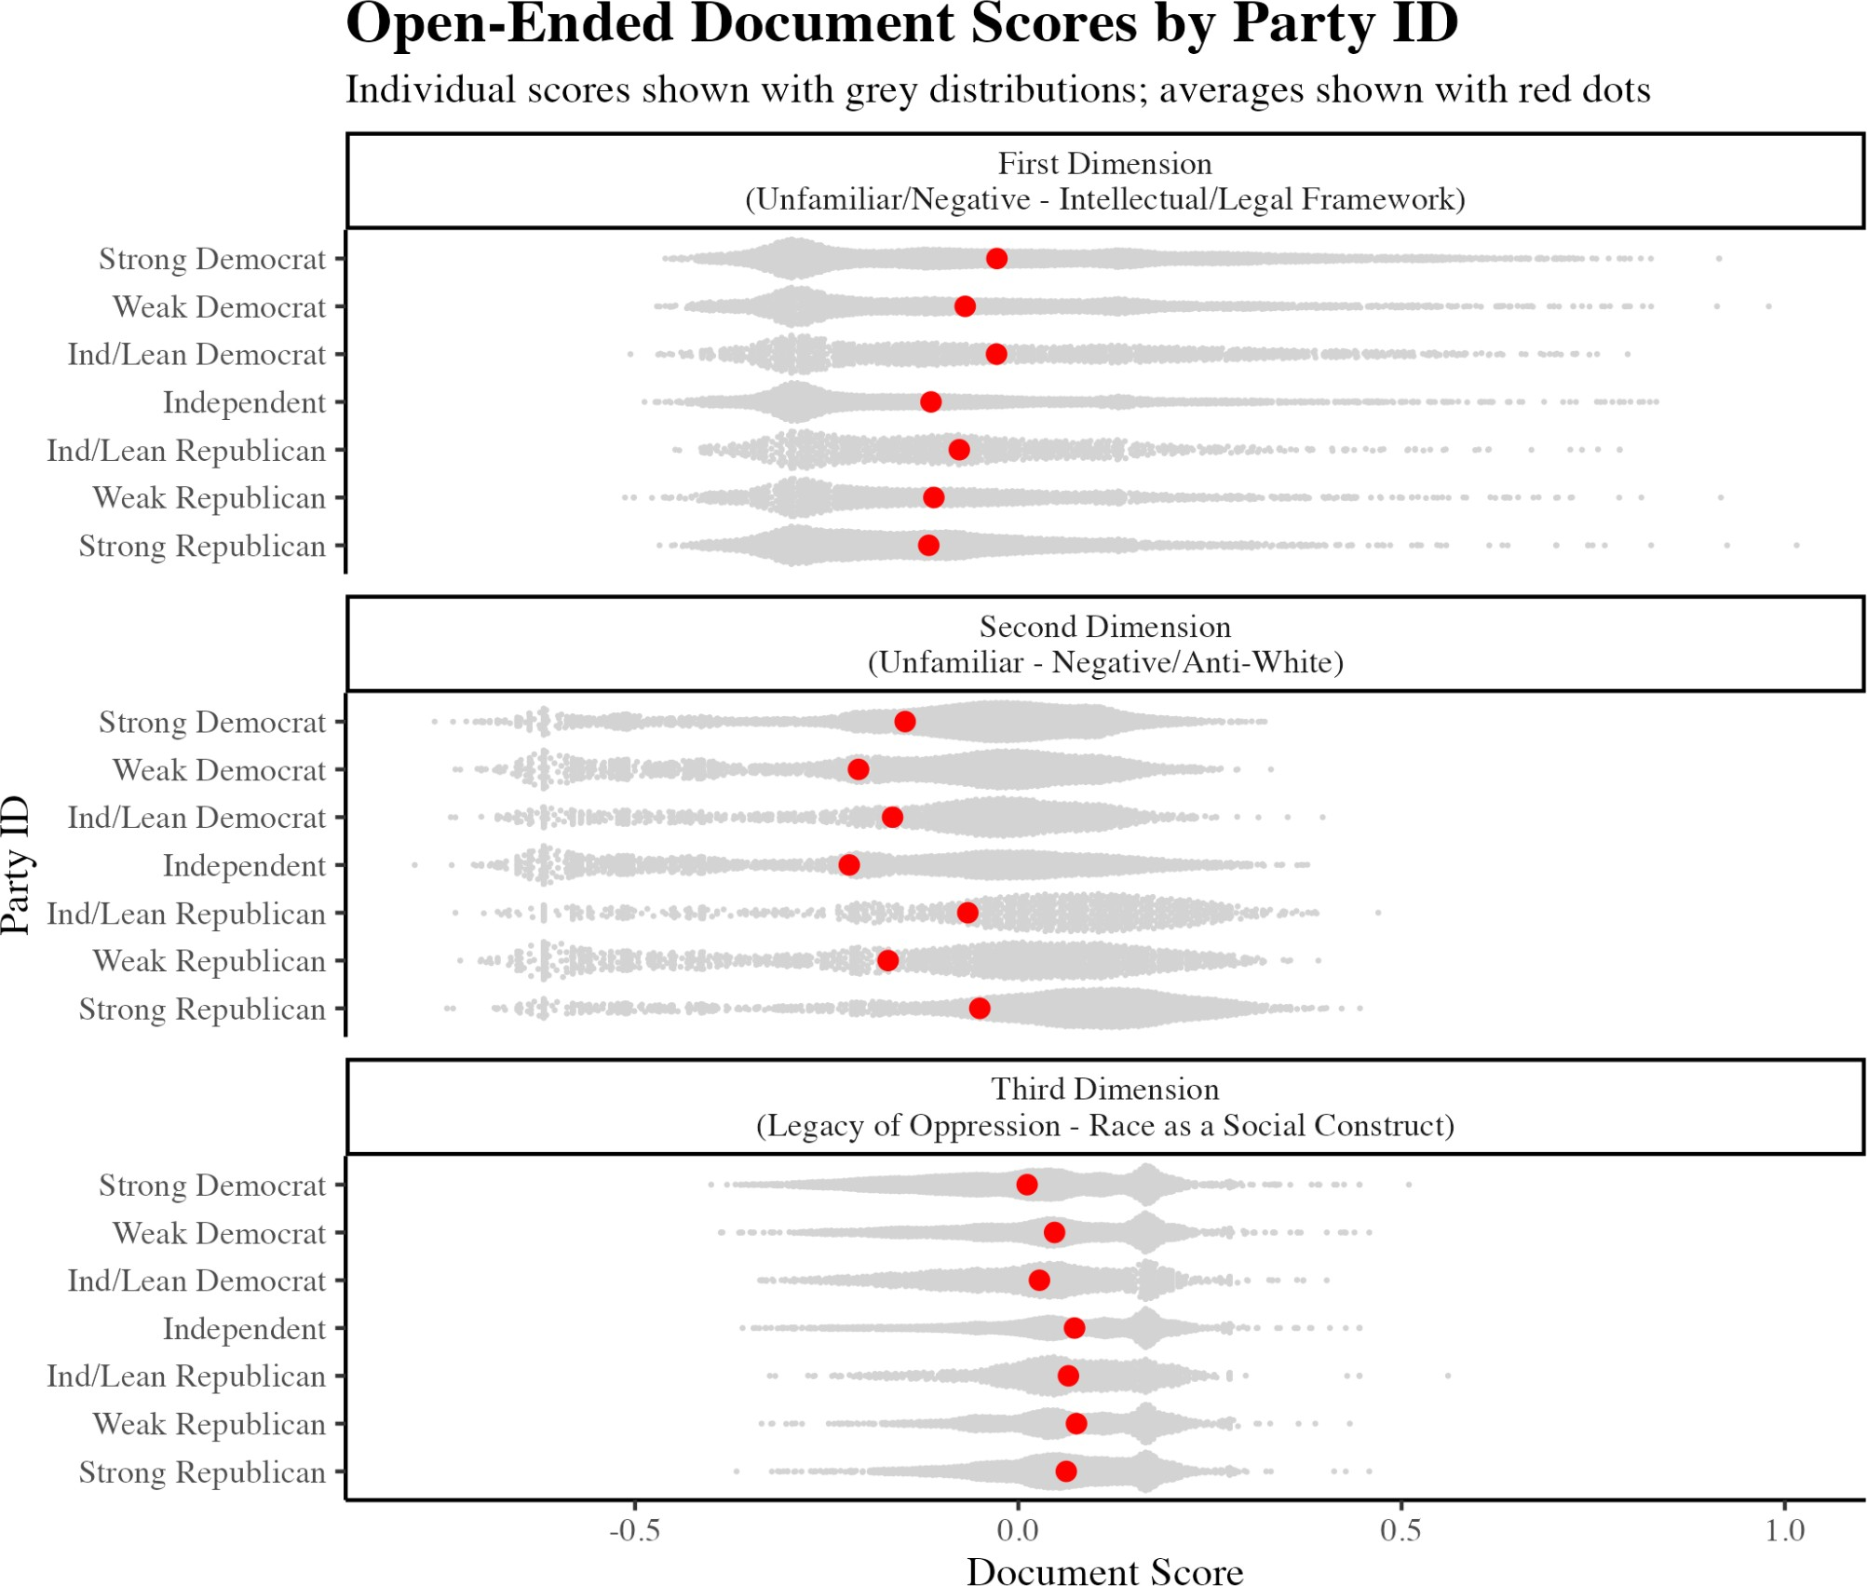

Figure D3. Average Document Scores by Party ID

Finally, we show distributions of document scores along these three dimensions broken out by race. We find that the median Black and Asian respondents are slightly more likely to discuss the concept with reference to it being an intellectual/legal framework (first dimension), while the median white and Black respondents are less unlikely to say they are unfamiliar with the concept (second dimension).

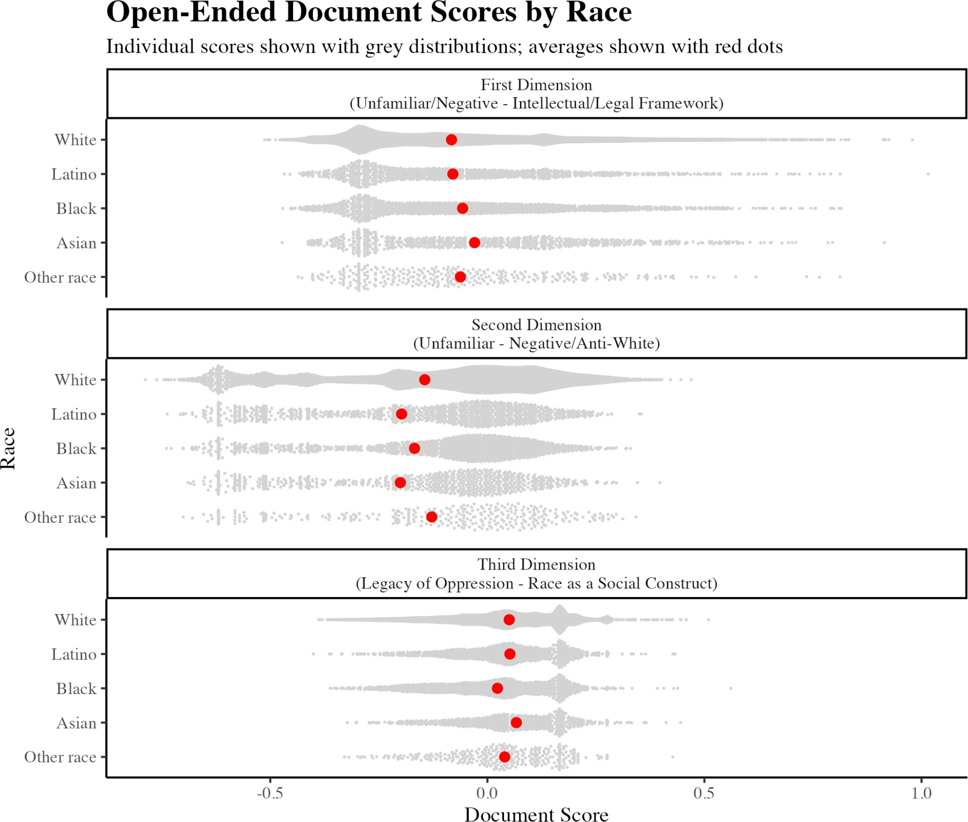

Figure D4. Average Document Scores by Race

References for Appendix D

1. Hobbs, William. “Text Scaling for Open-Ended Survey Responses and Social Media Posts.” Working paper, August 9, 2019. https://papers.ssrn.com/sol3/papers.cfm?abstract_id=3044864

Appendix E. Open-Ended Coding Table E1. Open-Ended Coding
Code | Description | Example Response | Category
Black/Minority Treatment | The way Black people/minorities/POC are treated; the way different races are treated | I think it is about how blacks were treated in our country over time, from slavery to the present. | Neutral/Positive
Construct | Race is a social construct; race is something society created/made up; race is not real/objective fact | race is not natural but is socially constructed  , culturally invented used to oppress and exploit people of color | Neutral/Positive
Equality | Promoting/teaching racial equality; ensuring equal rights; combating inequality/injustice | to ensure justice between the races | Neutral/Positive
History | Teaching about the history of racism | American history accurately reflecting racism and the historical mistreatment of African Americans | Neutral/Positive
Intersectionality | Intersectionality; intersectional framework/analysis (i.e., understanding race alongside gender, class, sexuality, etc.) | That race can intersect with other identities to produce complex combinations of power and advantage for certain people, mainly white people, over minorities. | Neutral/Positive
Perspectives | Teaching the perspectives and experiences of POC | It means teaching history not just through privileged white voices but through all voices | Neutral/Positive

Positive/Support (general) | Great/good/positive/impo rtant/should be taught; R specifically says they support it | i think that it is very important. | Neutral/Positive
Racism | Consequences of racism; how racism impacts society; persistence of racism | How racism and prejudice still affect individuals today | Neutral/Positive
Systemic/Institution al | Systemic racism; institutional racism; racism is not just individual but embedded in policies and institutions | How laws and systemic racism in this country have affected blacks | Neutral/Positive
Truth | Teaching the truth about history; how things really happened; not hiding our history | Teaching real history | Neutral/Positive
White Supremacy | Teaching about white supremacy | White is the dominant culture and all systems ere [sic] built to sustain white supremacy. White and white bodied people are better equipped to navigate systems and therefore have an advantage over non whites. CRT believes that race is instrumental in a person s [sic] lived experience over all else. | Neutral/Positive
Anti-White | Anti-White; racist against White people; making/teaching White people feel bad/guilty for being White; all white people are racist | It means my family, who are white, are in league with the devil and they are NOT. | Negative

Black Victim/Favors | Black people complaining/asking for special favors; teaching Black people and other minorities to be or feel like victims | that because blacks were treated badly centuries ago, it's an excuse for them to complain and want to be paid for what their ancestors went through  - all races have gone through something, but they don't cry about it, they pick themselves up and try to make the best of their lives now | Negative
Christian | Anti-Christian | It is anti-Gospel. If you believe the Bible and the gospel, CRT does not fall in line with either. | Negative
Divisive | Divisive; pits one race against another | it is something that perpetuates division among americans. it focuses on race as a bad thing of the past and how it continues today. we need to focus on race as a good thing; diversity is good and there are no victims accept [sic] those that choose to be so. | Negative
Marxist | Marxist; communist; totalitarian; socialism/socialist | This "theory" is based on Marxist teachings which substitutes oppressor and oppressed for bourgeoisie and proletariat. It is a divisive theory. | Negative

Negative/Oppose (general) | Negative/dislike/bad/har mful/wrong/stupid/ horrible/not a good thing; R specifically expresses opposition | Critical Race Theory assigns certain characteristics to certain races and thus iis [sic]unrealistic and unfair. | Negative
Post-Racial | Racism is over; too much focus on the past; we had a Black president (proof that racism is over); race doesn't matter; all about effort | All I know is that racism only exists when people keep bringing it up. | Negative
Propaganda | Indoctrination; brainwashing; propaganda | A bunch of brain washed idiots trying to teach children stupid information and lies | Negative
Racist | Promotes racism; is a racist theory; teaches people to be racist; theory that one race is superior to others; reverse racism | CRITICAL RACE THEORY IS SIMPLY  RACIST. We need to get back to reading, writing, and arithmetic. Our schools are lacking terrible [sic] where Johnny can't even read any longer let alone write in the cursive style. | Negative
College | It is taught in law school/college/graduate school | CRT is NOT taught in grades k-12. It is taught at college level and is a discussion on race issues in America. | Miscellaneous
Don't Know | Don't know; never heard of it; N/A; no comment | I don't really know | Miscellaneous
Flag | Nonsense response | gjhgdjhfgsjh | Miscellaneous

Kids | It is taught to children/in k-12 schools | Teaching kids how race affects modern society. | Miscellaneous
No Teach | NOT teaching about racism; hides history/truth about history; lying about our history; it is something that challenges or prevents racial equality or justice; CRT teaches things that are false (e.g. "all whites people are racist and that is not true" or "hides the truth about slavery", etc) | It means hiding the truth about this country from our kids. | Miscellaneous
Other | Other responses that do not fit in any of the other categories | Origins of ethics | Miscellaneous
Partisan | Mention of parties (Democrat or Republican); or mention of "partisan", "far right", "far left" "right-wing", "left-wing", etc | its [sic] a cheap ploy republicans use even if they have no idea what it is | Miscellaneous
Vote | Voting/elections | something the Repulbicans [sic] made up to make themseklves [sic] get more voites [sic] to stay in office | Miscellaneous
Wikipedia | Code for exact or extremely close matches to the first line of the wikipedia entry: "a | It is a framework of analysis by civil-rights scholars and activists to examine the | Miscellaneous

 | framework of analysis | intersection of race and
 | grounded in critical | law, and to challenge
 | theory, and an academic | mainstream American
 | movement of civil-rights | liberal approaches to
 | scholars and activists | racial justice.
 | who seek to examine the
 | intersection of race and
 | law in the United States
 | and to challenge
 | mainstream American
 | liberal approaches to
 | racial justice."

