APPENDIX
Table A1: Descriptive Statistics
Variable | Obs. | Mean | Std. Dev. | Min | Max
Support secession† | 1404 | 2.473 | 1.474 | 1 | 5
Support secession†# | 251 | 3.789 | 1.405 | 1 | 5
Ethnic marginalization | 1436 | 0.806 | 0.961 | 0 | 3
Ethnic marginalization# | 252 | 1.643 | 0.965 | 0 | 3
Democracy | 1439 | 2.589 | 0.87 | 1 | 4
Democracy# | 252 | 2.206 | 0.909 | 1 | 4
Igbo | 1447 | 0.174 | 0.379 | 0 | 1
Hausa/Fulani | 1447 | 0.256 | 0.437 | 0 | 1
Yoruba | 1447 | 0.227 | 0.419 | 0 | 1
Ethnic minorities | 1447 | 0.343 | 0.475 | 0 | 1
Deprivation index | 1444 | 3.403 | 3.374 | 0 | 16
Deprivation index# | 252 | 3.127 | 3.21 | 0 | 14
Literacy rate (LGA) | 1584 | 64.352 | 25.029 | 12.366 | 97.572
Literacy rate (LGA)# | 252 | 85.484 | 11.367 | 25.1 | 96.346
Political instability (LGA) | 1584 | 11.241 | 24.939 | 0 | 184
Political instability (LGA)# | 252 | 9.067 | 16.436 | 0 | 184
Age | 1448 | 32.658 | 12.428 | 18 | 80
Age# | 252 | 32.484 | 12.645 | 18 | 80
Gender | 1448 | 0.501 | 0.501 | 0 | 1
Gender# | 252 | 0.52 | 0.501 | 0 | 1
Note: All values are for the full sample except for those with the symbol # which are for the subsample of Igbo respondents, † denotes the dependent variable. Although the Afrobarometer dataset contains 1,600 potential observations, the variables in the table contain fewer observation because the relevant question was not asked to all the respondents. Moreover, I treated “don’t know” and “refused to answer” responses as missing, which may have exacerbated the problem of listwise deletion.

Table A2: Correlation between the variables (Igbo subsample)
Variables | (1) | (2) | (3) | (4) | (5) | (6) | (7) | (8)
(1) Support secession | 1.000
(2) Ethnic marginalization | 0.248 | 1.000
(3) Democracy | -0.257 | -0.295 | 1.000
(4) Deprivation index | -0.058 | -0.018 | -0.016 | 1.000
(5) Literacy rate (LGA) | 0.249 | 0.090 | -0.030 | -0.127 | 1.000
(6) Political instability | 0.009 | 0.038 | 0.098 | -0.025 | 0.048 | 1.000
(7) Age | 0.033 | -0.042 | -0.079 | -0.007 | 0.168 | -0.018 | 1.000
(8) Gender | 0.099 | -0.015 | -0.048 | -0.017 | 0.002 | 0.045 | 0.182 | 1.000

Table A3: Correlation between the variables (Full sample)
Variables | (1) | (2) | (3) | (4) | (5) | (6) | (7) | (8) | (9) | (10) | (11) | (12)
(1) Support secession | 1.000
(2) Ethnic marginalization | 0.329 | 1.000
(3) Igbo | 0.418 | 0.400 | 1.000
(4) Hausa/Fulani | -0.225 | -0.220 | -0.272 | 1.000
(5) Yoruba | -0.156 | -0.239 | -0.253 | -0.307 | 1.000
(6) Ethnic minorities | 0.001 | 0.084 | -0.345 | -0.419 | -0.389 | 1.000
(7) Democracy | -0.165 | -0.199 | -0.206 | 0.259 | -0.063 | -0.012 | 1.000
(8) Deprivation index | 0.059 | 0.085 | -0.043 | -0.058 | 0.009 | 0.079 | -0.074 | 1.000
(9) Literacy rate (LGA) | 0.293 | 0.233 | 0.377 | -0.682 | 0.308 | 0.044 | -0.278 | 0.009 | 1.000
(10) political instability | 0.039 | 0.033 | -0.046 | -0.128 | -0.044 | 0.192 | -0.018 | 0.030 | 0.115 | 1.000
(11) Age | -0.046 | -0.025 | -0.013 | -0.004 | 0.057 | -0.035 | -0.018 | 0.038 | -0.002 | 0.043 | 1.000
(12) Gender | -0.019 | 0.044 | 0.008 | 0.011 | -0.004 | -0.013 | -0.026 | 0.011 | -0.007 | 0.011 | 0.138 | 1.000

Table A4: Ethnic distribution of respondents
Ethnic group | Frequency | Percent
Hausa/Fulani | 371 | 25.62
Yoruba | 328 | 22.65
Igbo | 251 | 17.33
Ibibio | 35 | 2.42
Kanuri | 35 | 2.42
Ijaw | 33 | 2.28
Tiv | 26 | 1.80
Ikwere | 25 | 1.73
Efik | 24 | 1.66
Ebira | 20 | 1.38
Idoma | 19 | 1.31
Nupe | 18 | 1.24
Igala | 16 | 1.10
Isoko | 10 | 0.69
Edo | 10 | 0.69
Gwari | 9 | 0.62
Kalabari | 9 | 0.62
Jukun | 7 | 0.48
Urhobo | 4 | 0.28
Birom | 3 | 0.21
Shuwa-Arab | 1 | 0.07
Others | 194 | 13.41
Total | 1,448 | 100.00
Note: Based on the Round 7 Afrobarometer survey data (BenYishay et al. 2017) collected in 2017.

Table A5: Correlates of support for secession among non-Igbos
Support secession† | (1) | (2) | (3) | (4) | (5) | (6)
Ethnic marginalization | 0.363*** |  |  |  | 0.317*** | 0.318***
 | (0.085) |  |  |  | (0.084) | (0.085)
Democracy |  | -0.052 |  |  | 0.042 | 0.043
 |  | (0.07) |  |  | (0.071) | (0.071)
Deprivation index |  |  | 0.067*** |  | 0.055*** | 0.057***
 |  |  | (0.019) |  | (0.02) | (0.021)
Literacy rate (LGA) |  |  |  | 0.009** | 0.008** | 0.007**
 |  |  |  | (0.003) | (0.003) | (0.003)
Political instability |  |  |  |  |  | 0.004
 |  |  |  |  |  | (0.004)
Age |  |  |  |  |  | -0.01***
 |  |  |  |  |  | (0.004)
Gender |  |  |  |  |  | -0.234*
 |  |  |  |  |  | (0.13)
Intercept 1 | -0.216*** | -0.572*** | -0.206** | 0.102 | 0.535 | 0.093
 | (0.083) | (0.206) | (0.1) | (0.228) | (0.33) | (0.348)
Intercept 2 | 1.268*** | 0.895*** | 1.272*** | 1.573*** | 2.047*** | 1.619***
 | (0.096) | (0.223) | (0.125) | (0.216) | (0.321) | (0.334)
Intercept 3 | 1.456*** | 1.08*** | 1.463*** | 1.76*** | 2.232*** | 1.806***
 | (0.101) | (0.228) | (0.137) | (0.216) | (0.321) | (0.334)
Intercept 4 | 2.567*** | 2.186*** | 2.562*** | 2.862*** | 3.368*** | 2.947***
 | (0.159) | (0.268) | (0.2) | (0.217) | (0.317) | (0.325)
Observations | 1142 | 1144 | 1148 | 1144 | 1122 | 1122
Pseudo R² | 0.01 | 0.00 | 0.006 | 0.005 | 0.019 | 0.023
Log pseudolikelihood | -1515.42 | -1531.629 | -1532.121 | -1525.235 | -1474.986 | -1468.407
AIC statistic | 3040.84 | 3073.257 | 3074.243 | 3060.47 | 2965.973 | 2958.814
Note: Clustered robust standard errors are in parentheses, † is the dependent variable which has five ordinal categories, *** p<0.01, ** p<0.05, * p<0.10. All models are estimated using ordered logit (Ologit) regression.

Table A5 reports the results of regression models showing the correlates of support for secession among non-Igbos. In model 1, where I considered only ethnic marginalization, it carried a positive sign and was significant at the one percent level, as was the case with the Igbo subsample of respondents. This suggests that non-Igbos who feel that members of their ethnic group are treated unfairly by the Nigerian government are more supportive of IPOBs secessionist goal. This might be because the shared feeling of marginalization makes them sympathetic to IPOB’s plight. Model 2 shows that attitudes towards democracy among non-Igbos has no statistically significant effect on support for secession. This contrasts with the case of the Igbos where those who had positive attitudes towards Nigerian democracy were less supportive of secession. Model 3 shows that the household measure for socioeconomic condition—deprivation index—positively correlates with support for secession. The support for secession among poor non-Igbos might be because they do not have much confidence in the Nigerian government, especially given that they already live in deprivation and do not have much to lose if the oil-rich Eastern Region secedes. It might also be because they feel that the Igbos might be able to improve their economic lot if they secede from Nigeria and for their own government.
In model 4, the communal measure for socioeconomic condition—i.e., literacy rate—carried a positive sign and was significant at the one percent level. This suggests that non-Igbo individuals residing in communities with a high level of economic development are more supportive of IPOBs secessionist goal. This is consistent with the result found among the Igbos. The disparity between the results for the household and communal measures of socioeconomic condition indicates that effect of socioeconomic condition on support for secession depends on the level of aggregation. Moreover, these two variables do not measure the same thing. The correlation between the deprivation index and literacy rate for the non-Igbo subsample of respondents was 0.04. In model 5 where I added all the explanatory variables in the same model, the results were consistent with those in the baseline models. Model 6 shows that these results are robust to the inclusion of control variables for political instability and the demographic attributes of the respondents.
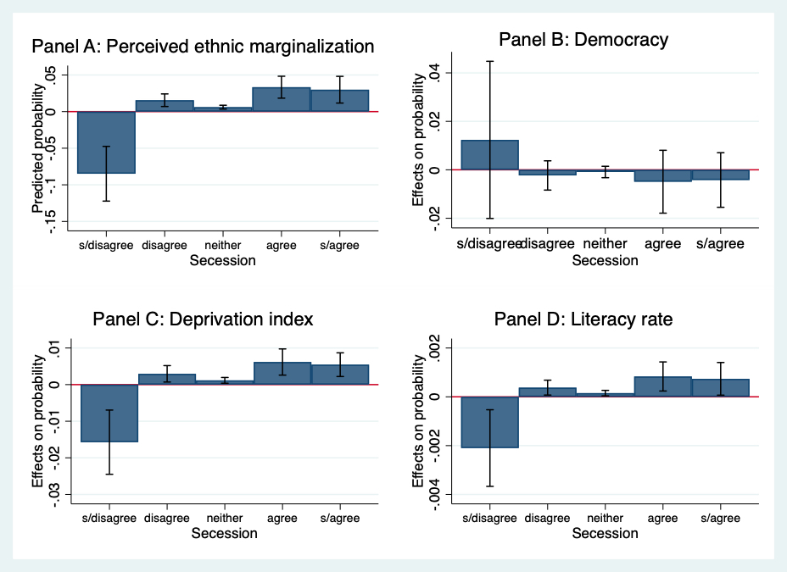
Figure A1: Average marginal effects of the explanatory variables on support for secession
Note: Panels A, B, C, and D show the average marginal effects of perceived ethnic marginalization, democracy, deprivation index, and literacy rate respectively on the five ordinal categories of the dependent variable which measures support for secession among non-Igbos. These results are based on the baseline regression models (i.e., models 1, 2, 3, and 4) reported in Table A5. Confidence intervals are at the 95 percent level.
To illustrate the effect sizes of the regression results reported in table A5, I present the predicted probabilities for the baseline models—i.e., models 1, 2, 3, and 4—in Figure A1. A cursory look at the four panels shows that the effect size is largest for the “strongly disagree” response category of the dependent variable. This contrasts with the results based on the Igbo subsample of respondents where the magnitude of the effect was largest for the “strongly agree” response category (See Figure 7 in manuscript).

