Appendix
Supplemental Information and Tables for
“White Racial Identity, Racial Attitudes and Latino Partisanship”
Content
- Summary of Control Variables . . . . . . . . 1
- Main paper - Multinomial Logistic Regression Tables . . . . . 9
- Main paper - Average Marginal Effects Tables . . . . . . 12
- Main paper - Predicted Probability Result Tables . . . . . 12
- Latino White Racial Identity Text Responses . . . . . . 14
- Immigrant Generation and White Racial Identity among Latinos . . . 15
- Demean-ed Models for Latino 3-Point Party ID . . . . . 16
- Demean-ed Models for Latino 3-Point Party ID including Multiracial White ID . 17
- Demean-ed Models for Latino 3-Point Party ID including Hispanic Race . . 21
- Comparison of 2020 Models With and Without Possible Repeat Respondents . 24
- Reverse Causality: Does Party ID Predict White Racial ID? . . . . 29

- Summary of Control Variables
The following two tables describe the control variables included in the five multinomial logistic regression model specifications used for analyzing the effect of racial identity and racial attitudes on Latino partisanship across six consecutive CES surveys. Table A1 describes the variable name, the type of variable, and its coding before being standardized on a zero to one scale. And, tables A2 through A9 presents overall descriptive statistics for all nine control variables by 3-point Party Identity (plus Not Sure) in the pooled CES Latino data sample used in the main paper.
Table A1. Control Variables
Demographic Variables
Variables | Type | Coding/Categories
Age | continuous | 18 to 99 years of age
Gender | binary | Male =1, Female =0
Social Incorporation Variables
Variables | Type | Coding/Categories
Education | 6 categories | 1) No High school, 2) High school graduate, 3) Some college, 4) 2-yr degree, 5) 4-yr degree, 6) Post-grad
Family Income | 16 categories | 1) Less than $10,000, 2) $10,000 - $19,999 … 16) $500,000 or more
Immigrant Generation | 5 categories | - Immigrant non-citizen: I am an immigrant to the USA and not a citizen of the USA  - Immigrant Citizen: I am an immigrant to the USA and a naturalized citizen  - First generation: I was born in the USA but at least one of my parents is an immigrant  - Second generation: My parents and I were born in the USA but at least one of my grandparents was an immigrant  - Third generation: My parents, grandparents and I were all born in the USA
Religiosity and Religion Variables
Variables | Type | Coding/Categories
Church Attendance | 6 categories | 1) Never, 2) Seldom, 3) a few times a year, 4) Once or twice a month, 5) Once a week, 6) More than Once a week
Protestant | binary | Protestant =1, All else =0
Catholic | binary | Catholic =1, All else =0
National Origin
Variables | Type | Coding/Categories
Cuban American | binary | Cuban =1, All else =0; CES 2016, 2018 & 2020 only

Table A2. Latino Partisanship by Mean Age
CES Year | Democrat  Mean (n) | Not Sure  Mean (n) | Independent  Mean (n) | Republican  Mean (n)
2010 | 39.29 (2,300) | 34.95 (492) | 36.49 (846) | 45.80 (1,164)
2012 | 39.10 (3,184) | 36.77 (116) | 37.88 (733) | 45.79 (1,270)
2014 | 40.20 (2,781) | 35.42 (426) | 37.01 (863) | 44.362 (1,517)
2016 | 40.04 (2,863) | 35.06 (340) | 40.34 (936) | 43.99 (1,159)
2018 | 40.51 (2,493) | 32.57 (362) | 40.85 (1,021) | 45.87 (1,536)
2020 | 43.01 (3,443) | 32.21 (555) | 40.92 (1,156) | 45.89 (1,575)
Note: Values represent weighted mean age of Latinos by partisanship, weighted total observations in parenthesis.

Table A3. Latino Partisanship by Gender
CES Year | Gender | Democrat  % (n) | Not Sure  % (n) | Independent  % (n) | Republican  % (n)
2010 | Female  Male | 51.9 (1194)  48.1 (1107) | 55.0 (270)  45.0 (221) | 42.2 (356)  57.8 (489) | 46.8 (545)  53.2 (619)
2012 | Female  Male | 53.6 (1708)  46.4 (1476) | 52.7 (61)  47.3 (55) | 45.5 (334)  54.5 (400) | 51.7 (657)  48.3 (613)
2014 | Female  Male | 53.8 (1495)  46.2 (1286) | 66.0 (281)  34.0 (145) | 45.1 (389)  54.9 (474) | 48.5 (736)  51.5 (781)
2016 | Female  Male | 52.1 (1491)  47.9 (1372) | 54.9 (186)  45.1 (153) | 53.9 (502)  46.1 (432) | 49.7 (576)  50.3 (583)
2018 | Female  Male | 52.0 (1815)  48.0 (1678) | 70.8 (256)  29.2 (106) | 47.1 (481)  55.9 (540) | 46.0 (706)  54.0 (829)
2020 | Female  Male | 53.3 (1834)  46.7 (1609) | 56.2 (312)  43.8 (243) | 46.7 (540)  53.3 (616) | 46.7 (735)  53.3 (840)
Note: Values represent weighted percent of Latinos by gender by partisanship, weighted total observations in parenthesis.

Table A4. Latino Partisanship by Family Income
CES Year | Family Income | Democrat  % (n) | Not Sure  % (n) | Independent  % (n) | Republican  % (n)
2010 | $50k or less  More than $50k | 46.8 (1077)  53.2 (1224) | 61.3 (301)  38.7 (190) | 54.3 (459)  45.7 (387) | 37.6 (438)  62.4 (727)
2012 | $50k or less  More than $50k | 67.4 (2146)  32.6 (1039) | 72.5 (84)  27.5 (31) | 69.2 (508)  30.8 (226) | 56.4 (716)  43.6 (554)
2014 | $50k or less  More than $50k | 63.0 (1751)  37.0 (1029) | 71.8 (306)  28.2 (120) | 63.8 (550)  36.2 (313) | 51.9 (788)  48.1 (729)
2016 | $50k or less  More than $50k | 63.1 (1808)  36.9 (1055) | 68.2 (232)  31.8 (108) | 61.5 (575)  38.5 (361) | 50.5 (585)  49.5 (574)
2018 | $50k or less  More than $50k | 61.6 (2153)  38.4 (1340) | 74.4 (269)  25.6 (93) | 70.4 (719)  29.6 (302) | 52.4 (805)  47.6 (730)
2020 | $50k or less  More than $50k | 61.8 (2130)  38.2 (1314) | 61.6 (342)  38.4 (213) | 65.7 (759)  34.3 (810) | 48.6 (766)  51.4 (810)
Note: Values represent weighted percent of Latinos by family income by partisanship, weighted total observations in parenthesis.

Table A5. Latino Partisanship by Education
CES Year | Education | Democrat  % (n) | Not Sure  % (n) | Independent  % (n) | Republican  % (n)
2010 | No High School | 16.0 (370) | 18.8 (92) | 19.7 (167) | 17.4 (203)
 | High School | 39.8 (915) | 53.3 (262) | 40.1 (339) | 36.0 (420)
 | College | 39.6 (911) | 25.7 (127) | 36.8 (311) | 42.1 (490)
 | Post grad | 4.5 (104) | 2.2 (11) | 3.4 (29) | 4.4 (51)
2012 | No High School | 17.0 (542) | 27.5 (32) | 16.3 (119) | 12.9 (164)
 | High School | 33.3 (1060) | 37.5 (44) | 36.4 (267) | 31.0 (393)
 | College | 45.4 (1447) | 32.0 (37) | 43.8 (321) | 51.0 (648)
 | Post grad | 4.3 (137) | 3.0 (4) | 3.5 (26) | 5.1 (65)
2014 | No High School | 16.2 (451) | 41.2 (176) | 24.6 (212) | 11.0 (167)
 | High School | 33.7 (936) | 32.2 (137) | 31.5 (272) | 39.4 (597)
 | College | 45.4 (1262) | 25.9 (110) | 40.0 (345) | 44.7 (679)
 | Post grad | 4.7 (131) | 0.7 (3) | 3.9 (34) | 4.9 (74)
2016 | No High School | 16.1 (460) | 32.1 (109) | 22.1 (207) | 6.3 (73)
 | High School | 35.9 (1028) | 33.6 (114) | 35.5 (332) | 42.2 (489)
 | College | 43.5 (1248) | 33.1 (112) | 38.5 (361) | 46.2 (536)
 | Post grad | 4.4 (126) | 1.2 (4) | 3.9 (37) | 5.3 (62)
2018 | No High School | 13.9 (487) | 39.7 (144) | 16.4 (167) | 12.9 (198)
 | High School | 34.5 (1206) | 28.0 (101) | 34.9 (356) | 35.0 (537)
 | College | 46.2 (1614) | 29.8 (108) | 44.8 (456) | 46.3 (712)
 | Post grad | 5.3 (185) | 2.6 (9) | 4.0 (41) | 5.8 (89)
2020 | No High School | 13.2 (455) | 27.5 (153) | 10.1 (117) | 7.3 (115)
 | High School | 33.9 (1168) | 45.3 (251) | 38.1 (441) | 39.3 (619)
 | College | 46.6 (1605) | 25.2 (140) | 46.5 (537) | 48.3 (760)
 | Post grad | 6.3 (216) | 2.0 (11) | 5.3 (61) | 5.2 (82)
Note: Values represent weighted percent of Latinos by education by partisanship, “College” includes “Some college”, “2-year” and “4-year”, weighted total observations in parenthesis.

Table A6. Latino Partisanship by Immigrant Generation
CES Year | Generation | Democrat  % (n) | Not Sure  % (n) | Independent  % (n) | Republican  % (n)
2010 | Immigrant non-citizen | 6.7 (153) | 12.1 (59) | 6.9 (58) | 4.1 (48)
 | Immigrant citizen | 19.5 (447) | 13.2 (65) | 12.1 (102) | 17.1 (198)
 | 1st generation | 29.2 (668) | 19.0 (93) | 31.5 (265) | 25.5 (295)
 | 2nd generation | 19.0 (436) | 18.3 (89) | 19.5 (164) | 27.6 (320)
 | 3rd generation | 25.6 (586) | 37.4 (182) | 30.0 (252) | 25.8 (299)
2012 | Immigrant non-citizen | 7.6 (240) | 15.5 (18) | 9.4 (69) | 5.4 (68)
 | Immigrant citizen | 17.3 (548) | 9.9 (11) | 14.0 (102) | 17.2 (217)
 | 1st generation | 29.5 (933) | 16.5 (19) | 27.5 (202) | 24.5 (311)
 | 2nd generation | 18.7 (593) | 14.6 (17) | 20.9 (153) | 24.3 (308)
 | 3rd generation | 26.8 (848) | 43.6 (50) | 28.2 (207) | 28.6 (362)
2014 | Immigrant non-citizen | 4.4 (122) | 13.1 (56) | 5.1 (44) | 3.3 (51)
 | Immigrant citizen | 15.3 (425) | 6.5 (28) | 12.7 (110) | 17.2 (259)
 | 1st generation | 31.7 (881) | 33.2 (141) | 28.9 (249) | 22.7 (342)
 | 2nd generation | 19.4 (539) | 13.0 (55) | 19.8 (171) | 24.8 (375)
 | 3rd generation | 29.1 (809) | 34.3 (146) | 33.4 (288) | 32.0 (483)
2016 | Immigrant non-citizen | 9.4 (265) | 22.1 (75) | 8.3 (78) | 7.1 (82)
 | Immigrant citizen | 13.7 (389) | 8.6 (29) | 15.7 (146) | 17.1 (197)
 | 1st generation | 33.2 (942) | 33.6 (114) | 33.2 (310) | 26.1 (300)
 | 2nd generation | 19.7 (559) | 14.4 (49) | 18.8 (175) | 22.9 (264)
 | 3rd generation | 24.0 (681) | 21.3 (72) | 23.9 (222) | 26.8 (308)
2018 | Immigrant non-citizen | 5.3 (185) | 30.3 (107) | 13.2 (135) | 4.7 (71
 | Immigrant citizen | 14.1 (495) | 11.9 (42) | 15.2 (155) | 18.8 (287)
 | 1st generation | 34.6 (1206) | 19.7 (70) | 28.9 (295) | 23.1 (354)
 | 2nd generation | 19.9 (694) | 11.0 (39) | 15.2 (155) | 23.5 (359)
 | 3rd generation | 26.1 (912) | 27.2 (96) | 27.5 (280) | 30.0 (459)
2020 | Immigrant non-citizen | 6.5 (223) | 16.3 (87) | 10.3 (118) | 5.4 (84)
 | Immigrant citizen | 12.1 (415) | 12.2 (65) | 11.9 (136) | 18.7 (293)
 | 1st generation | 33.6 (1147) | 25.3 (135) | 34.0 (390) | 24.0 (377)
 | 2nd generation | 20.3 (692) | 10.6 (56) | 18.6 (213) | 20.5 (322)
 | 3rd generation | 27.4 (937) | 35.7 (190) | 25.2 (289) | 31.5 (494)
Note: Values represent weighted percent of Latinos by generation by partisanship, weighted total observations in parenthesis.

Table A7. Latino Partisanship by Church Attendance
CES Year | Church Attendance | Democrat  % (n) | Not Sure  % (n) | Independent  % (n) | Republican  % (n)
2010 | Never  More than Once a Week | 22.0 (498)  5.8 (132) | 23.0 (102)  11.1 (50) | 26.4 (217)  8.3 (201) | 9.6 (110)  17.1 (233)
2012 | Never  More than Once a Week | 25.4 (793)  5.9 (186) | 31.3 (33)  8.5 (10) | 30.1 (216)  10.3 (74) | 12.8 (161)  18.3 (230)
2014 | Never  More than Once a Week | 25.6 (704)  7.4 (203) | 28.9 (106)  11.8 (44) | 28.7 (240)  11.4 (95) | 12.3 (183)  14.5 (215)
2016 | Never  More than Once a Week | 26.4 (739)  6.7 (187) | 42.5 (142)  4.5 (15) | 31.7 (282)  9.4 (83) | 18.8 (217)  9.6 (110)
2018 | Never  More than Once a Week | 31.7 (1083)  2.7 (93) | 23.6 (73)  12.0 (37) | 33.5 (337)  9.9 (101) | 16.4 (249)  10.2 (155)
2020 | Never  More than Once a Week | 34.6 (1160)  3.5 (117) | 33.3 (144)  12.9 (56) | 36.2 (413)  7.2 (82) | 21.4 (326)  9.1 (139)
Note: Values represent weighted percent of Latinos by the lowest and highest values in the church attendance variable by partisanship, weighted total observations in parenthesis.

Table A8. Latino Partisanship by Religion
CES Year | Religion | Democrat  % (n) | Not Sure  % (n) | Independent  % (n) | Republican  % (n)
2010 | Protestant  Catholic | 17.3 (399)  49.2 (1133) | 13.5 (67)  36.0 (177) | 20.6 (174)  33.9 (286) | 35.4 (412)  42.8 (499)
2012 | Protestant  Catholic | 13.5 (429)  48.1 (1532) | 14.3 (17)  39.1 (46) | 18.4 (135)  38.1 (279) | 34.6 (439)  41.4 (526)
2014 | Protestant  Catholic | 13.1 (364)  49.9 (1387) | 16.2 (69)  35.1 (149) | 24.9 (215)  26.9 (232) | 34.3 (520)  41.8 (634)
2016 | Protestant  Catholic | 13.2 (378)  47.5 (1361) | 13.9 (47)  31.0 (105) | 15.9 (148)  39.1 (366) | 33.7 (391)  36.8 (426)
2018 | Protestant  Catholic | 14.2 (494)  44.6 (1556) | 20.1 (73)  42.6 (154) | 21.9 (224)  33.5 (342) | 34.0 (523)  36.9 (567)
2020 | Protestant  Catholic | 13.4 (460)  43.2 (1489) | 19.0 (105)  31.2 (173) | 15.4 (178)  27.3 (317) | 28.1 (442)  27.4 (618)
Note: Values represent weighted percent of Latinos by religion by partisanship, weighted total observations in parenthesis.

Table A9. Latino Partisanship by Cuban Ethnicity
CES Year | Democrat  % (n) | Not Sure  % (n) | Independent  % (n) | Republican  % (n)
2016 | 4.2 (120) | 9.4 (32) | 4.7 (44) | 11.9 (138)
2018 | 3.9 (137) | 1.0 (4) | 6.3 (65) | 11.0 (168)
2020 | 3.9 (134) | 1.2 (7) | 5.5 (64) | 9.0 (142)
Note: Values represent weighted percent of Cuban Americans in the CES by survey year, weighted total observations in parenthesis.

- Multinomial Logistic Regression Model Results for Main Analysis
Table A10. Latino Partisanship by White Racial Identity
 | 2010 |  |  | 2012 |  |  | 2014 |  |  | 2016 |  |  | 2018 |  |  | 2020
Vars. | NS | Indep. | Rep. | NS | Indep. | Rep. | NS | Indep. | Rep. | NS | Indep. | Rep. | NS | Indep. | Rep. | NS | Indep. | Rep.
Race = White | 0.03  (0.29) | 0.47**  (0.20) | 0.69***  (0.21) | 0.06  (0.33) | 0.31  (0.20) | 0.66***  (0.20) | 0.61*  (0.36) | 0.40**  (0.19) | 0.63***  (0.17) | 0.43  (0.43) | 0.71***  (0.21) | 0.38**  (0.18) | 0.11  (0.46) | 0.28  (0.20) | 0.68***  (0.17) | -0.76**  (0.36) | 0.08  (0.25) | 0.93***  (0.27)
Ideology | 2.97***  (0.47) | 2.17***  (0.35) | 6.13***  (0.44) | 1.74***  (0.46) | 1.01***  (0.31) | 5.11***  (0.45) | 1.64***  (0.31) | 1.53***  (0.34) | 4.95***  (0.38) | 1.50**  (0.69) | 1.78***  (0.33) | 5.44***  (0.40) | 2.59***  (0.54) | 1.62***  (0.32) | 5.20***  (0.39) | 2.33***  (0.71) | 3.02***  (0.32) | 6.78***  (0.54)
Age | -2.05***  (0.69) | -1.29***  (0.43) | 0.89**  (0.40) | -0.85  (0.55) | -0.56  (0.42) | 0.97**  (0.47) | -2.711***  (0.82) | -0.83**  (0.41) | 0.18  (0.41) | -0.92  (0.99) | 0.46  (0.48) | 0.37  (0.45) | -3.51***  (0.78) | 0.38  (0.46) | 0.94**  (0.43) | -4.29***  (0.86) | -1.37***  (0.46) | -0.85**  (0.41)
Gender = Male | -0.08  (0.21) | 0.38***  (0.15) | 0.17  (0.14) | 0.13  (0.24) | 0.32**  (0.15) | 0.10  (0.16) | -0.75***  (0.23) | 0.41***  (0.15) | 0.41***  (0.14) | 0.03  (0.30) | -0.14  (0.18) | 0.26  (0.17) | -0.43  (0.34) | 0.35**  (0.16) | 0.41***  (0.16) | -0.31  (0.30) | 0.28*  (0.16) | 0.17  (0.16)
Family Income | -0.79*  (0.46) | -0.34  (0.29) | 0.93***  (0.28) | -2.31***  (0.73) | -0.56  (0.43) | 1.35***  (0.43) | -1.84***  (0.69) | -0.10  (0.41) | 1.16***  (0.37) | -1.74*  (0.94) | -0.44  (0.46) | 1.09***  (0.41) | -2.26***  (0.82) | -1.29***  (0.39) | 1.26***  (0.37) | -0.58  (0.87) | -0.44  (0.35) | 1.92***  (0.40)
Education | -0.79**  (0.38) | -0.07  (0.27) | 0.33  (0.25) | -0.72  (0.59) | -0.02  (0.30) | 0.56*  (0.32) | -2.14***  (0.54) | -0.41  (0.34) | 0.17  (0.26) | -1.84***  (0.69) | -0.36  (0.35) | 0.91***  (0.27) | -2.26***  (0.68) | -0.11  (0.30) | 0.33  (0.27) | -2.05***  (0.72) | 0.08  (0.28) | -0.02  (0.34)
Immigrant  Generation | 0.26  (0.38) | 0.18  (0.24) | 0.02  (0.24) | 0.53  (0.54) | 0.04  (0.23) | 0.14  (0.28) | -0.50  (0.42) | -0.01  (0.28) | 0.02  (0.25) | -0.85  (0.61) | -0.32  (0.27) | 0.14  (0.27) | -1.17*  (0.63) | -0.63**  (0.27) | 0.07  (0.26) | -0.65  (0.49) | -0.31  (0.28) | -0.21  (0.29)
Church Attend. | 0.25  (0.35) | -0.27  (0.26) | 0.77***  (0.26) | -0.53  (0.40) | -0.02  (0.28) | 0.34  (0.28) | -0.38  (0.37) | -0.10  (0.28) | 0.20  (0.26) | -0.58  (0.62) | -0.54*  (0.32) | -0.75**  (0.30) | 0.44  (0.61) | 0.50*  (0.28) | 0.47*  (0.26) | 0.16  (0.44) | 0.02  (0.31) | 0.39  (0.31)
Protestant | -0.73**  (0.32) | -0.15  (0.23) | 0.23  (0.22) | 0.13  (0.39) | 0.18  (0.25) | 0.57**  (0.26) | 0.23  (0.31) | 0.44*  (0.24) | 0.76***  (0.23) | -0.38  (0.58) | 0.22  (0.27) | 1.09***  (0.26) | 0.44  (0.54) | -0.03  (0.22) | 0.45**  (0.22) | 0.66*  (0.38) | -0.30  (0.25) | 0.29  (0.22)
Catholic | -0.55**  (0.24) | -0.56***  (0.18) | -0.22  (0.19) | -0.07  (0.27) | -0.27  (0.18) | 0.07  (0.20) | -0.67**  (0.27) | -0.81***  (0.20) | -0.08  (0.18) | -0.84**  (0.40) | -0.28  (0.21) | -0.04  (0.22) | -0.08  (0.36) | -0.62***  (0.19) | -0.18  (0.19) | -0.14  (0.34) | -0.75***  (0.20) | -0.24  (0.19)
Cuban | na | na | na | na | na | na | na | na | na | 0.98*  (0.57) | 0.14  (0.41) | 1.21***  (0.35) | -0.97  (0.74) | 0.38  (0.33) | 1.07***  (0.26) | -0.30  (0.57) | 0.43  (0.33) | 0.93***  (0.25)
Constant | -1.89***  (0.40) | -1.539***  (0.32) | -5.46***  (0.38) | -3.53***  (0.49) | -1.77***  (0.30) | -5.28***  (0.38) | -0.41  (0.42) | -1.58***  (0.30) | -4.52***  (0.34) | -0.86  (0.54) | -1.53***  (0.31) | -5.19***  (0.42) | -1.05*  (0.59) | -1.43***  (0.28) | -5.15***  (0.44) | -0.84  (0.60) | -1.56***  (0.32) | -4.98***  (0.40)
Obs. | 5,408 |  |  | 4,859 |  |  | 4,993 |  |  | 6,964 |  |  | 4,982 |  |  | 4,641
Pseudo R² | 0.2420 |  |  | 0.2020 |  |  | 0.1551 |  |  | 0.1384 |  |  | 0.1932 |  |  | 0.2065
Log Likelihood | -4555.2515 |  |  | -4106.6101 |  |  | -4803.2171 |  |  | -6244.8392 |  |  | -5636.5759 |  |  | -5502.8929
Note: Weighted multinomial logistic regression results for the association of white racial identity with Latino partisanship for the CES by survey year. Democrat is the omitted category in all models. Key variables presented in Figure 5 are bolded. Standard errors are in parenthesis. *** p<0.01, ** p<0.05, * p<0.1 (na= variable not available)

Table A11. Latino Partisanship by Racial Resentment and White Racial Identity
 | 2010 |  |  | 2012 |  |  | 2014 |  |  | 2016 |  |  |  | 2018 |  |  |  | 2020
Vars. | NS | Indep. | Rep. | NS | Indep. | Rep. | NS | Indep. | Rep. | NS |  | Indep. | Rep. | NS |  | Indep. | Rep. | NS |  | Indep. | Rep.
Racial Resentment | -0.31  (0.45) | 1.33***  (0.32) | 2.73***  (0.33) | 0.86*  (0.44) | 0.84**  (0.38) | 2.58***  (0.45) | 0.59  (0.47) | 1.08***  (0.35) | 2.64***  (0.32) | 2.27**  (1.04) |  | 0.57  (0.85) | 5.29***  (1.20) | 0.65  (0.46) |  | 1.43***  (0.31) | 3.15***  (0.33) | 0.74*  (0.38) |  | 1.62***  (0.28) | 3.60***  (0.33)
Race = White | 0.05  (0.34) | 0.28  (0.23) | 0.67***  (0.25) | -0.30  (0.49) | 0.33  (0.24) | 0.66**  (0.26) | 0.62  (0.41) | 0.40*  (0.21) | 0.67***  (0.19) | 0.61  (1.19) |  | 0.67  (0.58) | 0.55  (0.75) | 0.06  (0.48) |  | 0.17  (0.20) | 0.45**  (0.18) | -0.74**  (0.36) |  | 0.04  (0.26) | 0.87***  (0.27)
Ideology | 2.98***  (0.59) | 1.76***  (0.41) | 6.33***  (0.49) | 1.58**  (0.65) | 1.34***  (0.44) | 5.52***  (0.69) | 1.51***  (0.37) | 1.60***  (0.41) | 5.09***  (0.47) | 1.90  (1.19) |  | 1.17  (0.96) | 5.88***  (1.58) | 2.29***  (0.55) |  | 1.20***  (0.34) | 4.41***  (0.41) | 2.05***  (0.71) |  | 2.45***  (0.34) | 5.61***  (0.55)
Age | -1.99**  (0.84) | -1.33***  (0.49) | 0.29  (0.44) | -1.22*  (0.71) | -0.33  (0.53) | 0.33  (0.62) | -2.51***  (0.89) | -0.73*  (0.43) | -0.15  (0.48) | -3.90**  (1.92) |  | -1.37  (1.49) | 0.51  (1.61) | -3.51***  (0.77) |  | 0.22  (0.45) | 0.33  (0.47) | -4.42***  (0.87) |  | -1.61***  (0.49) | -1.47***  (0.45)
Gender = Male | -0.10  (0.25) | 0.37**  (0.17) | 0.18  (0.17) | 0.03  (0.34) | 0.65***  (0.19) | 0.25  (0.22) | -1.16***  (0.29) | 0.50***  (0.18) | 0.38**  (0.17) | -0.80  (0.87) |  | -0.16  (0.49) | 0.36  (0.56) | -0.44  (0.34) |  | 0.33**  (0.16) | 0.36**  (0.16) | -0.32  (0.30) |  | 0.23  (0.16) | 0.06  (0.17)
Family Income | -0.97*  (0.53) | -0.06  (0.33) | 0.94***  (0.33) | -3.25***  (1.19) | -0.35  (0.48) | 1.47**  (0.59) | -2.56***  (0.74) | -0.30  (0.48) | 1.06**  (0.43) | 0.35  (2.01) |  | 0.20  (1.23) | 1.54  (1.34) | -2.21***  (0.81) |  | -1.18***  (0.39) | 1.37***  (0.41) | -0.57  (0.86) |  | -0.39  (0.35) | 1.87***  (0.42)
Education | -1.11**  (0.47) | -0.12  (0.32) | 0.40  (0.29) | -0.67  (0.83) | 0.13  (0.38) | 0.74  (0.48) | -2.47***  (0.64) | -0.28  (0.39) | 0.52*  (0.31) | -3.39*  (1.80) |  | -1.74  (1.15) | 0.62  (0.89) | -2.11***  (0.69) |  | 0.11  (0.29) | 0.60**  (0.30) | -1.89***  (0.72) |  | 0.28  (0.29) | 0.16  (0.35)
Immigrant Generation | 0.32  (0.48) | -0.07  (0.27) | -0.14  (0.29) | 0.38  (0.75) | 0.01  (0.32) | 0.20  (0.37) | -0.93**  (0.47) | -0.37  (0.32) | -0.43  (0.28) | 0.85  (1.35) |  | -0.58  (0.94) | 0.17  (0.91) | -1.10*  (0.62) |  | -0.59**  (0.27) | 0.08  (0.28) | -0.62  (0.48) |  | -0.25  (0.28) | -0.24  (0.30)
Church Attendance | 0.20  (0.43) | -0.01  (0.29) | 0.64**  (0.28) | -0.17  (0.53) | 0.22  (0.31) | 0.55*  (0.32) | -0.22  (0.42) | -0.20  (0.34) | 0.26  (0.31) | -0.20  (1.35) |  | -0.32  (1.13) | 0.85  (0.90) | 0.41  (0.60) |  | 0.51*  (0.28) | 0.66**  (0.28) | 0.10  (0.44) |  | -0.08  (0.31) | 0.40  (0.33)
Protestant | -0.66*  (0.39) | -0.26  (0.26) | 0.44*  (0.25) | 0.14  (0.56) | -0.22  (0.29) | 0.18  (0.35) | 0.21  (0.36) | 0.56**  (0.27) | 0.80***  (0.28) | 0.59  (1.40) |  | 1.26  (0.93) | 1.71**  (0.78) | 0.41  (0.54) |  | -0.07  (0.22) | 0.35  (0.24) | 0.67*  (0.38) |  | -0.28  (0.25) | 0.34  (0.24)
Catholic | -0.60**  (0.29) | -0.54***  (0.19) | -0.05  (0.21) | -0.10  (0.36) | -0.32  (0.22) | -0.12  (0.24) | -0.62*  (0.33) | -0.79***  (0.23) | -0.11  (0.22) | 0.39  (0.98) |  | -0.15  (0.61) | 0.38  (0.63) | -0.13  (0.36) |  | -0.69***  (0.20) | -0.29  (0.19) | -0.15  (0.34) |  | -0.79***  (0.20) | -0.30  (0.20)
Cuban | na | na | na | na | na | na | na | na | na | -10.90***  (0.81) |  | 0.29  (0.73) | 0.96  (0.71) | -0.89  (0.75) |  | 0.45  (0.33) | 1.19***  (0.31) | -0.27  (0.58) |  | 0.41  (0.33) | 0.86***  (0.26)
Constant | -1.71***  (0.49) | -2.16***  (0.41) | -7.27***  (0.50) | -3.82***  (0.71) | -2.85***  (0.39) | -7.13***  (0.66) | -0.37  (0.50) | -2.04***  (0.35) | -6.11***  (0.45) | -3.17**  (1.55) |  | -1.05  (1.15) | -10.43***  (1.90) | -1.26**  (0.59) |  | -1.96***  (0.31) | -6.43***  (0.48) | -1.046*  (0.62) |  | -2.04***  (0.33) | -6.16***  (0.45)
Obs. | 4,156 |  |  | 2,970 |  |  | 3,996 |  |  |  | 2,606 |  |  |  | 4,961 |  |  |  | 4,639
Pseudo R² | 0.2885 |  |  | .2723 |  |  | .1934 |  |  |  | .2016 |  |  |  | .2540 |  |  |  | .2860
Log Likelihood | -3231.1093 |  |  | -2253.5711 |  |  | -3608.9313 |  |  |  | -509.76084 |  |  |  | -4014.2026 |  |  |  | -3590.2303
Note: Weighted multinomial logistic regression results for the association of white racial identity with Latino partisanship for the CES by survey year. Democrat is the omitted category in all models. Key variables presented in Figure 5 are bolded. Standard errors are in parenthesis. *** p<0.01, ** p<0.05, * p<0.1 (na= variable not available)

Table A12. Latino Partisanship by Color-Blind Racial Attitudes and White Racial Identity
 | 2016 |  |  | 2018 |  |  | 2020
Vars. | Not Sure | Indep. | Repub. | Not Sure | Indep. | Repub. | Not Sure | Indep. | Repub.
Color-Blind Attitudes | 1.31**  (0.63) | 2.06***  (0.41) | 3.64***  (0.36) | 2.13***  (0.64) | 2.34***  (0.35) | 4.19***  (0.35) | 2.30***  (0.61) | 2.50***  (0.33) | 4.26***  (0.34)
Race = White | 0.40  (0.41) | 0.59***  (0.22) | 0.20  (0.18) | -0.09  (0.52) | 0.11  (0.21) | 0.35*  (0.18) | -1.02***  (0.39) | -0.01  (0.28) | 0.74**  (0.30)
Ideology | 1.23*  (0.67) | 1.44***  (0.35) | 4.92***  (0.42) | 2.32***  (0.54) | 1.25***  (0.33) | 4.49***  (0.42) | 1.94**  (0.75) | 2.45***  (0.34) | 5.76***  (0.56)
Age | -0.71  (1.01) | 0.54  (0.50) | 0.32  (0.49) | -3.37***  (0.80) | 0.58  (0.47) | 1.16**  (0.49) | -4.65***  (0.91) | -1.49***  (0.48) | -1.02**  (0.49)
Gender = Male | 0.004  (0.30) | -0.19  (0.18) | 0.12  (0.18) | -0.48  (0.34) | 0.32*  (0.16) | 0.34*  (0.18) | -0.48  (0.30) | 0.14  (0.16) | -0.07  (0.17)
Family Income | -1.78*  (0.96) | -0.30  (0.46) | 1.22***  (0.44) | -2.25***  (0.83) | -1.18***  (0.40) | 1.19***  (0.43) | -0.58  (0.88) | -0.45  (0.37) | 1.75***  (0.49)
Education | -1.67**  (0.67) | -0.23  (0.35) | 1.04***  (0.30) | -2.05***  (0.69) | -0.03  (0.30) | 0.40  (0.31) | -1.97***  (0.74) | 0.22  (0.30) | 0.06  (0.39)
Immigrant Generation | -0.84  (0.59) | -0.35  (0.28) | 0.11  (0.28) | -1.05  (0.65) | -0.55**  (0.28) | 0.10  (0.30) | -0.50  (0.50) | -0.17  (0.29) | -0.03  (0.29)
Church Attendance | -0.63  (0.62) | -0.72**  (0.32) | -0.93***  (0.31) | 0.25  (0.63) | 0.35  (0.29) | 0.40  (0.29) | -0.02  (0.45) | -0.09  (0.31) | 0.33  (0.33)
Protestant | -0.38  (0.58) | 0.27  (0.27) | 1.17***  (0.28) | 0.50  (0.54) | 0.01  (0.23) | 0.54**  (0.24) | 0.69*  (0.39) | -0.30  (0.25) | 0.27  (0.24)
Catholic | -0.86**  (0.40) | -0.27  (0.22) | 0.06  (0.22) | -0.12  (0.37) | -0.66***  (0.20) | -0.18  (0.20) | -0.05  (0.34) | -0.66***  (0.20) | -0.10  (0.22)
Cuban | 0.97*  (0.55) | 0.03  (0.48) | 0.94**  (0.40) | -0.97  (0.74) | 0.41  (0.33) | 0.97***  (0.28) | -0.57  (0.66) | 0.33  (0.34) | 0.72**  (0.31)
Constant | -1.15**  (0.55) | -2.03***  (0.33) | -6.29***  (0.46) | -1.53**  (0.64) | -1.96***  (0.31) | -6.19***  (0.48) | -1.26**  (0.61) | -2.14***  (0.34) | -5.96***  (0.45)
Observations | 6,944 |  |  | 4,836 |  |  | 4,537
Pseudo R2 | 0.2156 |  |  | 0.2675 |  |  | 0.2982
Log Likelihood | -4,029.5601 |  |  | -3838.9071 |  |  | -3445.6831
Note: Weighted multinomial logistic regression results for the association of white racial identity, multiracial white, and color-blind racial attitudes with Latino partisanship for the CES by survey year. Democrat is the omitted category in all models. Key variables presented in Figure 5 are bolded. Standard errors are in parenthesis. *** p<0.01, ** p<0.05, * p<0.1

- Main paper - Average Marginal Effects Tables
The following three tables represent exact values and significance levels corresponding to the average marginal effects plots for Latino partisanship by racial identity and racial attitudes in Figures 4, 5, and 6 from the main paper.
Table A13. Average Marginal Effects of White Racial Identity on Latino Partisanship
 | Party ID | 2010 | 2012 | 2014 | 2016 | 2018 | 2020
White ID | Democrat | -0.092** | -0.093*** | -0.110*** | -0.112*** | -0.088*** | -0.049
 | Not Sure | -0.020 | -0.002 | 0.020 | 0.011 | -0.007 | -0.049**
 | Independent | 0.041 | 0.018 | 0.019 | 0.077*** | 0.012 | -0.015
 | Republican | 0.071** | 0.078*** | 0.071*** | 0.024 | 0.083*** | 0.113***
Ideology | Democrat | -0.766*** | -0.615*** | -0.650*** | -0.661*** | -0.640*** | -0.812***
 | Not Sure | 0.082*** | 0.0096 | 0.010 | 0.012 | 0.040** | 0.012
 | Independent | 0.026 | -0.025 | -0.017 | 0.033 | 0.005 | 0.130***
 | Republican | 0.657*** | 0.630*** | 0.658*** | 0.616*** | 0.595*** | 0.671***
Note: Values represent average marginal effect of white racial identity on Latino Partisanship in the CES by survey year corresponding to Figure 4. *** p<0.01, ** p<0.05, * p<0.1

Table A14. Average Marginal Effects of Racial Resentment,
and White Racial Identity on Latino Partisanship
 | Party ID | 2010 | 2012 | 2014 | 2016 | 2018 | 2020
Racial Resentment | Democrat | -0.281*** | -0.306*** | -0.324*** | -0.356*** | -0.368*** | -0.371***
 | Not Sure | -0.085*** | 0.003 | -0.008 | 0.064 | -0.013 | -0.016
 | Independent | 0.088** | 0.018 | 0.023 | -0.055 | 0.065* | 0.072**
 | Republican | 0.278*** | 0.286*** | 0.309*** | 0.347*** | 0.316*** | 0.315***
White ID | Democrat | -0.07* | -0.082** | -0.104*** | -0.107 | -0.049* | -0.032
 | Not Sure | -0.011 | -0.007 | 0.018 | 0.017 | -0.003 | -0.046**
 | Independent | 0.013 | 0.018 | 0.018 | 0.068 | 0.005 | -0.020
 | Republican | 0.068*** | 0.071** | 0.069*** | 0.022 | 0.047** | 0.098***
Ideology | Democrat | -0.694*** | -0.618*** | -0.601*** | -0.43*** | -0.480*** | -0.598***
 | Not Sure | 0.090** | 0.004 | 0.005 | 0.037 | 0.043** | 0.021
 | Independent | -0.032 | -0.010 | -0.016 | 0.014 | -0.023 | 0.091***
 | Republican | 0.636*** | 0.624*** | 0.612*** | 0.379*** | 0.460*** | 0.486***
Note: Values represent average marginal effect of racial resentment, and white racial identity on Latino Partisanship in the CES by survey year corresponding to Figure 6. *** p<0.01, ** p<0.05, * p<0.1

Table A15. Average Marginal Effects of Color-Blindness,
and White Racial Identity on Latino Partisanship
 | Party ID | 2016 | 2018 | 2020
Color-Blindness | Democrat | -0.468*** | -0.525*** | -0.502***
 | Not Sure | 0.008 | -0.025 | -0.039
 | Independent | 0.131*** | 0.130*** | 0.139**
 | Republican | 0.329*** | 0.369*** | 0.323***
White ID | Democrat | -0.085*** | -0.022 | -0.012
 | Not Sure | 0.011 | -0.00 | -0.059**
 | Independent | 0.067** | 0.002 | -0.017
 | Republican | 0.007 | 0.030 | 0.088***
Ideology | Democrat | -0.488*** | -0.450*** | -0.570***
 | Not Sure | 0.005 | 0.042** | 0.006
 | Independent | 0.007 | -0.024 | 0.079**
 | Republican | 0.476*** | 0.432*** | 0.485***
Note: Values represent average marginal effect of racial resentment, and white racial identity on Latino Partisanship in the CES by survey year corresponding to Figure 6. *** p<0.01, ** p<0.05, * p<0.1

- Main paper - Predicted Probability Tables
The following two tables represent exact values and significance levels corresponding to the predicted probability plots in Figures 7 and 8 in the main paper. Table A15 includes the average racial resentment score for each survey year, which is the value at which predicted probabilities for Latino partisanship were calculated. Table A16 includes average color-blindness scores.

Table A16. Latino Party Identification Based on Black Average Racial Resentment Scores
CCES/CES Year | 2010 | 2012 | 2014 | 2016 | 2018 | 2020
Average Racial Resentment Score | (0.3972) | (0.4023) | (0.3840) | (0.3839) | (0.3147) | (0.2944)
Democrat | 0.568*** | 0.689*** | 0.608*** | 0.690*** | 0.644*** | 0.626***
Independent | 0.106*** | 0.015*** | 0.055*** | 0.045** | 0.050*** | 0.065***
Not sure | 0.152*** | 0.121*** | 0.149*** | 0.185*** | 0.155*** | 0.174***
Republican | 0.175*** | 0.176*** | 0.188*** | 0.080*** | 0.150*** | 0.136***
Note: *** p<0.01, ** p<0.05, * p<0.1

Table A17. Latino Party Identification Based on Black Average Color-Blind Attitudes Scores
CCES/CES Year | 2016 | 2018 | 2020
Average Color-Blind Attitudes Score | (0.1392) | (0.1741) | (0.1766)
Democrat | 0.663*** | 0.633*** | 0.630***
Independent | 0.061*** | 0.046*** | 0.055***
Not sure | 0.145*** | 0.158*** | 0.166***
Republican | 0.131*** | 0.163*** | 0.149***
Note: *** p<0.01, ** p<0.05, * p<0.1

- White Racial Identity Text Responses
A total twenty-seven (27) text responses to the “race question” across six CES surveys from 2010 to 2020 included the words “white”, “Caucasian” or “European.” All responses are listed below; some text responses were used by more than one Latino respondent as indicated by an asterisk (*).
- “Both white & Hispanic" | - "White/latino"
- “Hispanic White" | - "white but with Guatemalen ancestry"
- "Hispanic/White" | - "white hispanic"
- "Latino/Brazilian/White" | - "white/hispanic"
- “WHITE HISPANIC" | - "Caucasian"
- “WHITE/HISPANIC" | - “Euro-American"
- "White & Latino" | - "Euroamericano"
- “White Hispanic" * | - "European"
- “White Latina" | - "European american"
- “White and Hispanic" | - "Mixed: White, Hispanic"
- “White and hispanic" | - "Hispanic Caucasian"
- “White with Cuban roots" | - “Hispanic american latino of caucasian.."
- "White/Hispanic" * | - "hispanic european mix"
- White/Hispanic - Hispanic is not an ethnicity!"

Table A13. Latino Respondents by White Racial Identity
Racial ID | 2010 | 2012 | 2014 | 2016 | 2018 | 2020
White | 15%  (726) | 12%  (619) | 19%  (1,086) | 17%  (919) | 16%  (1,003) | 13%  (858)
Non-White | 85%  (4,144) | 88%  (4,727) | 81%  (4,540) | 83%  (4,381) | 84%  (5,444) | 87%  (5,871)
Total | 4,870 | 5,346 | 5,626 | 5,300 | 6,447 | 6,729
Note: Values represent weighted total and percent of Latinos by White Racial Identity by survey year

“Race Question” Wording  What racial or ethnic group best describes you? | “Hispanic Heritage Question” Wording  Are you of Spanish, Latino, or Hispanic origin or descent?
- White  - Black  - Hispanic  - Asian  - Native American  - Middle Eastern  - Two or more races  - Other | - Yes  - No

- Immigrant Generation and White Racial Identity among Latinos
Figure A1 illustrates the predicted probability that Latino respondents in the CES will racially identify as white based on immigrant generation. Predicted values were calculated from logistic regression analysis of white racial identity among Latinos using all variables listed as control variables in the first section of this appendix. In Figure A1 immigrant non-citizens are the least likely to identify as white, and every generational group thereafter is more likely to identify as white in each survey year from 2010 to 2020.

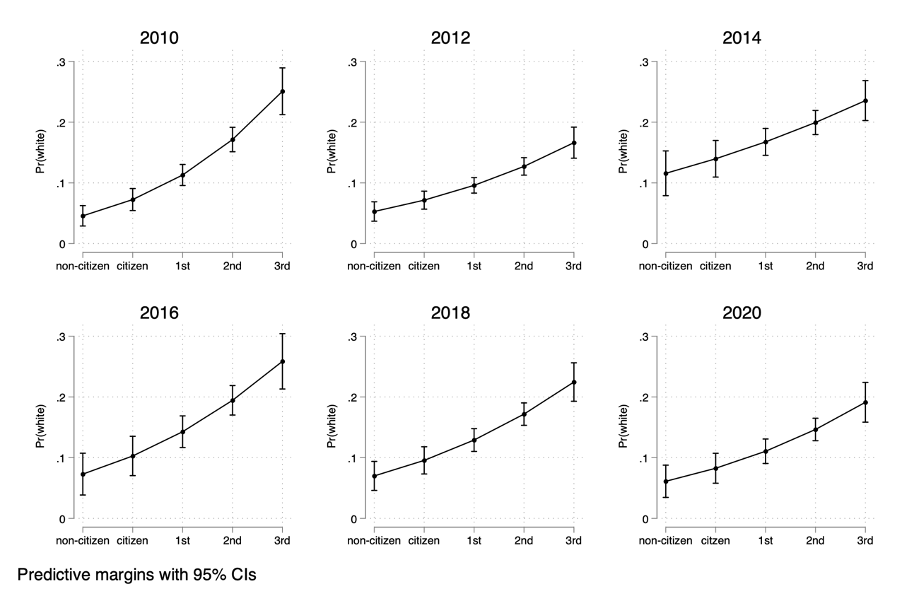
Figure A1. White Racial Identity by Immigrant Generation. Note: Plots show predictive margins with 95% CIs calculated from logit regression models for the effect of 5-point immigrant generation on white racial identification among Latinos in the CES by survey year.

- Demean-ed Models for Latino 3-Point Party ID
Figure A2. Latino Partisanship De-Meaned Models
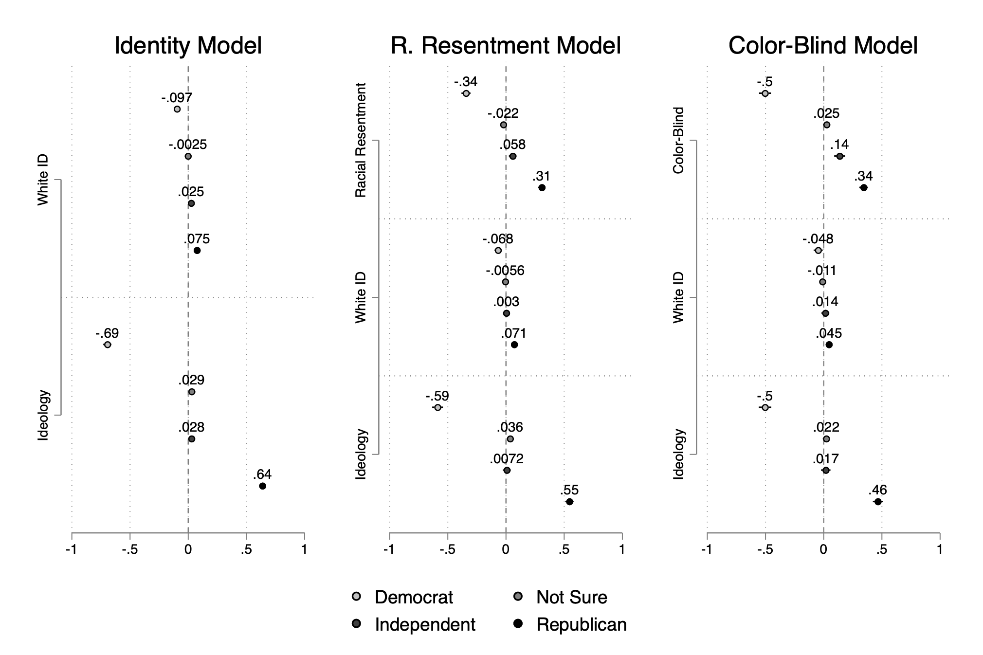
Note: Plotted values represent the average marginal effect on Latino partisan identification using demean-ed variables and survey year fixed effects, 95 percent confidence intervals. Left panel: White Racial Identity model, CES data from 2010-2020. Center panel: De-meaned racial resentment model, CES data from 2010-2020. Right panel: De-meaned color-blind racial attitudes CES data from 2016-2020.

This section of the appendix presents alternative models where data from the CES from 2010 to 2020 are pooled and analyzed using demean-ed variables and survey year fixed effects. Demean-ing is the process by which a new version of an existing variable is created by subtracting the mean from value of the original variable in each survey year. De-meaning “extracts the variation within subjects over time, but discards variation across units” (Brüderl and Ludwig 2015, p. 329) which reduces noise in estimations for pooled repeated cross-sectional data. In the main paper results were presented year by year, but models in this section will show the overall association of four key variables (white racial identity, multiracial white identity, racial resentment and color-blind racial attitudes) with Latino partisanship. Moreover, results are presented as average marginal effects (AME) plots for 3-point party identification plus “not sure” calculated from demean-ed multinomial logistic regressions with survey year fixed effects.
Figure A2 shows the AME of white racial identity and ideology on 3-point party identification in the left-hand panel. Results for the 3-point party identification plot show that white racial identity among Latinos from 2010 to 2020 decreases their likelihood to identify as Democrats by an average 9.7 percentage points (p<0.01), while increasing their likelihood to identify as Republicans by an average 7.5 percentage points (p<0.01). This follows the same pattern of results present in the first analysis of the main paper where white racial identity has a greater association with decreasing Latinos chances of identifying as Democrats in each survey year. The center panel presents the AME of racial resentment, white racial identity, and ideology on 3-point party identification among Latinos pooled from 2010 to 2020 in the CES. Racial resentment has a statistically significant AME on all four categories in the 3-point party identification demean-ed model. This racial attitude measure has a strong association with decreasing Latino Democratic identification by an average 34 percentage points (p<0.01), and a strong association with increasing Latino Republican identification by an average 31 percentage points (p<0.01). It also has a statistically significant AME on decreasing Latino identification as Independent (-2.2, p<0.05), and on increasing identification as “not sure” (+1.7, p<0.01). In this model white racial identity among Latino also has a statistically significant AME on Democratic (-6.8, p<0.01) and Republican identification (+7.1, p<0.01) even when accounting for racial resentment and ideological self-placement
The right-hand panel in Figure A2 the AME plot for the relationship between color-blind racial attitudes, white racial identity on 3-point party identification among Latinos pooled from 2016 to 2020 in the CES. Color-blind racial attitudes have a comparable association to that of ideology with Latino partisan identification. This racial attitude measure has the same AME as ideology with and association of 50 percentage points on decreasing Latino partisan identification as Democrats. It also has a strong association with increasing Latino identification as Republican (+34, p<0.01), saying they are “not sure” (+14, p<0.01).
Figure A3. Latino Partisanship De-Meaned Models without Ideology
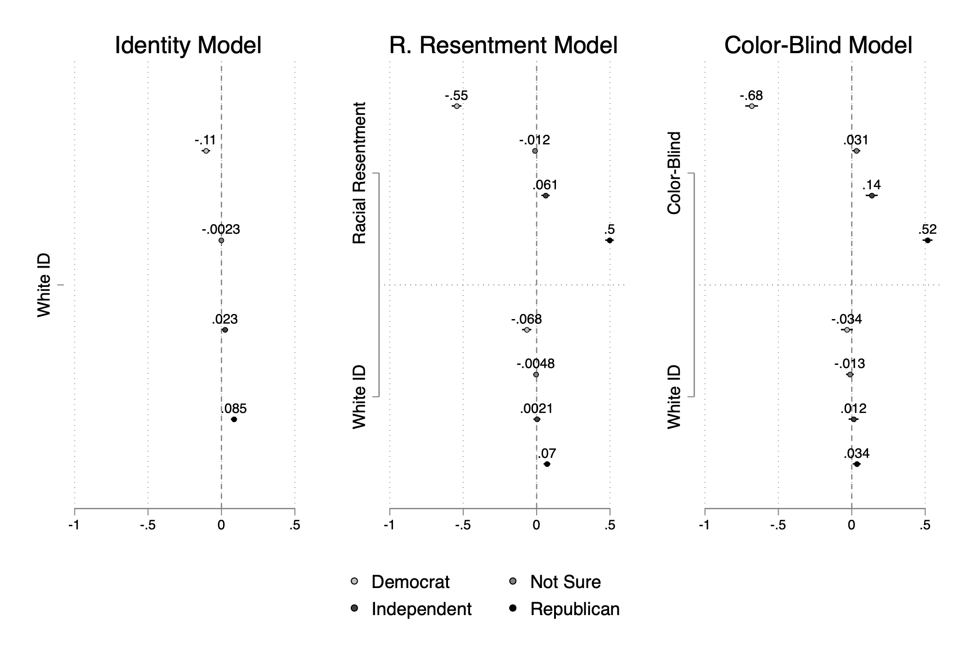
Note: Plotted values represent the average marginal effect on Latino partisan identification using demean-ed variables and survey year fixed effects, 95 percent confidence intervals. Left panel: White Racial Identity model, CES data from 2010-2020. Center panel: De-meaned racial resentment model, CES data from 2010-2020. Right panel: De-meaned color-blind racial attitudes CES data from 2016-2020.

Results discussed above show that even when pooling data from six consecutive CES surveys, in the case of the left-hand and center panels of Figures A2, and when pooling data from three consecutive CES surveys, in the right-hand panel of Figure A2, that white racial identity, racial resentment, and color-blind racial attitudes are all strongly related to decreased Democratic identification, and increased Republican identification among Latinos. Furthermore, these results hold even when removing ideology as a variable in each model as seen in Figure A3.

- Demean-ed Models for Latino 3-Point Party ID including Mutiracial White Identity
Table A10. Latinos Self-Identified as Multiracial Whites
Multi-racial ID | 2016 | 2018 | 2020
Multiracial White | 11%  (576) | 5%  (295) | 11%  (721)
Other | 89%  (4,724) | 95%  (6,152) | 89%  (6,008)
Total | 11%  (576) | 5%  (295) | 11%  (721)
Note: Values represent weighted total and percent of Latinos by Multiracial White Racial Identity by survey year.

Since 2016 the CES has allowed respondents to identify as multiracial in a follow up to the traditional race question. When identifying as multiracial respondents can select multiple races and ethnicities that make up their racial mix. This provides the opportunity to examine the role of multiracial white identity on Latino partisanship in light of the role that mestizaje plays in Latino racial identification. In 2016 and 2020 11% of Latinos in the CES indicated that “white” was part of their multiracial identity, while only 5% did so 2018.
The left-hand panel Figure A3 shows the AME of white racial identity, multiracial white identity and ideology on 3-point party identification. Results in this model show that white racial identity among Latinos continues to have a statistically significant association with Democratic (-8.8, p<0.01) and Republican partisan identification (+7.3, p<0.01). Interestingly, multiracial white identity has a larger AME (-9.4, p<0.01) on decreasing Latino’s likelihood of identifying as Democrats than white racial identity alone, but a smaller AME on increasing their likelihood to identify as Republicans (+6.0, p<0.01). In this case, white racial identity is not a significant predictor for identification as Independent or “note sure” while multiracial white identity is a significant predictor for identification as Independent (+4.8, p<0.05).
The AME plot in the center panel of Figure A3 includes demeaned racial resentment in addition to white, and multiracial white identity. In this plot racial resentment has similar but larger AME on Latino partisanship when compared to the results in Figure A2. Interestingly, white racial identity only has a statistically significant AME on increasing Republican identification in this model while multiracial white identity has a statistically significant AME on decreasing Democratic identification (-7.1, p<0.01), and increasing identification as Independent (+5.6, p<0.05).

Figure A3. Latino Partisanship De-Meaned Models including Multiracial White Identity
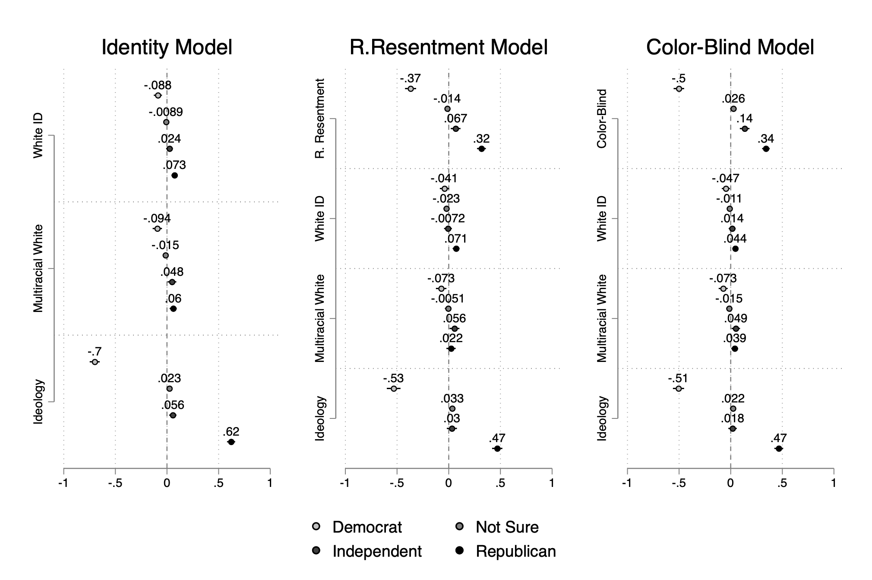
Note: Plotted values represent the average marginal effect on Latino partisan identification using demean-ed variables and survey year fixed effects, 95 percent confidence intervals. Left panel: CES data from 2010-2020. Center panel: CES data from 2010-2020, including de-meaned racial resentment. Right panel: CES data from 2016-2020 including de-meaned color-blind racial attitudes.

The right-hand panel in Figure A3 presents plots for the AME of color-blind racial attitudes, white and multiracial white identity on 3-point party identification among Latinos pooled from 2016 to 2020 in the CES. This racial attitude measure has the same exact AME on Democratic and Republican partisan identification than in Figure A2. In this demean-ed model, both white racial identity and multiracial white identity have a statistically significant AME on decreasing Latino identification as Democrats by an average 4.7 percentage point (p<0.05), and 7.3 percentage points (p<0.01) respectively. Both racial identity variables also have a significant AME on increasing Latino identification as Republicans, white racial identity by an average 4.4 percentage points (p<0.01), and multiracial white identity by an average 3.9 percentage points (p<0.05). Multiracial white identity also has a moderate association with Latinos saying they are “not sure” about their partisanship (+4.9, p<0.05).

- Demean-ed Models for Latino 3-Point Party ID including Hispanic Racial Identity
This section features two additional demean-ed models for 3-point Latino party identification that include Hispanic racial identity as a key independent dichotomous variable. Previous research by Stokes-Brown (2006) demonstrates that Latinos who identify as “Hispanic” in the race question of public opinion surveys have stronger Latino group consciousness, and identify more strongly with the Democratic Party.
Figure A4. Latino Partisanship De-Meaned Models including Hispanic Racial Identity
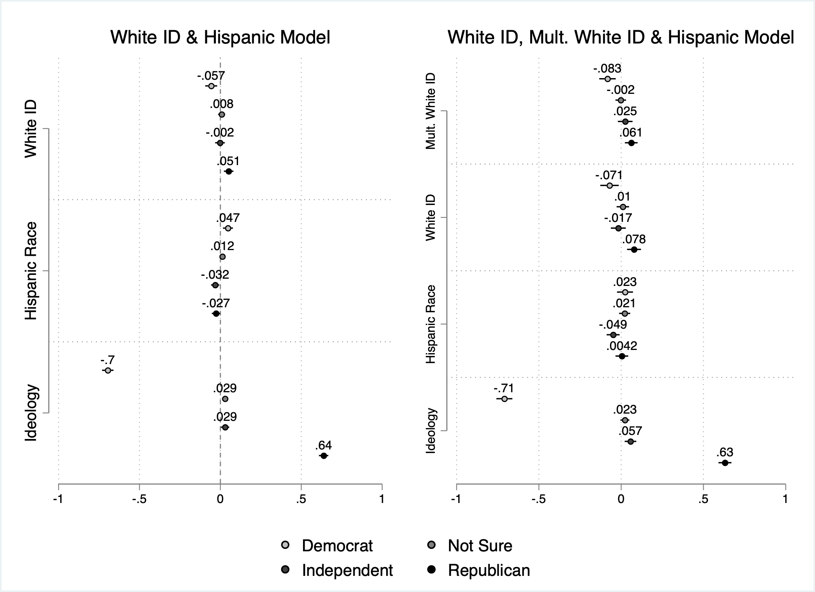
Note: Plotted values represent the average marginal effect of racial identity and ideology on Latino partisan identification using demean-ed variables and survey year fixed effects, 95 percent confidence intervals. Left panel: CES data from 2010-2020 for Hispanic racial identity, and white racial identity. Right panel: CES data from 2016-2020 Hispanic racial identity, multiracial white identity, and white racial identity.

The plot in the left hand panel of Figure A4 shows that the Hispanic race dummy has a statistically significant AME on increasing Democratic identification (+4.7, p<0.01) among Latinos pooled from 2010 to 2020 in the CES. It also has a moderate association with decreasing Republican identification (-3.2, p<0.05) and identification as “not sure” (-2.7, p<0.05) among Latinos. Still, white racial identity has a larger AME on Democratic (-5.7, p<0.01) and Republican (+5.1, p<0.01) partisan identification among Latinos pooled across the CES from 2010 to 2020. The plot in the right hand panel of Figure A4 includes three racial identity variables, multiracial white identity, white identity and Hispanic racial identity for Latino partisan identification among Latinos pooled across the CES from 2016 to 2020. This plot shows that Hispanic race only has a statistically significant association with identification as “not sure” among Latinos. However, both white and multiracial white identity have statistically significant AME on Democratic (-7.1, p<0.05 and -8.3, p<0.01 respectively) and Republican (+7.8, p<0.01 and +6.1, p<0.01) partisan identification.

- Comparison of 2020 Models With and Without Possible Repeat Respondents
A recent report about the 2020 CES stated that there are approximately 25% of all participants in this survey that also possibly participated in the 2018 CES (Schaffner, 2022). Schaffner, the PI of the CES, finds that these possible repeat respondents do not cause inferential problems for researchers using 2020 CES data. Specifically, he states that repeat respondents do not hold large differences from new respondents, and that “[r]emoving likely repeaters has no statistically distinguishable effect on the inferences” and that any effect on inference is marginal. Here I present a comparison of the models for 2020 CES used in the main paper to models with possible repeat Latino respondents removed from the analysis in figures A5, A6 and A7. Repeat respondents are identified as “2018 CES respondents to the 2020 file on zip code, birth year, and gender” (Schaffner, 2022, p. 2). I found that 22.49% of all 2020 CES Latino respondents are possible repeat respondents from the 2018 CES, a weighted total of 1,513 out of 6,729 Latinos.
Overall, in Figure A5 there was an average 1.3625 percentage point difference between the estimates of the compared models predicting Latino partisanship based on white racial identity, with differences going from 0 to 2.5 percentage points. In Figure A6 there is an average 1.79 difference between estimates of the compared models for Latino partisanship based on racial resentment and white racial identity, with differences going from 0 to 2.92 percentage points. Finally, in Figure A7 there is an average 1.45 percent point difference between estimates of the compared models for Latino partisanship based on color-blind racial attitudes and white racial identity, going from 0.3 to 2.3 percentage points. More importantly, the patterns of the association of each key independent variable is unchanged when comparing each model with possible repeat respondents to the models without possible repeat Latino respondents. Differences in estimated average marginal effects are almost indistinguishable.

Figure A5.
2020 CES AME of White Racial Identity on Latino Partisanship
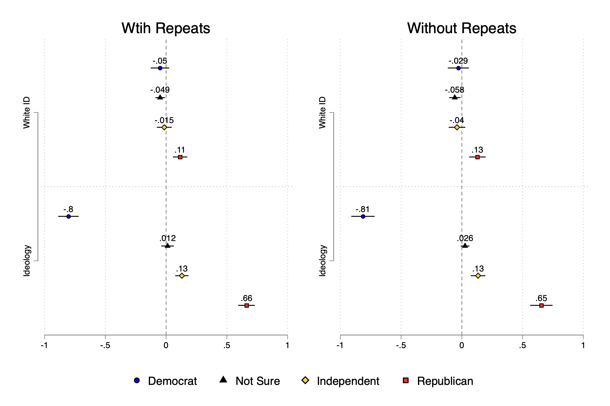

Figure A6.
2020 CES AME of White Racial Identity & Racial Resentment on Latino Partisanship
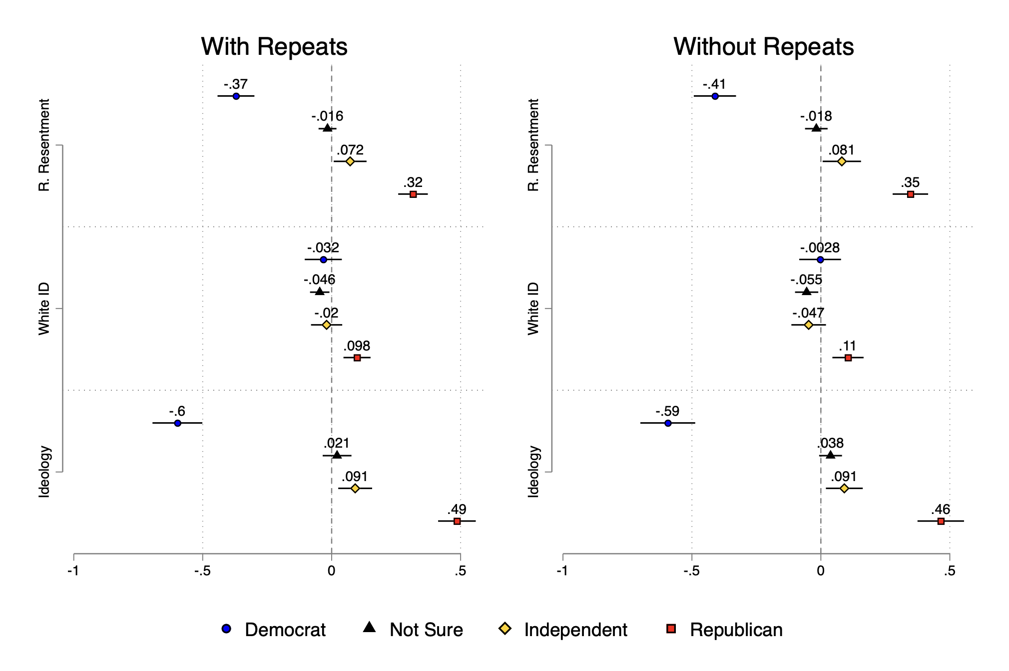

Figure A7.
2020 CES AME of White Racial Identity & Color-Blindness on Latino Partisanship
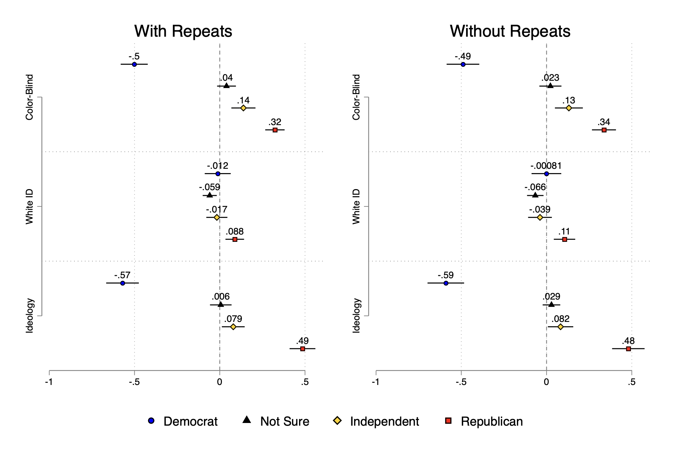

- Reverse Causality: Race Predicts Party ID
While research by Egan (2020) has put into question the directionality of the relationship between identities and partisanship, it also shows that racial and ethnic identities are among the most stable and least likely to be shifted to align with an individual’s partisan identity. As an extension of the question of reverse causality I have tested if consistent Republican partisanship is related to changing from Hispanic identity to white identity in the CES 2010-2012-2014 Panel Survey, as well as changing from any racial identity to white identity among all Latino/Hispanic respondents. Note that a weighted total of 1,001 (639 non-weighted) CES Panel Survey respondents who self-identified as Hispanic in one or more of the three waves of the panel. Originally, the CES Panel Survey included a weighted total of 1,857 (1,600 non-weighted) respondents identified as Hispanic in one or more of the first two waves of the panel. This represents an attrition rate of 53.9% for the weighted sample (39.9% non-weighted) in the third wave of the panel. I have included these results in the Supplemental Index for the paper due to word count constraints, and because of the high attrition rate for Latino/Hispanic respondents in the CES Panel Survey which may affect the validity of the analysis.
The coefficient plot below, drawn from OLS regressions, demonstrates that in bivariate models of changing to white racial identity by consistent Republican partisanship there is no statistically significant relationship. However, when including consistent Democratic, consistent Independent and consistent Not Sure partisanship, then consistent Republican partisanship is predictive of changing to white racial identity at the p<0.1 significance level. In the “Hispanic to White” model consistently identifying as Republican led to an increase of 25.5 percent in identification as white, and an increase of 28.2 percent in the “Any Race to White” model. While these are large point estimates the statistical significance level is weak. This along with the high attrition rates among Latino/Hispanic respondents suggests that further research with more consistent sampling in needed to assess the directionality of the relationship between social group identity and partisanship for this particular ethnoracial group.
Figure A8.
2010-2014 CES Panel Survey OLS Coefficient Plot
for the White Racial Identity by Latino Partisanship
