Online Appendix

Figures

Figure A1:
Sentiment from Text Analyses of
Cable vs Broadcast Depictions of Protesters
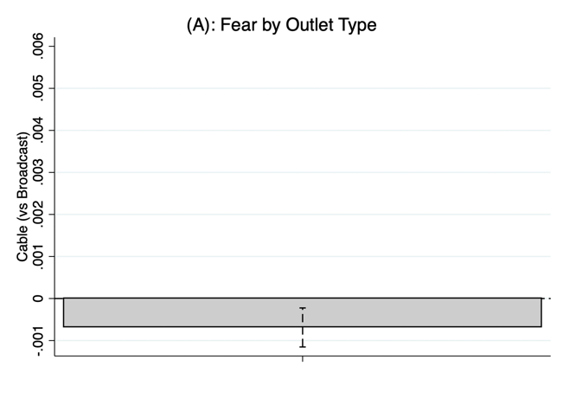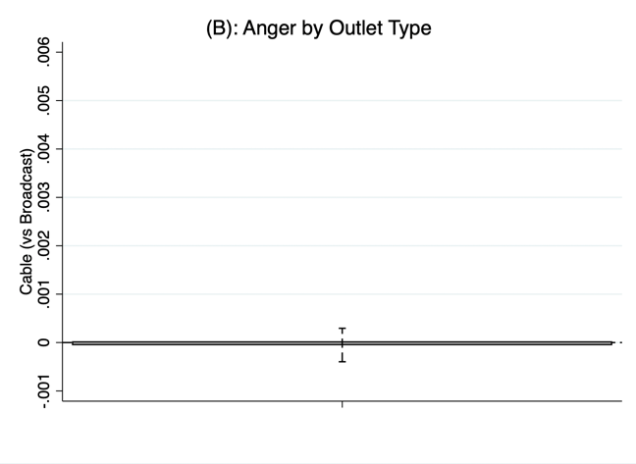

Figure A2:
Sentiment from Text Analyses of
Cable vs Broadcast Depictions by Protesters' Race

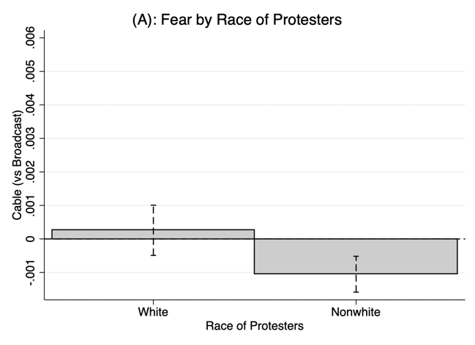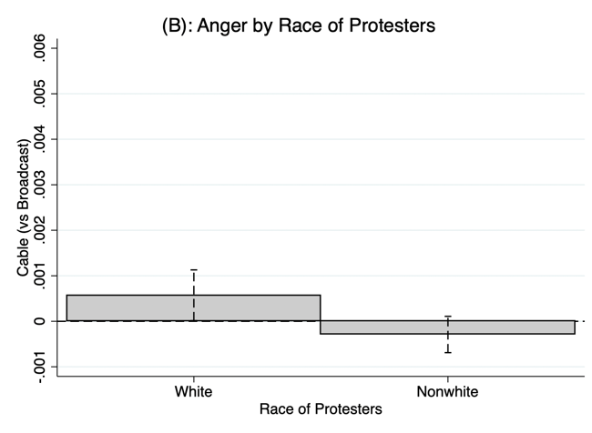

Figure A3:
Sentiment from Text Analysis of
Cable vs Broadcast Depictions of Protesters
By Media Outlet (Liberal Protests)

