Appendix A (Paper)
Appendix Table 1: Testing Whether the Correlations between Presidential Approval and Macropartisanship Vary by Race and Ethnicity
 | Hotelling's T-Test | Steiger's Z-Test
White vs. Black | 2.110**  (0.035) | 2.100**  (0.036)
White vs. Latino | 2.541**  (0.011) | 2.523**  (0.012)
Black vs. Latino | 0.190  (0.849) | 0.190  (0.849)
Hotelling's T-Test reports a t-statistic. Steiger's Z-Test reports a Z-statistic; p-values in parentheses. *p<0.10, **p<0.05, ***p<0.01.

Appendix Table 2: Testing Whether the Correlations between Polarization and Macropartisanship Vary by Race and Ethnicity
 | Hotelling's T-Test | Steiger's Z-Test
White vs. Black | -22.822***  (<0.001) | 15.296***  (<0.001)
White vs. Latino | -10.057***  (<0.001) | 8.974***  (<0.001)
Black vs. Latino | 8.091***  (<0.001) | 7.616***  (<0.001)
Hotelling's T-Test reports a t-statistic. Steiger's Z-Test reports a Z-statistic; p-values in parentheses. *p<0.10, **p<0.05, ***p<0.01.

Appendix B (Supplemental Online)

 | Latinos | Whites | Blacks | Overall | Latinos | Whites | Blacks | Overall
 | OLS | OLS | OLS | OLS | Newey-West | Newey-West | Newey-West | Newey-West
Consumer Index_{t-1} | 0.052** | 0.021*** | 0.013* | 0.023** | 0.380*** | 0.116*** | 0.020 | 0.149***
 | (0.022) | (0.008) | (0.007) | (0.010) | (0.130) | (0.037) | (0.020) | (0.035)
Polarization | 3.752 | -4.543 | -0.118 | -0.386 | -53.605 | -47.832** | 8.262 | -9.982
 | (7.792) | (2.846) | (2.684) | (3.534) | (43.089) | (18.636) | (8.610) | (18.394)
Reagan | 0.907 | -0.321 | -0.389 | 0.199 | 0.310 | -1.267 | -2.248 | 2.520
 | (1.077) | (0.379) | (0.379) | (0.498) | (6.758) | (2.563) | (1.583) | (2.589)
Bush I | -0.137 | -0.975** | -0.697* | -0.649 | -9.698 | -8.881*** | -4.334*** | -5.251**
 | (1.186) | (0.442) | (0.416) | (0.546) | (6.967) | (2.589) | (1.378) | (2.534)
Clinton | -0.173 | -0.508** | -0.504** | -0.307 | -1.874 | -3.635*** | -3.370*** | -1.919
 | (0.610) | (0.224) | (0.225) | (0.283) | (4.056) | (1.234) | (0.742) | (1.266)
Obama | 0.780 | 0.225 | 0.156 | 0.418 | 15.073*** | 2.980 | 0.230 | 4.332**
 | (0.847) | (0.278) | (0.269) | (0.368) | (3.961) | (1.842) | (0.857) | (1.816)
Macropartisanship_{t-1} | 0.899*** | 0.906*** | 0.887*** | 0.885*** | −−− | −−− | −−− | −−−
 | (0.022) | (0.019) | (0.023) | (0.022)
Constant | -0.306 | 0.222 | 0.227 | -0.004 | -1.685 | 1.711* | 1.618*** | -0.295
 | (0.424) | (0.152) | (0.152) | (0.195) | (2.878) | (0.977) | (0.577) | (0.964)
Observations | 398 | 398 | 398 | 398 | 399 | 399 | 399 | 399
R-squared | 0.862 | 0.909 | 0.889 | 0.870 | −−− | −−− | −−− | −−−
F | −−− | −−− | −−− | −−− | 8.81 | 6.95 | 20.95 | 11.42
Online Appendix Table 1: Consumer Confidences, Political Polarization, Administration, and Macropartisanship (No Presidential Approval)
Standard errors in parentheses
*** p<0.01, ** p<0.05, * p<0.10

 | Latinos | Whites | Blacks | Overall | Latinos | Whites | Blacks | Overall
 | OLS | OLS | OLS | OLS | Newey-West | Newey-West | Newey-West | Newey-West
Approval_{t-1} | 0.028* | 0.022*** | 0.014** | 0.017** | 0.214*** | 0.150*** | 0.090*** | 0.120***
 | (0.017) | (0.006) | (0.006) | (0.008) | (0.072) | (0.028) | (0.019) | (0.026)
Consumer Index_{t-1} | 0.029 | 0.018** | 0.013 | 0.020* | 0.242** | 0.065* | 0.005 | 0.106***
 | (0.023) | (0.008) | (0.008) | (0.011) | (0.105) | (0.034) | (0.022) | (0.034)
Republican Polarization | 24.023 | -14.388** | -6.486 | -1.544 | -33.507 | -98.195*** | -10.651 | -23.903
(Conservatism) | (15.818) | (5.867) | (5.483) | (7.269) | (70.212) | (34.410) | (18.542) | (40.243)
Reagan | 2.090* | -0.434 | -0.826** | 0.250 | 5.224 | -1.290 | -3.771** | 2.469
 | (1.123) | (0.391) | (0.398) | (0.519) | (5.969) | (2.214) | (1.557) | (2.608)
Bush I | 1.256 | -1.157*** | -1.065** | -0.570 | -2.288 | -7.249*** | -5.101*** | -4.120
 | (1.197) | (0.443) | (0.430) | (0.557) | (5.330) | (2.271) | (1.502) | (2.638)
Clinton | 0.488 | -0.689*** | -0.728*** | -0.299 | 0.519 | -3.741*** | -3.804*** | -1.745
 | (0.678) | (0.248) | (0.251) | (0.314) | (3.414) | (1.161) | (0.845) | (1.354)
Obama | -0.425 | 0.912** | 0.655 | 0.604 | 13.840** | 6.544*** | 1.861 | 5.554**
 | (1.257) | (0.442) | (0.421) | (0.569) | (5.379) | (2.489) | (1.336) | (2.752)
Macropartisanship_{t-1} | 0.890*** | 0.865*** | 0.866*** | 0.868*** | −−− | −−− | −−− | −−−
 | (0.022) | (0.022) | (0.024) | (0.023)
Constant | -0.582 | 0.203 | 0.323** | -0.042 | -3.589* | 0.999 | 1.886*** | -0.568
 | (0.389) | (0.134) | (0.140) | (0.176) | (1.951) | (0.690) | (0.485) | (0.744)
Observations | 398 | 398 | 398 | 398 | 399 | 399 | 399 | 399
R-squared | 0.864 | 0.912 | 0.891 | 0.871 | −−− | −−− | −−− | −−−
F | −−− | −−− | −−− | −−− | 7.56 | 9.97 | 24.64 | 13.58
Online Appendix Table 2: Presidential Approval, Consumer Confidence, Republican Polarization (Conservatism), Administration, and Macropartisanship

Standard errors in parentheses
*** p<0.01, ** p<0.05, * p<0.10

 | Latinos | Whites | Blacks | Overall | Latinos | Whites | Blacks | Overall
 | OLS | OLS | OLS | OLS | Newey-West | Newey-West | Newey-West | Newey-West
Approval_{t-1} | 0.028* | 0.020*** | 0.015** | 0.017** | 0.200*** | 0.145*** | 0.096*** | 0.121***
 | (0.017) | (0.006) | (0.006) | (0.008) | (0.066) | (0.029) | (0.019) | (0.026)
Consumer Index_{t-1} | 0.053** | 0.010 | 0.003 | 0.017* | 0.283*** | 0.018 | -0.031* | 0.085**
 | (0.021) | (0.007) | (0.007) | (0.010) | (0.101) | (0.033) | (0.017) | (0.034)
Democratic Polarization | 3.640 | 4.533 | -5.549 | -1.245 | 89.509 | 44.686** | -35.737*** | -1.818
(Conservatism) | (12.160) | (4.289) | (4.239) | (5.487) | (58.762) | (20.422) | (11.448) | (19.729)
Reagan | 0.382 | 0.131 | -0.100 | 0.422 | 1.931 | 2.233 | -0.932 | 4.095**
 | (0.888) | (0.314) | (0.309) | (0.418) | (5.072) | (1.768) | (1.350) | (1.903)
Bush I | -0.587 | -0.509 | -0.278 | -0.380 | -6.277 | -3.840*** | -1.916* | -2.409
 | (1.023) | (0.363) | (0.354) | (0.468) | (5.032) | (1.452) | (1.109) | (1.494)
Clinton | -0.317 | -0.328* | -0.438** | -0.227 | -0.239 | -1.606** | -2.760*** | -0.971
 | (0.531) | (0.188) | (0.196) | (0.244) | (2.889) | (0.727) | (0.543) | (0.847)
Obama | 1.328** | -0.057 | 0.168 | 0.486** | 12.144*** | 0.006 | 0.859* | 3.871***
 | (0.573) | (0.175) | (0.175) | (0.247) | (1.769) | (0.998) | (0.515) | (1.129)
Macropartisanship_{t-1} | 0.885*** | 0.879*** | 0.859*** | 0.868*** | −−− | −−− | −−− | −−−
 | (0.023) | (0.021) | (0.025) | (0.023)
Constant | -0.195 | 0.122 | 0.119 | -0.091 | -1.962 | 0.724 | 0.915** | -0.929
 | (0.425) | (0.148) | (0.148) | (0.195) | (2.313) | (0.677) | (0.455) | (0.668)
Observations | 398 | 398 | 398 | 398 | 399 | 399 | 399 | 399
R-squared | 0.863 | 0.911 | 0.891 | 0.871 | −−− | −−− | −−− | −−−
F | −−− | −−− | −−− | −−− | 8.30 | 11.37 | 33.17 | 13.81

Online Appendix Table 3: Presidential Approval, Consumer Confidence, Democratic Polarization (Conservatism), Administration, and Macropartisanship
Standard errors in parentheses
*** p<0.01, ** p<0.05, * p<0.10

Online Appendix Table 4: ARMA Models of Presidential Approval, Consumer Confidence, Polarization, and Administration

 | Latinos | Whites | Blacks | Overall
 | ARMA(1, 1) | ARMA(1, 1) | ARMA(1, 1) | ARMA(1, 1)
Approval_{t-1} | 0.053 | 0.003 | 0.009 | 0.015
 | (0.045) | (0.013) | (0.014) | (0.015)
Consumer Index_{t-1} | 0.048 | 0.049** | 0.021 | 0.068***
 | (0.045) | (0.019) | (0.013) | (0.020)
Polarization | 53.942*** | -18.589 | 4.200 | -15.767*
 | (14.671) | (11.915) | (5.348) | (9.290)
Reagan | 11.447*** | -0.91 | -2.494** | -0.144
 | (3.14) | (1.492) | (1.166) | (1.668)
Bush I | 8.115*** | -1.961* | -3.820*** | -2.764**
 | (2.399) | (1.027) | (0.919) | (1.279)
Clinton | 4.049** | -2.299*** | -2.808*** | -2.257**
 | (1.579) | (0.851) | (0.616) | (0.988)
Obama | 4.413 | 3.288* | 1.131 | 4.329***
 | (2.845) | (1.773) | (0.836) | (1.189)
AR(1) | 0.911*** | 0.972*** | 0.875*** | 0.921***
 | (0.023) | (0.041) | (0.030) | (0.028)
MA(1) | 0.016 | -0.077 | 0.098 | 0.014
 | (0.062) | (0.079) | (0.070) | (0.066)
Constant | -4.671* | 0.840 | 1.316* | 0.266
 | (2.407) | 2.802) | (0.721) | (1.243)
Sigma | 3.061*** | 1.087*** | 1.061*** | 1.408***
 | (0.137) | (0.072) | (0.046) | (0.095)
Observations | 399 | 399 | 399 | 399

Online Appendix Figure 1: Autocorrelations of Macropartisanship by Race or Ethnicity
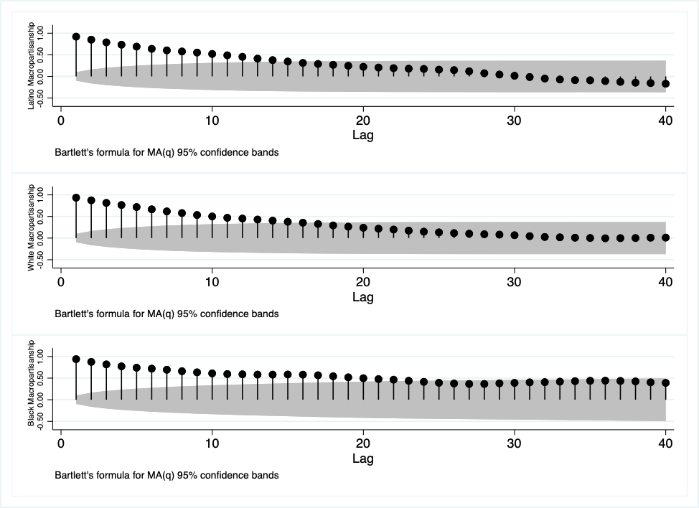Online

Online Appendix Figure 2: Partial Autocorrelations of Macropartisanship
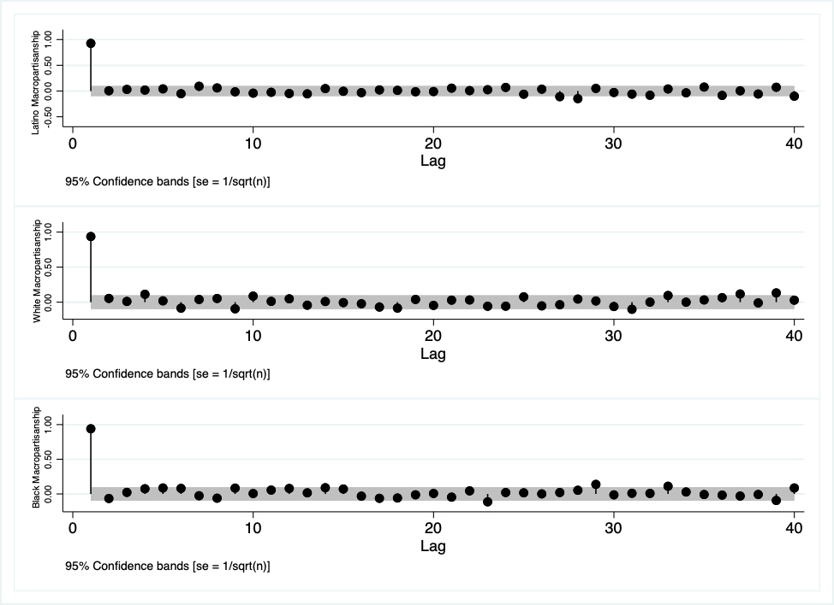

Online Appendix Figure 3: Latino Macropartisanship with Confidence Intervals
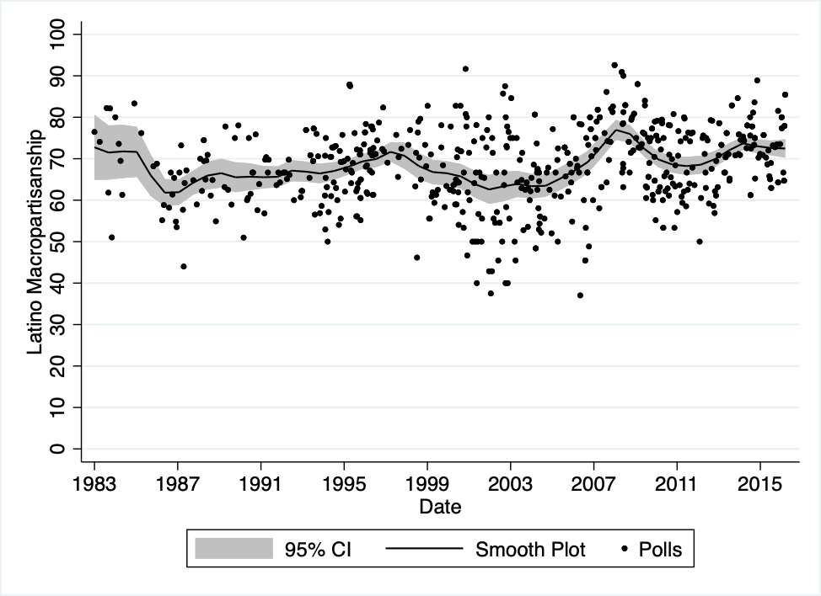

Online Appendix Figure 4: White Macropartisanship with Confidence Intervals
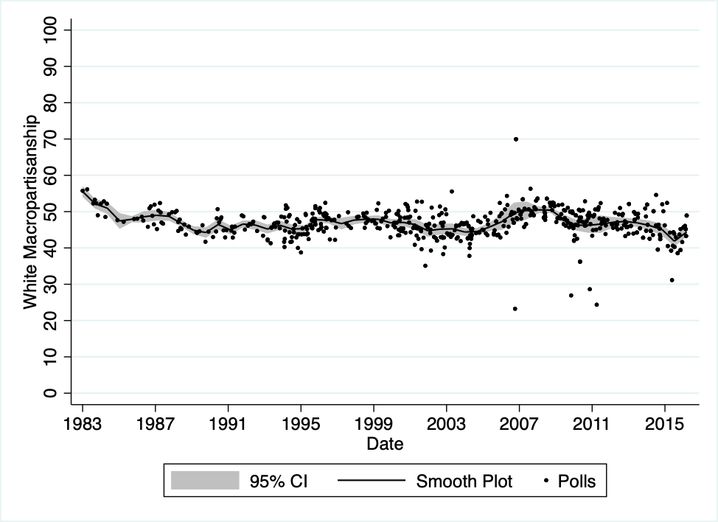
Online Appendix Figure 5: Black Macropartisanship with Confidence Intervals 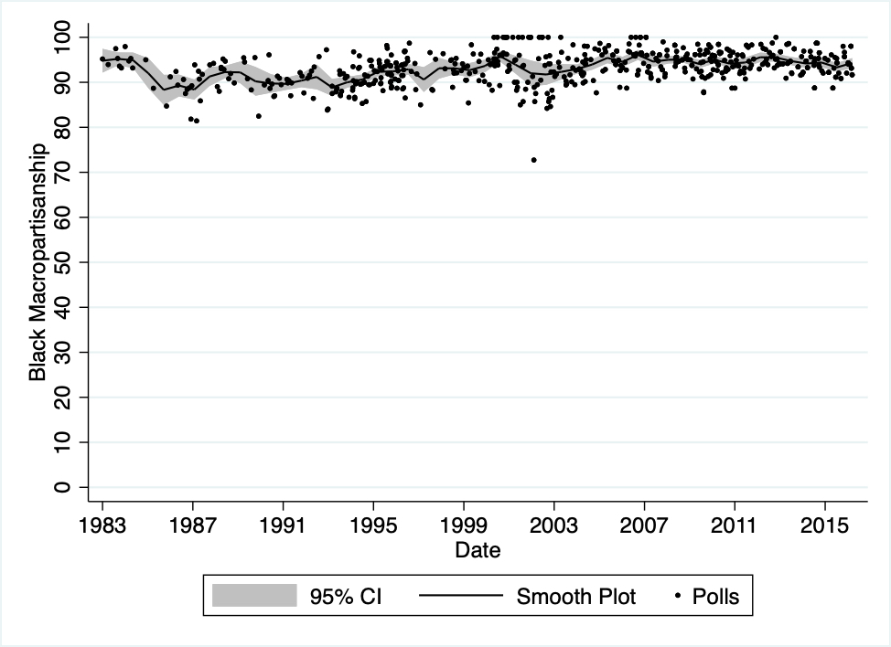

Figures 3-5 present raw CBS and CBS/NYTimes polls with a scatterplot and local polynomial smooth plots with confidence intervals shown over time.

