Appendix A. Density of Xenophobic Attitudes by Country

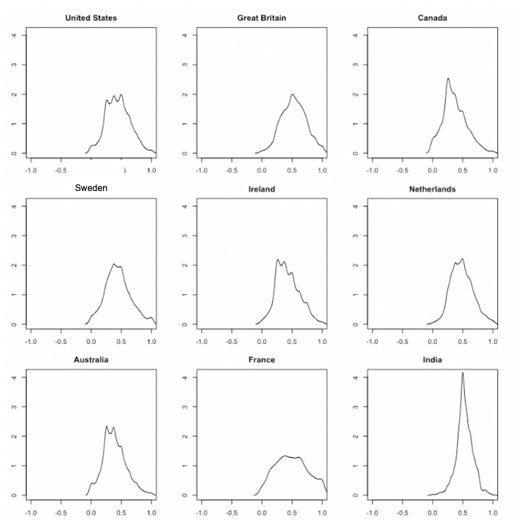

Appendix B. Density of Ascriptive to Achievable Identities by Country

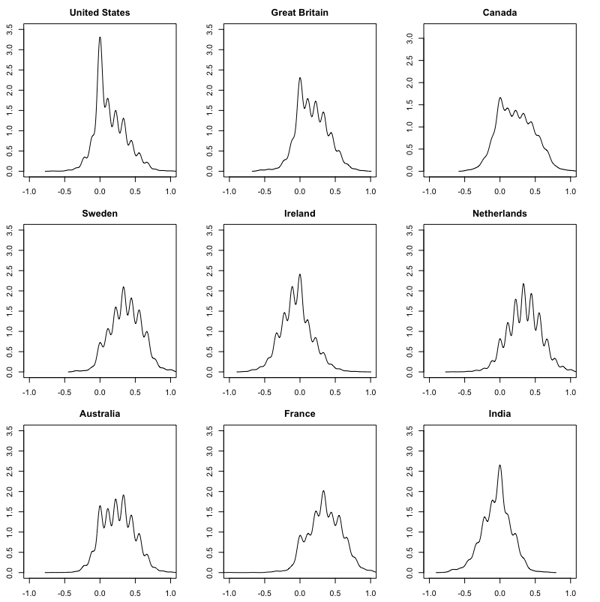

Appendix C. ISSP Descriptive Variables

Indicator | Total  (N=31,028)
Female | 47.10%
Age (in years) | 47.38  (SD=14.29)
Both parents are citizen | 91.75%
One parent is a citizen | 2.73%
Neither parent are citizens | 5.51%
Non-citizen | 1.24%
Urban | 32.15%
Suburban | 38.51%
Rural | 29.34%
Employed | 78.67%
Unemployed | 21.33%
Married/Living with Partner | 69.07%
Not Married/Living with a Partner | 30.93%
Left-Right Political Ideology | 0.490  (SD = 0.247)
Wave 1: 1995 | 19.22%  (n=5,965)
Wave 2: 2003 | 35.71%  (n=11,079)
Wave 3: 2013 | 45.07%  (n=13,984)

Appendix D: Robustness Political Ideology Mid-Point Substitution
Predictors | DV: Maintaining Traditions |  | DV: Government Assistance
 | 1 | 2 | 3 | 4
 | Study Variables |  | Study Variables
Achievable Identity | 0.089** | 0.087** | -0.037* | -0.034*
 | (0.013) | (0.014) | (0.016) | (0.016)
 | Control Variables |  | Control Variables
Xenophobia | -0.517** | -0.498** | -0.392** | -0.374**
 | (0.040) | (0.042) | (0.034) | (0.035)
Female | 0.018** | 0.016** | 0.006 | 0.006
 | (0.004) | (0.003) | (0.004) | (0.004)
Age | -0.046** | -0.047** | -0.007 | -0.010
 | (0.009) | (0.009) | (0.011) | (0.010)
Parent citizen  status¹ | 0.021 | 0.017 | -0.055** | -0.056**
 | (0.014) | (0.013) | (0.011) | (0.010)
Non-citizen | -0.026⁺ | -0.028* | 0.019 | 0.020
 | (0.014) | (0.013) | (0.013) | (0.013)
Urban | 0.011 | 0.007 | 0.003 | 0.001
 | (0.007) | (0.006) | (0.006) | (0.006)
Employed | 0.012** | 0.010** | -0.012* | -0.015**
 | (0.004) | (0.004) | (0.005) | (0.005)
Married | -0.006 | -0.005 | -0.016** | -0.016**
 | (0.005) | (0.005) | (0.005) | (0.005)
Religiosity | -0.020** | -0.018** | 0.031** | 0.029**
 | (0.007) | (0.007) | (0.008) | (0.008)
Left-Right Ideology | -0.000⁺ |  | -0.000
(Midpoint substitution) | (0.000) |  | (0.000)
Constant | 0.621** | 0.629** | 0.813** | 0.810**
 | (0.027) | (0.025) | (0.025) | (0.029)
N | 39486 | 44528 | 39206 | 44225
Log Likelihood | -4466.750 | -5132.841 | -1460.068 | -1696.086
AIC | 8965.500 | 10295.682 | 2952.135 | 3422.171
Year Fixed Effects | Yes | Yes | Yes | Yes
Unstandardized beta coefficients with robust standard errors clustered by country in parentheses. +p<.10, *p<.05,**p<.01.

Appendix E. Robustness: Identity Predicting Multicultural excluding Immigrant Culture Item
Predictors | DV: Maintaining Traditions | DV: Government Assistance
 | 1 | 2
 | Study Variables | Study Variables
Achievable  Identity | 0.110** | -0.034⁺
 | (0.015) | (0.018)
 | Control Variables | Control Variables
Xenophobia | -0.486** | -0.309**
 | (0.034) | (0.034)
Female | 0.018** | 0.004
 | (0.004) | (0.004)
Age | -0.060** | -0.012
 | (0.010) | (0.012)
Parent citizen  status | 0.028* | -0.049**
 | (0.014) | (0.011)
Non-citizen | -0.033* | -0.007
 | (0.015) | (0.020)
Urban | 0.007 | 0.001
 | (0.008) | (0.006)
Employed | 0.011** | -0.011⁺
 | (0.004) | (0.006)
Married | -0.001 | -0.016**
 | (0.006) | (0.005)
Religiosity | -0.006 | 0.040**
 | (0.007) | (0.009)
Left-Right Ideology | -0.091** | -0.122**
 | (0.016) | (0.020)
Constant | 0.649** | 0.829**
 | (0.029) | (0.025)
N | 29777 | 29621
Log Likelihood | -3169.311 | -983.808
AIC | 6370.623 | 1999.616
Year Fixed Effects | Yes | Yes
Unstandardized beta coefficients with robust standard errors clustered by country in parentheses. +p<.10, *p<.05,**p<.01.

Appendix F. Robustness: Excluding Non-Citizens and Those with Parental Immigrant Heritage
Predictors | DV: Maintaining Traditions |  | DV: Government Assistance
 | 1 | 2 | 3 | 4
 | Study Variables |  | Study Variables
Achievable  Identity |  | 0.107** |  | -0.039*
 |  | (0.014) |  | (0.019)
 | Control Variables |  | Control Variables
Xenophobia | -0.564** | -0.537** | -0.372** | -0.382**
 | (0.040) | (0.037) | (0.038) | (0.036)
Female | 0.019** | 0.018** | 0.004 | 0.004
 | (0.004) | (0.004) | (0.004) | (0.004)
Age | -0.058** | -0.055** | -0.002 | -0.003
 | (0.010) | (0.010) | (0.012) | (0.013)
Urban | 0.008 | 0.006 | -0.003 | -0.003
 | (0.008) | (0.008) | (0.005) | (0.005)
Employed | 0.017** | 0.014** | -0.013* | -0.012⁺
 | (0.005) | (0.004) | (0.007) | (0.006)
Married | 0.000 | -0.000 | -0.019** | -0.019**
 | (0.005) | (0.005) | (0.005) | (0.005)
Religiosity | -0.018* | -0.007 | 0.034** | 0.030**
 | (0.007) | (0.008) | (0.008) | (0.009)
Left-Right Ideology | -0.088** | -0.085** | -0.104** | -0.105**
 | (0.016) | (0.016) | (0.019) | (0.019)
Constant | 0.715** | 0.676** | 0.794** | 0.809**
 | (0.027) | (0.027) | (0.024) | (0.022)
N | 27028 | 27028 | 26887 | 26887
Log Likelihood | -2686.087 | -2596.070 | -459.864 | -445.892
AIC | 5922.302 | 5220.140 | 1192.777 | 919.785
Year Fixed Effects | Yes | Yes | Yes | Yes
Unstandardized beta coefficients with robust standard errors clustered by country in parentheses. +p<.10, *p<.05,**p<.01.

Appendix G. Identity Predicting Support for Custom and Tradition Maintenance by Gender
Predictors | Females |  | Males
 | DV: Maintaining Traditions | DV: Government Assistance | DV: Maintaining Traditions | DV: Government Assistance
 | 1 | 2 | 3 | 4
 | Study Variables |  | Study Variables
Achievable  Identity | 0.116** | -0.046* | 0.091** | -0.050*
 | (0.017) | (0.019) | (0.014) | (0.020)
 | Control Variables |  | Control Variables
Xenophobia | -0.530** | -0.388** | -0.534** | -0.377**
 | (0.041) | (0.036) | (0.036) | (0.037)
Age | -0.054** | -0.032* | -0.060** | 0.006
 | (0.014) | (0.013) | (0.011) | (0.015)
Parent citizen  status | 0.034* | -0.036** | 0.024 | -0.052**
 | (0.014) | (0.013) | (0.016) | (0.013)
Non-citizen | -0.059** | -0.005 | -0.011 | -0.009
 | (0.021) | (0.027) | (0.028) | (0.020)
Urban | 0.005 | 0.003 | 0.009 | -0.005
 | (0.008) | (0.005) | (0.009) | (0.009)
Employed | 0.012* | -0.016* | 0.014⁺ | -0.009
 | (0.006) | (0.006) | (0.008) | (0.008)
Married | 0.003 | -0.019** | -0.003 | -0.017**
 | (0.007) | (0.005) | (0.007) | (0.006)
Religiosity | -0.004 | 0.035** | -0.010 | 0.041**
 | (0.009) | (0.011) | (0.010) | (0.009)
Left-Right Ideology | -0.093** | -0.106** | -0.077** | -0.120**
 | (0.016) | (0.019) | (0.018) | (0.021)
Constant | 0.658** | 0.857** | 0.661** | 0.854**
 | (0.028) | (0.028) | (0.034) | (0.027)
N | 13794 | 13712 | 15605 | 15541
Log Likelihood | -1413.717 | -212.178 | -1646.123 | -494.298
AIC | 2857.434 | 454.357 | 3322.245 | 1018.596
Year Fixed Effects | Yes | Yes | Yes | Yes
Unstandardized beta coefficients with robust standard errors clustered by country in parentheses. +p<.10, *p<.05,**p<.01.
Appendix H. Variable Survey Responses and Coding

 | Variable | Item(s) | Response Options | Value
Independent Variable | Achievable Identity | Standardized scale from the following items:  Some people say that the following things are important for being truly [nationality]. Others say they are not important. How important do you think each of the following is:  - To have been born in [country]?  - To have [country nationality] citizenship?  - To be a [religion]?  - To be able to speak [country language]?  - To respect [country nationality] political institutions and laws?  - To feel [country nationality]? | Very important | (0)
 |  |  | Fairly important | (0.25)
 |  |  | Neither nor | (0.5)
 |  |  | Not very important | (0.75)
 |  |  | Not important at all | (1)
Dependent Variables | Maintaining Traditions | It is impossible for people who do not share [country’s] customs and traditions to become fully [country’s nationality]. | Agree strongly | (0)
 |  |  | Agree | (0.25)
 |  |  | Neither agree nor disagree | (0.5)
 |  |  | Disagree | (0.75)
 |  |  | Disagree strongly | (1)
 | Government Assistance | Ethnic minorities should be given governmental assistance to preserve their customs and traditions. | Disagree strongly | (0)
 |  |  | Disagree | (0.25)
 |  |  | Neither agree nor disagree | (0.5)
 |  |  | Agree | (0.75)
 |  |  | Agree strongly | (1)
Robustness | National Identity | How close do you feel to: [country]? | Not close at all | (0)
 |  |  | Not very close | (0.33)
 |  |  | Close | (0.66)
 |  |  | Very close | (1)
Control Variables | Xenophobia | Aggregate scale of the following items:  - Immigrants increase crime rates;  - Immigrants are generally good for the [country’s] economy*;  - Immigrants take jobs away from people who were born in [country];  - Immigrants improve [country’s nationality] society by bringing new ideas and cultures.*  * Reverse coded. | Disagree strongly | (0)
 |  |  | Disagree | (0.25)
 |  |  | Neither agree nor disagree | (0.5)
 |  |  | Agree | (0.75)
 |  |  | Agree strongly | (1)
 | Female | Sex of respondent (ISSP reported) | Male | (0)
 |  |  | Female | (1)
 | Age | Age of respondent (calculated from year of birth in 2013 wave; ager reported in 2003; categories from wave 1995) | 16 to 29 | (0)
 |  |  | 30 to 39 | (0.25)
 |  |  | 40 to 49 | (0.5)
 |  |  | 50 to 59 | (0.75)
 |  |  | 60 and older | (1)
 | Parent citizenship status | At the time of your birth, were both, one or neither of your parents citizens of [country]?  If a country was recently part of a larger political union, citizenship should refer to the preceding national state. | Neither parent was a citizen of [country] | (0)
 |  |  | Only my father/mother was a citizen of [country] | (0.5)
 |  |  | Both were citizens of [country] | (1)
 | Non-citizen | Are you a citizen of [country]? | Yes | (0)
 |  |  | No | (1)
 | Urban | Type of community: Urban/Rural (based on self-assessment by respondent) | Suburb, town or small city; Country village; Farm or home in the country; Rural | (0)
 |  |  | Urban | (1)
 | Employed | Current employment status, current economic position, main source of living. | Unemployed | (0)
 |  |  | Full-time employed; Part-time employed; Employed less than part-time | (1)
 | Married | Marital status of respondent (legal status) | Widowed; Divorced; Separated; Single | (0)
 |  |  | Married, living as married | (1)
Control Variables | Religiosity | How often do you attend religious services? | Never | (0)
 |  |  | Less frequently than once a year | (0.2)
 |  |  | Several times a year | (0.4)
 |  |  | Once a month | (0.6)
 |  |  | 2-3 times a month | (0.8)
 |  |  | Once a week or more | (1)
 | Left-Right Ideology | Party preference or vote intention, coded to left-right position (ISSP derived) | Far left, etc. | (0)
 |  |  | Left, center left | (0.25)
 |  |  | Center, liberal | (0.5)
 |  |  | Right, conservative | (0.75)
 |  |  | Far right, etc. | (1)

