Appendix

A. About the Portals Policing Project

A Portal (from the inside and outside):
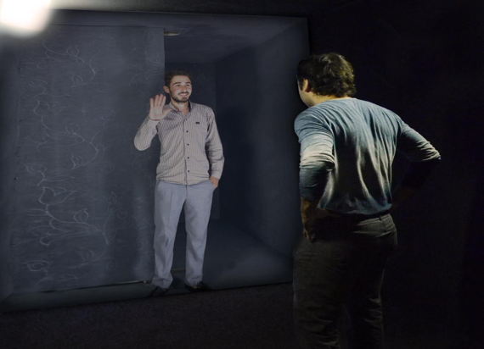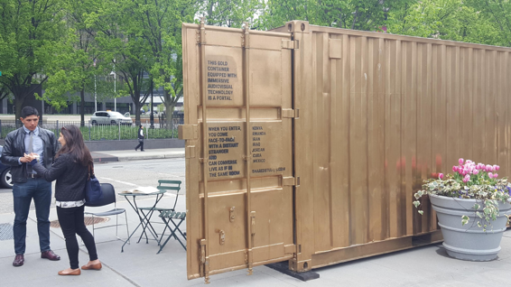

About:
The Portals Policing Project was a project in collaboration with Amar Bakshi, artist and founder of Shared Studios. Bakshi invented the Portal as a means of connecting geographically distant places around the world with one another to foster conversation and collaboration on topics such as art, food, entrepreneurship, and politics. The Portals currently operate in more than 40 sites across six continents.
After observing the Portals method, Vesla Weaver and Tracey Meares collaborated with Bakshi to initiate the Portals Policing Project. The Project collected and video-recorded dialogues for two years, beginning in April 2016 and concluding in April 2018. At some sites, the Portals remained and continue to connect local communities on topics related to policing and beyond. We are seeking funding for a launch of new Portals and a new phase of the project, but this phase will be less about collecting data and more about using the Portal as a “civic infrastructure” that helps to build power within and across communities.
The Portals sites were selected largely because of convenience and connections – the existence of community partners who would help run the Portal and share space. We often partnered with local nonprofit organizations that have an artistic and justice-oriented mission; they typically provided the Portal a physical space in a central location with high foot-traffic as well as an enduring connection to the community. They were deeply involved in Portals programming beyond our criminal justice dialogues, including facilitating “shared meals,” movie nights, and art initiatives.
For more on the Portals Policing Project, please go to the website, portalspolicingproject.com. For more about the Portal technology, go to sharedstudios.com.

Table A1. Portals Location Descriptions.
City | Neighborhood | Total Participants | Dates | Dominant Race/  Ethnicity | Neighborhood Type | Site Type
Milwaukee (227) | Amani/COA Goldin Youth and Family Center | 227 | April 2016–March 2017 (minimal thereafter) | Black | Segregated | Community Center and public park
Chicago (250) | Grand Boulevard/  Harold Washington Cultural Center | 53 | September 2016–December 2016 | Black | Segregated | Cultural Center
 | South Chicago Christian Center | 94 | December 2016–May 2017 and August 2017–October 2017 | Black | Segregated | Small thrift store
 | Little Village/Instituto del Progresso Latino | 58 | November 2017–February 2018 | Latino | In Transition/  Educational | Alternative School
 | Back of the Yards/  LetUsBreathe Collective | 45 | March 2018 | Black | Segregated | Activist
Los Angeles (521) | South Los Angeles/  Mercado la Paloma | 217 | December 2017–March 2018 | Latino | Downtown | Community Market
 | Boyle Heights | 9 |  | Latino | In Transition | Community Arts
 | LA Law Library | 188 | June 2017–September 2017 | Majority Black | Downtown | Public library
 | California State University Dominguez Hills | 107 | November 2017–December 2017 | Latino | Educational Institution | College campus
Baltimore (462) | Downtown/Lexington Market | 162 | February 2017–October 2017 | Black | Downtown | Community Market
 | Station North/  Ynot Lot | 301 | November 2017–March 2018 | Black | In Transition | Activist/  Arts
Mexico City (118) | Chapultepec Park | 118 | June 2017–March 2017 | Latino | Downtown | Public park
Newark (100) | Lincoln Park and Military Park | 100 | April 2016–October 2017 | Black | In Transition | Public park

B. iPad Survey Questions

Surveys were typically administered orally by the Portal curator. Questions were delivered in the following order:

- Age
- Gender
- Race
- Are you Hispanic or Latino?
- Highest Level of Education Attained
- Have you ever been a victim of a crime?
- Has anyone in your family ever been a victim of a crime?
- Have you ever been stopped by the police for something other than a traffic violation?
- How many times in your lifetime?
- How old were you when this first happened to you?
- When was the last time this happened?
- I have confidence that the local police department can do its job well
- In general, how much do you trust the police?
- Have you participated in a Portal dialogue before?
- If yes, how many times?
- How did you hear about the Portal?

C. Participant Characteristics

Table C1: All black Portals participants, by gender
 | Female | Male | Other
N | 253 | 542 | 8
Mean age | 36.711 | 37.178 | 24.875
Education (%)
Grades 1-8 | 0.90 | 0.70 | 0.00
Some high school | 17.80 | 17.70 | 12.50
High school graduate | 35.20 | 35.20 | 50.0
Some college or technical school | 20.60 | 26.60 | 12.50
College graduate | 18.20 | 13.40 | 25.00
Post graduate degree | 6.70 | 5.70 | 0.00
No response | 1.58 | .60 | 0.00
Have you ever been a victim of a crime? | 60.3 | 72.60 | 37.50
Trust in Police (%)
All of the time | .20 | 1.50 | 0.00
Most of the time | 10.70 | 36.70 | 12.50
Sometimes | 28.10 | 29.00 | 25.00
Rarely | 24.50 | 20.30 | 50.00
Never | 23.30 | 36.70 | 12.50
No response* | 11.10 | 7.00 | 0.00
Confidence in the local police department to do their jobs well (%)
Strongly agree | 3.50 | 4.40 | 0.00
Agree | 17.50 | 17.70 | 37.50
Neither agree nor disagree | 24.10 | 18.60 | 12.50
Disagree | 24.10 | 22.30 | 25.00
Strongly disagree | 25.90 | 29.00 | 12.50
Don’t know | 3.50 | 6.50 | 12.50
No response | 1.32 | 1.90 | 0.00

*Newark participants did not respond to this survey question, as it was not included in the survey during the pilot’s phase

Table C2: Police contact of black participants by gender
 | Female | Male | Other
N | 253 | 542 | 8
Police stops in one’s lifetime (%)
Never stopped | 35.60 | 12.50 | 0.00
1 to 2 times | 26.10 | 10.90 | 25.00
3 to 4 times | 13.00 | 14.00 | 25.00
5 to 7 times | 7.10 | 12.70 | 25.00
More than 7 times | 17.40 | 49.60 | 25.00
Last police stop (%)
Never stopped | 35.60 | 12.50 | 0.00
More than 5 years ago | 13.40 | 11.10 | 12.50
In the last 5 years | 13.80 | 14.60 | 12.50
In the last year | 16.60 | 28.00 | 37.50
In the last month | 11.10 | 17.70 | 37.50
In the last week | 8.80 | 14.40 | 0.00
No response | 1.80 | 1.80 | 0.00
Age first police stop  SD | 16.269  (11.009) | 15.296  (13.593) | 9.250  (2.659)
Stopped as a minor (%) | 72.50 | 86.20 | 1.00

Figure C1
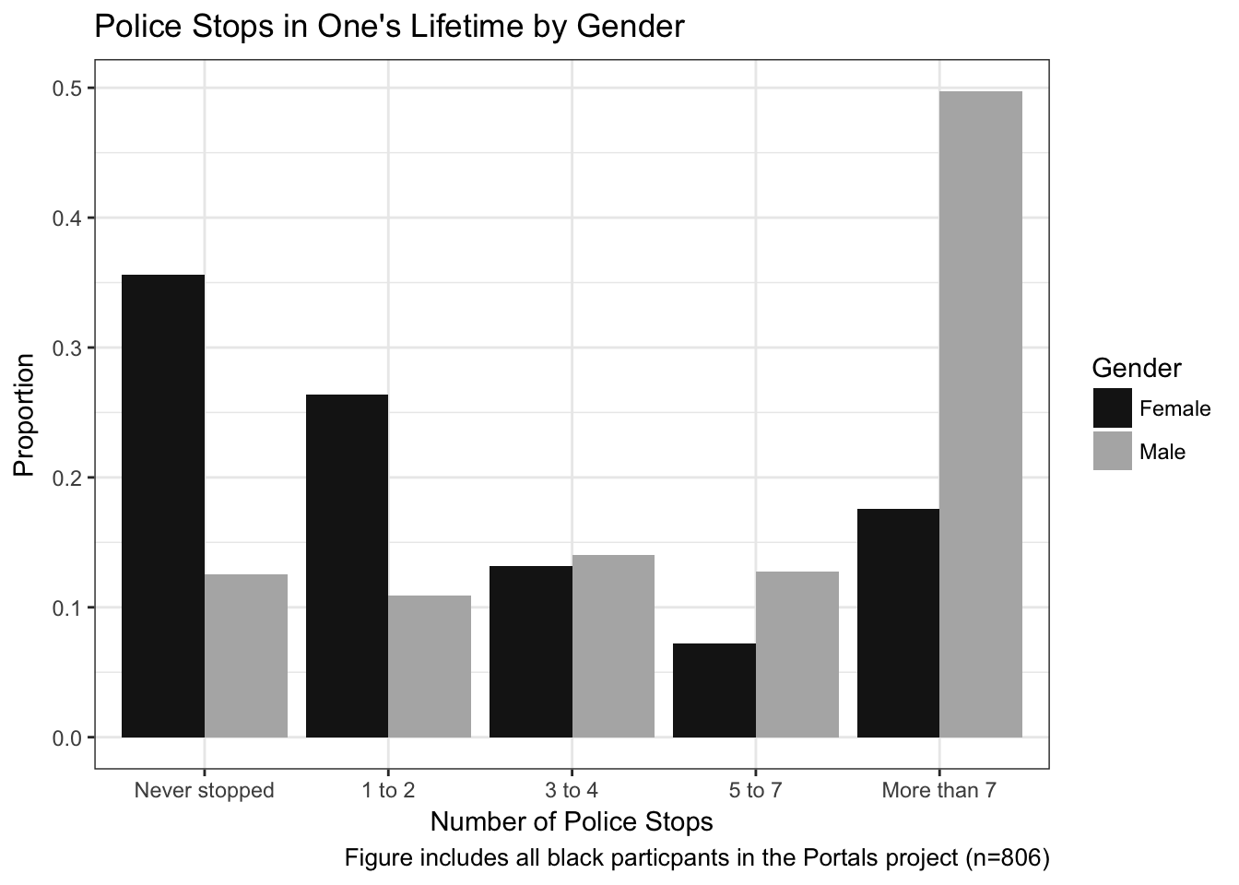

Figure C2
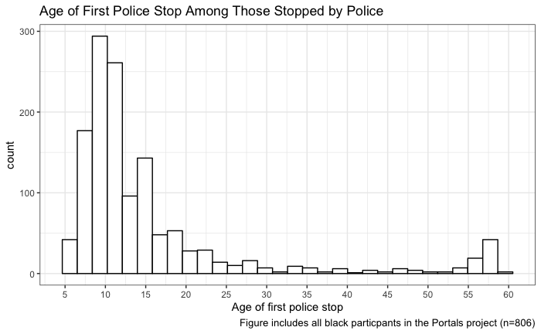

Figure C3
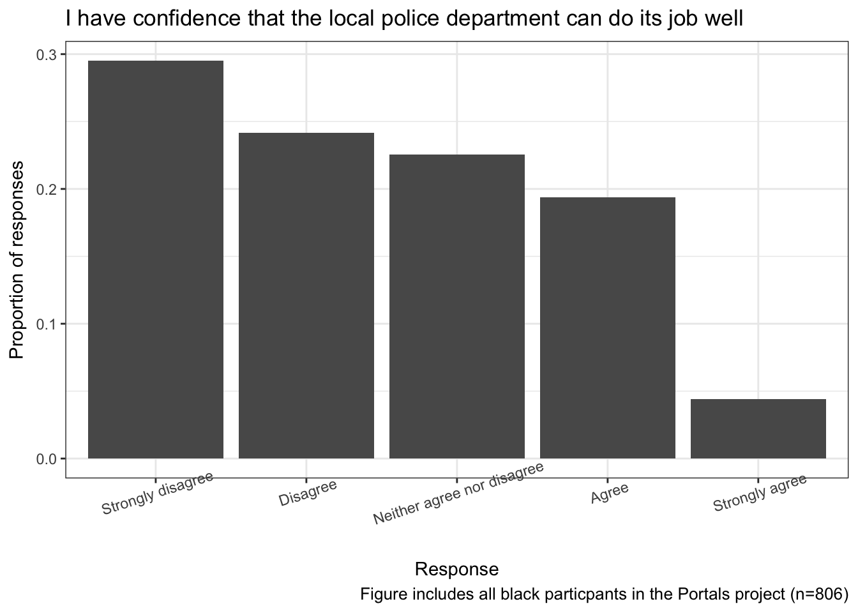

Figure C4
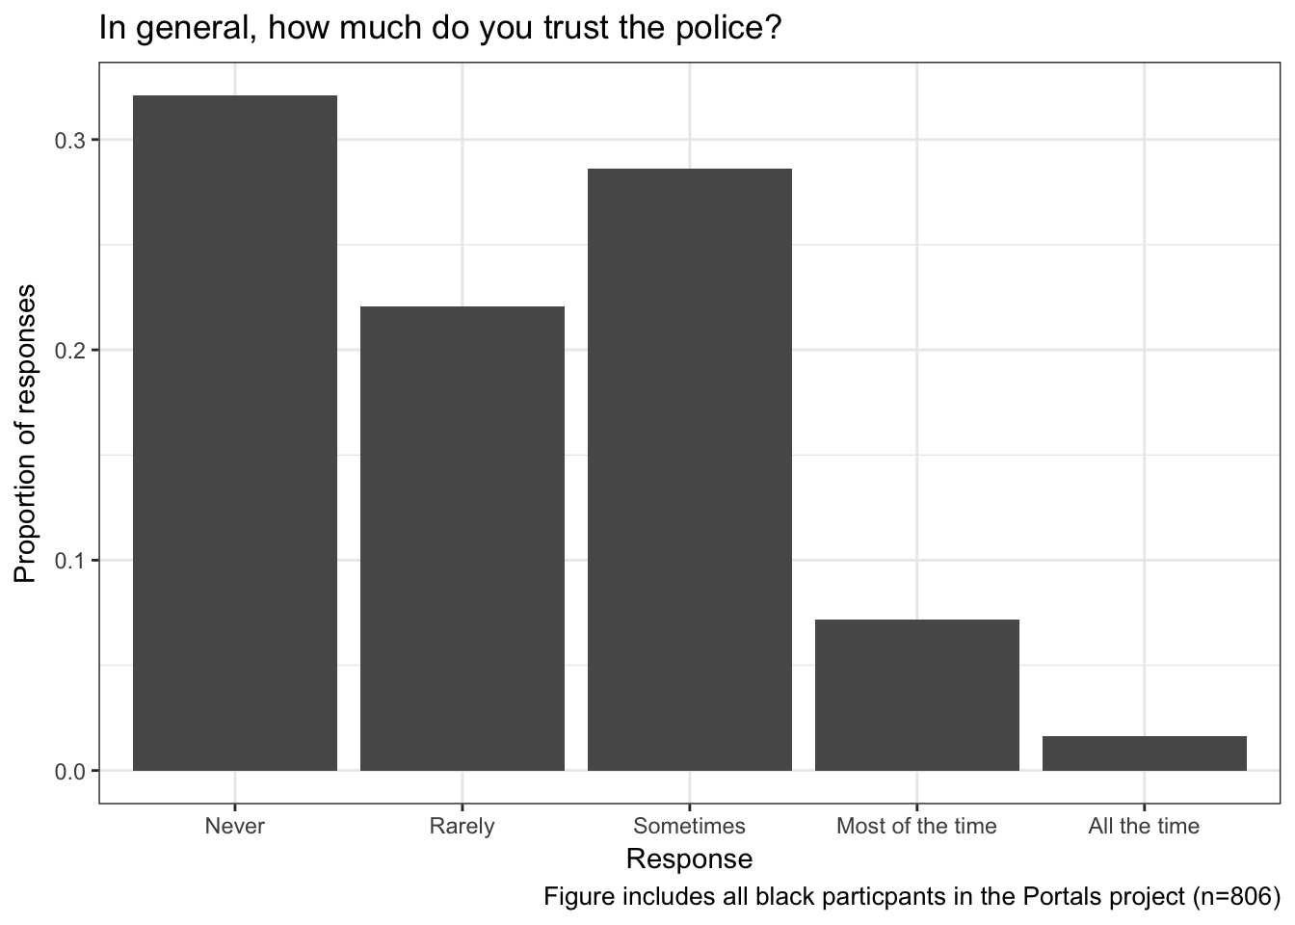

Table C3: Gender pairings*
Gender Pair | Count
FF | 21
FM | 99
MM | 108
Other Pairings | 6
Total | 234
Note: Newark-Milwaukee pairings are excluded as a result of missing data during the pilot phase of the project.D. City Level Comparisons
D. Participants by City
Table D1: Conversation pairings by city between black participants
City A | City B | Count
Baltimore | LA | 24
Chicago | Baltimore | 25
LA | Baltimore | 29
Milwaukee | Baltimore | 41
Milwaukee | Chicago | 92
Milwaukee | Newark | 59
Milwaukee | Chicago | 92

Figure D1
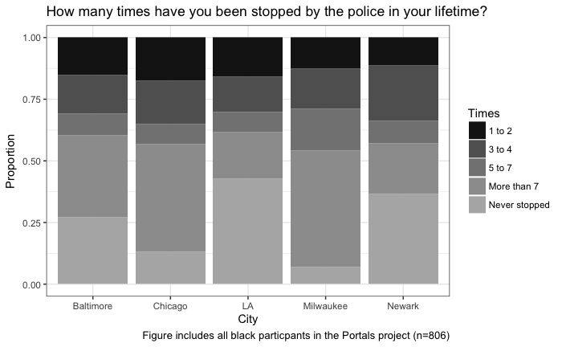

Figure D2
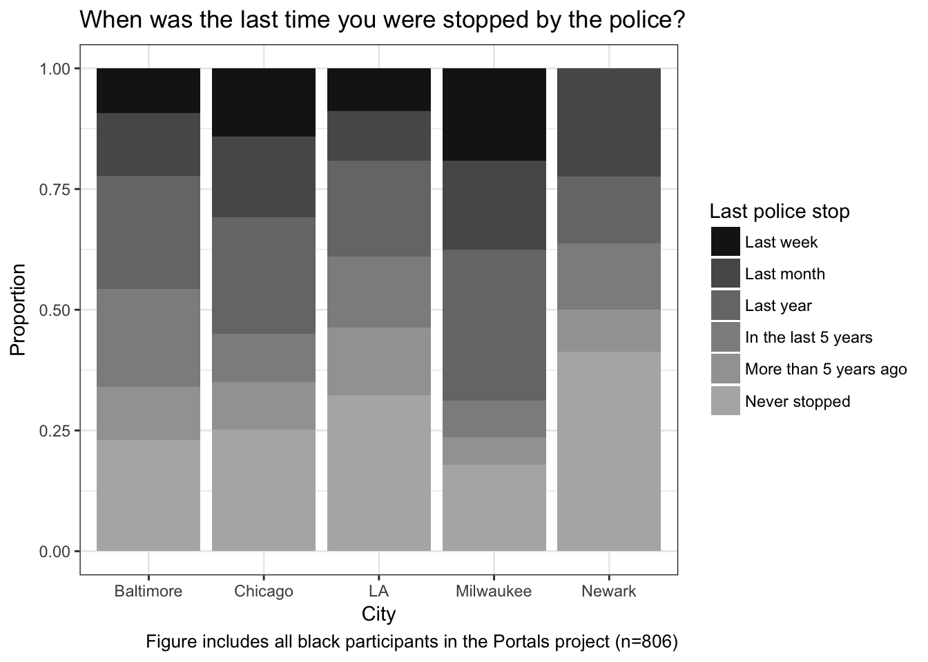

E. Extended Discussion on Coding and Conversation Analysis
One researcher coded the initial set of participant responses in the conversations using the coding software Dedoose, and these coded excerpts were later read and when necessary revised by other members of the research team. Next, we worked with a research assistant to group the coded excerpts thematically then returned to the data to explore how these excerpts unfolded in context. It was here we began to notice a difference in responses both with regard to substance and the action implied by the responses.
To account for variation within collective autonomy, the research team mapped conversations between participants, noting each dialogue’s key themes and structure, including how it progressed from start to finish. While doing so, we were attentive to how dialogues varied by the characteristics of each pairing, including age/generation, gender, trust in police, and education. We also compared conversations between black participants to conversations where only one or non-black participant was present to assess whether the themes we were identifying in black-black pairings were indeed unique. See the table below for some examples of this process.

Table E1: Conversation Mapping
Dyad Information |  |  |  |  |  |  | Conversation Themes and Content
Date and Location | Cities | Race | Gender | Age | Police Contact | Education | Conversation Progression | Meta themes | Quotes
De-identified | C M | B B | M M | 22  18 | 1-2  Never stopped | Some high school  Some high school | The law isn’t for us  Family history  Affirmations of Black worth  Critique of the media’s framing of Black life  Retreat/”keep your head low” rhetoric  Personal responsibility frames | Reliance on us  Bolster awareness/knowledge/pride  Our history as god’s originals  Re-definition  Aspirations for solidarity and resilience  Control our Resources  Control our narratives  Retreat | “Most of them required to be assholes because they hiding behind the shield of law”  “We're pretty much predominant with natural athletes, things of that nature. We pick up shit. They don't like that about us, you know, we're not, we're not liked period. And they know that if we had the smarts that they had, if we played they game, we'd pretty much beat them. So, the rules have got to be set to the point that we lose. “  “They [the media] parade us losing, losing ourselves.”  …  “keep your head low.”
De-identified | L M | B B | M M | 18  38 | 1-2  Never stopped | High school  Some high school | police are a central problem in the lives of their communities.  Policing own communities  Coming together | Bolster respect, regard for ourselves  Be accountable, responsible for our communities  Control our resources  Third parties exerting authority  Self determination  Aspirations for Solidarity and Resistance | “They don't need no permission to do what they doing.”  “Shit. If it weren’t for the police everything would be, it’d be, I ain’t gonna say it’ll be all, all great and shit, but it’d be better…”  “it's like they just putting people on like they got their own gang like, okay, no you shouldn't be doing this, you should be doing this, you gotta do more of this, you know what I'm saying?”  “We gotta come together, man. They got too much.”
De-identified | B  C | W  B | F  F | 29  48 | 1 -2  5-7 | College  College | Disagreement throughout this conversation on tactics  Black woman:  Police abolition  Absolving hierarchies  Coming together to creatively imagine solutions beyond punishment  Creating communities that give people the resources they need  White woman:  Thinks the term abolition is appropriation  Sees police as necessary to protect women and children  Has served as an activist herself (helped elect Mosley Braun in Chicago)  Critiques capitalism | Bolster awareness/knowledge/pride  Our history as god’s originals  Redefinition  Aspirations for solidarity and resilience  Control our resources, communities  Problems with third parties exerting authority  Self-determination  Control our narratives | Black woman:  “I want to say that uh when we say police abolitionists we want to uh destroy the system that that was built that is on police the police system  Um that mainly happens because there are resources lackin in that neighborhood and and so our collective focus is on on bringing those resources that are readily available so we focus on health care, nutrition, education, the art, um things like that restore the justice  It just I can't see I can't see it being like a outwardly facing um um object that's coming in to and swoop in and save us like it has to be like a village type deal like if something happens in our neighborhood, in our community that those are the folks that have to deal with it”  White woman:  “Uh vigilante justice is is not the solution uh you know those often create far more problems than actually help or prevent and often it escalates dynamics that disproportionally affect women and children.”
De-identified | B  C | W  B | F  F | 29  48 | 1 -2  5-7 | College  College | Disagreement throughout this conversation on tactics  Black woman:  Police abolition  Absolving hierarchies  Coming together to creatively imagine solutions beyond punishment  Creating communities that give people the resources they need  White woman:  Thinks the term abolition is appropriation  Sees police as necessary to protect women and children  Has served as an activist herself (helped elect Mosley Braun in Chicago)  Critiques capitalism | Bolster awareness/knowledge/pride  Our history as god’s originals  Redefinition  Aspirations for solidarity and resilience  Control our resources, communities  Problems with third parties exerting authority  Self-determination  Control our narratives | Black woman:  “I want to say that uh when we say police abolitionists we want to uh destroy the system that that was built that is on police the police system  Um that mainly happens because there are resources lackin in that neighborhood and and so our collective focus is on on bringing those resources that are readily available so we focus on health care, nutrition, education, the art, um things like that restore the justice  It just I can't see I can't see it being like a outwardly facing um um object that's coming in to and swoop in and save us like it has to be like a village type deal like if something happens in our neighborhood, in our community that those are the folks that have to deal with it”  White woman:  “Uh vigilante justice is is not the solution uh you know those often create far more problems than actually help or prevent and often it escalates dynamics that disproportionally affect women and children.”
De-identified | B L | B B | M  M | 55  65 | 3 to 4  More than 7 | Post-grad  Post-grad | Affirmation of Black history/Black worth  We gonna win  We know our communities better  Historical memory | Bolster awareness/knowledge/pride  Our history as god’s originals  Redefinition  Aspirations for solidarity and resistance  Control our resources  Problems with third parties exerting control  Control our narratives | “So, they don't know what happens in the urban city. I was raised in the projects, and around the projects, to so I know what time of day it is, and they come in looking like that, then they either selling drugs [inaudible 00:03:51]. Those cops up there  I'm sorry, I know I'm talking you guys to death, but I gotta get this off my chest…”  “if you look at the culture and the history of black people from Africa, we've always had dialogue, look at us, we've had communication, we had kingdoms. …  “Ordinary people are not gonna do that. You know. But again, these conversations that we have, a lot of it is gonna have to come from us, as, as a people first. But you know what? I've, I've always said this, do you know I'm honored to be black.”  “So this whole thing with the policing, I know it's wrong and it's bad, but do you know, we still gonna win. If we won over slavery, and we won over the clan, and we won over Jim Crow, and we won over crack in the neighborhoods, and we won over everything that they did ... ... what they tried to ... every time they tried to kill us ... it's just like our old saying, you tried to bury me, but you didn't know I was a seed. And when you bury a seed it grows.”

For additional discussion about the Portals method, questions of representativeness, and further details about participants, readers should see our elaborated discussion in Weaver, Prowse, Piston 2019.

