Supplemental Appendix
Table S.A. 1 A T-test and F-Test Assessing Differences between Means and Standard Deviations for the 4 and 5 point candidate trait scales A: Normalized and B: with the 5 point scale collapsed into 4 points from the 2008 American National Election Study.
 | Normalized |  | Collapsed 4 pt
 | All | Black | All | Black
Leader (4pt) | 0.602 (0.303) | 0.861 (0.211) | 2.805 (0.908) | 3.584 (0.634)
Leader (5pt) | 0.569 (0.317) | 0.827 (0.217) | 3.078 (1.04) | 3.779 (0.52)
Mean Difference | -.033* | -.035+ | .272* | .198*
SD Test-P-Value | 0.8183 | 0.1683 | 0.0492 | 0.0174
Empathy (4pt) | 0.587 (0.319) | 0.847 (0.207) | 2.76 (0.957) | 3.54 (0.621)
Empathy (5pt) | 0.553 (0.325) | 0.833 (0.232) | 3.017 (1.07) | 3.76 (0.583)
Difference | -.033* | -0.014 | .257* | .219*
SD Test-P-Value | 0.3003 | 0.0196 | 0.0045 | 0.6885
Intelligence (4pt) | 0.791 (0.234) | 0.924 (0.156) | 3.372 (0.702) | 3.773 (0.469)
Intelligence (5pt) | 0.734 (0.243) | 0.873 (0.189) | 3.626 (0.706) | 3.874 (0.421)
Difference | -.056* | -.051* | .254* | .097*
SD Test-P-Value | 0.2766 | 0.0014 | 0.186 | 0.0475
Knowledge (4pt) | 0.667 (0.269) | 0.864 (0.192) | 3.002 (0.807) | 3.591 (0.577)
Knowledge (5pt) | 0.626 (0.273) | 0.821 (0.213) | 3.322 (0.892) | 3.796 (0.527)
Difference | -.04* | -.043* | .321* | .205*
SD Test-P-Value | 0.616 | 0.007 | 0.0592 | 0.517
Morality (4pt) | 0.622 (0.291) | 0.807 (0.203) | 2.867 (0.873) | 3.421 (0.61)
Morality (5pt) | 0.585 (0.29) | 0.804 (0.227) | 3.17 (0.96) | 3.744 (0.572)
Difference | -.037* | 0.002 | .303* | .323*
SD Test-P-Value | 0.2804 | 0.0663 | 0.006 | 0.2753
* Significant at .05. Standard Errors in Parenthesis. The standard deviations are significantly different if the P value is less than .05

Assessing the Alternatives
I also estimate the relative strength of other potential mediators on explaining the relationship between descriptive representation and black political participation to provide information on the relative strength of the candidate trait hypothesis. As mentioned earlier, there are several alternative mediators that are hypothesized to explain the relationship between descriptive representation and higher levels of black turnout. First, some argue the presence of a black candidate on the ballot increases black political participation through changing levels of external efficacy, internal efficacy, and political interest in the black community (Bobo & Gilliam, 1990; Washington, 2006). Second, Philpot, Shaw, and McGowen (2009) hypothesize that the relationship between the presence of a black candidate on the ballot and higher levels of black turnout may be explained by black candidates higher levels of co-racial campaign contact. To explore the relative strength of these alternative mechanisms, I also estimate the mediating effects of external efficacy, internal efficacy, political interest and campaign contact on the relationship between descriptive representation and political participation. Finally, Fraga (2015) and Keele et al., (2013) argue that descriptive representation’s effect on turnout is largely driven by blacks campaigning in majority-minority districts in which blacks are already voting at higher rates. To assess whether large changes in the number of blacks living in black districts in the Clinton and Obama years could explain Obama’s effect on increasing black turnout, I assess the size of the black population in the respondent’s congressional district as a mediator.

Variables Wording Used to Code Each Participation Variable from the ANES
- Voted-“In talking to people about elections, we often find that a lot of people were not able to vote because they weren't registered, they were sick, or they just didn't have time. Which of the following statements best describes you: One, I did not vote (in the election this November); Two, I thought about voting this time - but didn't; Three, I usually vote, but didn't this time; or Four, I am sure I voted?”
- Proselytize-“During the campaign, did you talk to any people and try to show them why they should vote for or against one of the parties or candidates?”
- Wear Campaign Gear-“Did you wear a campaign button, put a campaign sticker on your car, or place a sign in your window or in front of your house?”
- Attend Campaign Rally-“Did you go to any political meetings, rallies, speeches, dinners, or things like that in support of a particular candidate?”
- Campaign Contributions-“During an election year people are often asked to make a contribution to support campaigns. Did you give money to an INDIVIDUAL CANDIDATE running”

Table SA 4: Mediation Analysis Assessing the Effects of Alternate Mediators on the Relationship Between Obama and Participation
External Efficacy | Vote | Proselytize | Wear Campaign Gear | Attend Rally | Campaign Contribute
Avg Med Effect (T) | -0.001 (-0.005, 0.001) | -0.005 (-0.012, 0) | -0.005 (-0.012, 0) | -0.001 (-0.005, 0.002) | 0 (-0.004, 0.003)
Avg Med Effect (C) | -0.002 (-0.007, 0.001) | -0.004 (-0.01, 0) | -0.002 (-0.006, 0) | -0.001 (-0.004, 0.002) | 0 (-0.001, 0.001)
Avg Dir Effect (T) | 0.093* (0.045, 0.141) | 0.149* (0.091, 0.206) | 0.201* (0.156, 0.241) | 0.027 (-0.014, 0.061) | 0.114* (0.086, 0.139)
Avg Dir Effect (C) | 0.093* (0.045, 0.141) | 0.15* (0.091, 0.206) | 0.203* (0.157, 0.246) | 0.027 (-0.014, 0.061) | 0.115* (0.086, 0.139)
Total Effect | 0.091* (0.044, 0.14) | 0.145* (0.087, 0.202) | 0.198* (0.153, 0.239) | 0.026 (-0.014, 0.061) | 0.114* (0.086, 0.139)
% Mediated | NS | NS | NS | NS | NS
N | 1399 | 1451 | 1451 | 1451 | 1450
Internal Efficacy | Vote | Proselytize | Wear Campaign Gear | Attend Rally | Campaign Contribute
Avg Med Effect (T) | -0.003 (-0.007, 0) | -0.01 (-0.02, -0.002) | -0.006 (-0.013, 0) | -0.001 (-0.004, 0.003) | -0.002 (-0.006, 0.002)
Avg Med Effect (C) | -0.004 (-0.01, 0) | -0.008 (-0.017, -0.002) | -0.003 (-0.007, 0) | 0 (-0.003, 0.002) | 0 (-0.001, 0)
Avg Dir Effect (T) | 0.096* (0.047, 0.145) | 0.154* (0.095, 0.209) | 0.2* (0.155, 0.24) | 0.027 (-0.013, 0.061) | 0.114* (0.086, 0.139)
Avg Dir Effect (C) | 0.095* (0.047, 0.144) | 0.155* (0.096, 0.211) | 0.203* (0.157, 0.246) | 0.027 (-0.013, 0.061) | 0.116* (0.086, 0.14)
Total Effect | 0.092* (0.045, 0.141) | 0.145* (0.088, 0.201) | 0.197* (0.152, 0.238) | 0.026 (-0.013, 0.061) | 0.114* (0.086, 0.138)
% Mediated | NS | NS | NS | NS | NS
N | 1401 | 1453 | 1453 | 1453 | 1453
Campaign Contact | Vote | Proselytize | Wear Campaign Gear | Attend Rally | Campaign Contribute
Avg Med Effect (T) | 0.014* (0.007, 0.022) | 0.049* (0.034, 0.065) | 0.038* (0.026, 0.053) | 0.031* (0.021, 0.042) | 0.025* (0.016, 0.036)
Avg Med Effect (C) | 0.019* (0.009, 0.029) | 0.044* (0.03, 0.059) | 0.021* (0.013, 0.032) | 0.032* (0.02, 0.049) | 0.005* (0.002, 0.011)
Avg Dir Effect (T) | 0.071* (0.026, 0.116) | 0.119* (0.061, 0.175) | 0.171* (0.124, 0.213) | -0.007 (-0.053, 0.032) | 0.102* (0.073, 0.126)
Avg Dir Effect (C) | 0.075* (0.028, 0.123) | 0.114* (0.059, 0.166) | 0.154* (0.111, 0.194) | -0.005 (-0.04, 0.024) | 0.082* (0.058, 0.104)
Total Effect | 0.089* (0.042, 0.135) | 0.163* (0.105, 0.215) | 0.192* (0.151, 0.23) | 0.026 (-0.012, 0.057) | 0.107* (0.081, 0.129)
% Mediated | 18.2% | 28.3% | 15.4% | NS | 14.1%
N | 1597 | 1698 | 1698 | 1698 | 1698
Political Interest | Vote | Proselytize | Wear Campaign Gear | Attend Rally | Campaign Contribute
Avg Med Effect (T) | 0.011* (0.002, 0.02) | 0.025* (0.007, 0.044) | 0.016* (0.004, 0.028) | 0.014* (0.004, 0.025) | 0.014* (0.004, 0.025)
Avg Med Effect (C) | 0.014* (0.003, 0.027) | 0.021* (0.006, 0.037) | 0.007* (0.002, 0.014) | 0.012* (0.003, 0.021) | 0.003* (0.001, 0.006)
Avg Dir Effect (T) | 0.076* (0.027, 0.125) | 0.147* (0.088, 0.203) | 0.188* (0.143, 0.229) | 0.022 (-0.019, 0.057) | 0.117* (0.087, 0.143)
Avg Dir Effect (C) | 0.079* (0.028, 0.131) | 0.143* (0.085, 0.197) | 0.18* (0.135, 0.222) | 0.019 (-0.017, 0.051) | 0.106* (0.078, 0.13)
Total Effect | 0.09* (0.039, 0.141) | 0.168* (0.107, 0.223) | 0.196* (0.151, 0.236) | 0.033 (-0.005, 0.067) | 0.12* (0.092, 0.145)
% Mediated | 13.9% | 13.8% | 5.8% | NS | 7.0%
N | 1353 | 1454 | 1454 | 1454 | 1454
Percent Black in District | Vote | Proselytize | Wear Campaign Gear | Attend Rally | Campaign Contribute
Avg Med Effect (T) | -0.003* (-0.008, 0) | 0.003 (-0.003, 0.011) | -0.001 (-0.007, 0.006) | 0.001 (-0.003, 0.005) | 0.003 (-0.001, 0.009)
Avg Med Effect (C) | -0.005* (-0.011, 0) | 0.003 (-0.002, 0.009) | 0 (-0.003, 0.003) | 0.001 (-0.002, 0.004) | 0.001 (0, 0.002)
Avg Dir Effect (T) | 0.088* (0.04, 0.137) | 0.18* (0.121, 0.232) | 0.2* (0.156, 0.239) | 0.033 (-0.005, 0.065) | 0.111* (0.085, 0.133)
Avg Dir Effect (C) | 0.087* (0.04, 0.134) | 0.179* (0.121, 0.232) | 0.201* (0.156, 0.241) | 0.033 (-0.005, 0.066) | 0.108* (0.082, 0.131)
Total Effect | 0.084* (0.035, 0.131) | 0.182* (0.126, 0.234) | 0.2* (0.154, 0.238) | 0.034 (-0.003, 0.065) | 0.111* (0.086, 0.134)
% Mediated | -4.5% | NS | 6.6% | NS | 10.0%
N | 1597 | 1722 | 1722 | 1722 | 1721
Political Trust | Vote | Proselytize | Wear Campaign Gear | Attend Rally | Campaign Contribute
Avg Med Effect (T) | 0.001 (-0.003, 0.006) | 0 (-0.007, 0.006) | -0.005 (-0.014, 0.001) | -0.003 (-0.009, 0) | 0.004 (-0.001, 0.01)
Avg Med Effect (C) | 0.001 (-0.005, 0.008) | 0 (-0.006, 0.005) | -0.002 (-0.006, 0) | -0.003 (-0.007, 0) | 0.001 (0, 0.002)
Avg Dir Effect (T) | 0.096* (0.038, 0.152) | 0.157* (0.09, 0.221) | 0.246* (0.193, 0.294) | 0.022 (-0.019, 0.06) | 0.114* (0.081, 0.145)
Avg Dir Effect (C) | 0.097* (0.038, 0.154) | 0.157* (0.09, 0.22) | 0.249* (0.195, 0.298) | 0.023 (-0.019, 0.061) | 0.111* (0.078, 0.141)
Total Effect | 0.098* (0.04, 0.155) | 0.156* (0.09, 0.22) | 0.244* (0.192, 0.293) | 0.02 (-0.021, 0.058) | 0.115* (0.082, 0.147)
% Mediated | NS | NS | NS | NS | NS
N | 958 | 1042 | 1042 | 1042 | 1042
* Significant at .05. NS=Not Significant at .05. Results are derived from thirty separate mediation analyses predicting the mediating effect of several variables hypothesized to explain the relationship between Obama and changes in political activity. Total Effects present min-max probabilities. The models include controls for gender, age, marital status, income, education, partisanship, R's time at residence, church attendance, % black in R’s congressional district (in all models except the one where this variable becomes the mediator), south, and days to register before the election. Only blacks are included in the analysis above.

Table SA 5: Mediation Analysis Assessing the Effects of Candidate Traits on the Relationship between Voting in the Primary in Years Where Clinton (1992) and Jackson (1988) were the Competing for the Democratic Presidential Nomination
 | All Traits Combined | Leader | Empathy | Intelligence | Knowledge | Moral
ACME (C) | 0.06* (0.03, 0.09) | 0.04*(0.02,0.07) | 0.06*(0.02,0.1) | 0.03*(0.01,0.06) | 0.03*(0.01,0.05) | 0.03*(0,0.07)
ACME (T) | 0.06* (0.03, 0.09) | 0.04*(0.02,0.07) | 0.06*(0.02,0.09) | 0.03*(0.01,0.05) | 0.03*(0.01,0.05) | 0.03*(0,0.06)
Dir. Effect (C) | 0.02 (-0.06, 0.1) | 0.04(-0.04,0.13) | 0.04(-0.05,0.12) | 0.07(-0.01,0.15) | 0.07(-0.01,0.16) | 0.07(-0.01,0.16)
Dir. Effect (T) | 0.02 (-0.05, 0.09) | 0.04(-0.04,0.12) | 0.03(-0.05,0.12) | 0.07(-0.01,0.15) | 0.07(-0.01,0.15) | 0.07(-0.01,0.16)
Total Effect | 0.08+ (0.01, 0.15) | 0.08*(0,0.16) | 0.09*(0.01,0.17) | 0.1*(0.02,0.17) | 0.1*(0.02,0.18) | 0.1*(0.02,0.18)
% Mediated | 69% | 51% | 62% | 30% | 26% | 27%
N | 441 | 461 | 473 | 483 | 475 | 470
+Significant at .10* Significant at .05. NS=Not Significant at .05. Total Effects present min-max probabilities. The models include controls for gender, age, marital status, income, education, partisanship, R's time at residence, church attendance, % black in R’s congressional district, south, and days to register before the election. Only blacks are included in the analysis above.

Table SA. 6: Mediation Analysis Assessing the Effects of Candidate Traits on the Relationship Between Obama and Participation Using Kerry and Gore as Comparisons Rather than Clinton
All Characteristics | Vote | Proselytize | Wear Campaign Gear | Attend Rally | Campaign Contribute
Avg Med Effect (T) | 0.026* (0.012, 0.041) | 0.06* (0.039, 0.082) | 0.052* (0.032, 0.073) | 0.028* (0.015, 0.042) | 0.035* (0.021, 0.051)
Avg Med Effect (C) | 0.03* (0.02, 0.05) | 0.06* (0.04, 0.08) | 0.04* (0.02, 0.07) | 0.02* (0.01, 0.05) | 0.02* (0.01, 0.05)
Avg Dir Effect (T) | 0.07* (0.01, 0.12) | 0.02 (-0.06, 0.09) | 0.06 (-0.02, 0.13) | 0.02 (-0.04, 0.06) | 0.04* (-0.02, 0.09)
Avg Dir Effect (C) | 0.07* (0.01, 0.14) | 0.02 (-0.06, 0.09) | 0.05 (-0.02, 0.11) | 0.01 (-0.03, 0.05) | 0.03* (-0.01, 0.07)
Total Effect | 0.1* (0.04, 0.16) | 0.08* (0, 0.15) | 0.1* (0.04, 0.16) | 0.04 (0, 0.08) | 0.07* (0.03, 0.1)
% Mediated | 0.31 | 0.78 | 0.46 | NS | 0.42
N | 1391 | 1494 | 1494 | 1493 | 1493
Leadership | Vote | Proselytize | Wear Campaign Gear | Attend Rally | Campaign Contribute
Avg Med Effect (T) | 0.01* (0, 0.021) | 0.037* (0.02, 0.055) | 0.003 (-0.002, 0.009) | 0.031* (0.015, 0.048) | 0.012* (0.001, 0.024)
Avg Med Effect (C) | 0.01* (0, 0.03) | 0.04* (0.02, 0.05) | 0.002 (-0.001, 0.006) | 0.02* (0.01, 0.04) | 0.01* (0, 0.02)
Avg Dir Effect (T) | 0.1* (0.05, 0.16) | 0.04 (-0.03, 0.11) | 0.07* (0.01, 0.11) | 0.09 (0.02, 0.15) | 0.06* (0.01, 0.09)
Avg Dir Effect (C) | 0.11* (0.05, 0.17) | 0.04 (-0.03, 0.11) | 0.07* (0.01, 0.11) | 0.09 (0.02, 0.14) | 0.05* (0.01, 0.09)
Total Effect | 0.12* (0.06, 0.18) | 0.08* (0.01, 0.15) | 0.07* (0.01, 0.11) | 0.12* (0.06, 0.17) | 0.07* (0.02, 0.1)
% Mediated | 0.103 | 0.38 | 0.23 | NS | 0.142
N | 1396 | 1499 | 1499 | 1499 | 1498
Empathy | Vote | Proselytize | Wear Campaign Gear | Attend Rally | Campaign Contribute
Avg Med Effect (T) | 0.022* (0.011, 0.036) | 0.051* (0.031, 0.071) | 0.052* (0.033, 0.072) | 0.021* (0.009, 0.035) | 0.043* (0.029, 0.059)
Avg Med Effect (C) | 0.03* (0.02, 0.05) | 0.05* (0.03, 0.07) | 0.04* (0.03, 0.07) | 0.02* (0.01, 0.04) | 0.03* (0.02, 0.06)
Avg Dir Effect (T) | 0.08* (0.03, 0.14) | 0.03 (-0.05, 0.1) | 0.06 (-0.01, 0.13) | 0.02 (-0.04, 0.06) | 0.04 (-0.02, 0.08)
Avg Dir Effect (C) | 0.09* (0.03, 0.15) | 0.03 (-0.05, 0.1) | 0.06 (-0.01, 0.11) | 0.02 (-0.03, 0.05) | 0.03 (-0.02, 0.06)
Total Effect | 0.11* (0.06, 0.17) | 0.08* (0.01, 0.15) | 0.11* (0.05, 0.16) | 0.04 (-0.01, 0.07) | 0.07* (0.03, 0.1)
% Mediated | 0.238 | 0.63 | 0.44 | NS | 0.53
N | 1402 | 1506 | 1506 | 1505 | 1505
Intelligence | Vote | Proselytize | Wear Campaign Gear | Attend Rally | Campaign Contribute
Avg Med Effect (T) | 0.015* (0.007, 0.026) | 0.045* (0.026, 0.064) | 0.025* (0.008, 0.043) | 0.018* (0.006, 0.031) | 0.027* (0.013, 0.041)
Avg Med Effect (C) | 0.02* (0.01, 0.04) | 0.04* (0.02, 0.06) | 0.02* (0.01, 0.04) | 0.01* (0, 0.03) | 0.02* (0.01, 0.03)
Avg Dir Effect (T) | 0.09* (0.04, 0.15) | 0.03* (-0.04, 0.1) | 0.09* (0.02, 0.15) | 0.02 (-0.03, 0.06) | 0.05 (0, 0.09)
Avg Dir Effect (C) | 0.1* (0.04, 0.16) | 0.03* (-0.04, 0.1) | 0.09* (0.02, 0.14) | 0.02 (-0.02, 0.06) | 0.04 (0, 0.08)
Total Effect | 0.11* (0.06, 0.18) | 0.08* (0.01, 0.15) | 0.11* (0.05, 0.17) | 0.04 (0, 0.07) | 0.07* (0.03, 0.1)
% Mediated | 0.16 | 0.57 | 0.2 | NS | 0.31
N | 1426 | 1530 | 1530 | 1530 | 1529
Knowledge | Vote | Proselytize | Wear Campaign Gear | Attend Rally | Campaign Contribute
Avg Med Effect (T) | -0.002 (-0.007, 0.002) | 0 (-0.005, 0.005) | 0.025* (0.011, 0.04) | 0.011* (0.001, 0.021) | 0.018* (0.008, 0.03)
Avg Med Effect (C) | -0.002 (-0.007, 0.002) | 0 (-0.003, 0.003) | 0.02* (0.01, 0.03) | 0.01* (0, 0.02) | 0.01* (0, 0.02)
Avg Dir Effect (T) | 0.01 (-0.05, 0.08) | 0.21* (0.14, 0.27) | 0.09* (0.03, 0.15) | 0.04 (-0.01, 0.07) | 0.06* (0.01, 0.1)
Avg Dir Effect (C) | 0.01 (-0.05, 0.08) | 0.21* (0.14, 0.27) | 0.09* (0.02, 0.14) | 0.03 (-0.01, 0.07) | 0.06* (0.01, 0.09)
Total Effect | 0.01 (-0.05, 0.08) | 0.21* (0.14, 0.27) | 0.11* (0.05, 0.17) | 0.04 (0, 0.08) | 0.07* (0.03, 0.1)
% Mediated | NS | 0.51 | 0.19 | NS | 0.192
N | 1426 | 1530 | 1530 | 1529 | 1529
Moral | Vote | Proselytize | Wear Campaign Gear | Attend Rally | Campaign Contribute
Avg Med Effect (T) | 0.015* (0.007, 0.025) | 0.02* (0.007, 0.034) | 0.024* (0.012, 0.039) | 0.019* (0.009, 0.029) | 0.017* (0.007, 0.028)
Avg Med Effect (C) | 0.02* (0.01, 0.04) | 0.02* (0.01, 0.03) | 0.02* (0.01, 0.03) | 0.01* (0.01, 0.03) | 0.01* (0, 0.02)
Avg Dir Effect (T) | 0.09* (0.04, 0.15) | 0.06* (-0.02, 0.13) | 0.09* (0.02, 0.15) | 0.03 (-0.02, 0.07) | 0.06* (0.01, 0.1)
Avg Dir Effect (C) | 0.1* (0.04, 0.16) | 0.06* (-0.02, 0.13) | 0.08* (0.02, 0.14) | 0.03 (-0.02, 0.06) | 0.05* (0.01, 0.09)
Total Effect | 0.04* (0.06, 0.18) | 0.08* (0, 0.15) | 0.04* (0.04, 0.16) | 0.04 (0, 0.08) | 0.07* (0.03, 0.1)
% Mediated | 0.16 | 0.25 | 0.21 | NS | 0.182
N | 1402 | 1506 | 1506 | 1505 | 1505
* Significant at .05. NS=Not Significant at .05. Results are derived from thirty separate mediation analyses predicting the mediating effect of candidate traits in explaining the relationship between Obama and changes in political activity. Total Effects present min-max probabilities. The models include controls for gender, age, marital status, income, education, partisanship, R's time at residence, church attendance, % black in R’s congressional district, south, and days to register before the election.

Note: It is possible that the mediation effect in this paper can be better attributed to the overall likability of the candidate, rather than candidate traits. To assess this possibility, I control for candidate likability as measure by feeling thermometer scores for Clinton and Obama. This model is illustrated below in Figure 1. The models in the paper are illustrated in Figure 2. It is important to note that the multiple mediation models presented below suffer from the same problems as traditional Linear Structural Equation Models in that they treat the dependent variable as continuous. While this is certainly a shortcoming, the models do provide the opportunity to explore whether the mediation effect of candidate traits still exists when the overall likeability of the candidate is accounted for. The results below demonstrate that candidate traits matter above and beyond candidate likeability.
Figure 1: Model Estimate in Table SA. 10 Below
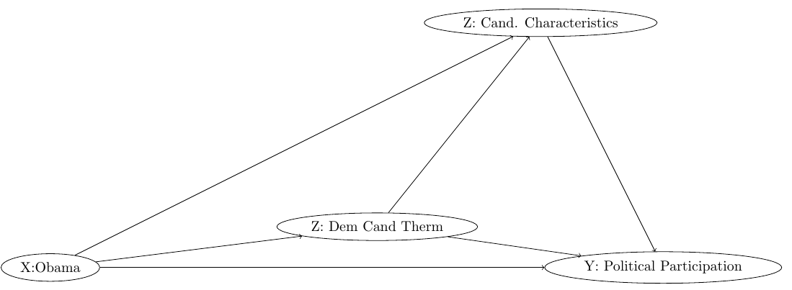

Figure 2: Model Estimate Presented in the Main Manuscript in Table 1
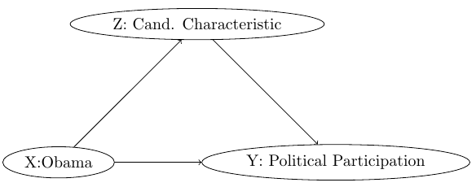

Table SA.7-Multiple Mediation Analysis Predicting the Effect of Candidate Traits on the Relationship Between Obama and Black Political Participation Holding Constant Candidate Feeling Thermometers
All Traits | Vote | Proselytize | Wear Campaign Gear | Attend Campaign Rally | Campaign Contributions
ACME (Treated) | 0.018* (.00, .04) | .066* (.04, .09) | .028* (.00, .05) | .019* (.00, .03) | .025* (.01, .04)
ACME (Control) | 0.017 (-.017, .05) | .038 (-.00, .08) | .018 (-.00, .05) | .012 (-.00, .03) | .00, (-.00, .01)
ACME(Average) | 0.018* (.00, .03) | .06* (.04, .08) | .026* (.01, .04) | .017* (.01, .03) | .019*, (.00, .03)
Total Effect | 0.114* (.08, .14) | .159* (.13, .19) | .19* (.17, .23) | .03* (-00, .07) | .09* (.07, .11)
% Mediated | 15.8% | 37.7% | 13.7% | NS | 21.1%
N | 1541 | 1660 | 1660 | 1660 | 1659
* Significant at .05. NS=Not Significant at .05. Results are derived from five separate mediation analyses predicting the mediating effect of candidate traits in explaining the relationship between Obama and changes in political activity. Total Effects present min-max probabilities. The models include controls for gender, age, marital status, income, education, partisanship, R's time at residence, church attendance, % black in R’s congressional district, south, and days to register before the election.

Table SA.8- Mediation Analysis Predicting the Effect of Candidate Traits on the Relationship Between High and Low Linked Fate and Vote Validated Participation in the 2012 Presidential Election
Vote Validated | All Personality | Leadership | Empathy | Intelligence | Knowledge | Moral
Avg Med Effect (T) | 0.02 (0.01, 0.04) | 0.02 (0, 0.03) | 0.02 (0, 0.04) | 0.01 (0, 0.03) | 0.01 (0, 0.03) | 0.02 (0, 0.03)
Avg Med Effect (C) | 0.03 (0.01, 0.05) | 0.02 (0, 0.04) | 0.02 (0, 0.04) | 0.02 (0, 0.03) | 0.02 (0, 0.03) | 0.02 (0, 0.04)
Avg Dir Effect (T) | 0.08 (0, 0.17) | 0.08 (0, 0.17) | 0.08 (0, 0.17) | 0.09 (0, 0.17) | 0.09 (0, 0.17) | 0.09 (0.01, 0.17)
Avg Dir Effect (C) | 0.09 (0, 0.17) | 0.09 (0, 0.17) | 0.09 (0, 0.17) | 0.09 (0, 0.17) | 0.09 (0, 0.17) | 0.09 (0.01, 0.18)
Total Effect | 0.11 (0.02, 0.19) | 0.1 (0.02, 0.18) | 0.1 (0.02, 0.18) | 0.1 (0.02, 0.18) | 0.1 (0.02, 0.18) | 0.11 (0.03, 0.19)
% Mediated | 21.6% | 16.2% | 17.2% | 13.7% | 13.7% | 15.5%
N | 446 | 454 | 454 | 455 | 453 | 448
* Significant at .05. NS=Not Significant at .05. Results are derived from six separate mediation analyses predicting the mediating effect of candidate traits in explaining the relationship between high and low linked fate blacks and changes in political activity. The models include controls for gender, age, marital status, income, education, partisanship, R's time at residence, church attendance, % black in R’s congressional district, south, and days to register before the election.

Table SA.9 Results from Mediation Analysis Examining the Relationship Between X (Obama) And Y (Vote, Proselytizing, Wear Campaign Gear, Attend Campaign Rally, Campaign Contributions) Through Z (Perceptions of Candidate Empathy) Treating Controls for Political Interest, Democratic Candidate Feeling Thermometers, and and Campaign Contact as Pre-Treatment Controls. 95% Confidence Intervals in Parentheses.
Med=All Traits Combined | Vote | Proselytize | Wear Campaign Gear | Attend Campaign Rally | Campaign Contributions
Avg Med Effect (T) | 0.01* (0, 0.02) | 0.02* (0.01, 0.04) | 0.01* (0, 0.02) | 0.01* (0, 0.01) | 0.01* (0, 0.02)
Avg Med Effect (C) | 0.01* (0, 0.02) | 0.02* (0.01, 0.04) | 0.01* (0, 0.02) | 0.01* (0, 0.02) | 0* (0, 0.01)
Avg Dir Effect (T) | 0.01 (-0.04, 0.07) | 0.05 (-0.02, 0.12) | 0.12* (0.06, 0.18) | -0.04 (-0.1, 0.01) | 0.09* (0.04, 0.12)
Avg Dir Effect (C) | 0.02 (-0.04, 0.07) | 0.05 (-0.02, 0.12) | 0.12* (0.06, 0.17) | -0.04 (-0.09, 0.01) | 0.08* (0.04, 0.11)
Total Effect | 0.02 (-0.03, 0.08) | 0.08* (0.01, 0.14) | 0.13* (0.07, 0.18) | -0.03 (-0.09, 0.02) | 0.09* (0.05, 0.13)
% Mediated | NS | 30.3% | 7.1% | NS | 7.4%
N | 1290 | 1391 | 1391 | 1391 | 1390
* Significant at .05. 95% Confidence Intervals in Parenthesis.
Some may argue that variables such as candidate feeling thermometers, campaign contact, and political interest are pre-treatment controls rather than post-treatment mediators given the growing intensity of partisan politics in contemporary America. I assess this possibility in Table SA.8 above. Even after treating these variables as being pre-treatment controls, rather than post-treatment mediators, the results do not significantly change. The one notable change is that after controlling for these variables there is not a significant difference in voter participation between the Clinton and Obama years. However, by including both traits and feeling thermometer in the same model, we are controlling for many, if not all of the factors, which would make the race of the candidate significant. While the link between descriptive representation and vote is not significant after the inclusion of all of these controls, the combination of candidate traits remains a significant mediator of this relationship.

Figure SA1: Descriptive Statistics for Black and White Political Participation Between the Clinton and
Obama Years
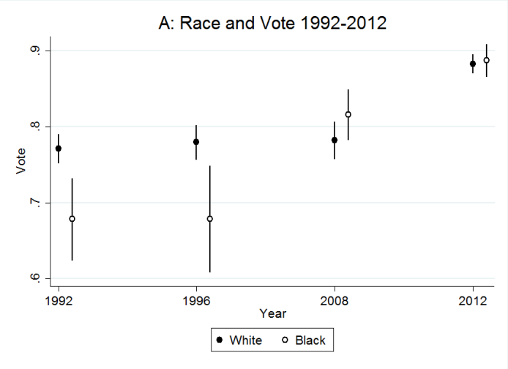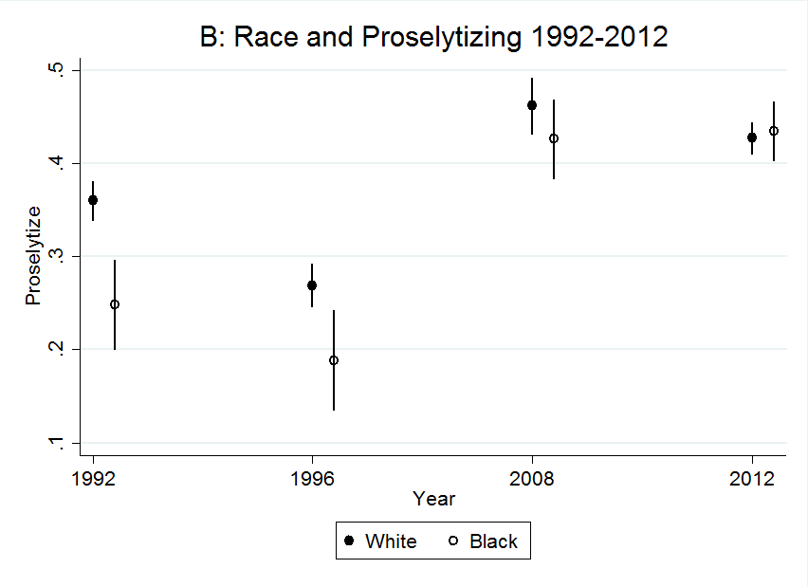
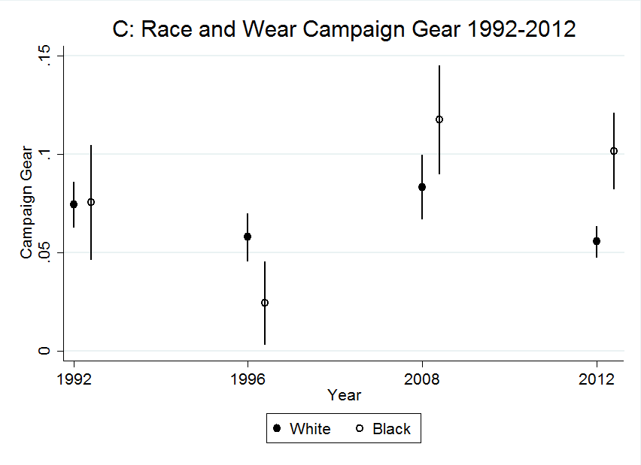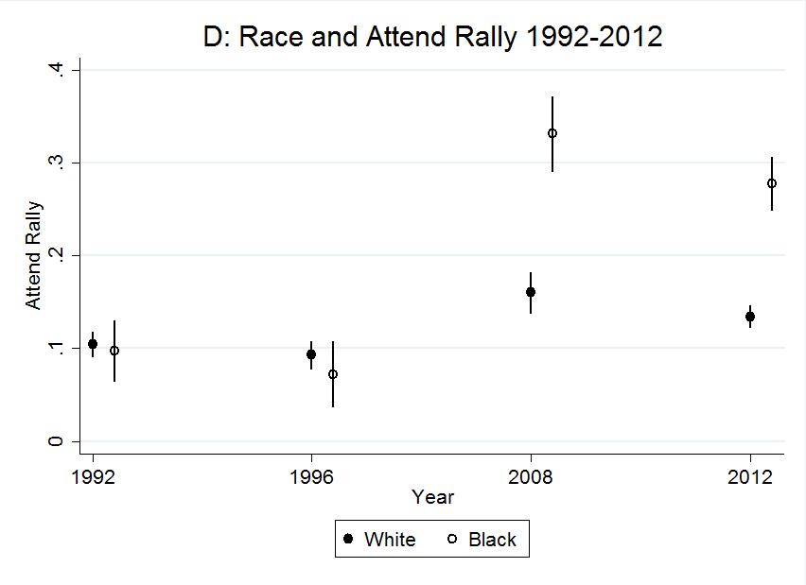
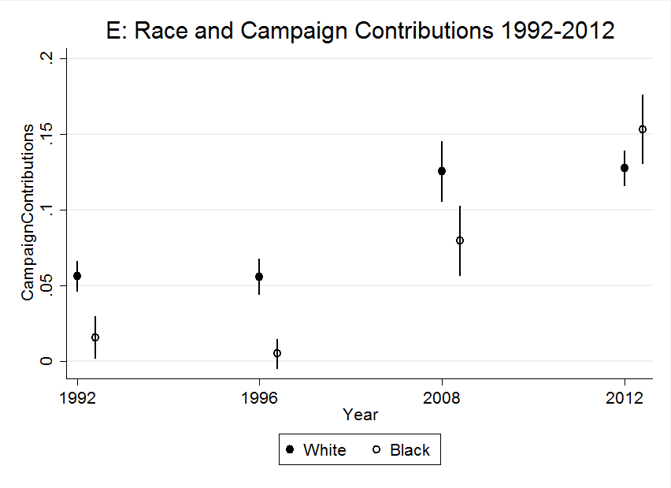
NOTE: THE DEPENDENT VARIABLES PRESENTED ON THE Y-AXIS IN EACH GRAPH HAVE DIFFERENT SCALES.

Are Blacks Unique in Both Trait Evaluation and Participation
Given that I argue that descriptive representation influences perceptions of candidate traits, which in turn improves blacks’ participation rates, it is important to show that black respondents both viewed Obama’s traits more positively and experienced a significantly greater level of growth in political participation than non-blacks during the 2008 and 2012 elections. If whites and Latinos followed the same pattern as blacks than it is possible that there is something specific about Obama, rather than something related to descriptive representation, which motivated individuals to see him as holding better candidate traits relative to Clinton. Moreover, if individuals participated more in 2008 and 2012 than in the Clinton years, it is possible that factors outside of descriptive representation increased turnout for all racial/ethnic groups. To assess this possibility, I examine whether both differences in perceptions of candidate traits of Obama relative to Clinton and growth in participation between the Obama and Clinton years was significantly greater for blacks using regression analysis, an interaction term for race and years where Obama was on the ballot (black*Obama), and the aforementioned controls listed above.
Figure 1 presents the marginal effects for race and the presence of Obama on the ballot from six OLS regressions predicting candidate traits (Figure 1A: All Traits combined, 1B: Leadership, 1C: Empathy, 1D: Knowledge. 1E: Intelligence, and 1F: Morality) and Figure 2 presents the same marginal effects from five logit regressions predicting political participation (2A: Vote, 2B: Proselytizing, 2C: Wear Campaign Gear, 2D: Attend Campaign Rally, and 2E: Make Campaign Contributions) (See Supplemental Appendix for results in tabular form). For each regression, I use the control variables described above (i.e. age, income, partisanship etc…) and interaction terms for race and years in which Obama was on the ballot. Each figure includes
Figure SA2: Marginal Effects from OLS Regression Examining the Interactive Effect of Descriptive Representation and Race on Perceptions of Candidate Traits. 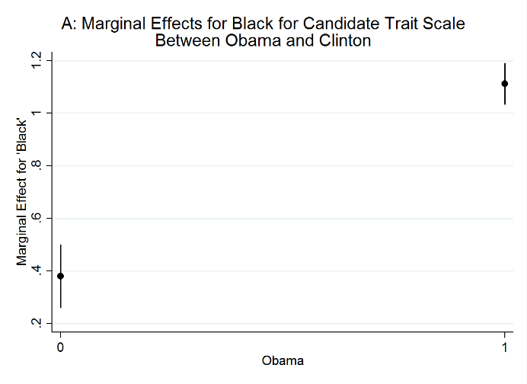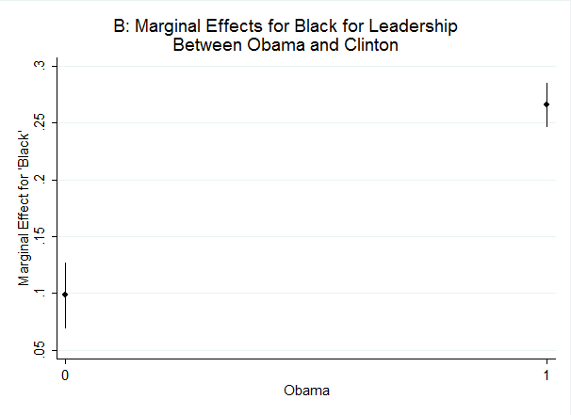
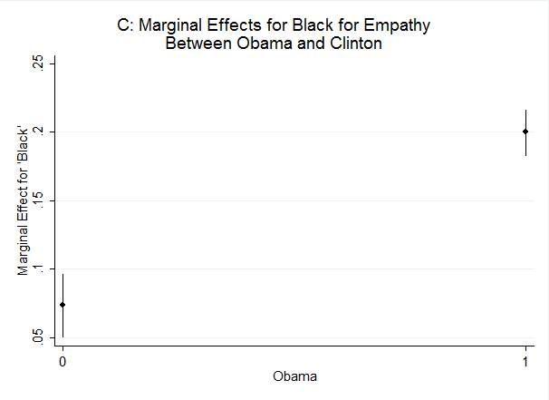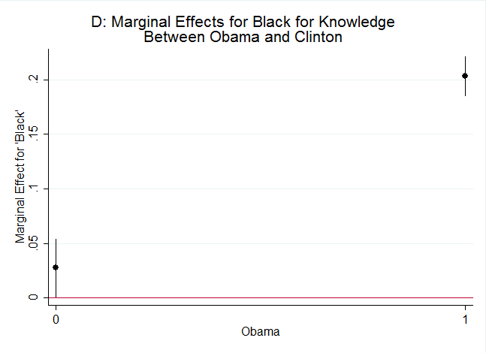

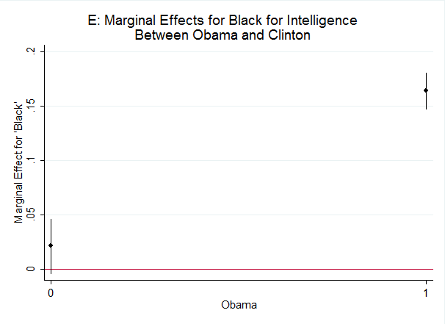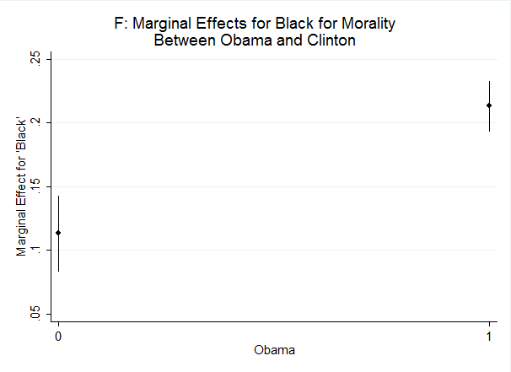
Results are Derived from six separate OLS Regression predicting candidate traits and controlling for age, gender, marital status income, education, partisanship, length of residence, % black in district, voter registration date, church attendence, and south. NOTE: THE DEPENDENT VARIABLES PRESENTED ON THE Y-AXIS IN EACH GRAPH HAVE DIFFERENT SCALES.
an estimate for the marginal effect which presents the instantaneous effects in changes in attitudes about presidential characteristics/political participation (Y) when the respondent is black (X) in years where Obama was or was not a presidential candidate (Moderator).
The results in Figures 1 and 2 provide strong evidence that blacks were unique in both their growth in perceptions of Obama as holding more positive characteristics than Clinton and in their levels of participation. Figure 1A which presents the marginal effect for the combined trait scale indicates that blacks in years with Obama had almost a .8 higher score on the five point trait scale relative to blacks during the Clinton years. Moreover, blacks during the Obama years had about a 1 point higher score on the 5 point trait scale than non-blacks during the Obama years. The interactive effect of black and Obama was also statistically significant for each individual candidate trait (see Figure (1B-1F)). The largest growths were for leadership and empathy. Blacks’ scores on these traits were about .15 points higher on a 1 point scale during the Obama years than the Clinton years, relative to non-blacks.
In addition to blacks viewing Obama as being more positive across all candidate traits, I also find that blacks were significantly more likely to participate in most electoral activities during the Obama years. Holding constant several variables, I find that black political participation grew significantly in all areas, relative to non-blacks, except for proselytizing. However, even here blacks were significantly more likely to proselytize in 2008 and 2012, then comparable blacks in 1992 and 1996. This growth in proselytizing, however, was not unique to blacks. Nonetheless, the results in Figures 1 and 2 demonstrate that blacks experienced a unique and significantly greater amount of growth in both perceptions of Obama as holding better candidate traits than Clinton and in their levels of participation in most areas during the Obama years. Thus, there does appear to be both a link between descriptive representation and higher levels of favorability toward Obama’s characteristics and greater rates of participation.
Figure SA3: Marginal Effects from Logit Regression Examining the Interactive Effect of Descriptive Representation and Race on Political Participation.
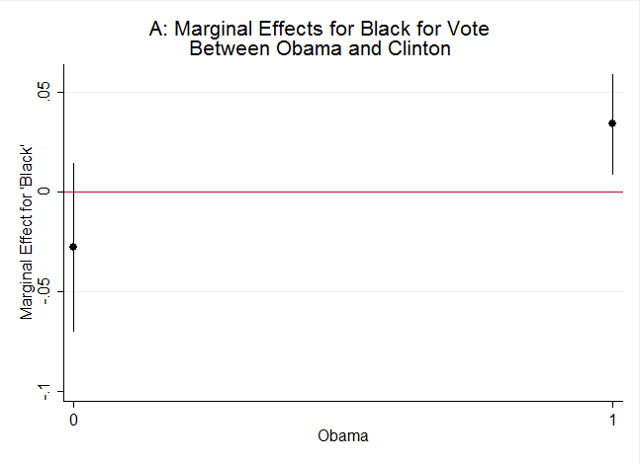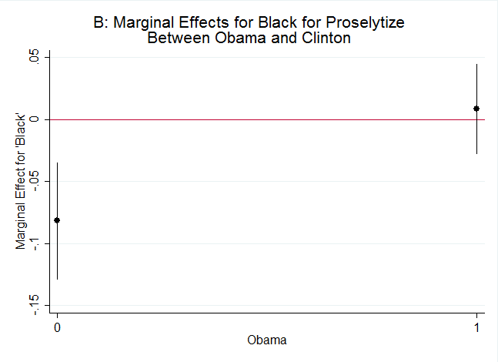
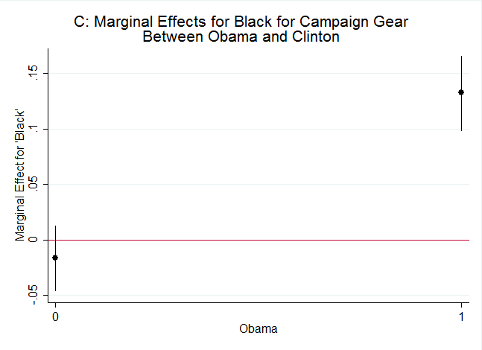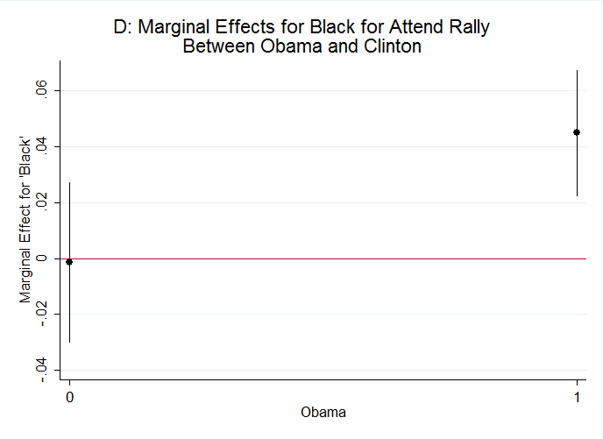
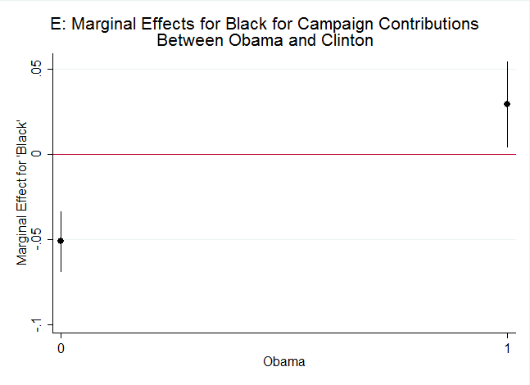

Results are Derived from five separate Logit Regressions predicting political activity and controlling for age, gender, marital status income, education, partisanship, length of residence, % black in district, voter registration date, church attendence, and south. See Supplemental Appendix for full results. NOTE: THE DEPENDENT VARIABLES PRESENTED ON THE Y-AXIS IN EACH GRAPH HAVE DIFFERENT SCALES.
Table SA 10: Mediation Analysis Assessing the Effects of Candidate Traits on the Relationship Between Obama and Participation for Whites Only
All Traits | Vote | Proselytize | Campaign Gear | Attend Rally | Campaign Contribute
Avg Med Effect (T) | 0.003 (-0.002, 0.01) | -0.001 (-0.007, 0.005) | 0.006 (-0.001, 0.014) | 0.001 (-0.002, 0.004) | -0.002 (-0.006, 0.001)
Avg Med Effect (C) | 0.003 (-0.002, 0.01) | 0 (-0.004, 0.003) | 0.004 (-0.001, 0.011) | 0 (-0.001, 0.003) | -0.001 (-0.004, 0.001)
Avg Dir Effect (T) | 0.02 (-0.04, 0.1) | 0.21* (0.14, 0.27) | 0.06 (-0.01, 0.1) | 0.04 (-0.01, 0.07) | 0.03 (-0.03, 0.07)
Avg Dir Effect (C) | 0.02 (-0.04, 0.1) | 0.21* (0.14, 0.27) | 0.05 (-0.01, 0.1) | 0.04 (-0.01, 0.06) | 0.03 (-0.03, 0.07)
Total Effect | 0.03 (-0.04, 0.1) | 0.21* (0.14, 0.27) | 0.06 (-0.01, 0.11) | 0.04 (-0.01, 0.07) | 0.03 (-0.03, 0.07)
% Mediated | NS | NS | NS | NS | NS
N | 5956 | 6422 | 6422 | 6422 | 6421
Rho | 0.1 | 0.2 | 0.2 | 0.2 | 0.2
R2 | 0.01 | 0.04 | 0.04 | 0.04 | 0.04
Leadership | Vote | Proselytize | Campaign Gear | Attend Rally | Campaign Contribute
Avg Med Effect (T) | 0.006* (0.003, 0.008) | 0.01* (0.006, 0.014) | 0 (-0.003, 0.003) | -0.002 (-0.004, 0) | 0 (-0.003, 0.002)
Avg Med Effect (C) | 0.01* (0, 0.01) | 0.01* (0.01, 0.01) | 0 (0, 0) | 0 (0, 0) | 0 (0, 0)
Avg Dir Effect (T) | 0.05* (0.03, 0.08) | 0.07* (0.04, 0.1) | 0.04* (0.02, 0.06) | -0.01 (-0.03, 0.01) | 0.05* (0.03, 0.06)
Avg Dir Effect (C) | 0.05* (0.03, 0.08) | 0.07* (0.04, 0.1) | 0.04* (0.02, 0.06) | -0.01 (-0.03, 0.01) | 0.05* (0.03, 0.06)
Total Effect | 0.06* (0.04, 0.08) | 0.08* (0.05, 0.11) | 0.04* (0.02, 0.06) | -0.01 (-0.03, 0) | 0.05* (0.03, 0.06)
% Mediated | 9.9 | 12.3 | NS | NS | NS
N | 6172 | 6640 | 6643 | 6643 | 6642
Rho | 0.1 | 0.1 | 0.1 | 0.2 | 0.1
R2 | 0.01 | 0.01 | 0.01 | 0.04 | 0.01
Intelligence | Vote | Proselytize | Campaign Gear | Attend Rally | Campaign Contribute
Avg Med Effect (T) | -0.002* (-0.004, -0.001) | -0.002 (-0.004, 0) | -0.001 (-0.003, 0) | -0.001* (-0.003, 0) | -0.004 (-0.006, -0.002)
Avg Med Effect (C) | 0* (0, 0) | 0 (0, 0) | 0 (0, 0) | 0* (0, 0) | 0 (0, 0)
Avg Dir Effect (T) | 0.06* (0.04, 0.08) | 0.08* (0.05, 0.1) | 0.04* (0.02, 0.06) | -0.01 (-0.03, 0) | 0.05* (0.03, 0.06)
Avg Dir Effect (C) | 0.06* (0.04, 0.08) | 0.08* (0.05, 0.1) | 0.04* (0.02, 0.06) | -0.01 (-0.03, 0) | 0.05* (0.03, 0.06)
Total Effect | 0.06* (0.04, 0.08) | 0.07* (0.05, 0.1) | 0.04* (0.02, 0.06) | -0.01 (-0.03, 0) | 0.04* (0.03, 0.06)
% Mediated | -0.03 | NS | NS | NS | NS
N | 6294 | 6767 | 6767 | 6769 | 6769
Rho | 0.1 | 0.1 | 0.1 | 0.1 | 0.2
R2 | 0.01 | 0.01 | 0.01 | 0.01 | 0.04
Knowledge | Vote | Proselytize | Campaign Gear | Attend Rally | Campaign Contribute
Avg Med Effect (T) | -0.002 (-0.006, 0.001) | 0.002 (-0.003, 0.007) | -0.002 (-0.006, 0.002) | -0.004* (-0.007, -0.001) | -0.006* (-0.01, -0.003)
Avg Med Effect (C) | 0 (-0.01, 0) | 0 (0, 0.01) | 0 (0, 0) | 0* (-0.01, 0) | 0* (-0.01, 0)
Avg Dir Effect (T) | 0.06* (0.04, 0.09) | 0.07* (0.04, 0.1) | 0.04* (0.02, 0.06) | -0.01 (-0.02, 0.01) | 0.05* (0.03, 0.06)
Avg Dir Effect (C) | 0.06* (0.04, 0.09) | 0.07* (0.04, 0.1) | 0.04* (0.02, 0.06) | -0.01 (-0.02, 0.01) | 0.05* (0.03, 0.07)
Total Effect | 0.06* (0.04, 0.08) | 0.07* (0.05, 0.1) | 0.04* (0.02, 0.06) | -0.01 (-0.03, 0) | 0.04* (0.03, 0.06)
% Mediated | NS | NS | NS | NS | -0.11
N | 6287 | 6763 | 6763 | 6762 | 6762
Rho | 0.1 | 0.2 | 0.1 | 0.1 | 0.2
R2 | 0.01 | 0.04 | 0.01 | 0.01 | 0.04
Moral | Vote | Proselytize | Campaign Gear | Attend Rally | Campaign Contribute
Avg Med Effect (T) | -0.005* (-0.007, -0.002) | -0.008* (-0.013, -0.005) | 0 (-0.003, 0.003) | 0 (-0.001, 0.002) | 0.001 (-0.001, 0.004)
Avg Med Effect (C) | -0.01* (-0.01, 0) | -0.01* (-0.01, 0) | 0 (0, 0) | 0 (0, 0) | 0 (0, 0)
Avg Dir Effect (T) | 0.07* (0.05, 0.09) | 0.08* (0.06, 0.11) | 0.04* (0.02, 0.06) | -0.01* (-0.03, 0) | 0.04* (0.03, 0.06)
Avg Dir Effect (C) | 0.07* (0.04, 0.09) | 0.08* (0.06, 0.11) | 0.04* (0.02, 0.06) | -0.01* (-0.03, 0) | 0.04* (0.03, 0.06)
Total Effect | 0.06* (0.04, 0.09) | 0.08* (0.05, 0.11) | 0.04* (0.02, 0.06) | -0.01* (-0.03, 0.01) | 0.04* (0.03, 0.06)
% Mediated | -0.08 | -0.11 | NS | NS | NS
N | 6160 | 6627 | 6629 | 6628 | 6627
Rho | 0.1 | 0.1 | 0.1 | 0.2 | 0.1
R2 | 0.01 | 0.01 | 0.01 | 0.04 | 0.01
Empathy | Vote | Proselytize | Campaign Gear | Attend Rally | Campaign Contribute
Avg Med Effect (T) | 0.001 (-0.003, 0.004) | 0.001 (-0, 0.002) | -0.001 (-0.005, 0.003) | -0.003* (-0.006, -0.001) | -0.005* (-0.009, -0.001)
Avg Med Effect (C) | 0 (0, 0.01) | 0.001 (-0, 0.001) | 0 (0, 0) | 0* (-0.01, 0) | 0* (-0.01, 0)
Avg Dir Effect (T) | 0.07* (0.05, 0.09) | 0.06* (0.03, 0.09) | 0.04* (0.02, 0.06) | -0.01 (-0.03, 0) | 0.05* (0.03, 0.07)
Avg Dir Effect (C) | 0.07* (0.05, 0.09) | 0.06* (0.03, 0.09) | 0.04* (0.02, 0.06) | -0.01 (-0.03, 0) | 0.05* (0.03, 0.07)
Total Effect | 0.07* (0.05, 0.1) | 0.06* (0.03, 0.1) | 0.04* (0.02, 0.06) | -0.02 (-0.03, 0) | 0.04* (0.03, 0.06)
% Mediated | NS | NS | NS | NS | NS
N | 6169 | 6722 | 6724 | 6722 | 6723
Rho | 0.1 | 0.1 | 0.1 | 0.2 | 0.1
R2 | 0.01 | 0.01 | 0.01 | 0.04 | 0.01
* Significant at .05. NS=Not Significant at .05. Results are derived from thirty separate mediation analyses predicting the mediating effect of candidate traits in explaining the relationship between Obama and changes in political activity. Total Effects present min-max probabilities. The models include controls for gender, age, marital status, income, education, partisanship, R's time at residence, church attendance, % black in R’s congressional district, south, and days to register before the election.

Table SA 11: Mediation Analysis Assessing the Effects of Candidate Traits on the Relationship Between Obama and Participation for Latinos Only
All Characteristics | Vote | Proselytize | Wear Campaign Gear | Attend Rally | Campaign Contribute
Avg Med Effect (T) | 0.003 (-0.002, 0.01) | -0.001 (-0.007, 0.005) | 0.006 (-0.001, 0.014) | 0.001 (-0.002, 0.004) | -0.002 (-0.006, 0.001)
Avg Med Effect (C) | 0.003 (-0.002, 0.01) | 0 (-0.004, 0.003) | 0.004 (-0.001, 0.011) | 0 (-0.001, 0.003) | -0.001 (-0.004, 0.001)
Avg Dir Effect (T) | 0.02 (-0.04, 0.1) | 0.21* (0.14, 0.27) | 0.06 (-0.01, 0.1) | 0.04 (-0.01, 0.07) | 0.03 (-0.03, 0.07)
Avg Dir Effect (C) | 0.02 (-0.04, 0.1) | 0.21* (0.14, 0.27) | 0.05 (-0.01, 0.1) | 0.04 (-0.01, 0.06) | 0.03 (-0.03, 0.07)
Total Effect | 0.03 (-0.04, 0.1) | 0.21* (0.14, 0.27) | 0.06 (-0.01, 0.11) | 0.04 (-0.01, 0.07) | 0.03 (-0.03, 0.07)
% Mediated | NS | NS | NS | NS | NS
N | 1154 | 1154 | 1154 | 1154 | 1153
Rho | 0.1 | 0.2 | 0.2 | 0.2 | 0.2
R2 | 0.01 | 0.04 | 0.04 | 0.04 | 0.04
Leadership | Vote | Proselytize | Wear Campaign Gear | Attend Rally | Campaign Contribute
Avg Med Effect (T) | 0 (-0.004, 0.004) | -0.001 (-0.007, 0.002) | 0.003 (-0.002, 0.009) | 0 (-0.003, 0.003) | -0.001 (-0.005, 0.001)
Avg Med Effect (C) | 0 (-0.004, 0.004) | -0.001 (-0.004, 0.001) | 0.002 (-0.001, 0.006) | 0 (-0.001, 0.001) | -0.001 (-0.003, 0.001)
Avg Dir Effect (T) | 0.02 (-0.05, 0.09) | 0.21* (0.14, 0.27) | 0.07* (0.01, 0.11) | 0.04* (0, 0.07) | 0.03 (-0.02, 0.07)
Avg Dir Effect (C) | 0.02 (-0.05, 0.09) | 0.21* (0.14, 0.27) | 0.07* (0.01, 0.11) | 0.04* (0, 0.07) | 0.03 (-0.03, 0.07)
Total Effect | 0.02 (-0.05, 0.09) | 0.21* (0.14, 0.27) | 0.07* (0.01, 0.11) | 0.04* (0, 0.07) | 0.03 (-0.03, 0.07)
% Mediated | NS | NS | NS | NS | NS
N | 1178 | 1177 | 1177 | 1177 | 1176
Rho | 0.1 | 0.1 | 0.1 | 0.2 | 0.1
R2 | 0.01 | 0.01 | 0.01 | 0.04 | 0.01
Intelligence | Vote | Proselytize | Wear Campaign Gear | Attend Rally | Campaign Contribute
Avg Med Effect (T) | 0 (-0.005, 0.006) | 0 (-0.003, 0.003) | 0.001 (-0.007, 0.008) | 0 (-0.002, 0.002) | 0 (-0.002, 0.002)
Avg Med Effect (C) | 0 (-0.005, 0.006) | 0 (-0.002, 0.002) | 0 (-0.004, 0.005) | 0 (-0.001, 0.001) | 0 (-0.001, 0.001)
Avg Dir Effect (T) | 0.01 (-0.05, 0.08) | 0.2* (0.13, 0.26) | 0.07* (0.01, 0.12) | 0.04* (0, 0.07) | 0.03 (-0.03, 0.07)
Avg Dir Effect (C) | 0.01 (-0.05, 0.08) | 0.2* (0.13, 0.26) | 0.07* (0.01, 0.12) | 0.04* (0, 0.07) | 0.03 (-0.03, 0.07)
Total Effect | 0.01 (-0.05, 0.08) | 0.2* (0.13, 0.26) | 0.07* (0.01, 0.12) | 0.04* (0, 0.07) | 0.03 (-0.03, 0.07)
% Mediated | NS | NS | NS | NS | NS
N | 1106 | 1107 | 1107 | 1107 | 1107
Rho | 0.1 | 0.1 | 0.1 | 0.1 | 0.2
R2 | 0.01 | 0.01 | 0.01 | 0.01 | 0.04
Knowledge | Vote | Proselytize | Wear Campaign Gear | Attend Rally | Campaign Contribute
Avg Med Effect (T) | -0.002 (-0.007, 0.002) | 0 (-0.005, 0.005) | -0.003 (-0.01, 0.001) | -0.002 (-0.008, 0.001) | 0 (-0.003, 0.003)
Avg Med Effect (C) | -0.002 (-0.007, 0.002) | 0 (-0.003, 0.003) | -0.002 (-0.006, 0.001) | 0 (-0, 0) | 0 (0, 0)
Avg Dir Effect (T) | 0.01 (-0.05, 0.08) | 0.21* (0.14, 0.27) | 0.08* (0.02, 0.12) | 0.04* (0, 0.07) | 0.03 (-0.03, 0.07)
Avg Dir Effect (C) | 0.01 (-0.05, 0.08) | 0.21* (0.14, 0.27) | 0.08* (0.02, 0.12) | 0.04* (0, 0.07) | 0.03 (-0.03, 0.07)
Total Effect | 0.01 (-0.05, 0.08) | 0.21* (0.14, 0.27) | 0.07* (0.02, 0.12) | 0.04* (0, 0.07) | 0.03 (-0.03, 0.07)
% Mediated | NS | NS | NS | NS | NS
N | 1183 | 1184 | 1184 | 1184 | 1183
Rho | 0.1 | 0.2 | 0.1 | 0.1 | 0.2
R2 | 0.01 | 0.04 | 0.01 | 0.01 | 0.04
Moral | Vote | Proselytize | Wear Campaign Gear | Attend Rally | Campaign Contribute
Avg Med Effect (T) | 0.002 (-0.012, 0.017) | -0.007 (-0.023, 0.008) | 0.016* (0.006, 0.029) | -0.003 (-0.013, 0.005) | -0.007 (-0.017, 0.002)
Avg Med Effect (C) | 0 (-0.01, 0.02) | 0 (-0.01, 0) | 0.01* (0, 0.02) | 0 (-0.01, 0) | 0 (-0.01, 0)
Avg Dir Effect (T) | 0.01 (-0.06, 0.08) | 0.2* (0.13, 0.26) | 0.05 (-0.01, 0.1) | 0.04* (0, 0.07) | 0.04 (-0.02, 0.07)
Avg Dir Effect (C) | 0.01 (-0.06, 0.08) | 0.21* (0.13, 0.27) | 0.05 (-0.01, 0.1) | 0.04* (0, 0.07) | 0.04 (-0.02, 0.08)
Total Effect | 0.01 (-0.06, 0.08) | 0.2* (0.12, 0.26) | 0.07* (0, 0.11) | 0.04* (0, 0.07) | 0.03 (-0.03, 0.07)
% Mediated | NS | NS | 19.9 | NS | NS
N | 1088 | 1089 | 1089 | 1089 | 1089
Rho | 0.1 | 0.1 | 0.1 | 0.2 | 0.1
R2 | 0.01 | 0.01 | 0.01 | 0.04 | 0.01
Empathy | Vote | Proselytize | Wear Campaign Gear | Attend Rally | Campaign Contribute
Avg Med Effect (T) | 0 (-0.005, 0.004) | 0 (-0.004, 0.004) | -0.001 (-0.01, 0.006) | 0 (-0.003, 0.002) | 0 (-0.002, 0.003)
Avg Med Effect (C) | 0 (-0.01, 0) | 0 (0, 0) | 0 (-0.01, 0) | 0 (0, 0) | 0 (0, 0)
Avg Dir Effect (T) | 0.04 (-0.03, 0.11) | 0.22* (0.14, 0.28) | 0.07* (0.01, 0.12) | 0.04* (0, 0.07) | 0.03 (-0.03, 0.07)
Avg Dir Effect (C) | 0.04 (-0.03, 0.11) | 0.22* (0.14, 0.28) | 0.07* (0.01, 0.12) | 0.04* (0, 0.07) | 0.03 (-0.03, 0.07)
Total Effect | 0.04 (-0.03, 0.11) | 0.22* (0.14, 0.28) | 0.07* (0.01, 0.12) | 0.04* (0, 0.07) | 0.03 (-0.03, 0.07)
% Mediated | NS | NS | NS | NS | NS
N | 1086 | 1087 | 1087 | 1087 | 1087
Rho | 0.1 | 0.1 | 0.1 | 0.2 | 0.1
R2 | 0.01 | 0.01 | 0.01 | 0.04 | 0.01
* Significant at .05. NS=Not Significant at .05. Results are derived from thirty separate mediation analyses predicting the mediating effect of candidate traits in explaining the relationship between Obama and changes in political activity. Total Effects present min-max probabilities. The models include controls for gender, age, marital status, income, education, partisanship, R's time at residence, church attendance, % black in R’s congressional district, south, and days to register before the election.

Screen Shots of Experimental Treatment

External Efficacy is measured with a question which asks “How much do you agree with the following statement ‘Public officials don't care much what people like me think’” for all of 1992 and 1996. Half of respondents in both 2008 and 2012 are also asked the same question. The other half of the respondents in 2008 and 2012 are asked “How much do public officials care what people like you think?”. The results presented in Table SA. 4 combine both question types together as both are measured on a five point scale. However, even when only comparing the consistent measures across all years, external efficacy is not a significant mediator of the relationship between descriptive representation and political participation.
Internal Efficacy is measured with a question which asks “How much do you agree with the following statement ‘People like me don't have any say about what the government does” for all of 1992 and 1996. Half of respondents in both 2008 and 2012 are also asked the same question. The other half of the respondents in 2008 and 2012 are asked “How much can people like you affect what the government does? The results presented in Table SA. 4 combine both question types together as both are measured on a five point scale. However, even when only comparing the consistent measures across all years, internal efficacy is not a significant mediator of the relationship between descriptive representation and political participation.
While external efficacy is asked similarly to the question about candidate empathy, it differs in that the former asks about whether government as a whole cares about people like you, whereas the latter asks specifically whether the candidate cares more about people like you. It is possible that individuals may feel that a candidate or a particular politician cares about them, but that the government as a whole does not. This may be particularly true in both 1996 and 2012 in which blacks may have felt that Democrats Obama and Clinton cared about people like them, but where skeptical that the federal government cared about them because the other branches of government were controlled by conservatives. A correlation analysis yields a Pearson’s R of .16*** which is significant at .01, demonstrating that the variables are significantly related, but that the relationship is only moderately strong.
In addition these variables, I also tested political trust which did not have a significant mediating effect. I attempted to test linked fate as mediator, this however was not asked in the 1992 or 1996 ANES. However, a comparison of blacks’ levels of linked fate in the 2008 and 2012 ANES and the black linked fate measure in the 1996 National Black Election Study (See supplemental appendix) demonstrates that black linked fate has declined over time. This increasing linked fate cannot explain why Obama increased black political participation.

