Data Supplement 1. Patient flow chart.
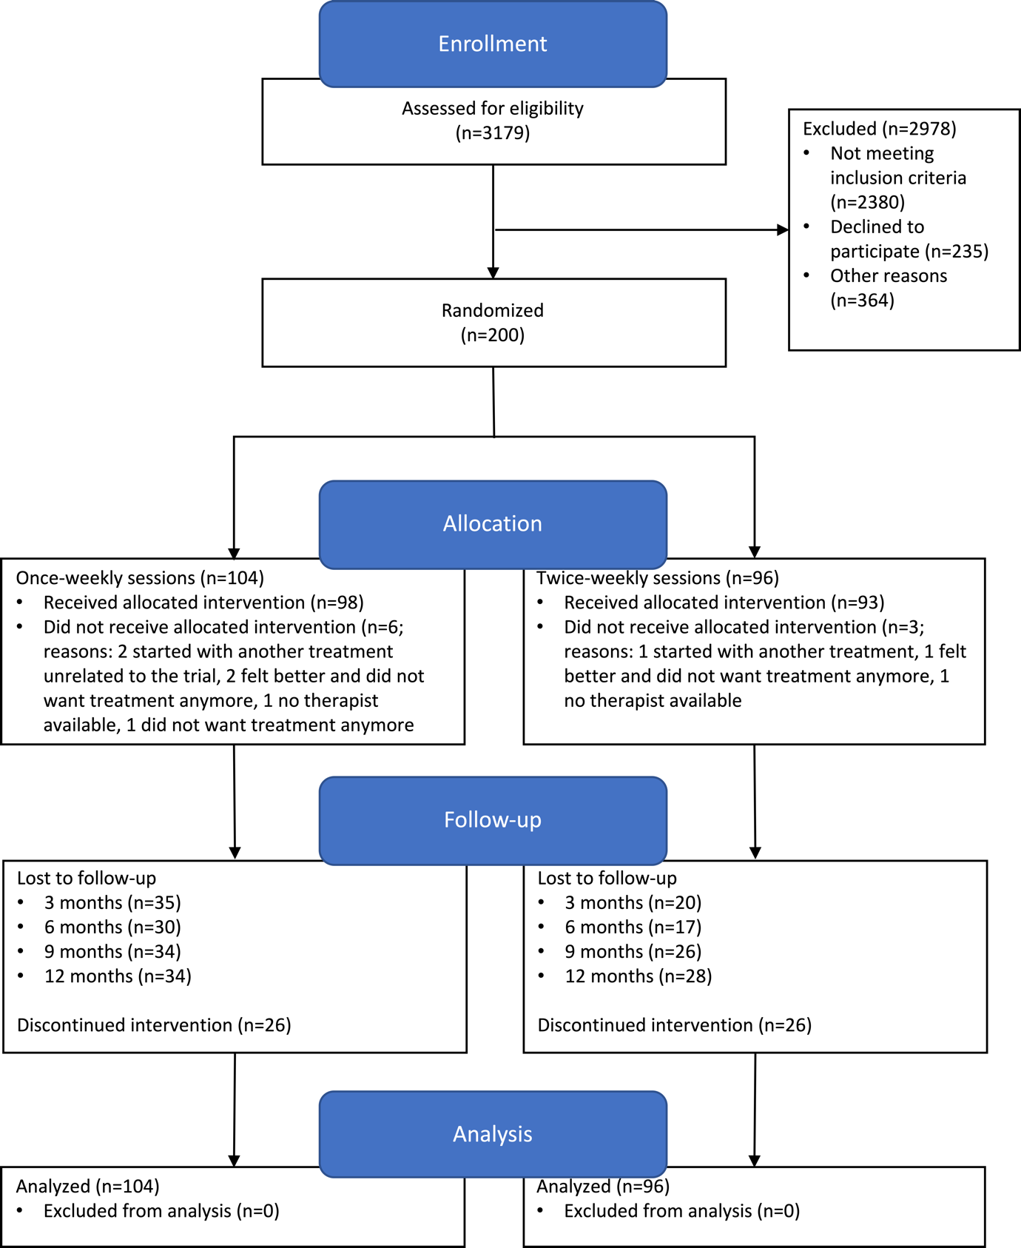

Data Supplement 2. Course of Beck Depression Inventory (BDI-II) scores over 12 months.

Data Supplement 3. Distribution of total societal costs after 12 months.
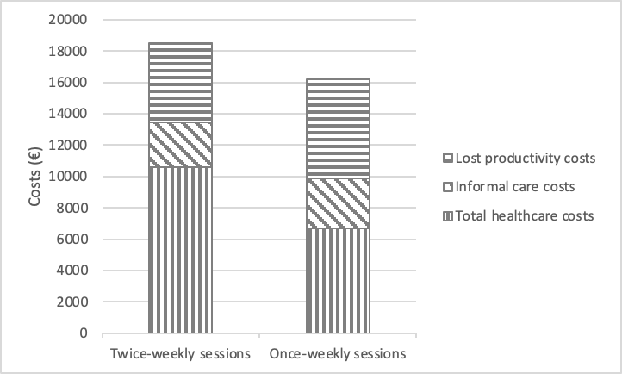

Data Supplement 4. Mean (SE) clinical outcomes and costs 12 months after start of treatment stratified by session frequency and differences in costs and effects after multiple imputation for Sensitivity Analysis 3 (outliers recoded as missing and subsequently imputed).
 |  | Two sessions per week  (n = 96) | One session per week  (n = 104) | Mean difference (95%CI)^{1,2}
Clinical outcomes
BDI-II³ |  |  |  | -1.29 (-3.82 ; 1.24)
 | Baseline | 34.80 (1.07) | 34.62 (0.93)
 | 3 months | 24.34 (1.73) | 27.71 (1.89)
 | 6 months | 22.44 (1.83) | 23.81 (2.35)
 | 9 months | 22.12 (2.17) | 22.58 (1.80)
 | 12 months | 20.41 (2.02) | 21.36 (2.38)
EQ-5D-5L
 | Baseline | 0.49 (0.028) | 0.44 (0.030)
 | 3 months | 0.58 (0.040) | 0.52 (0.044)
 | 6 months | 0.62 (0.037) | 0.57 (0.050)
 | 9 months | 0.58 (0.045) | 0.061 (0.038)
 | 12 months | 0.57 (0.046) | 0.64 (0.045)
 | QALY | 0.58 (0.025) | 0.56 (0.026) | 0.020 (-0.053 ; 0.093)
PFS | 12 months | 76.98 (3.18) | 79.53 (2.93) | -2.62 (-10 ; 4.89)
MFS | 12 months | 59.62 (3.57) | 56.88 (4.57) | 2.81 (-9.13 ; 14.74)
Cost outcomes
Total healthcare costs
Primary care |  | 764 (76) | 719 (73) | 45 (-122 ; 220)
Secondary care |  | 1616 (377) | 1452 (297) | 160 (-494 ; 1168)
Mental care |  | 4087 (735) | 1656 (283) | 2408 (1339 ; 3819)
Medication |  | 60 (10) | 48 (7) | 12 (-8 ; 34)
Intervention |  | 1614 (53) | 1438 (61) | 175 (19 ; 338)
Supportive care |  | 35 (21) | 27 (12) | 7 (-24 ; 78)
Informal care costs |  | 2589 (263) | 2921 (260) | -334 (-1007 ; 330)
Lost productivity costs |  | 4053 (425) | 4928 (507) | -875 (-2018 ; 238)
Absenteeism unpaid work |  | 2499 (244) | 2788 (269) | -290 (-935 ; 348)
Presenteeism paid work |  | 1117 (293) | 1843 (433) | -730 (-1611 ; 82)
Absenteeism paid work |  | 437 (90) | 297 (65) | 145 (-22 ; 323)
Total societal costs |  | 14818 (1129) | 13189 (807) | 1599 (-691 ; 4118)
¹ 95% confidence intervals estimated using bias-corrected and accelerated bootstrapping
² All analyses adjusted for type of psychotherapy (Cognitive Behavioral Therapy or Interpersonal Psychotherapy)
³ Overall effect over time (12 months after start of treatment) corrected for BDI score at baseline
BDI = Beck Depression Inventory, QALY = Quality-Adjusted Life-Year, PCS = RAND-36 Physical Component Score, MCS = RAND-36 Mental Component Score

