Table 1 – International Classification of Primary Care (ICPC-1) codes identifying psychiatric episodes
Psychiatric episode | ICPC-1 code
*Mood and/or anxiety disorder
Panic disorders, including panic attack disorder and generalized anxiety disorder | 1874
Other neurotic disorders, including phobias and compulsive disorders | 1879
Depressive disorders, also including post-partum depression | 1876
Bipolar disorder | 1873
Suicide attempt | 1877
Post traumatic stress disorder/crisis, and transient stress | 1802
*Substance use disorder
Problematic alcohol use | 1815
Acute alcohol abuse/intoxication | 1816
Drug abuse | 1819
Tobacco abuse | 1817
Medication abuse | 1818
*Psychotic disorder
Schizophrenia all types | 1872
Other/unspec psychosis | 1898
*Neurocognitive disorder
Parkinsonism | 1787
Dementia senile/Alzheimer | 1870
Delirium (excl. delirium tremens) | 1871
*Eating disorder
Boulimia | 2106
Eating problems in children | 1811
*Somatic symptom disorder
Hysterical/hypochondriacal disorder | 1875
*Personality disorder and/or gambling disorder | 1880
* Codes used in exclusion criteria
Epilepsy all types | 1788
Neuropathy | 1794

Table 2 – Anatomical Therapeutic Chemical Classification (ATC) codes identifying psychiatric drug prescriptions
Psychiatric drug |  |  | ATCcode
Major drug class | Minor drug class | Specific drug name
Amphetamines
 |  | Dexamphetamine | N06BA02
 |  | Lisdexamphetamine | N06BA12
 |  | Methylphenidate | N06BA04
 |  | Amfetamine | N06BA01
Antiepileptics
 |  | Carbamazepine | N03AF01
 |  | Lamotrigine | N03AX09
 |  | Pregabalin | N03AX16
 |  | Valproic acid | N03AG01
Antidepressants
 | SSRI (non-selective) | Duloxetine | N06AX21
 |  | Trazodone | N06AX05
 |  | Venlafaxine | N06AX16
 | SSRI (selective) | Citalopram | N06AB04
 |  | Dapoxetine | G04BX14
 |  | Escitalopram | N06AB10
 |  | Fluoxetine | N06AB03
 |  | Fluvoxamine | N06AB08
 |  | Paroxetine | N06AB05
 |  | Sertraline | N06AB06
 | Tricyclic antidepressants | Amitriptyline | N06AA09
 |  | Clomipramine | N06AA04
 |  | Dusolepin | N06AA16
 |  | Doxepin | N06AA12
 |  | Imipramine | N06AA02
 |  | Maprotiline | N06AA21
 |  | Nortriptyline | N06AA10
 | Tetracyclic antidepressants | Mianserin | N06AX03
 |  | Mirtazepine | N06AX11
 | AD, rest group (i.e. bupropion, vortioxetine) | Bupropion | N06AX12
 |  | Vortioxetine | N06AX26
 |  | Agomelatine | N06AX22
 |  | Hyperici herba | N06AX25
 | MAO A inhibitors (i.e. moclobemide) | Moclobemide | N06AG02
 | MAO inhibitors, non-selective (i.e. phenelzine tranylcypromine) | Phenelzine | N06AF03
 |  | Tranylcypromine | N06AF04
Benzodiazepine receptor agonists |  | Alprazolam | N05BA12
 |  | Bromazepam | N05BA08
 |  | Brotizolam | N05CD09
 |  | Clobazam | N05BA09
 |  | Clorazepate | N05BA05
 |  | Diazepam | N05BA01
 |  | Flunitrazepam | N05CD03
 |  | Flurazepam | N05CD01
 |  | Loprazolam | N05CD11
 |  | Lorazepam | N05BA06
 |  | Lormetazepam | N05CD06
 |  | Midazolam | N05CD08
 |  | Nitrazepam | N05CD02
 |  | Oxazepam | N05BA04
 |  | Prazepam | N05BA11
 |  | Temazepam | N05CD07
 |  | Zolpidem | N05CF02
 |  | Zopiclone | N05CF01
 |  | Clonazepam | N03AE01
 |  | Chlordiazepoxide | N05BA02
Antipsychotics, atypical |  | Aripiprazole | N05AX12
 |  | Brexpiprazole | N05AX16
 |  | Cariprazine | N05AX15
 |  | Clozapine | N05AH02
 |  | Lurasidone | N05AE05
 |  | Olanzapine | N05AH03
 |  | Paliperidone | N05AX13
 |  | Quetiapine | N05AH04
 |  | Risperidone | N05AX08
 |  | Sertindole | N05AE03
 |  | Chlorpromazine | N05AA01
Antipsychotics, typical |  | Amisulpride | N05AL05
 |  | Bromperidol | N05AD06
 |  | Chloorprothixene | N05AF03
 |  | Flupenthixol | N05AF01
 |  | Fluspirilene | N05AG01
 |  | Haloperidol | N05AD01
 |  | Penfluridol | N05AG03
 |  | Periciazine | N05AC01
 |  | Pimozide | N05AG02
 |  | Pipamperone | N05AD05
 |  | Sulpride | N05AL01
 |  | Tiapride | N05AL03
 |  | Zuclopenthixol | N05AF05
 |  | Fluphenazine | N05AB02
 |  | Perphenazine | N05AB03
 |  | Droperidol | N05AD08
Antipsychotics, other |  | Lithium | N05AN01
Pharmacotherapy for alcohol addiction |  | Acamprosate | N07BB03
 |  | Disulfiram | N07BB01
 |  | Nalmefene | N07BB05
 |  | Naltrexone | N07BB04
Pharmacotherapy for nicotine addiction |  | Nicotine | N07BA01
 |  | Varenicline | N07BA03
Psychiatric drug, rest group |  | Buspiron (indication: anxiety disorder) | N05BE01
 |  | Atomoxetine (indication: ADHD) | N06BA09

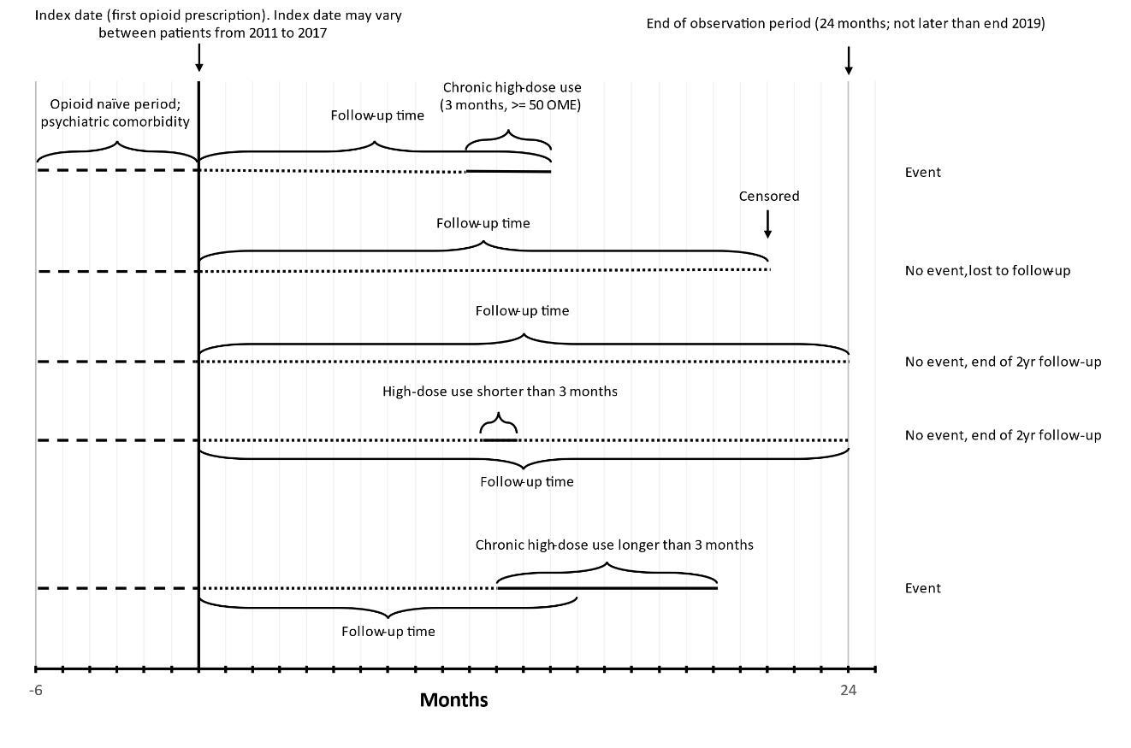
Figure - The follow-up period for each patient started with new opioid use (between 2011-2017) and was completed until the chronic high-dose (CHD) event occurred (between 2013-2019) or end of the 2 year follow-up. In case patients were deregistered, e.g. due to GP switch or death, censoring occurred. The CHD event comprise a minimal period of 3 months, but can comprise a longer period as illustrated.

Methods
CHD opioid use was identified by using the duration, dosage, and number of the prescribed opioids. The opioid prescription duration was calculated by identifying repeat prescriptions, and using the start date of the repeat prescription as stop date of the previous prescription, similar to Weesie et al. Prescriptions for the same drug were considered repeat prescriptions when their start date was less than 90 days apart. The end date of a prescription was defined as the start date of the next prescription. The duration of the last prescription in a series of repeat prescriptions was calculated as the average duration of the previous prescriptions. For non-repeat prescriptions the duration was fixed at 14 days, the standard duration of a first prescription in the Netherlands. For each prescription a daily dose was calculated by dividing the amount prescribed (e.g. number of pills) by the duration and converting this to oral morphine equivalents (OME). For each day the total opioid use was calculated by adding the daily dose of all active prescriptions. Chronic high-dose use was defined as a period of 90 subsequent days where the average daily dose was greater than 50 OME, and this dose was exceeded on a majority of days.
This method only depends on the type of drug prescribed, the starting date, and the total prescribed dose to identify CHD opioid use. Therefore, it is not sensitive to patient compliance to the prescribed dosing schedule and also accounts for prn (as needed) dosings.
Weesie YM, Hek K, Schermer TRJ, Schellevis FG, Leufkens HGM, Rook EJ, et al. Use of Opioids Increases With Age in Older Adults: An Observational Study (2005-2017). Front Pharmacol. 2020;11:648.

Table 3 - Sensitivity analysis in which the total OME of first prescription was included as a correction factor. Total OME was first categorised into <100 OME, 100-200 OME, 200-300 OME, and ≥300 OME.
Psychiatric disorders | N | CHD opioid use  N (%) | HR (95% CI)  Unadjusted | HR (95% CI)  Adjustedª
No | 92829 | 1494 (1.61) | 1 [reference] | 1 [reference]
Yes | 44949 | 1314 (2.92) | 1.97 (1.83-2.12) | 1.67 (1.55-1.80)
Psychiatric episode
No psychiatric episode | 118046 | 2290 (1.94%) | 1 [reference] | 1 [reference]
Mood and/or anxiety disorder | 9736 | 202 (2.07%) | 1.05 (0.91-1.21) | 1.12 (0.97-1.29)
Substance use disorder | 3800 | 122 (3.21%) | 1.65 (1.37-1.97) | 1.59 (1.33-1.91)
Psychotic disorder | 463 | 14 (3.02%) | 1.66 (0.98-2.81) | 2.21 (1.31-3.74)
Neurocognitive disorder | 3076 | 102 (3.32%) | 2.58 (2.11-3.14) | 1.47 (1.20-1.80)
Multiple psychiatric episodes | 1706 | 58 (3.40%) | 1.90 (1.46-2.47) | 1.94 (1.49-2.52)
Psychiatric drug  No psychiatric drug | 100972 | 1669 (1.65%) | 1 [reference] | 1 [reference]
PhT mood and/or anxiety disorder | 31184 | 981 (3.15%) | 2.02 (1.87-2.19) | 1.71 (1.58-1.85)
PhT substance use disorder | 514 | 17 (3.31%) | 2.00 (1.24-3.22) | 2.08 (1.29-3.36)
Antipsychotics | 1152 | 25 (2.17%) | 1.97 (1.33-2.92) | 1.66 (1.12-2.47)
PhT ADHD | 460 | 3 (0.65%) | 0.39 (0.13-1.21) | 1.00 (0.32-3.11)
Psychiatric polypharmacy | 3496 | 113 (3.23%) | 2.46 (2.04-2.98) | 2.52 (2.08-3.05)
CHD chronic high dose, HR hazard ratio, PhT pharmacotherapy.

Table 4 - Sensitivity analysis in which SNRI’s were excluded.
Psychiatric disorders | N | CHD opioid use  N (%) | HR (95% CI)  Unadjusted | HR (95% CI)  Adjustedª
No | 93139 | 1510 (1.62) | 1 [reference] | 1 [reference]
Yes | 44639 | 1298 (2.91) | 1.95 (1.81-2.10) | 1.72 (1.60-1.86)
Psychiatric drug  No psychiatric drug | 100022 | 1696 (1.67%) | 1 [reference] | 1 [reference]
PhT mood and/or anxiety disorder | 29484 | 954 (3.13%) | 2.00 (1.85-2.17) | 1.68 (1.55-1.82)
PhT substance use disorder | 504 | 17 (3.26%) | 1.95 (1.21-3.14) | 2.02 (1.25-3.26)
Antipsychotics | 1207 | 26 (2.11%) | 1.84 (1.25-2.71) | 1.57 (1.06-2.31)
PhT ADHD | 466 | 3 (0.64%) | 0.38 (0.12-1.17) | 0.93 (0.30-2.88)
Psychiatric polypharmacy | 3287 | 112 (3.30%) | 2.51 (2.07-3.04) | 2.53 (2.09-3.06)
CHD chronic high dose, HR hazard ratio, PhT pharmacotherapy.

