**Supplementary materials**

**Details of the methods**

**1. Participants**

Twenty-four outpatients with AN were recruited from Kyoto University Hospital. Three patients were excluded because of missing post-intervention fMRI data or self-reported measure data or artifacts in their fMRI data. The final sample consisted of 21 AN patients (11 restricting type/10 binge-purging type; mean age: 37.1 years, standard deviation: 11.77 years; age range: 22 to 59 years; average duration of illness: 18.81 years). Diagnosis and sub-classification of AN were confirmed by a psychiatrist who conducted structured interviews using the Japanese version of the Diagnostic and Statistical Manual of Mental Disorders 5(1). The exclusion criteria were as follows: patients under 16 and over 60 years old, patients with intellectual disability, schizophrenia, bipolar I disorder, neurocognitive disorder, neurological diseases, diseases affecting the metabolism of the central nervous system, and persons with a history of significant head injury. Ten of the participants with AN were prescribed psychotropic medications such as antipsychotics, antidepressants, anxiolytics, or antiepileptics. The participants underwent fMRI scanning and psychological evaluation before and after MBI within 4 weeks.

**2. Psychological measures**

Participants completed the EDE-Q 6.0 (2, 3) and the STAI (4, 5). We examined both state and trait anxiety because mindfulness is considered to alter personality traits (6) and some studies have demonstrated an association between mindfulness and trait anxiety (7, 8). SPSS version 24 (Chicago, IL, USA) was used for the t-test and correlation analyses.

**3. fMRI task**

Participants were instructed to imagine gaining various amounts of weight: 50 g, 500 g, 1 kg, 3 kg, and 5 kg. They were then asked to regulate their emotions using three different strategies: same as usual (SAU), try to not do anything and experience emotions (ACCEPT), or try to observe bodily sensations (BODY). Each weight condition occurs once in each regulation strategy. The presentation of the weight conditions was pseudo-randomized between regulation strategies. Each emotion strategy occurred five times during the task. The task consisted of 15 trials. Each trial took 612 sec, and the whole task took 637.4 sec in total (40.8 sec × 15 trials + 25.4 sec task instruction). Participants underwent fMRI scanning after confirming that they fully understood the procedure of the task. The E-PRIME 2.0 Professional software (www. pstnet.com/eprime; Psychology Software Tools, Sharpsburg, PA, USA) implemented on a Windows 7 computer was used to present the tasks and collect behavioral data.

**4. MBI**

The MBI consisted of four weekly sessions, and the duration of each session was 90 minutes. Participants were instructed to practice 5 minutes of focused attention meditation and 10 to 20 minutes of body-scanning daily. Each session comprised psychoeducation and meditation practice. The psychoeducational elements and practice during the sessions and home practice are shown in Table 2. Given the physical condition of AN, we set a minimum amount of practice. Participants were instructed to complete 5 minutes of focused attention meditation using the sensation of breathing in a sitting posture and either a 10- or 20-minute body scan with recorded guidance.

**5. fMRI data acquisition**

All fMRI data were acquired using a 3-Tesla MRI scanner (Siemens Trio, Erlangen, Germany) at the Human Brain Research Center, Graduate School of Medicine, Kyoto University. Functional images were obtained using an echo-planar imaging sequence (repetition time [TR] = 720 ms, echo time [TE] = 29 ms, flip angle = 50°, field of view [FOV] = 192 × 192 mm, matrix size = 64 × 64, slice thickness/gap = 3 mm/0 mm, and 50 interleaved axial slices). The full fMRI acquisition consisted of 885 volumes, of which the first 13 volumes were excluded to ensure signal stability. High-resolution T1-weighted structural images were also acquired using the magnetization prepared rapid gradient echo sequence (TR = 2000 ms, TE = 3.4 ms, flip angle = 8°, FOV = 225 × 240 mm, slice thickness = 1 mm, and 208 axial slices). Participants wore earplugs to reduce noise and laid on their backs on the scanner bed. They performed the task by pressing a button held in their dominant hand. Visual stimuli were presented on an MRI-compatible liquid crystal display, and participants viewed stimuli through a mirror attached to the head coil.

**6. fMRI data preprocessing and denoising**

FSL5 (FMRIB Software Library, www.fmrib.ox.ac.uk/fsl) (9) and SPM12 (Welcome Department of Imaging Neuroscience, University of London, London, UK) were used for the fMRI analyses. After inter-scan slice timing correction, head motion was corrected using three-dimensional motion correction and data repair(10). This repairing procedure aims to remove motion-related signal drop-out and involves searching for time points presenting (a) abrupt global signal change exceeding 1% and (b) frame-wise displacement exceeding a Euclidian distance of ± 1 mm or ± 1° rotation per TR. In addition, 24 parameters related to head motion were used to regress out motion effects. Functional images were then co-registered to the T1 anatomical image. Subsequently, structural images were matched to a template via a tissue probability map. Functional images were spatially normalized using the warping parameters from the structural image normalization and resliced into 4 mm isotropic voxels.

Finally, a recently proposed denoising method (11, 12) was used to deal with contamination from non-neural signal components. This procedure involves tracking regional variations of low-frequency oscillations of systemic origin using the bandpass-filtered (0.008–0.07 Hz) global signal as an initial seed. The phase shift in each voxel was tracked up to 7 s up- and downstream to create a phase lag map, and the corresponding time series were set for each region. This spatiotemporal lag structure was then regressed out from the original data. This process is considered global signal regression, tailored for each voxel that affects only the slow signal components. The functional images were then spatially smoothed using a Gaussian filter with a full width at half maximum of 4 mm and resliced into 2 mm isotropic voxels.

**7. Statistics**

The results of the paired t-test for each psychological measure were thresholded using the Bonferroni correction (i.e., EDE-Q 6.0, p < 0.05/4; STAI, p < 0.05/2).

Regarding fMRI analyses, activation during each event (i.e., visual cue, weight-related anxiety induction, ACCEPT, BODY, SAU, and rating) was modeled on the basis of the hemodynamic response function. The results were family-wise error corrected (one-tailed/p = 0.05 at the cluster level). ROI analyses were performed using the PickAtlas toolbox within SPM12. The mean β-values of the ACCEPT > SAU contrast extracted from each ROI at each time point were used for the correlation analyses. ROIs were anatomically defined in the regions that showed a significant decrease in the paired t-test. For the MFG/IFS, we used the MFG as the ROI. Changes in activity and trait anxiety for the ACCEPT > SAU contrast were calculated by subtracting pre-intervention measures from the post-intervention measures. We checked the normality of the distribution and used nonparametric tests (Wilcoxon signed-rank test and Spearman’s rank correlation test) for variables that were not normally distributed. The significance levels were not corrected for multiple comparisons regarding correlation analyses.

**Table 1. Demographics and clinical characteristics**

|  |  |  |
| --- | --- | --- |
| **Demographic data** | Mean | Standard Deviation |
| Age | 37.10 | 11.77 |
| Years of Education | 14.52 | 2.29 |
| BMI | 14.76 | 2.86 |
| Duration of illness | 18.81 | 10.65 |
| **EDE-Q** |  |  |
| Restraint | 2.76 | 1.46 |
| Eating Concern | 2.83 | 1.75 |
| Shape Concern | 3.13 | 1.78 |
| Weight Concern | 3.02 | 1.73 |
| **STAI** |  |  |
| State | 54.25 | 11.03 |
| Trait | 61.13 | 8.53 |
| Medication |  |  |

**Table 2. Content of the brief mindfulness-based intervention (MBI)**

|  |  |  |  |
| --- | --- | --- | --- |
|  | Practice | Psychoeducation | Home practice |
| 1st session | Focused attention meditation | What is Mindfulness? | Focused attention meditation (5 minutes) |
| 2nd session | Body scan | Body and mind connection | Focused attention meditation (5 minutes) and Body scan (either 10 or 20 minutes) |
| 3rd session | Raisin exercise | Acceptance | Focused attention meditation (5 minutes) and Body scan (either 10 or 20 minutes) |
| 4th session | Mindful walking | Non-judgmental attitude | Focused attention meditation (5 minutes) and Body scan (either 10 or 20 minutes) |

**Fig 1. The emotion regulation task**

**END**

**＋**

**(ACCEPT)**

**Imagine you have gained 50g weight**

**Accept the emotion as it is**

**REST**

**START**

**How unpleasant is it now？**

**1. Not at all**

**2. Not so much**

**3. A little bit**

**4. Very much**

**Weight-related anxiety induction**

**Instruction**

**Regulation**

**Rating**

2.4sec

2.4sec

14.4sec

7.2sec

4.8sec

2.4sec

7.2sec

**Conditions**

50 g, 500 g, 1 kg, 3 kg, and 5kg

**Conditions**

ACCEPT,

BODY, SAU

**Fig 2. Correlation between the reduction in brain activity and reduction in trait anxiety**

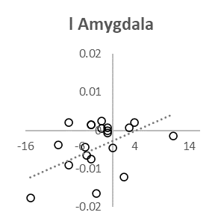

Change in

ACCEPT > SAU contrast

Change in trait anxiety

r = 0.36

*p* = 0.06

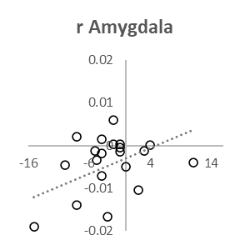

r = 0.45

*p* = 0.02

Change in

ACCEPT > SAU contrast

Change in trait anxiety

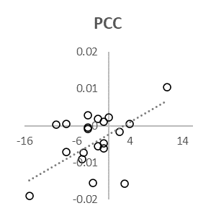

r = 0.54

*p* = 0.01

Change in

ACCEPT > SAU contrast

Change in trait anxiety

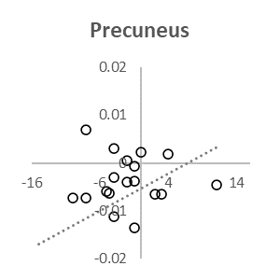

r = 0.34

*p* = 0.07

Change in

ACCEPT > SAU contrast

Change in trait anxiety

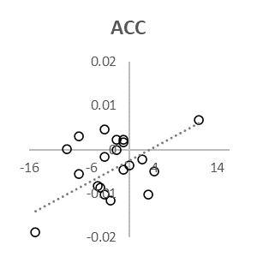

Change in

ACCEPT > SAU contrast

Change in trait anxiety

r = 0.51

*p* = 0.01

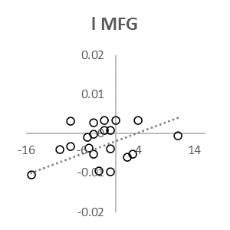

Change in

ACCEPT > SAU contrast

Change in trait anxiety

r = 0.40

*p* = 0.04

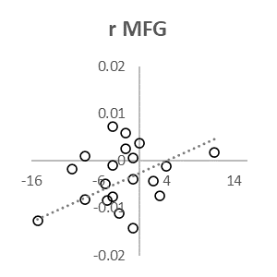

Change in

ACCEPT > SAU contrast

Change in trait anxiety

r = 0.42

*p* = 0.03

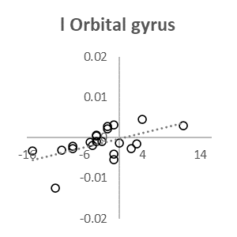

Change in

ACCEPT > SAU contrast

Change in trait anxiety

r = 0.54

*p* = 0.01

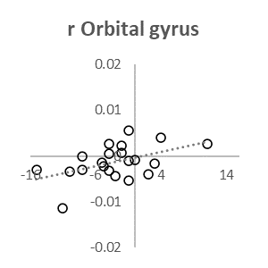

Change in

ACCEPT > SAU contrast

Change in trait anxiety

r = 0.48

*p* = 0.01

Abbreviation: PCC, posterior cingulate cortex.

**References**

1. Takahashi S, Ono Y, Someya T, Kanba S, Ozaki N, Mimura M et al. *Japanese version of diagnostic and statistical manual of mental disorders: DSM-5.* Tokyo: Igakusyoin; 2014.

2. Murphy R, Straebler S, Cooper Z, Fairburn, CG. Cognitive behavioral therapy for eating disorders. *Psychiatric Clinics* 2010; **33**(3): 611-627.

3. Nakai Y, Noma S, Nin K, Terumukai S, Wonderlich S. A. Eating disorder behaviors and attitudes in Japanese adolescent girls and boys in high schools. *Psychiatry Research* 2015; **230**(2): 722-724.

4. Spielberger CD, Gorsuch RW, Luschene RE. *State Trait Anxiety Inventory.* Palo Alto, CA: Consulting Psychologists Press; 1970.

5. Shimizu H, Imae K. Development of the Japanese edition of the Spielberger State-Trait Anxiety Inventory (STAI) for student use. *Japanese Journal of Educational Psychology* 1981; **29**(4): 348-353.

6. Tang Y-Y, Hölzel BK, Posner MI. The neuroscience of mindfulness meditation. *Nature Reviews Neuroscience* 2015; **16**(4): 213-225.

7. Davidson RJ, Kabat-Zinn J, Schumacher J, Rosenkranz M, Muller D, Santorelli S, et al. Alterations in brain and immune function produced by mindfulness meditation. *Psychosomatic medicine* 2003; **65**(4): 564-570.

8. Bergen-Cico D, Cheon S. The mediating effects of mindfulness and self-compassion on trait anxiety. *Mindfulness* 2014; **5**(5): 505-519.

9. Smith SM, Jenkinson M, Woolrich MW, Beckmann CF, Behrens TE, Johansen-Berg H, et al. Advances in functional and structural MR image analysis and implementation as FSL. *Neuroimage* 2004; **23**: S208-219.

10. Mazaika PK, Hoeft F, Glover GH, Reiss AL. Methods and software for fMRI analysis of clinical subjects. *Neuroimage* 2009; **47**(Suppl 1): S58.

11. Aso T, Urayama S, Fukuyama H, Murai T. Axial variation of deoxyhemoglobin density as a source of the low-frequency time lag structure in blood oxygenation level-dependent signals. *PloS one* 2019; **14**(9): e0222787.

12. Aso T, Jiang G, Urayama S, Fukuyama H. A resilient, non-neuronal source of the spatiotemporal lag structure detected by BOLD signal-based blood flow tracking. *Frontiers in neuroscience* 2017; **11**: 256.