Supplementary Material

Supplementary Table 1. Correlations TOTPOW - psychophysiological parameters

Group x condition. first 10 s interval
Patients (N=18) |  | IBI (ms) | RMSSDln
MC only | correlation (Pearson) | -.025 | .322
 | Sig. (2-sided) | .921 | .192
MC neg | correlation (Pearson) | -.392 | .004
 | Sig. (2-sided) | .108 | .988
MC pos | correlation (Pearson) | -.093 | -.051
 | Sig. (2-sided) | .712 | .841
Controls (N=18) |  | IBI (ms) | RMSSDln
MC only | correlation (Pearson) | -.114 | -.364
 | Sig. (2-sided) | .654 | .138
MC neg | correlation (Pearson) | -.101 | -.148
 | Sig. (2-sided) | .690 | .557
MC pos | correlation (Pearson) | .133 | .239
 | Sig. (2-sided) | .600 | .339
Note. IBI = interbeat interval; MC only = mirror confrontation without any cognition; MC neg = mirror confrontation with negative cognition, MC pos = mirror confrontation with positive cognition; RMSSDln = natural logarithm of Root Mean Square of Successive Differences.

Supplementary Table 2. TOTPOW left vs. right hemispheres

Condition = MC only |  | Hemi both | Hemi left | Hemi right | Hemi difference (left – right)
Patients | M | 62.2852 | 62.4428 | 62.1541 | .2463
 | SD | 5.14715 | 5.27914 | 5.12978 | 1.81407
Controls | M | 62.3073 | 62.3976 | 62.2171 | .1538
 | SD | 4.00779 | 4.29253 | 3.94218 | 2.01842
Condition = MC neg
Patients | M | 60.9014 | 61.0430 | 60.7622 | .3159
 | SD | 4.63306 | 4.90402 | 4.57476 | 2.09771
Controls | M | 64.2177 | 64.3317 | 64.1112 | .1957
 | SD | 5.67896 | 5.92409 | 5.63097 | 2.13454
Condition = MC pos
Patients | M | 62.7680 | 62.7933 | 62.7430 | .1128
 | SD | 5.18143 | 5.13012 | 5.32418 | 1.49763
Controls | M | 63.9534 | 63.8949 | 64.0118 | -.1689
 | SD | 4.65443 | 4.66525 | 4.84991 | 2.09955
Note. M = mean; MC only = mirror confrontation without any cognition; MC neg = mirror confrontation with negative cognition, MC pos = mirror confrontation with positive cognition; SD = standard deviation.

Figure S1. Time course of total power in the left hemisphere during mirror confrontation
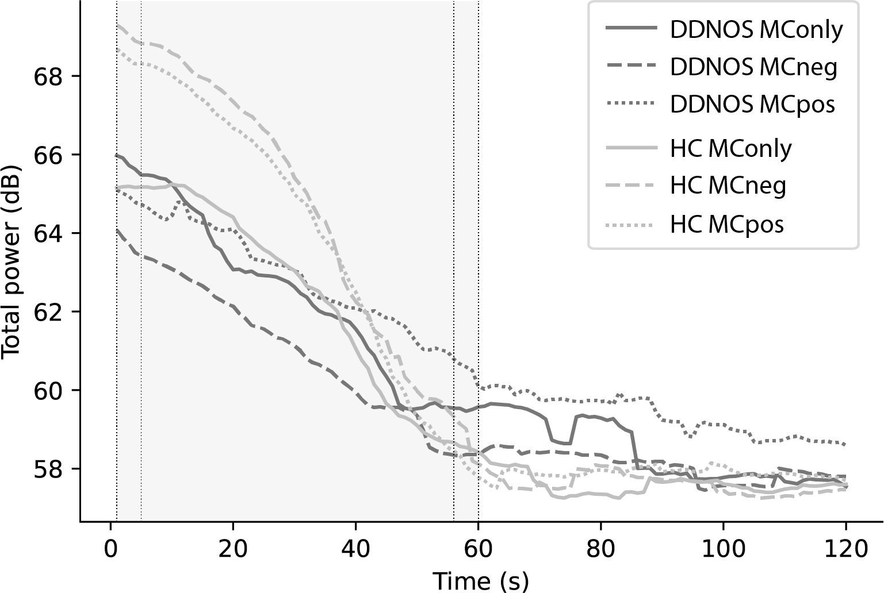
Note. Total frontal EEG power in dB plotted against time for the entire duration of mirror confrontation (MC). The first minute of the signal used for analysis is highlighted in grey, and the first and last 5 s segments are denoted by vertical dotted lines. DDNOS = people with dissociative disorder not otherwise specified; HC = healthy controls; MConly = MC without any cognition; MCneg = MC with negative cognition, MCpos = MC with positive cognition.

Figure S2. Time course of total power in the right hemisphere during mirror confrontation
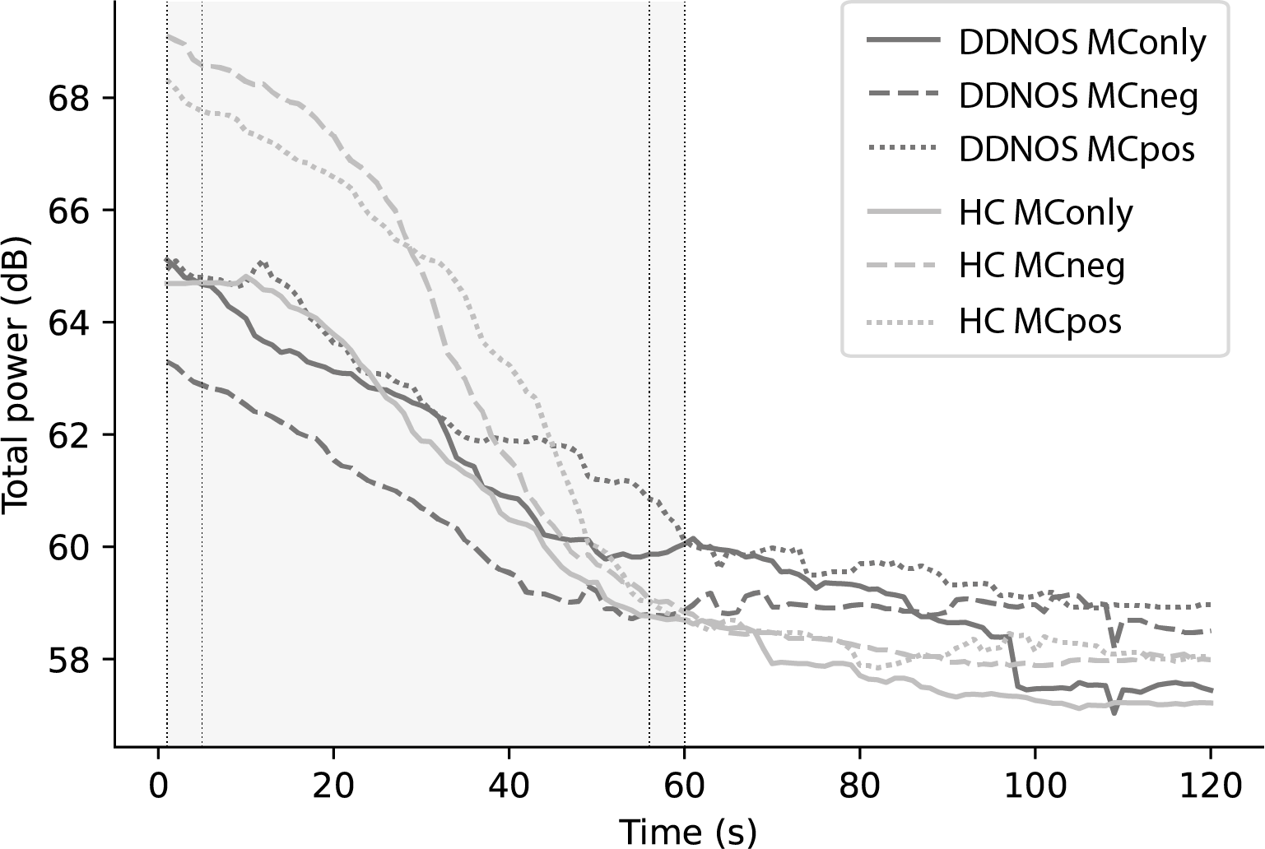
Note. Total frontal EEG power in dB plotted against time for the entire duration of mirror confrontation (MC). The first minute of the signal used for analysis is highlighted in grey, and the first and last 5 s segments are denoted by vertical dotted lines. DDNOS = people with dissociative disorder not otherwise specified; HC = healthy controls; MConly = MC without any cognition; MCneg = MC with negative cognition, MCpos = MC with positive cognition.

Supplementary Table 3. Linear mixed models

Fixed effects | Hemi both |  |  | Hemi left |  |  | Hemi right |  |  | Hemi difference  (Hemi left – Hemi right)
MC only | df | F-value | Sig. | df | F-value | Sig. | df | F-value | Sig. | df | F-value | Sig.
Constant | 43.729 | 10290.9 | .000 | 45.884 | 10032.1 | .000 | 42.848 | 9827.27 | .000 | 68.980 | 8.809 | .004
Time | 206.993 | 190.335 | .000 | 208.000 | 186.634 | .000 | 206.99 | 165.177 | .000 | 205.167 | 14.890 | .000
Group | 43.729 | .411 | .525 | 45.884 | .282 | .598 | 42.848 | .534 | .469 | 68.980 | .505 | .480
Group * Time | 206.993 | 3.105 | .080 | 208.000 | 2.075 | .151 | 206.99 | 3.994 | .047 | 205.167 | .872 | .352
MC neg
Constant | 43.862 | 9219.30 | .000 | 42.753 | 8032.13 | .000 | 46.236 | 9687.94 | .000 | 55.552 | 2.360 | .130
Time | 206.141 | 227.077 | .000 | 206.141 | 222.908 | .000 | 206.16 | 196.621 | .000 | 205.571 | 2.060 | .153
Group | 43.862 | 21.344 | .000 | 42.753 | 16.589 | .000 | 46.236 | 24.919 | .000 | 55.552 | 1.715 | .196
Group * Time | 206.141 | 35.707 | .000 | 206.141 | 27.349 | .000 | 206.16 | 38.629 | .000 | 205.571 | 5.223 | .023
MC pos
Constant | 45.693 | 10650.0 | .000 | 45.766 | 11213.0 | .000 | 46.377 | 9500.12 | .000 | 61.989 | 1.223 | .273
Time | 208 | 222.119 | .000 | 208.000 | 247.063 | .000 | 208.00 | 178.668 | .000 | 207.149 | 5.356 | .022
Group | 45.693 | 9.972 | .003 | 45.766 | 11.834 | .001 | 46.377 | 7.831 | .007 | 61.989 | .302 | .585
Group * Time | 208 | 33.141 | .000 | 208.000 | 43.247 | .000 | 208.00 | 22.159 | .000 | 207.149 | 4.299 | .039
Note. MConly = mirror confrontation without any cognition; MC neg = mirror confrontation with negative cognition, MC pos = mirror confrontation with positive cognition.

