Supplemental Table 1. Chi square analysis of characteristics of baseline-only (n = 666) and rest of participants involved at other phases (n = 1055). (Total N = 1721).
 | Response | Baseline-only (n, 666) (%) | Rest (n, 1055) (%) | Chi squared result
Age | 18-25 years | 33 (5.0) | 51 (4.8) | 3.8, p = 0.58
 | 26-35 years | 169 (25.4) | 270 (25.6)
 | 36-50 years | 275 (41.3) | 419 (39.7)
 | 51-60 years | 155 (23.3) | 242 (22.9)
 | 61-70 years | 33 (5.0) | 66 (6.3)
 | > 70 years | 1 (0.2) | 7 (0.7)
Ethnicity | White | 324 (48.7) | 812 (77.0) | 153.9, p < 0.001
 | Asian | 238 (35.7) | 148 (13.8)
 | Black | 40 (6.0) | 38 (3.6)
 | Mixed | 25 (3.8) | 26 (2.5)
 | Other | 20 (3.0) | 22 (2.1)
 | Prefer not to say | 19 (2.9) | 11 (1.0)
Gender identity | Female | 432 (64.9) | 782 (74.1) | 23.4, p < 0.001
 | Male | 217 (32.6) | 266 (25.2)
 | Prefer not to say | 11 (1.7) | 5 (0.5)
 | Prefer to self-define | 6 (0.9) | 2 (0.2)
Relationship status | Divorced | 24 (3.6) | 32 (3.0) | 5.2, p = 0.27
 | Prefer not to say | 24 (3.6) | 25 (2.4)
 | Married/Living w/ partner or family | 443 (66.5) | 698 (66.2)
 | Other | 77 (4.1) | 33 (3.1)
 | Single | 148 (22.2) | 267 (25.3)
Number living in household | 1 | 87 (13.1) | 140 (13.3) | 20.4, p < 0.001
 | 2 | 187 (28.1) | 355 (33.7)
 | 3-5 | 341 (51.2) | 526 (49.9)
 | 6 or more | 51 (7.7) | 34 (3.2)
Highest level of education | GCSEs / A-levels | 44 (6.6) | 77 (7.3)
 | Bachelor’s / diploma | 292 (43.8) | 479 (45.4)
 | Master's / PhD | 281 (42.2) | 434 (41.1)
 | Other | 49 (7.4) | 65 (6.2)
Mental health outcomes at baseline* | Major depressive disorder | 121 (21.7) | 262 (25.7) | 3.2 p = 0.07
 | Generalised anxiety disorder | 101 (18.3) | 207 (20.3) | 1.0, p = 0.32
 | Clinical insomnia | 72 (13.2) | 172 (17.0) | 3.8, p = 0.052
 | Emotional exhaustion | 226 (43.6) | 409 (40.6) | 1.2, p = 0.27
 | Depersonalisation | 76 (14.6) | 127 (12.6) | 1.2, p = 0.27
 | High-medium wellbeing | 396 (75.6) | 750 (74.3) | 0.3, p = 0.60
Note. All demographic data is self-reported. ‘Asian’ category includes South Asian, Chinese, and any other Asian background. ‘Mixed’ category includes mixed Black and White, mixed Asian and White, and mixed any other/multiple ethnic backgrounds.

Supplemental Table 2. Baseline demographic, social and educational characteristics of participants, categorised as HCPs and non-HCPs.
Characteristic | Response | HCPs  n = 1574 (%) | Non-HCPs  n = 147 (%) | Overall  N = 1721 (%)
Age | 18-25 years | 76 (4.8) | 8 (5.4) | 84 (4.9)
 | 26-35 years | 390 (24.8) | 49 (33.3) | 439 (25.5)
 | 36-50 years | 638 (40.5) | 56 (38.1) | 694 (40.3)
 | 51-60 years | 372 (23.6) | 25 (17.0) | 397 (23.1)
 | 61-70 years | 92 (5.8) | 7 (4.8) | 99 (5.8)
 | > 70 years | 6 (0.4) | 2 (1.4) | 8 (0.5)
Ethnicity | White | 1027 (65.3) | 109 (74.2) | 1136 (66.0)
 | Asian | 359 (22.8) | 25 (17.0) | 384 (22.3)
 | Black | 74 (4.7) | 4 (2.7) | 78 (4.5)
 | Mixed | 48 (3.1) | 3 (2.0) | 51 (3.0)
 | Other | 39 (2.5) | 3 (2.0) | 42 (2.4)
 | Prefer not to say | 27 (1.7) | 3 (2.0) | 30 (1.7)
Gender identity | Female | 1105 (70.2) | 109 (74.2) | 1214 (70.5)
 | Male | 447 (28.4) | 36 (24.5) | 483 (28.1)
 | Prefer not to say | 14 (0.9) | 2 (1.4) | 16 (0.9)
 | Prefer to self-define | 8 (0.5) | 0 (0.0) | 8 (0.5)
Relationship status | Divorced | 54 (3.4) | 2 (1.4) | 56 (3.3)
 | I prefer not to disclose | 46 (2.9) | 3 (2.0) | 49 (2.9)
 | Married/Living with partner or family | 1048 (66.6) | 93 (63.3) | 1141 (66.3)
 | Other (please specify) | 52 (3.3) | 8 (5.4) | 60 (3.4)
 | Single | 374 (23.8) | 41 (27.9) | 415 (24.1)
Number living in household | 1 | 210 (13.3) | 17 (11.6) | 227 (13.2)
 | 2 | 487 (30.9) | 55 (37.4) | 542 (31.5)
 | 3-5 | 799 (50.8) | 68 (46.3) | 867 (50.4)
 | 6 or more | 78 (5.0) | 7 (4.8) | 85 (4.9)
Highest level of education | GCSEs or A-levels | 113 (7.2) | 8 (5.4) | 121 (7.0)
 | Bachelor’s degree/diploma | 735 (46.7) | 36 (24.5) | 771 (44.8)
 | Master's degree or PhD | 613 (39.0) | 102 (69.4) | 715 (41.6)
 | Other | 113 (7.2) | 1 (0.7) | 114 (6.6)
Other education generally includes professional qualifications such as Doctor of Medicine, MBA,

Supplemental Table 3. Baseline demographic, social and educational characteristics of all HCPs, categorised into patient facing and non-patient facing HCPs.
Characteristic | Response | Patient facing HCPs  n = 1345 (%) | Non-patient facing HCPs  n = 192 (%) | Overall  N = 1537 (%)
Age | 18-25 years | 64 (4.8) | 9 (4.7) | 73 (4.8)
 | 26-35 years | 346 (25.7) | 35 (18.2) | 381 (24.8)
 | 36-50 years | 561 (41.7) | 66 (34.4) | 627 (40.8)
 | 51-60 years | 301 (22.4) | 60 (31.3) | 361 (23.5)
 | 61-70 years | 70 (5.2) | 19 (9.9) | 89 (5.8)
 | > 70 years | 3 (0.2) | 3 (1.6) | 6 (0.4)
Ethnicity | White | 865 (64.3) | 140 (72.9) | 1005 (65.4)
 | Asian | 313 (23.3) | 37 (19.3) | 350 (22.8)
 | Black | 66 (4.9) | 6 (3.1) | 72 (4.7)
 | Mixed | 42 (3.1) | 5 (2.6) | 47 (3.1)
 | Other | 35 (2.6) | 3 (1.6) | 38 (2.5)
 | Prefer not to say | 24 (1.8) | 1 (0.5) | 25 (1.6)
Gender identity | Female | 945 (70.3) | 136 (70.8) | 1081 (70.3)
 | Male | 382 (28.4) | 53 (27.6) | 435 (28.3)
 | Prefer not to say | 11 (0.8) | 2 (1.0) | 13 (0.9)
 | Prefer to self-define | 7 (0.5) | 1 (0.5) | 8 (0.5)
Relationship status | Divorced | 43 (3.2) | 9 (4.7) | 52 (3.4)
 | I prefer not to disclose | 36 (2.7) | 5 (2.6) | 41 (2.7)
 | Married/Living with partner or family | 896 (66.6) | 129 (67.2) | 1025 (66.7)
 | Other (please specify) | 42 (3.1) | 7 (3.7) | 49 (3.2)
 | Single | 328 (24.4) | 42 (21.9) | 370 (24.1)
Number living in household | 1 | 181 (13.5) | 23 (12.0) | 204 (13.3)
 | 2 | 408 (30.3) | 66 (34.4) | 474 (30.8)
 | 3-5 | 686 (51.0) | 97 (50.5) | 783 (50.9)
 | 6 or more | 70 (5.2) | 6 (3.1) | 76 (4.9)
Highest level of education | GCSEs or A-levels | 69 (5.1) | 38 (19.8) | 107 (7.0)
 | Bachelor’s degree/diploma | 657 (48.9) | 65 (33.9) | 722 (47.0)
 | Master's degree or PhD | 522 (38.8) | 78 (40.6) | 600 (39.0)
 | Other | 97 (7.2) | 11 (5.7) | 108 (7.0)
Other education includes professional qualifications such as Doctor of Medicine, MBA,

Supplementary Table 4. Self-reported positive COVID-19 test result at baseline and phase 3 follow-up, stratified by HCP status.
 |  | HCPs (%) | Non-HCPs (%) | Overall (%)
Baseline (n, 1597) |  | 269 (18.5) | 4 (2.8) | 273 (17.1)
Phase 3 follow-up (n, 733) |  | 178 (26.5) | 12 (20.0) | 190 (25.9)
Note. The total number of HCPs providing adequate responses on this item was 1455 at baseline, and 673 at phase 3 follow-up. The total number of non-HCPs providing adequate responses on this item was 142 at baseline, and 60 at phase 3 follow-up.

Supplementary Table 5. Self-reported positive COVID-19 test result at baseline and phase 3 follow-up in HCPs, stratified by patient facing status.
 |  | Patient facing HCPs (%) | Non-patient facing HCPs (%) | Overall (%)
Baseline (n, 1455) |  | 243 (19.1) | 26 (14.1) | 269 (18.5)
Phase 3 follow-up (n, 736) |  | 164 (26.0) | 15 (14.4) | 179 (24.3)
Note. The total number of patient facing HCPs providing adequate responses on this item was 1271 at baseline, and 632 at phase 3 follow-up. The total number of non-patient facing HCPs providing adequate responses on this item was 184 at baseline, and 104 at phase 3 follow-up.

Supplementary Table 6. Prevalence of mental health, burnout, and wellbeing outcomes in HCPs and non-HCPs at baseline, phase 2, and phase 3.
 |  | % of HCPs | % of non-HCPs
Major depressive disorder
 | Baseline | 24.7 | 20.4
 | Phase 2 | 24.6 | 27.4
 | Phase 3 | 28.0 | 26.2
Generalised anxiety disorder
 | Baseline | 19.9 | 16.9
 | Phase 2 | 23.5 | 24.5
 | Phase 3 | 20.8 | 25.0
Clinical insomnia
 | Baseline | 16.1 | 11.4
 | Phase 2 | 16.9 | 17.0
 | Phase 3 | 16.3 | 15.5
Emotional exhaustion (burnout)
 | Baseline | 41.9 | 39.3
 | Phase 2 | 42.8 | 35.2
 | Phase 3 | 43.2 | 35.4
Depersonalisation (burnout)
 | Baseline | 13.4 | 12.1
 | Phase 2 | 15.5 | 11.4
 | Phase 3 | 21.2 | 15.9
Average-high wellbeing
 | Baseline | 75.0 | 72.9
 | Phase 2 | 70.8 | 65.7
 | Phase 3 | 70.0 | 64.3
Note. The number of HCPs and non-HCPs providing valid data differs for each mental health outcome: for major depressive disorder, 1434 HCPs and 142 non-HCPs were included at baseline, followed by 836 and 106 at phase 2, and 724 and 84 at phase 3 follow-up. For generalised anxiety disorder, 1429 HCPs and 142 non-HCPs were included at baseline, followed by 834 and 106 at phase 2, and 723 and 84 at phase 3 follow-up. For clinical insomnia, 1418 HCPs and 141 non-HCPs were included at baseline, followed by 834 and 106 at phase 2, and 722 and 84 at phase 3 follow-up. For emotional exhaustion and depersonalisation, 1386 HCPs and 140 non-HCPs were included at baseline, followed by 828 and 105 at phase 2, and 717 and 82 at phase 3 follow-up. For wellbeing, 1393 HCPs and 140 non-HCPs were included at baseline, followed by 828 and 105 at phase 2, and 720 and 84 at phase 3 follow-up.

Supplementary Table 7. Prevalence of mental health, burnout, and wellbeing outcomes in patient facing HCPs and non-patient facing HCPs at baseline, phase 2, and phase 3.
 |  | % of patient facing HCPs | % of non-patient facing HCPs
Major depressive disorder
 | Baseline | 24.5 | 25.7
 | Phase 2 | 24.3 | 27.0
 | Phase 3 | 27.7 | 26.9
Generalised anxiety disorder
 | Baseline | 20.2 | 19.8
 | Phase 2 | 23.6 | 24.4
 | Phase 3 | 20.4 | 22.3
Clinical insomnia
 | Baseline | 16.3 | 14.7
 | Phase 2 | 16.5 | 18.3
 | Phase 3 | 16.4 | 15.5
Emotional exhaustion (burnout)
 | Baseline | 42.7 | 33.9
 | Phase 2 | 43.1 | 37.4
 | Phase 3 | 44.6 | 32.4
Depersonalisation (burnout)
 | Baseline | 14.4 | 6.7
 | Phase 2 | 15.5 | 12.2
 | Phase 3 | 21.6 | 19.6
Average-high wellbeing
 | Baseline | 75.5 | 70.7
 | Phase 2 | 70.8 | 71.3
 | Phase 3 | 70.8 | 64.1
Note. The number of patient facing HCPs and non-patient facing HCPs providing valid data differs for each mental health outcome: for major depressive disorder, 1275 patient facing HCPs and 187 non-patient facing HCPs were included at baseline, followed by 729 and 115 at phase 2, and 629 and 104 at phase 3 follow-up. For generalised anxiety disorder, 1269 patient facing HCPs and 187 non-patient facing HCPs were included at baseline, followed by 728 and 115 at phase 2, and 629 and 103 at phase 3 follow-up. For clinical insomnia, 1261 patient facing HCPs and 184 non-patient facing HCPs were included at baseline, followed by 728 and 115 at phase 2, and 628 and 103 at phase 3 follow-up. For emotional exhaustion and depersonalisation, 1232 patient facing HCPs and 180 non-patient facing HCPs were included at baseline, followed by 722 and 115 at phase 2, and 624 and 102 at phase 3 follow-up. For wellbeing, 1238 patient facing HCPs and 181 non-patient facing HCPs were included at baseline, followed by 722 and 115 at phase 2, and 626 and 103 at phase 3 follow-up.

Supplementary Fig. 1. Adjusted difference in mean scores for depression (PHQ-9), anxiety (GAD-7), clinical insomnia (ISI-7), and burnout summative scores (EEDP2Q) in HCPs and non-HCPs at baseline, phase 2, and phase 3.

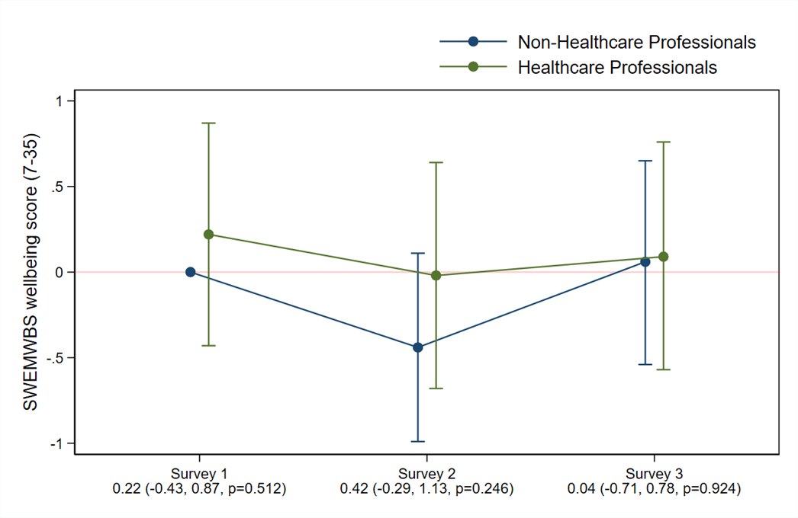
Supplementary Fig. 2. Adjusted difference in mean scores for wellbeing (SWEMWBS) in HCPs and non-HCPs at baseline, phase 2, and phase 3.

Supplementary Fig. 3. Adjusted difference in mean scores for depression (PHQ-9), anxiety (GAD-7), clinical insomnia (ISI-7), and burnout summative scores (EEDP2Q) in patient facing HCPs and non-patient facing HCPs at baseline, phase 2, and phase 3.
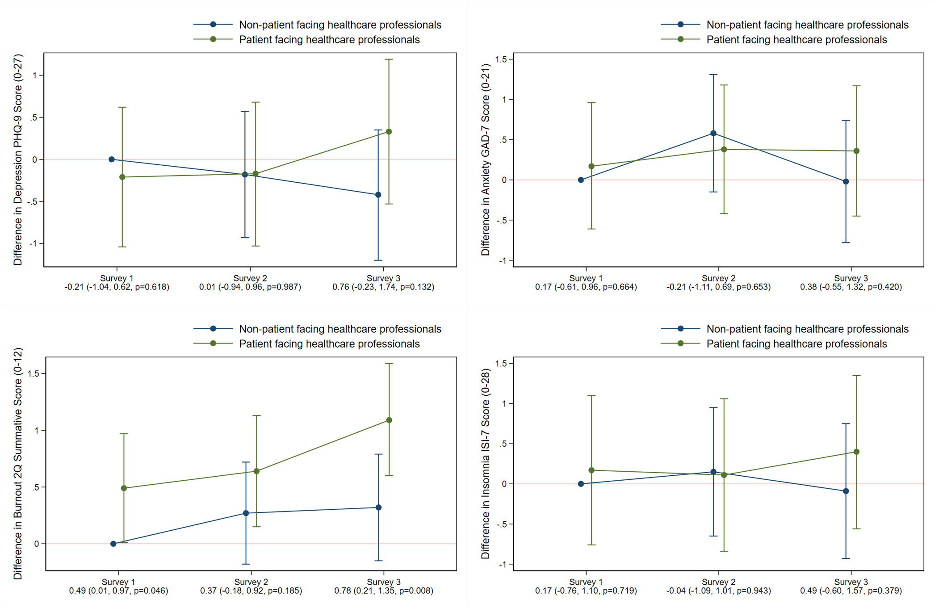
Supplementary Fig. 4. Adjusted difference in mean scores for wellbeing (SWEMWBS) in patient facing HCPs and non-patient facing HCPs at baseline, phase 2, and phase 3.

