Appendix 1: Data extraction Form
Appendix 2: AMSTAR 2 checklist
Appendix 3: List of excluded studies with reasons
Appendix 4: Cochrane Risk of bias summary graph

Appendix 1: Data extraction form.

Data extraction form – adapted from Cochrane Collaboration

Notes on using data extraction form:
- Be consistent in the order and style you use to describe the information for each report.
- Record any missing information as unclear or not described, to make it clear that the information was not found in the study report(s), not that you forgot to extract it.
- Include any instructions and decision rules on the data collection form, or in an accompanying document. It is important to practice using the form and give training to any other authors using the form.

General Information
Date form completed (dd/mm/yyyy)
Name/ID of person extracting data
Contact details of person extracting data
Reference citation (full citation)
Study author contact details (Email)
Publication type (e.g. full report, abstract, letter)
Notes:

Study details
Study Name
Author
Year of publication
Journal Name
Volume, Issue, Page
Status (published, ongoing etc)
Notes

DO NOT PROCEED IF STUDY EXCLUDED FROM REVIEW

Characteristics of included studies

Participants
 | Description  Include comparative information for each intervention or comparison group if available |  | Location in text or source (pg & ¶/fig/table/other)
Population description (from which study participants are drawn)
Setting (e.g. intensive care unit, service providers, institutions, day care centre etc)
Method of recruitment of participants (e.g. phone, mail, clinic patients)
Informed consent obtained | Yes No Unclear
Study Group | Age of participants
 | Number of participants  by sex | M:  W:
 | Type of epilepsy (e.g. high frequency: 20, low frequency:18)
 | Type of pharmacological regime
Severity of intellectual
disability
 | IQ (if reported)
 | Co-morbidities (physical and other)
Control Group | Age of participants
 | Number of participants  by sex | M:  W:
 | Type of epilepsy (e.g. high frequency, low frequency or type of seizure etc.)
 | Type of pharmacological regime
 | IQ (if reported)
 | Co-morbidities (physical and other)
State different types of psychiatric disorders identified
Notes:

Methods
 | Descriptions as stated in report/paper | Location in text or source (pg & ¶/fig/table/other)
Aim of study (e.g. efficacy, equivalence, pragmatic)
Design (e.g. parallel, crossover, non-RCT, controlled study)
Sampling technique (e.g. random)
Method of establishing Diagnosis | For psychiatric disorders:  For ID:

Outcomes
Copy and paste table for each outcome.
Outcome 1
 | Description as stated in report/paper |  |  |  |  |  |  |  |  | Location in text or source (pg & ¶/fig/table/other)
Primary outcome if dichotomous (e.g. %) | Number of psychiatric disorders (Epilepsy group) | Total number of participants (N; Epilepsy group) |  | Number of psychiatric disorders (non-epilepsy group) |  |  | Total control number of participants  (N; non-epilepsy group)
Primary outcome if continuous | Mean (Epilepsy; EP group) | SD (EP) | N (EP) |  |  | Mean  (non-epilepsy group) |  | SD  (non-epilepsy group) | N
Statistical methods used and appropriateness of these (e.g. proportion, %, risk ratio, odds ratio)
Secondary outcome
Number of missing data
Reason for missing data
Other
Is outcome/tool validated? | Yes No Unclear
Notes:

Other information
 | Description as stated in report/paper | Location in text or source (pg & ¶/fig/table/other)
Key conclusions of study authors
References to other relevant studies
Correspondence required for further study information (from whom, what and when)
Notes:

Other

Study funding sources (including role of funders)
Possible conflicts of interest (for study authors)
Notes:

Appendix 2: AMSTAR 2 checklist
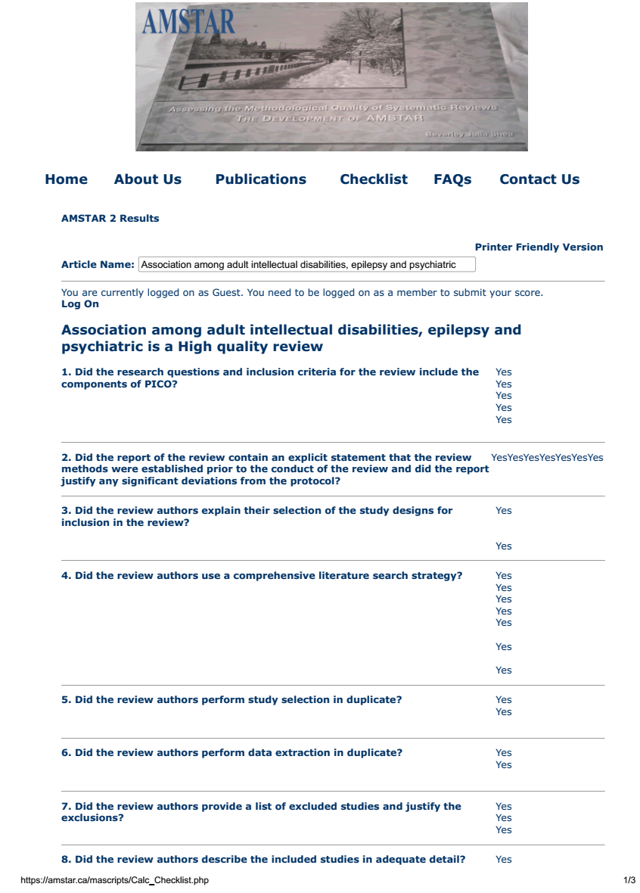

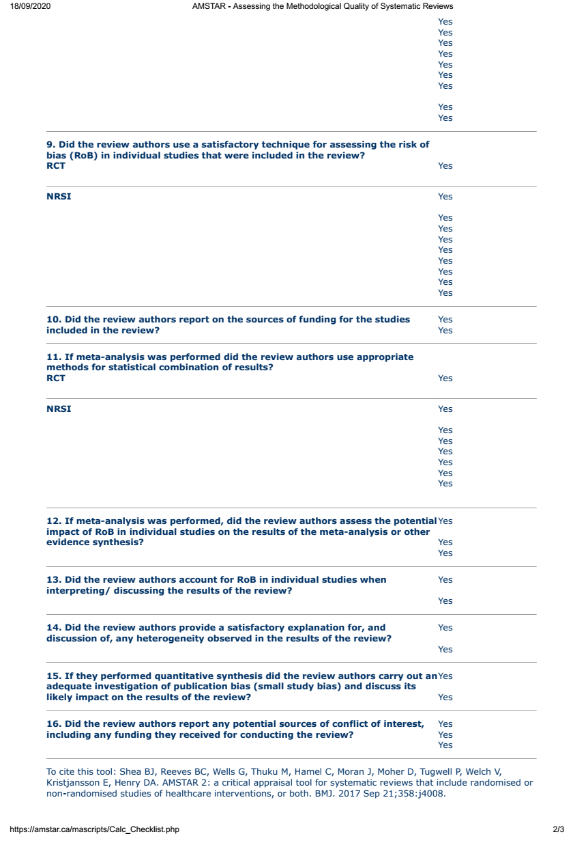
Appendix 3: List of excluded studies with reasons
Reference | Title | Reason for exclusion
Bhaumik et al., 2008 | Psychiatric service use and psychiatric disorders in  adults with intellectual disability | Does not provide data on psychiatric disorders related to epilepsy and ID
Deb, 1997 | Mental Disorder in Adults with Mental Retardation and Epilepsy | Presented data on the same cohort as Deb S, Hunter D. Psychopathology of People with Mental Handicap and Epilepsy II: Psychiatric Illness. Br J Psychiatry 1991; 159: 826–30.
Doherty et al., 2019 | Eslicarbazepine acetate in epilepsy patients with psychiatric comorbidities  and intellectual disability: Clinical practice findings from the Euro-Esli study | Not all participants have ID, no data for psychiatric disorders in ID and epilepsy
Endermann, 2015 | Rehabilitation for young adults with epilepsy and mild intellectual  disabilities: Results of a prospective study with repeated  measurements | Does not provide information on psychiatric disorders in relation to epilepsy and antiepileptic drug related factors
Folch et al., 2018 | Health indicators in intellectual developmental disorders: The  key findings of the POMONA-ESP project | Does not provide information on psychiatric disorders in relation to epilepsy and antiepileptic drug related factors
Lund, 1986 | Behavioural symptoms and autistic psychosis  in the mentally retarded adult | Does not provide information on psychiatric disorders in relation to epilepsy and antiepileptic drug related factors
McCarron et al., 2017 | A prospective 20-year longitudinal follow-up of dementia in persons  with Down syndrome | Same sample as McCarron et al., 2014.
McGrother et al., 1996 | Community care for adults with learning disability and their carers: needs and outcomes from the Leicestershire register | Does not provide information on psychiatric disorders in relation to epilepsy and antiepileptic drug related factors
McVicker et al., 1994 | Prevalence and associated features of epilepsy in adults with down's syndrome | Does not provide information on psychiatric disorders in relation to epilepsy and antiepileptic drug related factors
Mula et al., 2004 | Psychiatric adverse events in patients with epilepsy and learning disabilities taking levetiracetam | Data on psychiatric adverse events of a specific Antiepileptic Medicine (levetiracetam).
Zimmermann & Endermann, 2008 | Self–proxy agreement and correlates of health-related quality of life  in young adults with epilepsy and mild intellectual disabilities | Does not provide information on psychiatric disorders in relation to epilepsy and antiepileptic drug related factors
McCarron et al., 2016 | A prospective 18-year longitudinal follow-up of dementia in persons with  Down syndrome | No full text and same sample as McCarron et al., 2014
McCarron et al., 2012 | A prospective fourteen-year longitudinal follow-up of dementia in persons with  Down syndrome | No full text
Gostason, 1985 | Psychiatric illness among the mentally retarded. A swedish population study | Book
Doran et al., 2011 | Seizures are associated with a marked worsening of dementia in Down syndrome | No full text, oral presentation
Lott, 2013 | Neurodevelopment and aging in down syndrome | No full text, oral presentation
Monetti et al., 2012 | Epilepsy and psychiatric disorders in a “learning disability” patient's series | No full text, oral presentation
Deb, 1987 | Effect of folate metabolism on the psychopathology of adults with mental  retardation and epilepsy | No data on psychiatric disorders
Meins, 1993 | Prevalence and risk factors for depressive disorders in adults with intellectual Disability. | No access to full text
Belov & Kazakovtsev,1989 | Psychoses and mental retardation in epilepsy: Clinical aspects, evolution of syndromes, and prognosis | No access to full text
Pary, R. (1993). | Mental retardation, mental illness, and seizure diagnosis. | No access to full text

Appendix 4: Summary graph of Risk of bias in 25 controlled studies.
